Unit : 3D1 Block graphs
Topic : Favourite Colour of Our Class
Key Stage : 1

Learning Objectives:
- Collect data and construct frequency tables
- Construct block graphs using a one-to-one representation

Prerequisite Knowledge:
Read block graphs

Teaching Resources:
- Colour paper
- Drawing paper

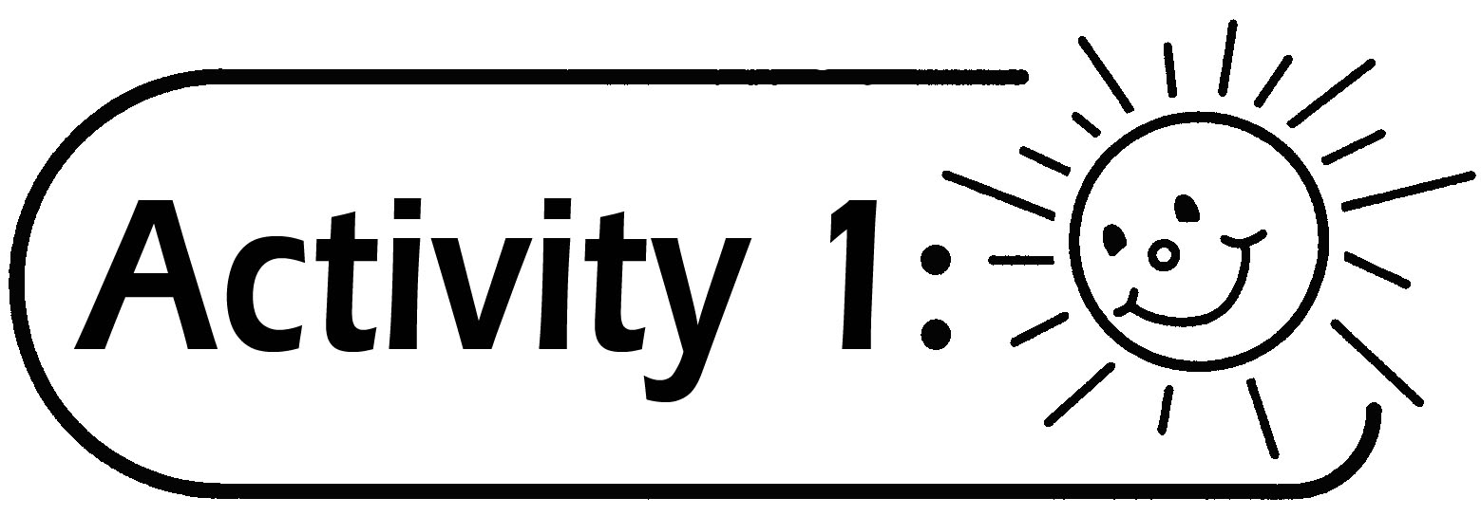
Favourite Colour of Our Class
- Pupils nominate some of their favourite colours.
- Pupils discuss the way of collecting data.
For example:
- By raising hands and count the number of hands; or
- 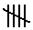Collect the data within the group first. The group leader reports the data of the group to the whole class. Each pupil in the class records the data of other groups.
- Pupils can use the symbols to record the data in the frequency table in the following way:

Colour | Red | Blue | Green | Yellow
Tally Mark
Frequency | 10 | 8 | 7 | 7

- Use the results to construct a block graph using a one-to-one representation on the blackboard.

Questions for Discussion:
- Which is the most/ the least favourite colour of the class?
- How many pupils like red?
- How many classmates like red more/less than those who like green?
- How many classmates took part in the survey?
- If the total number of classmates in the survey is less than the total number in the class, what are the possible reasons? Explain.
- What are the benefits of using a frequency table?
- Can we know the number of classmates who like white? Why?
- If some classmates like colours other than those chosen in the survey, how can it be dealt with?
- Would the results be the same if the neighbouring class conducted the same survey?

Remarks:
- The teacher should prepare sufficient paper of the same colour in case too many pupils choose the same colour paper.
- If the length of the drawing paper is not long enough to display the total number of blocks, the teacher can put the blocks directly on the blackboard.
- If the total number of classmates shown in the survey is less than the total number of the classmates in the class, the possible reasons are:
- Some pupils did not raise their hands;
- Counting mistakes;
- Absentee; or
- Other appropriate reasons.

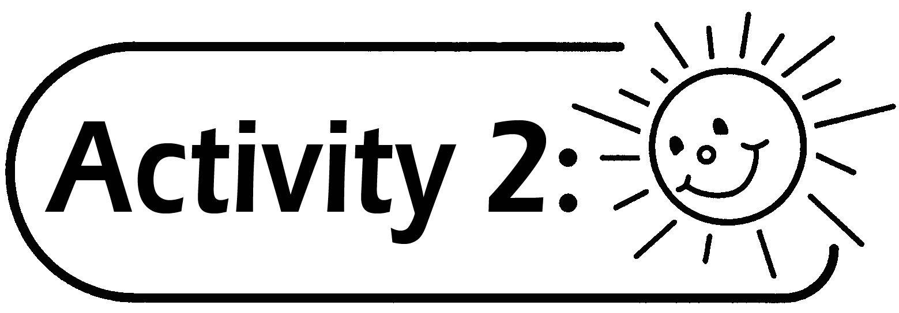
- Every two groups of pupils (10 to 12 pupils) are given a piece of drawing paper.
- Pupils collect the data of the favourite fruits within the combined group and construct a block graph.
- Pupils have to write down the item names and the title in the appropriate location of the block graph.
- Discuss the problems and difficulties encountered in constructing the block graph.
- Compare the results of the graphs constructed.

Generic Skills Fostered:
- Collaboration Skills
- Communication Skills
- Critical Thinking Skills
- Problem Solving Skills

