Unit : 3D1 Block graphs
Topic : Our Favourite Fruits
Key Stage : 1

Learning Objective:
Read and construct block graphs

Prerequisite Knowledge:
Able to read and construct pictograms

Teaching Resources:
- White square cards
- Fruits cards or magnetic fruit cards

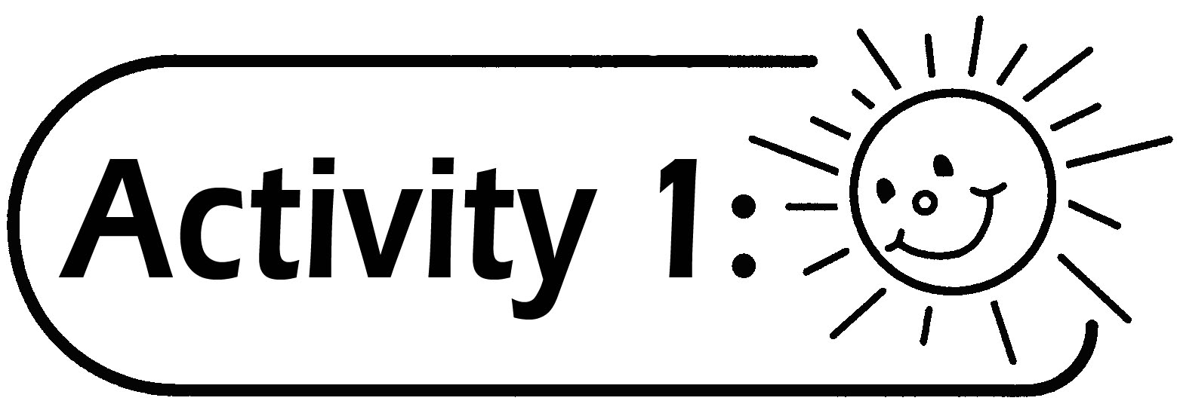
Construct the pictogram “Our Favourite Fruits”. Pupils take turns to choose the fruit cards (or magnetic fruit cards) from the teacher’s desk and stick them on the blackboard. The completed graph will look like the one shown below.

Our Favourite Fruits
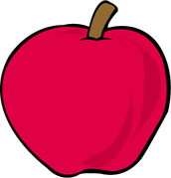
 |  |  |  | 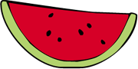
 |  |  |  |  |  | 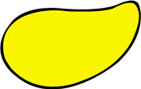
apple |  | orange |  | watermelon |  | mango

Remarks:
The teacher may first find out the types of fruits pupils like or fix the number of participants in order to make sure that there are enough fruit cards for the activity.

Questions for Discussion:
- What is the name of this chart?
- Which is the most popular fruit among the classmates? How many pupils like it?
- What is the least popular fruit among the classmates? How many pupils like it?
- How many pupils take part in the study?
- Is it easy to make a pictogram? What are the difficulties encountered?
- Is there any faster method to present the same data with pictures?

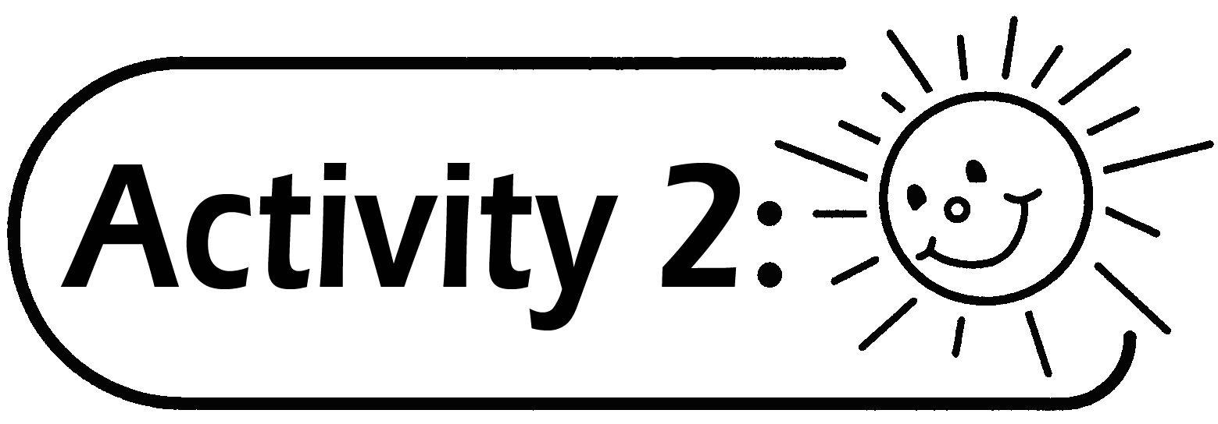

Pupils cover each fruit card with a white square card, thus changing the pictogram into the graph as shown below.
Our Favourite Fruits

apple |  | orange |  | watermelon |  | mango
Conclusion: The graph above is called Block Graph. It uses blocks to represent the data.
Notes on making Block Graphs:
- The size of each block should be the same.
- The space between each group of blocks is the same. There is no fixed rule on the width of the space between. (see Figure 1).
- There should not be any space between the blocks in each group (see Figure 2).

 |  |  |  |  |  |  |  |  |  | ü |  | ×
(Figure 1) |  |  |  |  |  |  | (Figure 2)

Generic Skills Fostered:
- Collaboration Skills
- Critical Thinking Skills

