Study the pictogram below and answer the questions.

Beautiful Flowers
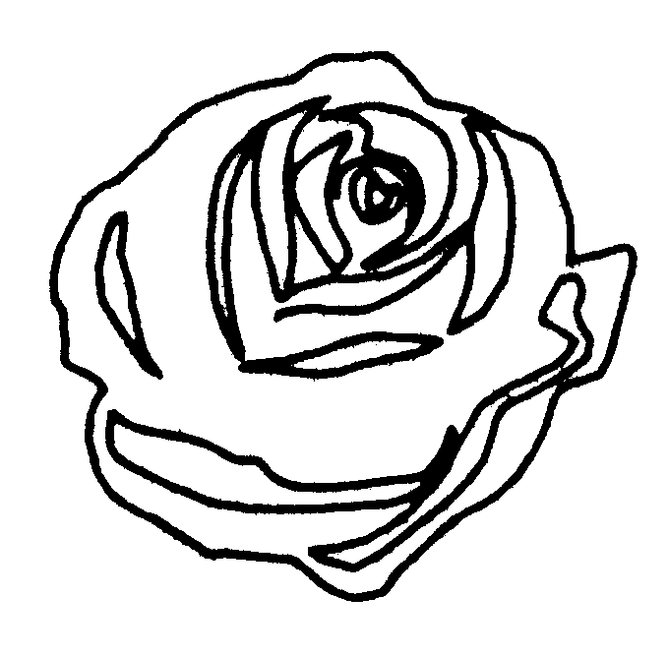
 | 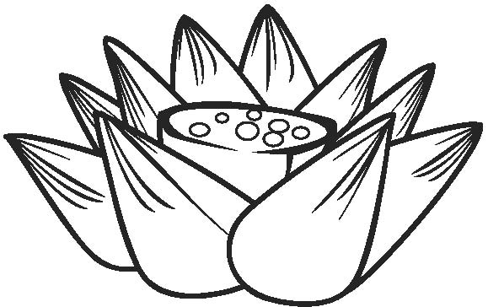 |  | 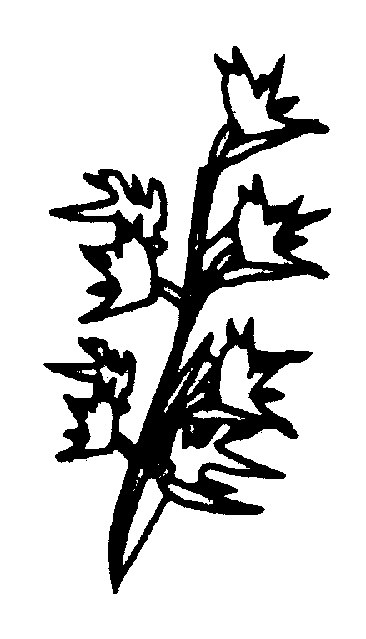
Rose | Lotus | Bauhinia | Gladious

1. |  | The most favourite flower is .
2. |  | The number of people who like and are the same. It is because there are persons each.
3. |  | There are persons taking part in this study.
4. |  | The disadvantage(s) of using a pictogram to represent the number of people  is/are  .  Way(s) for improvement:  .

