Unit : 3D1 Block graphs
Topic : Shapes of Balloons
Key Stage : 1

Learning Objectives:
- Understand block graphs
- Read block graphs

Prerequisite Knowledge:
- Read pictograms
- Construct pictograms using a one-to-one representation

Teaching Resources:
- Worksheet – Shapes of Balloons
- Four balloons of different shapes(see Appendix)
- Square paper

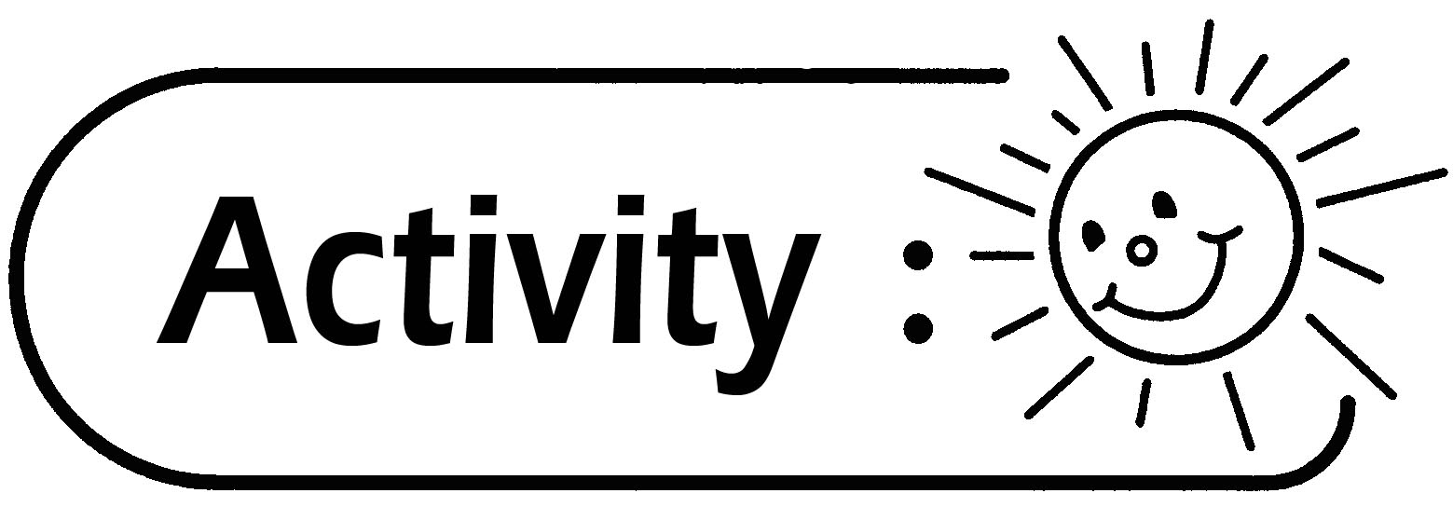
Survey on the numbers of balloons of different shapes
- The teacher shows balloons of different shapes and lets pupils choose their favourite balloons. Pupils discuss the criteria for constructing a pictogram.
- Pupils construct a pictogram by placing the balloons on the blackboard (see Figure 1).
- The teacher revises the skills of reading pictograms with pupils after completing the construction.
- According to the information of the pictogram, pupils construct a block graph with square paper (see Figure 2).
- Pupils read the block graph and discuss.
- Pupils distinguish the differences between pictograms and block graphs. Compare their advantages and disadvantages.
- Using the information above, pupils construct a block graph in the Worksheet and answer the questions.

Pictogram Block graph

Figure 1 Figure 2

Questions for Discussion:
Pictogram:
- What criteria do you consider in constructing the pictogram after choosing the balloons?
- Which is the most favourite balloon?
- Which two balloons have the same frequency? How do you know? What is the frequency?
- How many balloons are there altogethers in the bag?

Block graph:
- How many pupils does each block represent?
- Is the size of each block the same? Why?
- Which is the most favourite balloon?
- Which two shapes have the same frequency of balloons? How do you know? What is the frequency?
- How many blocks are there altogethers in the block graph? What do these blocks represent? How are the blocks related to the total number of balloons in the pictogram?
- Study the pictogram and the block graph. Try to state their characteristics and their similarities.
- If you would conduct another survey, e.g. the colours of balloons, which graph would you use? Why? (Accept any reasonable answers)

Remarks:
- Fruits or cartoon characters can be used instead of balloons in order to arouse pupils’ interest.
- Square stickers can be used instead of square paper in constructing the block graph.
- A pictogram shows clearly the objects taking part in the survey and is easier to be understood by pupils. However, it is time consuming and inconvenience in constructing the graph or drawing the pictures.
- A block graph is easier to construct but abstractly presented. It does not show the pictures of objects taking part in the survey.
- The size of each block should be the same. The space between each group of blocks should be the same (see Figure 3).

Figure 3

- There should not be any space between the blocks in the same group (see Figure 4).

Incorrect Correct

Figure 4

Generic Skills Fostered:
- Collaboration Skills
- Communication Skills
- Critical Thinking Skills

