According to the block graph below, answer the questions.
Different Shapes of Balloons

1. |  | Stick the shapes of the balloons in the boxes.
2. |  | According to the information provided, draw the blocks and complete the block graph.
3. |  | Each block in the graph represents balloon(s).
4. |  | 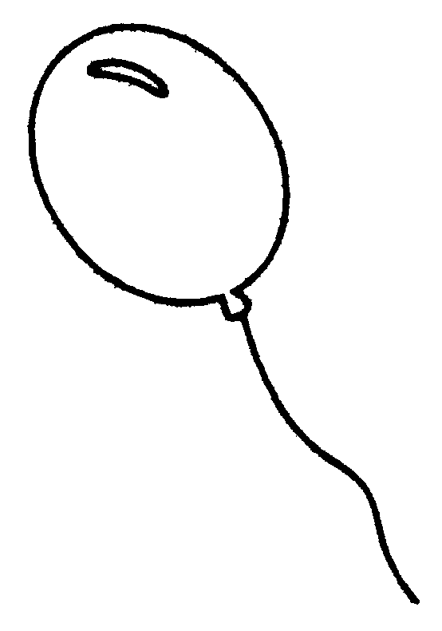  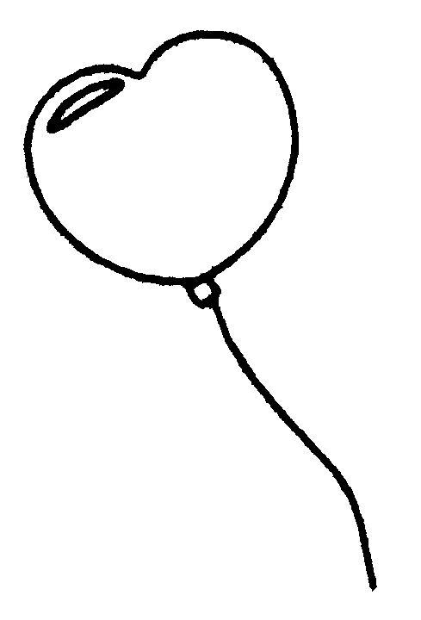  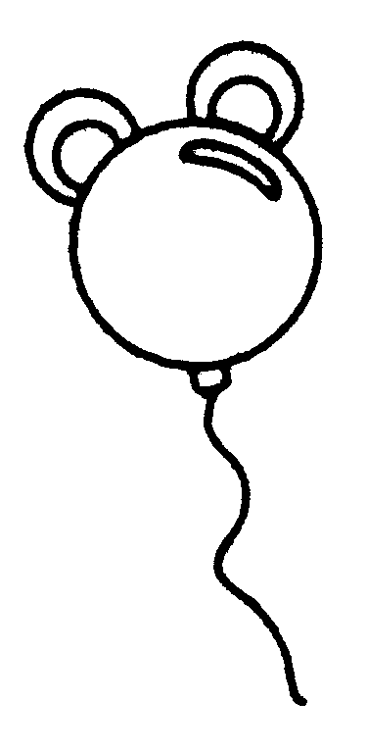  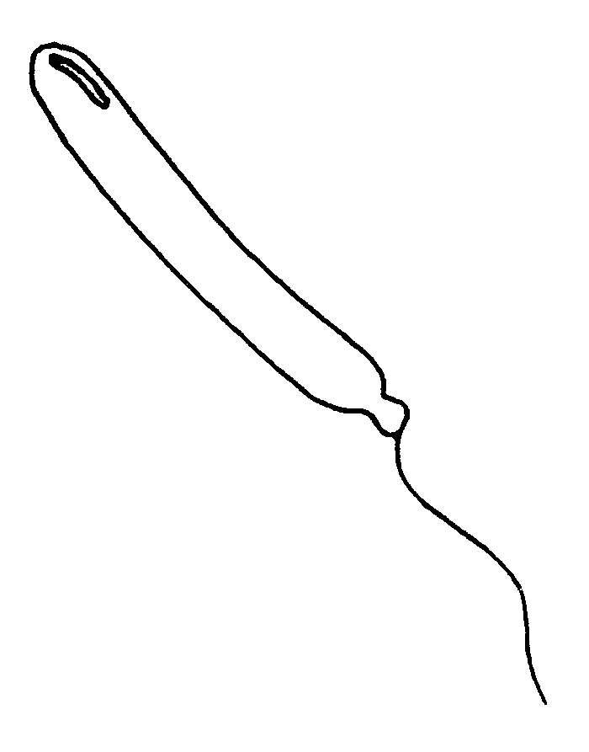  The balloon with the largest number is ( / / / ).
5. |  | ( / / / ) and ( / / / )  have the same number of balloons. It is because they (have / do not have) the same number of blocks. There are blocks each.

6. |  | Is there any difference between the data shown in the pictogram and the block graph?  .
7. |  | If you carry out another study, for example, the colours of balloons, you will draw a ( pictogram / block graph ) to show the data. It is because  .

