Unit : 1M1 Length and distance (I)
Topic : Measuring Tools
Key Stage : 1

Learning Objective:
Compare the lengths of objects and the distances between objects with improvised units

Prerequisite Knowledge:
- Understand the concept of length
- Compare the lengths of objects directly

Teaching Resources:
- Paper clips
- Stationery
- Books

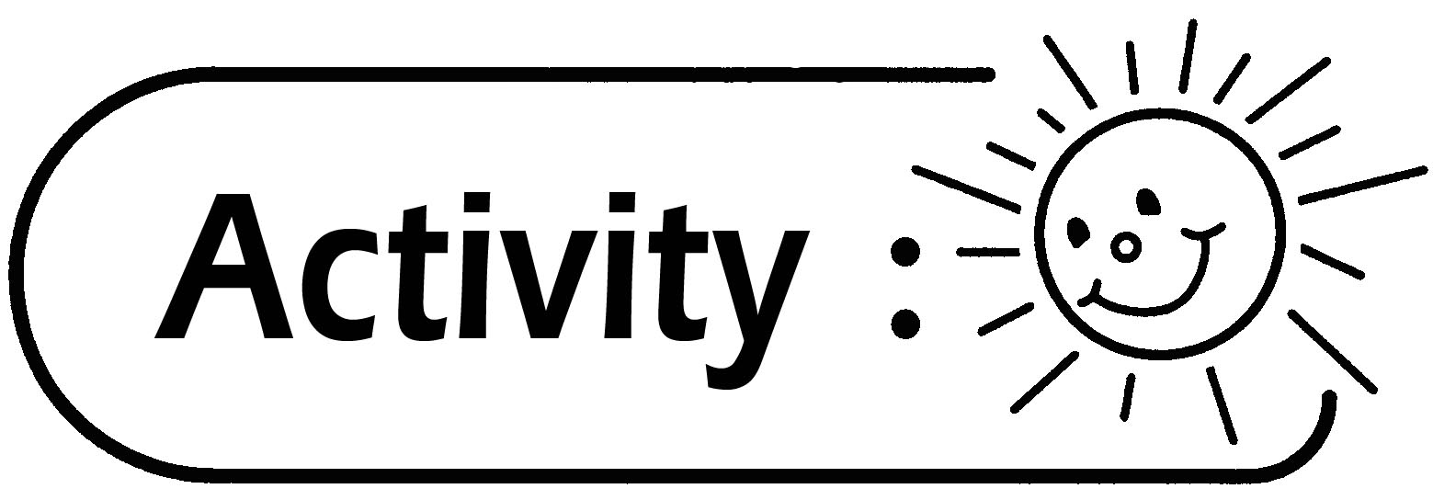
- Pupils are grouped in four.
- Two pupils of each group measure the lengths of the following objects with their finger spans and record the results in the following table.

Length of the object | Measuring tool | Measurement
A pencil | Finger span
A pencil box | Finger span
A Mathematics book | Finger span
A pupil’s desk | Finger span

- The other two pupils of each group measure the lengths of the following objects with paper clips and record the results in the following table.

Length of the object | Measuring tool | Measurement
A pencil | Paper Clips
A pencil box | Paper Clips
A mathematics book | Paper Clips
A pupil’s desk | Paper Clips

- The teacher guides the discussion among pupils.

Questions for Discussion:
- When using the same measuring tool to compare the lengths of different objects, which object is the longest? Which object is the shortest?
- Is it possible to measure the length of the same object by using different measuring tools (finger span or paper clips)? What do you find?
- What measuring method can be used to compare the lengths of different objects?
- Other than using finger span and paper clips as measuring tools, what other objects can be used and is accessible easily?
- The teacher guides pupils to choose the measuring tools for measuring the following objects.

Object | Measuring tool
Length of a rubber
Length of the teacher’s desk
Width of the door
Length of the blackboard
Width of the classroom

Generic Skills Fostered:
- Collaboration Skills
- Communication Skills
- Creativity

