Unit : 1M3 Length and distance (II)
Topic : Measuring in Centimetres
Key Stage : 1

Learning Objectives:
- Understand the need of using standard unit
- Introduce centimetre (cm)
- Measure and compare the lengths of objects and the distances between objects with centimetre

Prerequisite Knowledge:
- Understand the concept of length and distance
- Compare the lengths of objects and the distances between objects directly
- Compare the lengths of objects and the distances between objects with improvised units

Teaching Resources:
- Centimetre rules
- Straws
- Chalks
- Stationary
- Worksheet

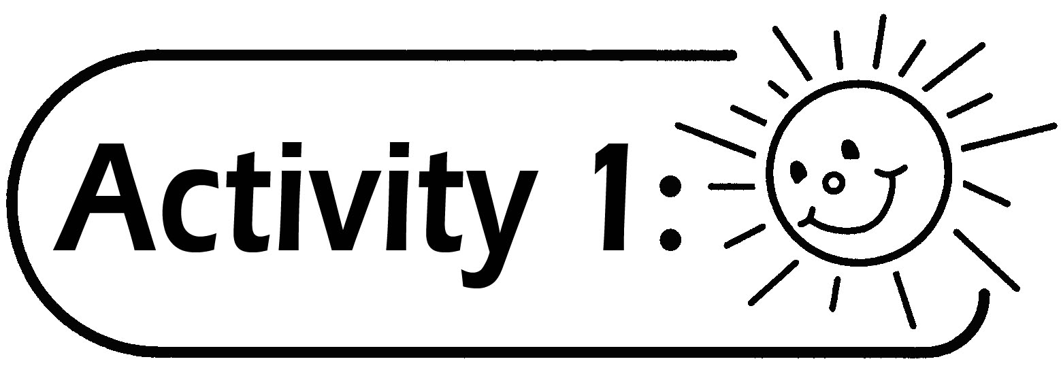
- Pupils measure the lengths of objects with their finger spans (e.g. the length of the desk, the length of the mathematics book).
- Pupils record the results on the Worksheet and present the results.
- The teacher measures the lengths of the same objects that are measured by pupils with his/ her finger span. Records the results on the blackboard.

Questions for Discussion:
- Compare the results among the teacher and pupils, why are there differences in the measurement of the same objects?
- How to solve this problem?

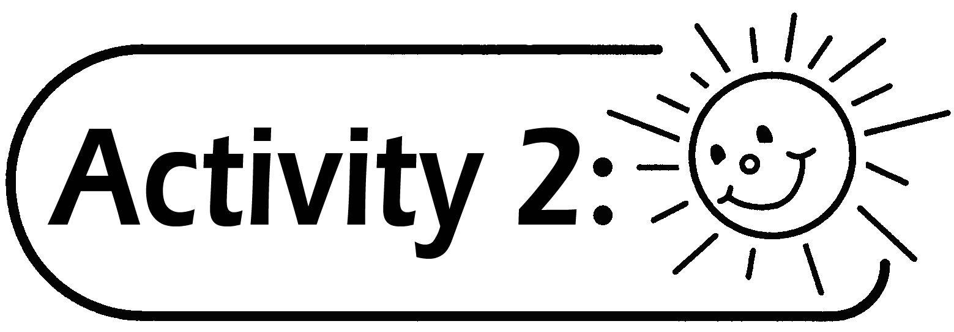
- Distribute the centimetre rules of equal length to the pupils.
- The teacher introduces the standard measuring unit ‘centimetre’ (cm) and guides pupils to observe the length of 1 centimetre (cm) on the centimetre rule.
- The teacher discusses with pupils on the points they need to note when using the centimetre rule.
- Pupils measure the lengths of different objects in the Worksheet with centimetre rules and record the measurement in ‘centimetre’ (cm).

Questions for Discussion:
- How to measure objects with centimetre rules?
- Is it necessary to place the object at ‘0’ on the centimetre rule? Why?
- How to use the following broken centimetre rule for measurement?

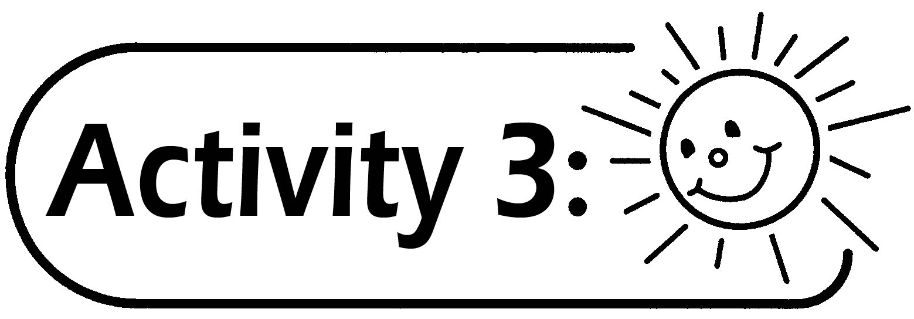
- Pupils are grouped in 3 to 4. They estimate the length of the objects before measuring (e.g. a pencil, a straw, a piece of chalk and a rubber) and then measure the lengths of the objects and record the measurements on the Worksheet.
- The teacher invites pupils with the nearest estimated answer to share their experiences.

Remarks:
If pupils do not have centimetre rules, they can use rulers marked in centimetre.
Generic Skills Fostered:
- Collaboration Skills
- Communication Skills
- Critical Thinking Skills
- Problem Solving Skills

