Price List

Items | Price
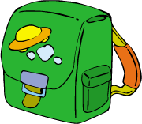  School bag | $189.00
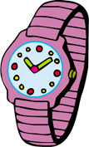  watch | $223.80
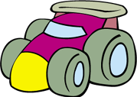  Four Wheels Drive Toy | $32.60
  Soft Toy | $54.90
Train Model | $89.50
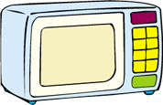  Microwave | $1030.00
  Toy Dog | $478.00

