Measure the lengths of the following objects with your finger span:
The length of a pupil’s desk | about ______ finger span(s)
The length of a mathematics textbook | about ______ finger span(s)

Measure the lengths of the objects in the pictures below with a centimetre rule.
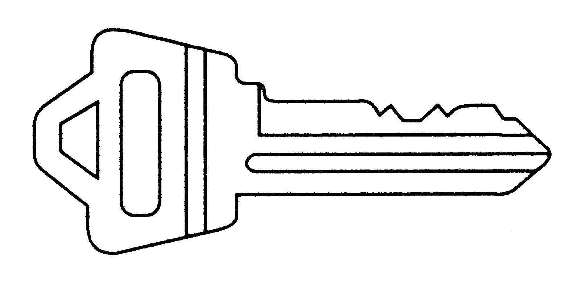 |  |  |  |  |  |  | ________ cm
key |  |  |  |  |  |  | ________ cm
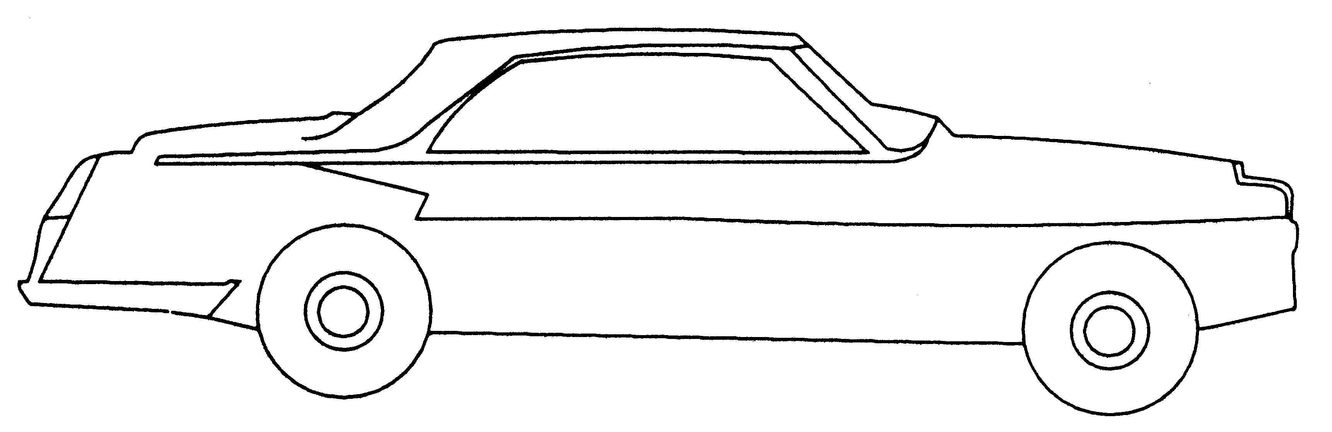 |  |  |  |  |  |  | ________ cm
toy car |  |  |  |  |  |  | ________ cm
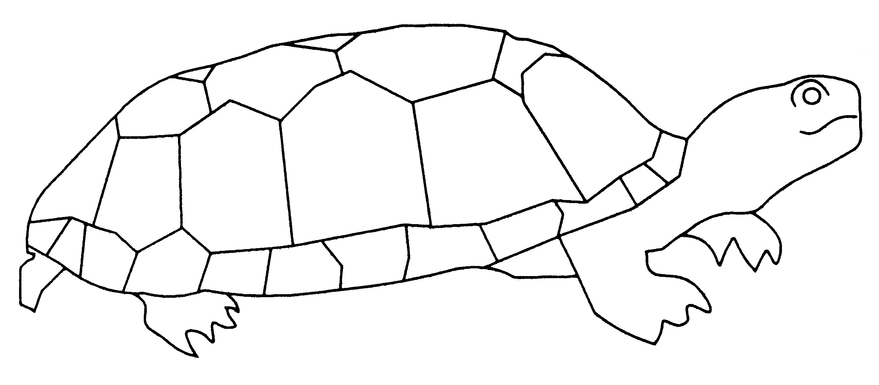 |  |  |  |  |  |  | ________ cm
toy tortoise |  |  |  |  |  |  | ________ cm

Estimate first and then measure the lengths of the objects (in centimetres).
 | Estimate (cm) | Measurement (cm)
a pencil
a straw
a piece of chalk
a rubber

