Use the table below to record the exact number of notes and coins used in buying the following items. | 10￠
 | 20￠
 | 50￠
 | $1
 | $2 | 2
 | $5 | 1
 | $10 | 1
 | $20 | 1
 | $50 | 1
 | $100 | 1
 | $500
 | $1000
 |  | 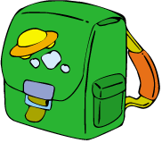 |  |  |  |  | 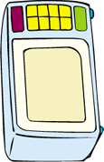 | 

