Unit : 3M3 Capacity
Topic : Whose Bottle Has the Largest Capacity?
Key Stage : 1

Learning Objectives:
Use the improvised unit to measure and compare the capacity of containers

Prerequisite Knowledge:
Pupils have come across containers of different capacity in their daily lives

Teaching Resources:
- Funnels
- Buckets (for water storage)
- Bottles (three for each group)
- Plastic cups or Paper cups of different sizes
- Worksheet

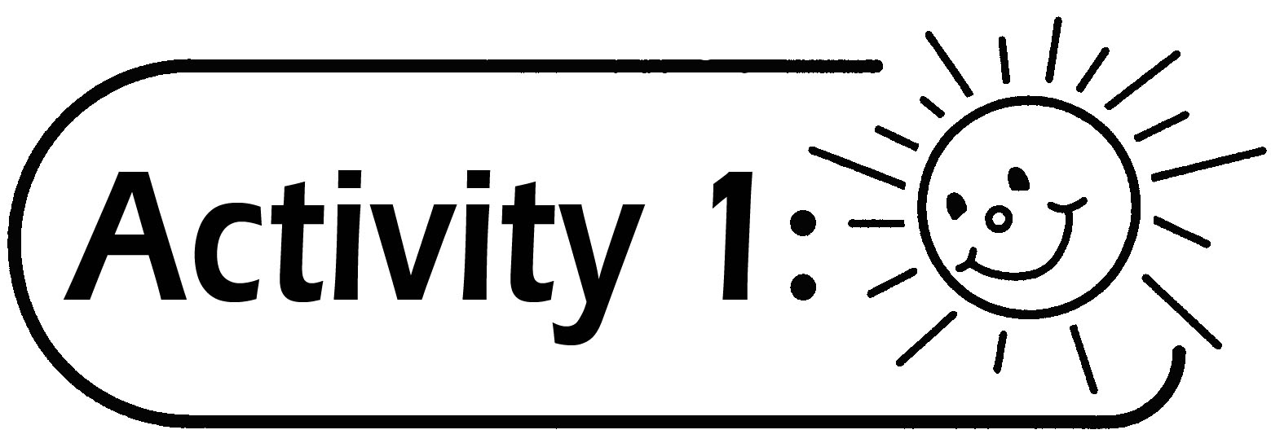
- Pupils are divided into groups of 4 to 6.
- Each group is given a plastic cup or paper cup (different sizes for each group).
- Each group prepares three empty bottles of different sizes and label them with numbers (For example: 1, 2, 3).
- Fill up the three empty bottles with water. Count the number of cups of water required to fill up the bottles.
- Compare the capacities of the bottles and record the results on the Worksheet.

Questions for Discussion:
- Which bottle in your group has the largest capacity? Why?
- Is it possible to compare the capacity of the largest bottle among different groups? Why?
- How to compare the capacity of the largest bottle among different groups?

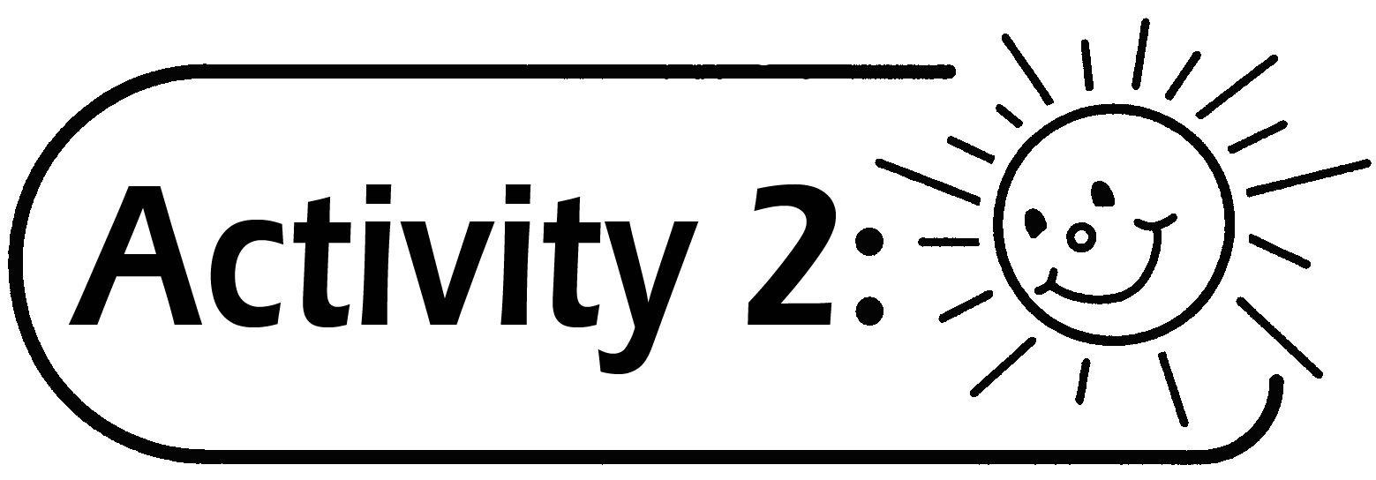
- The teacher gives each group a plastic cup or paper cup of the same size. Guide the pupils to re-count the number of cups needed to fill up the bottle with the largest capacity.
- Compare the capacity of the bottles among the groups and find out which group’s bottle has the largest capacity.

Remarks:
- The teacher guides the pupils to find out that they should use the same unit to compare the capacity of the containers.
- The capacity of the plastic cups or paper cups used should not be too large.
- Prepare towels to clean up the water spilt in order to avoid wetting the floor and desks.

Generic Skills Fostered:
- Collaboration Skills
- Communication Skills
- Critical Thinking Skills
- Problem Solving Skills

