 | Number of Paper Strips |  | Length Measured  with a Metre Rule
 | Short Paper Strip (10 cm) | Long Paper Strip (100 cm) | Length Measured  with a Metre Rule
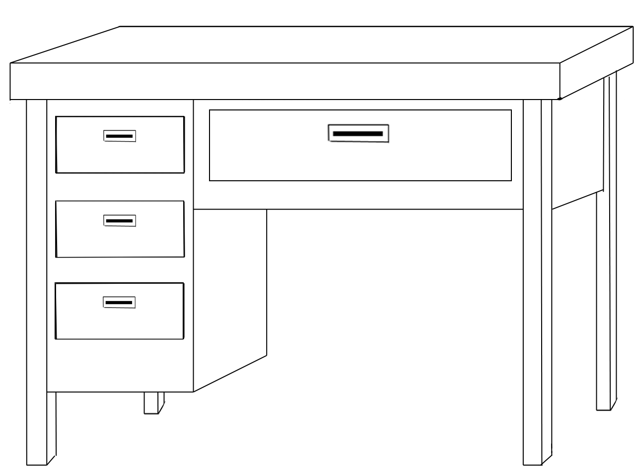

Teacher’s desk
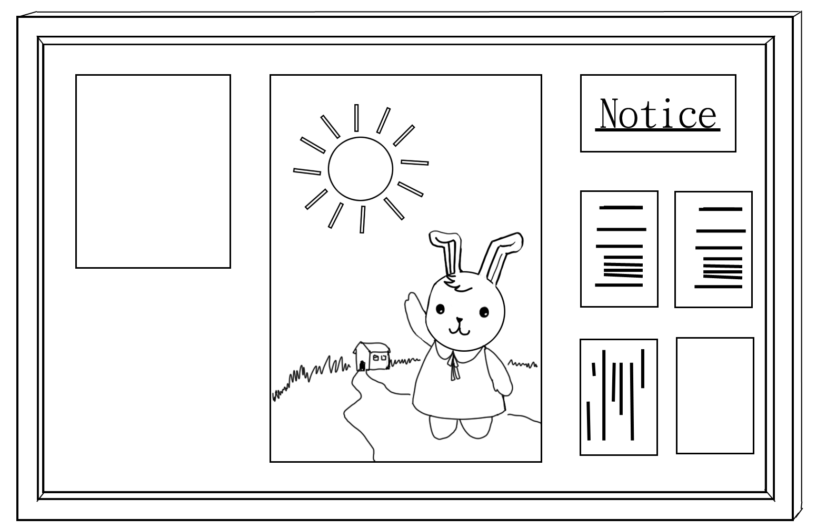

Display board
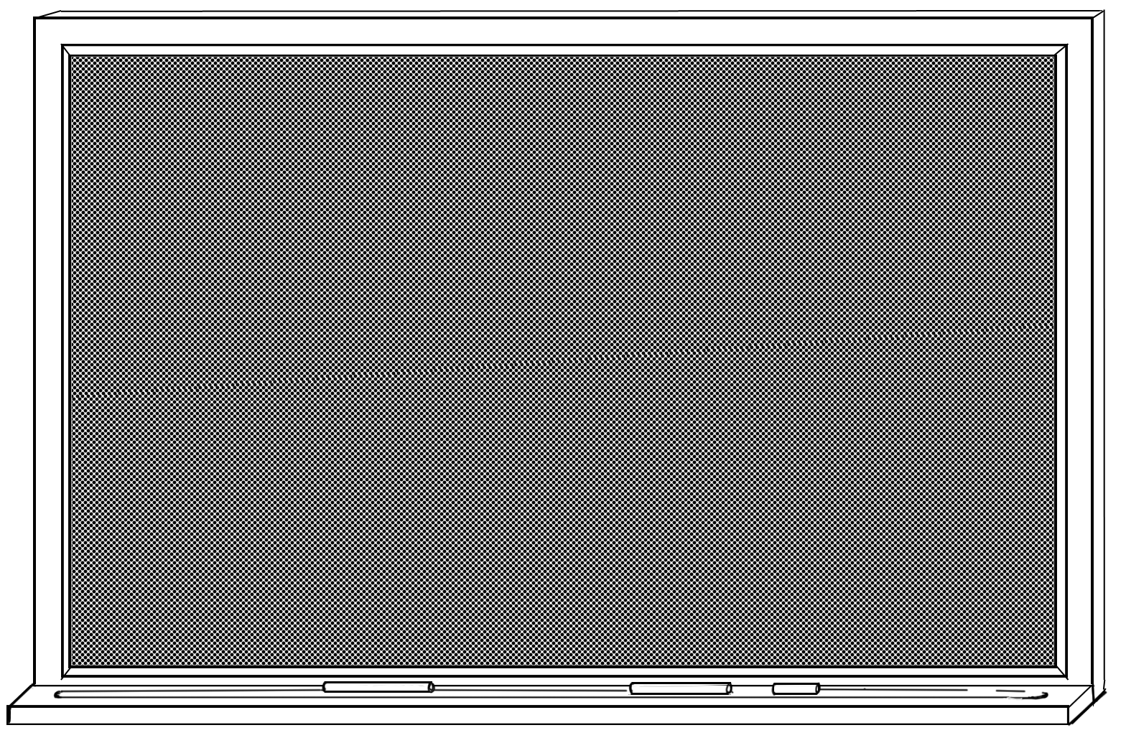

Blackboard

