Unit : 3M1 Length and distance (IV)
Topic : Record of Our Class
Key Stage : 1

Learning Objectives:
- Choose the appropriate tools for measurement
- Record the lengths of objects and the distances between objects with appropriate units

Prerequisite Knowledge:
- Understand the measuring units millimetre (mm), centimetre (cm) and metre (m)
- Use ruler and measuring tape to measure the length of an object
- Recognise different parts of the body

Teaching Resources:
- Ruler (marked in millimetre and centimetre)
- Measuring tape (marked in centimetre and metre)
- Metre rule
- Worksheet

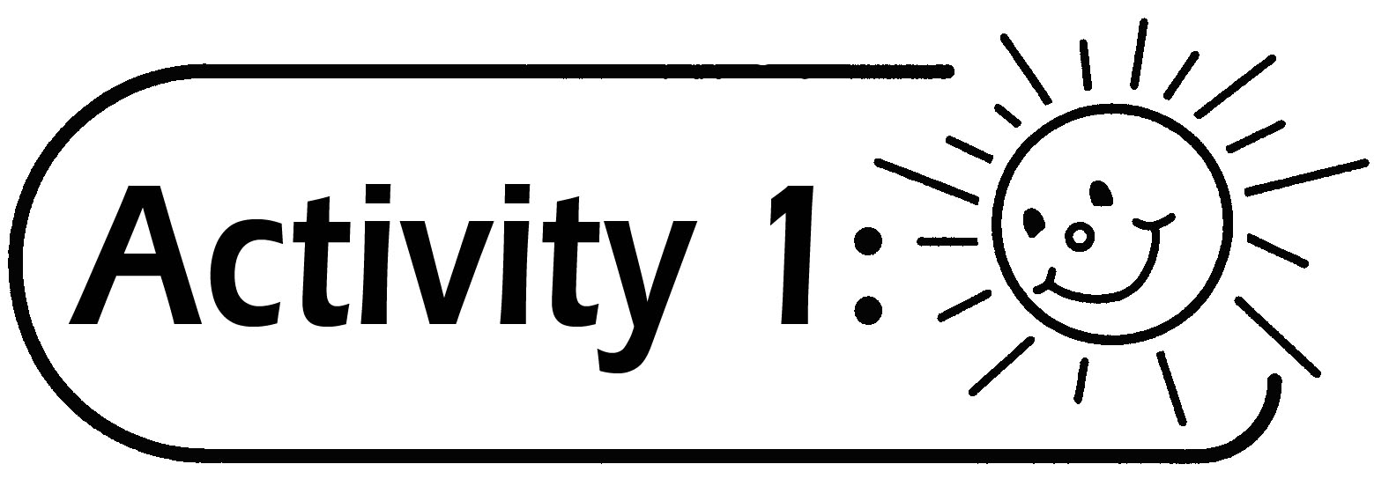
- Pupils are grouped in pairs.
- Before the activity, the teacher explains to pupils the parts of the body they are going to measure. If necessary, teacher can explain with diagrams. For example, for Item 6, the distance to be measured is from A to B (see Figure 1).
- Pupils finish the Worksheet as instructed.
- The teacher discusses with pupils on the problems encountered in the measurement activity. Compare the results of each item and find out whose result is the ‘Record of the Class’.

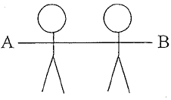

(Figure 1)
Questions for Discussion:
- What is/are the problem(s) encountered in measuring activity?
- How to choose the appropriate measuring units?
- Can we use different units to measure the same object? Why?
- How to choose the appropriate measuring tool(s)?
- Can we use different tools to measure the same object? Why?

The teacher guides pupils to conclude that in different situation, different measuring units and tools should be used for measuring different objects. For example, millimeter (mm) or centimeter (cm) are used for measuring shorter objects, metre for measuring longer objects and measuring tape is better for measuring curved objects.

Remarks:
- The teacher can firstly revise the measuring units millimetre (mm), centimetre (cm) and metre (m) with pupils if necessary.
- The teacher can modify the objects to be measured in the Worksheet, for example, the length round the head can be replaced by the length round the waist.
- If the resources are limited (e.g. not enough metre rules), the teacher can arrange some groups to do Items 4 to 6 first.

Generic Skills Fostered:
- Collaboration Skills
- Communication Skills
- Critical Thinking Skills
- Problem Solving Skills

