Unit : 6M3 Speed
Topic : Understand Speed
Key Stage : 2

Learning Objectives:
- Understand the concept of speed
- Use ‘metre per second’ (m/s) or ‘kilometre per hour’ (km/h) as the unit of speed
- Solve simple problems

Prerequisite Knowledge:
- Understand time and distance
- Understand multiplication, division and their relationship

Teaching Resources:
- Metre rules
- Stopwatches
- Animal cards (see Appendix)
- Transportation Vehicle cards (see Appendix)
- Speed Limit Sign cards (see Appendix)

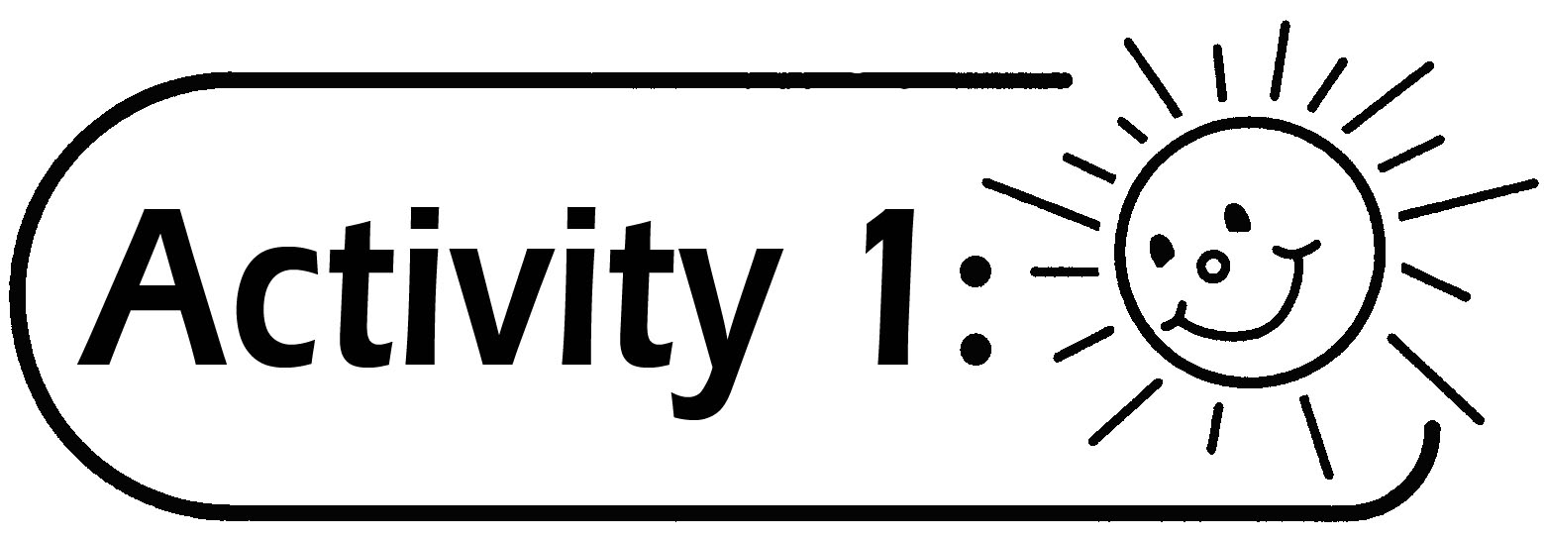
- The teacher gives the Animals cards to the pupils and guides them to arrange the animals from the fastest to the slowest in running.
- The teacher gives the Transportation Vehicle cards to the pupils and guides them to arrange the vehicles from the fastest to the slowest in travelling.
- The teacher gives pupils the Speed Limit Sign cards and guides them to describe the meaning of the signs.
- The teacher explains the concept of speed.
- The teacher guides the pupils to recognise the unit of speed and read the units.
Questions for Discussion:
- If four kinds of animal travel the same distance, which animal takes the least time? Which animal takes the longest time?
- Do animals of the same kind have the same speed?
- Do the speed of the vehicles remain unchanged in travelling? Explain the change briefly.
- What are the meanings of the numbers and words written on the Speed Limit Sign cards?

Remarks:
- Before doing the ordering activity, the teacher reminds pupils to choose the speed of a certain animal or vehicle as a reference and then use this to compare the speed of other animals or vehicles.
- The teacher can encourage pupils to collect the data of the speed of other animals or vehicles for display on the board.
- The standard unit of speed is km/h and m/s.

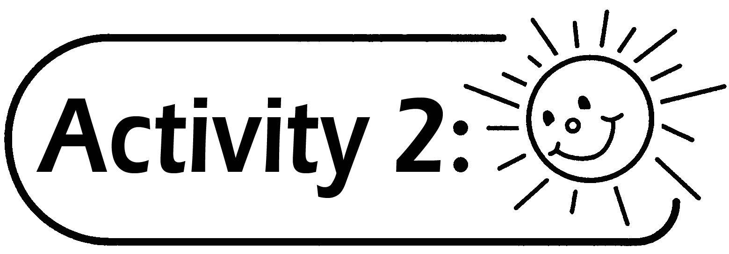
- The teacher invites a pupil to walk along the blackboard back and forth at normal speed in the classroom once or twice. Record the time the pupil takes and measure the distance he/she walks. Explain the method of calculating the speed in the table below.

Distance | Time | Speed = Distance ÷ Time
- Repeat the above activity to consolidate pupils’ understanding of the concept of speed.
- Use the speed of the pupil to calculate the time he/she takes to walk a certain distance.

Distance | Speed | Time = Distance ÷ Speed

- Use the walking speed of the pupil to find the distance he/she walked within a period of time.

Speed | Time | Distance = Speed × Time

Questions for Discussion:
- How to measure (or find out) the walking speed of a person?
- How to find the time required for the pupil to walk for a certain distance by using his walking speed?
- How to find the distance walked by the pupil within a period of time by using his/her walking speed?
- By using the pupil’s walking speed and the time used to go home from the school, how can he/she find the distance between the school and his/her home?

Remarks:
- Pupils can suggest different reasonable ways to find the walking speed of classmates.
- The teacher can use some concrete examples to help pupils understand Questions 2 and 3 for discussion.
- Indivisibility of numbers may occur in finding the walking speed or time.

Generic Skills Fostered:
- Communication Skills
- Critical Thinking Skills
- Numeracy Skills
- Problem Solving Skills

