Unit : 3M3 Capacity
Topic : My Container
Key Stage : 1

Learning Objectives：
- Understand 1 litre ＝ 1000 millilitres
- Measure the capacity of containers using ‘mL’

Prerequisite Knowledge：
- Understand the standard measuring unit ‘L’
- Measure the capacity of containers using ‘L’

Teaching Resources：
- 1L measuring cup for each group（calibrate in ‘mL’ and ‘L’）
- Four paper-packed drinks of 250ml
- Water
- Worksheet
- (a) Each group prepares an empty bottle of Yakult（calibrated in 100mL）
  - Each pupil prepares his/ her own cup, water bottle and rice bowl

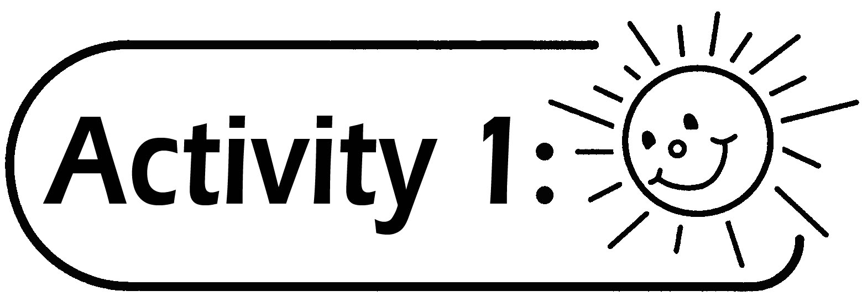
- Pupils are grouped into 4 to 6.
- The teacher shows a measuring cup and four paper-packed drinks of 250mL.
- The teacher invites four pupils to pour the paper-packed drink into the measuring cup in turns, and reminds them to observe the height of liquid after each pour. The teacher could guide pupils to tell the capacity of one packet is 250 mL, two packets is 500 mL, three packets is 750 mL and four packets is 1000 mL.

Questions for Discussion：
- How many milliliters of drink have been poured into the container？
- How many litre is equal to 1000 mL？
- Guide pupils to write 1L＝1000mL in the Worksheet.

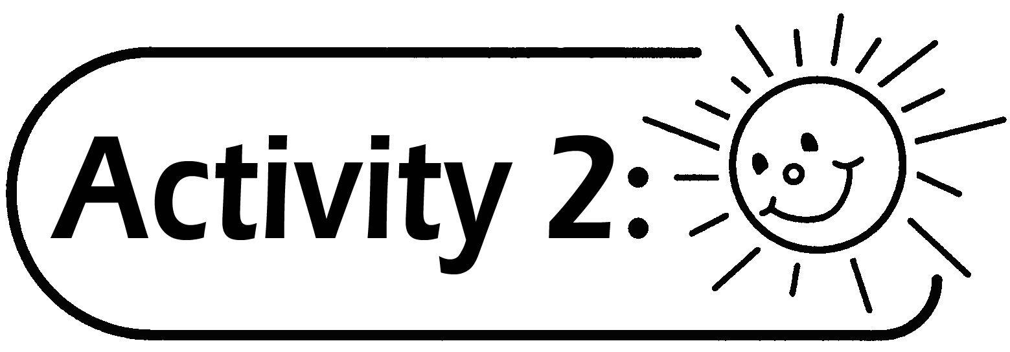
- The teacher introduces the symbol of mL and hints the pupils that the capacity of a Yakult bottle is 100ml.
- The teachers guides the pupils to fill up a measuring cup with water, using a Yakult bottle, 100mL in each pouring. This can enhance pupils’ understanding of the concept of 1L = 1000 mL.

Questions for Discussion：
- How many times of pouring are required to fill up the measuring cup?
- What is the capacity of 10 bottles of Yakult? How many liters is it equivalent to?
- What is the capacity of 20 bottles of Yakult? How many liters is it equivalent to?

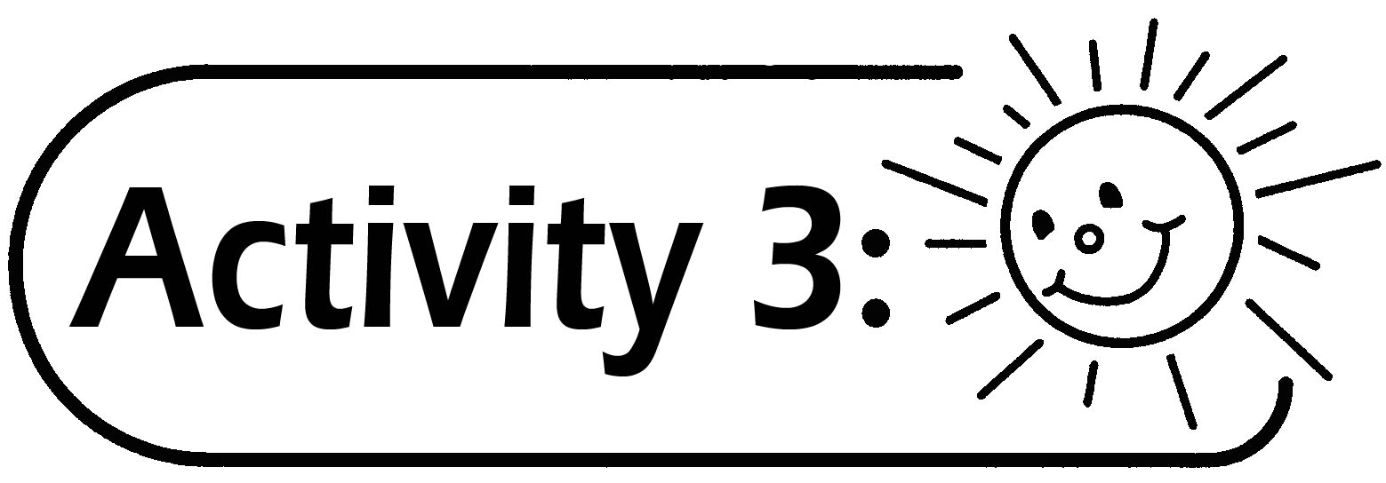
Using the measuring cup, pupils firstly estimate, then measure the capacity of their cups, water bottles and rice bowls, and record the results in the Worksheet.

Questions for Discussion：
- Among the cup, water bottle and rice bowl, which has the largest capacity？
- How many cups of water do you drink each day？How many ‘L’ or ‘mL’ of water have you drunk？

Extended Learning：
Ask pupils to go to a supermarket, find five items having their capacity measured in ‘mL’ and five items in ‘L’. Record them in the Worksheet.

Remarks：
- Prepare towels to wipe the water spilt on the floor and desks.
- The teacher can provide students with measuring cups or pupils can make their own measuring cups.
- Lets pupils know that on average a person needs to drink eight cups of water a day (about 2 liters), in order to maintain good health.

Generic Skills Fostered：
- Collaboration Skills
- Numeracy Skills
- Study Skills

