Unit : 1N1 Numbers to 10
Topic : Composition of Numbers
Key Stage : 1

Learning Objectives:
Understand the composition of numbers 1 - 10

Prerequisite Knowledge:
- Counting
- Understanding 1 - 10

Teaching Resources:
- Computer drawing software (alternatively, beads could be used for this activity)
- Computer graphic file — 1N1_01.BMP
- Worksheet — The Composition of 5, The Composition of 6


- The teacher opens the computer drawing software. Pupils select a number from 1 to 10, e.g. 5. The teacher uses the software to draw the same number of circles.

- Pupils colour some of the circles with any one colour, e.g. red, and colour the rest of the circles with another colour, e.g. yellow. Pupils record the results in the Worksheet “The Composition of 5” (Remarks 1). (See Figure 1)

Figure 1
- The teacher divides the class into groups. Pupils repeat Step 2, find out the other compositions of the number and record the results in the Worksheet.

- Pupils arrange the compositions and draw conclusions on the compositions of the number. (e.g. the compositions of 5, see Figure 2)

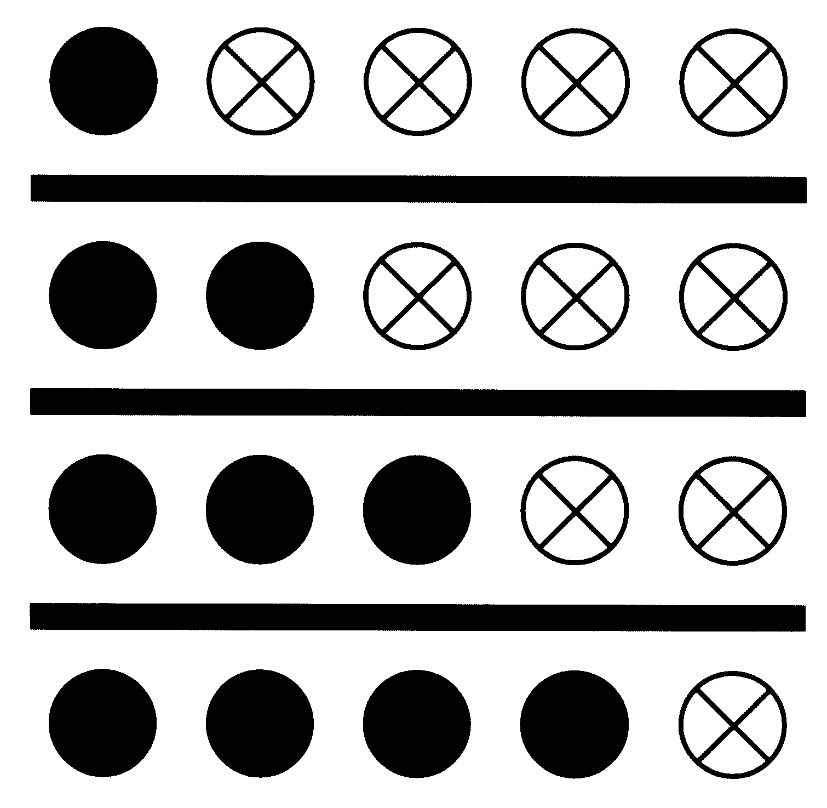
Figure 2
Questions for Discussion:
- What are the numbers of the circles of the two different colours respectively?
- What are the other combinations?
- How can all the combinations be found systematically?
- If the total number of circles remains the same and the number of circles of one colour increases, what happens to the number of circles of the other colour?
- If the total number of circles remains the same and the number of circles of one colour decreases, what happens to the number of circles of the other colour?


- The teacher opens the file 1N1_01.BMP to a full screen (Remarks 2).

- Pupils use this file to repeat the colouring activity described in Steps 2 to 4 of Activity 1 and find out all the combinations of 6.

- Pupils arrange the above results and record the results systematically in the Worksheet “The Composition of 6”.

Questions for Discussion:
- If the total number of circles remains the same and the number of circles of one colour increases, what happens to the number of circles of the other colour?

- If the total number of circles remains the same and the number of circles of one colour decreases, what happens to the number of circles of the other colour?
- Compare the above observations with Questions 4 and 5 of the Discussion in Activity 1, what observations are similar or different?

Remarks:
- Colour at least one circle with a colour.

- Prepare the graphic file “1N1_01.BMP”:
  - Use drawing tools to draw a circle and a straight line. Do not fill in any colour for the circle.
  - Duplicate the circle to six in a row.
  - Duplicate the straight lines and the circles (see Figure 3).

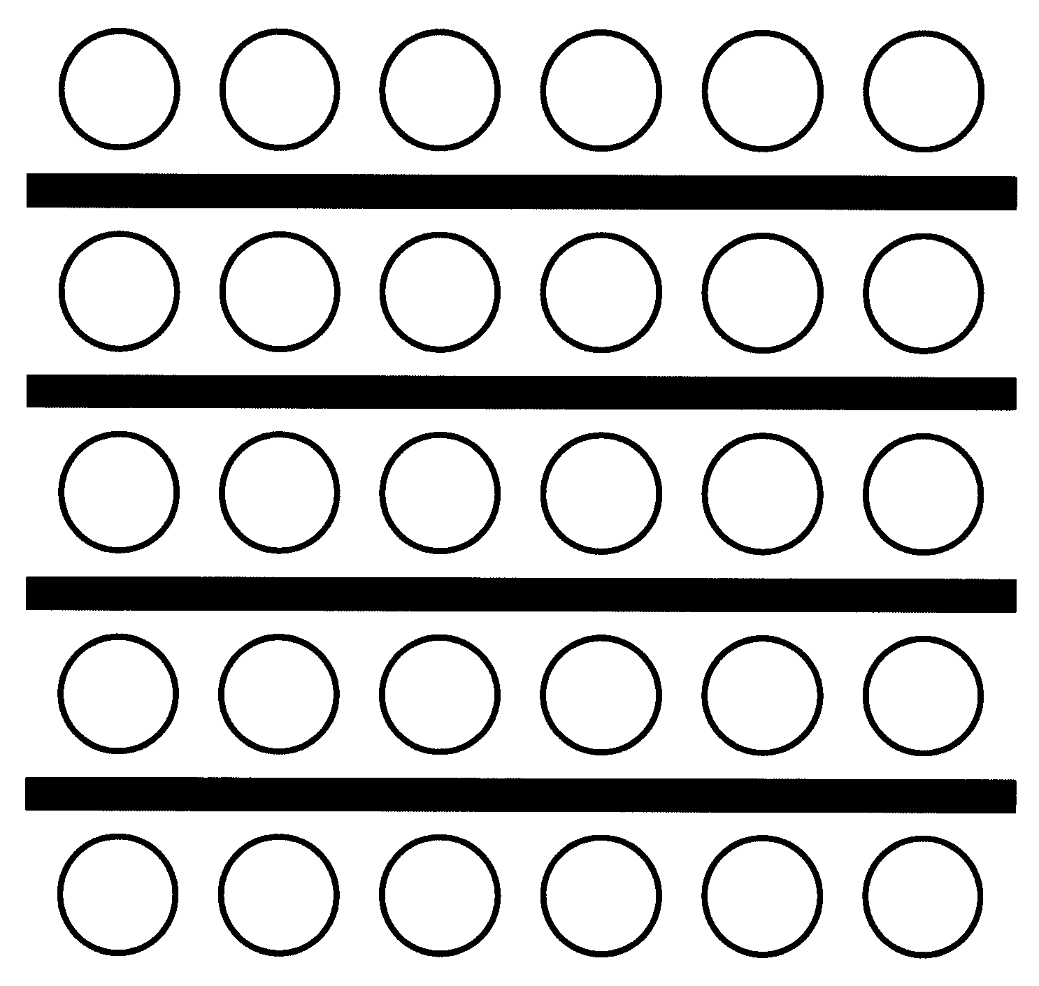
Figure 3

- The teacher may prepare some more graphic files before-hand and asks pupils to repeat Activity 2 to find out the combinations of all the numbers from 1 to 10.

Generic Skills Fostered:
- Critical Thinking Skills
- Information Technology Skills

