The Composition of 5

Colour the circles with two colours to show the different compositions of 5.

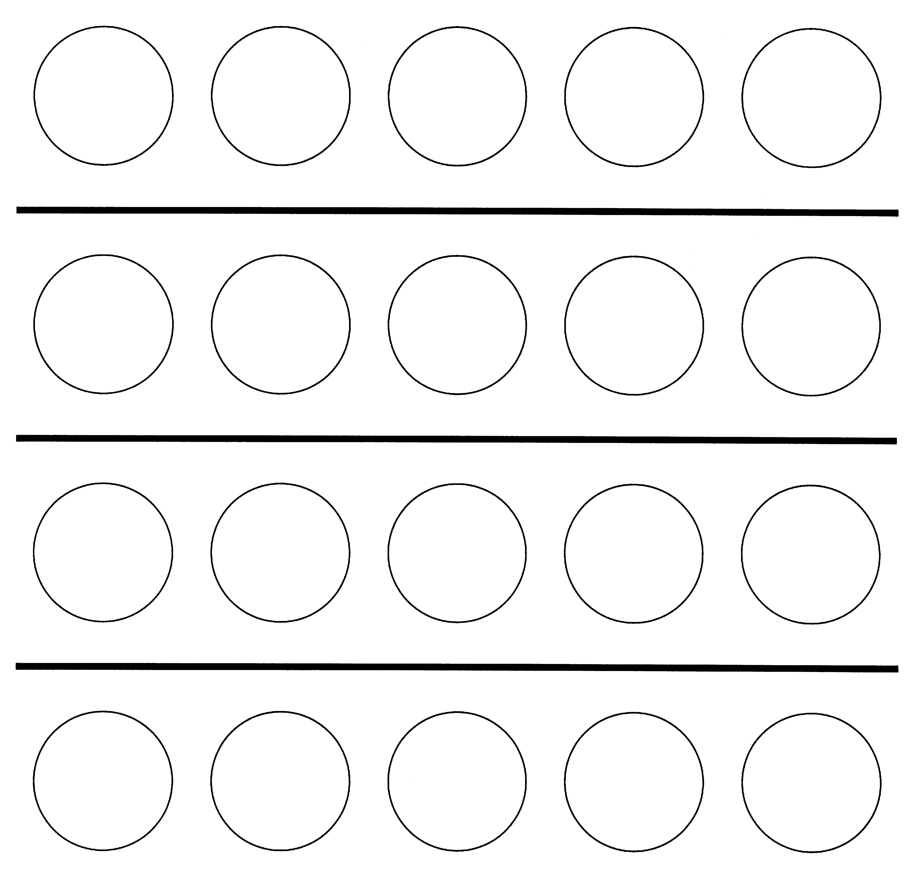
1.

2.

3.

4.

The Composition of 6

Colour the circles with two colours to show the different compositions of 6.

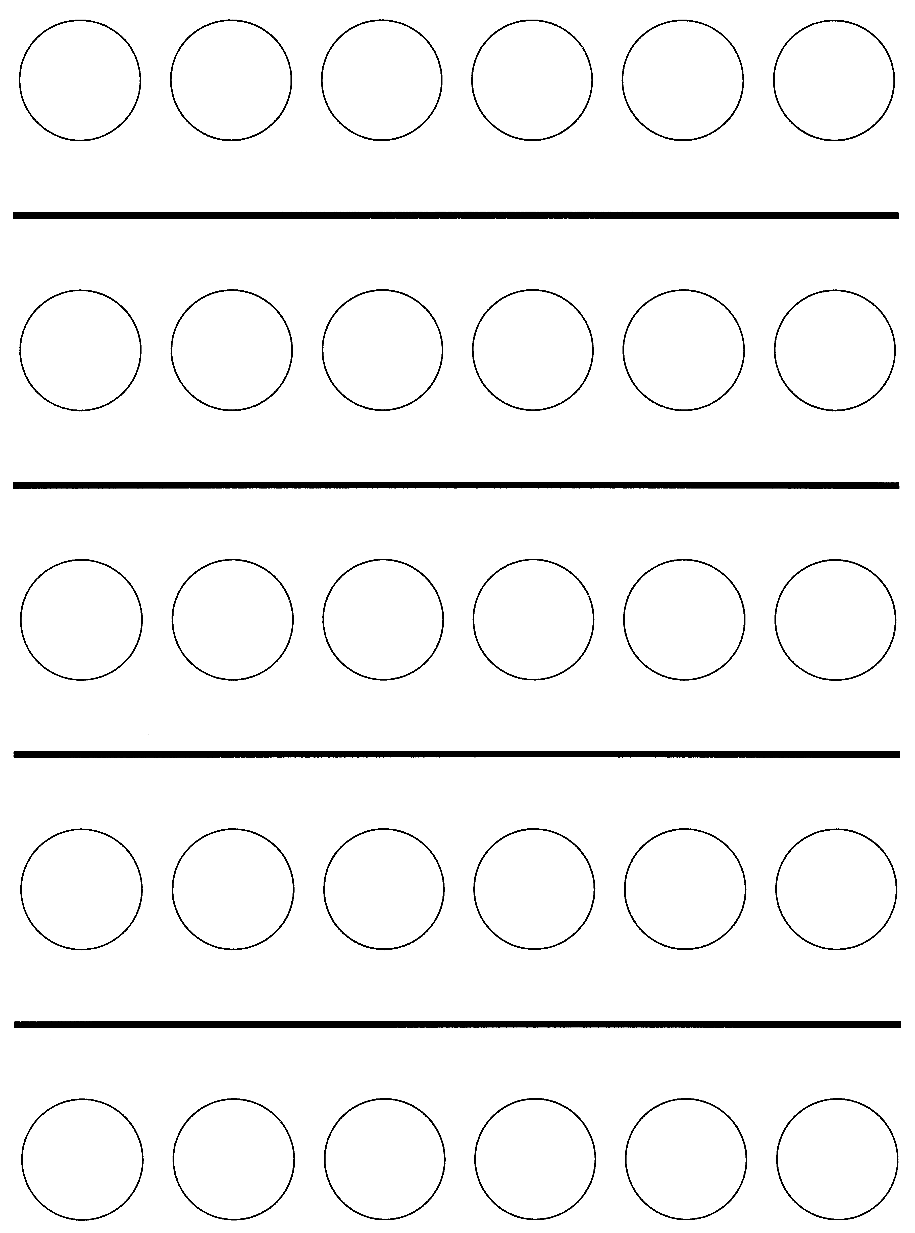
1.

2.

3.

4.

5.

