Picture File “1N2_01”

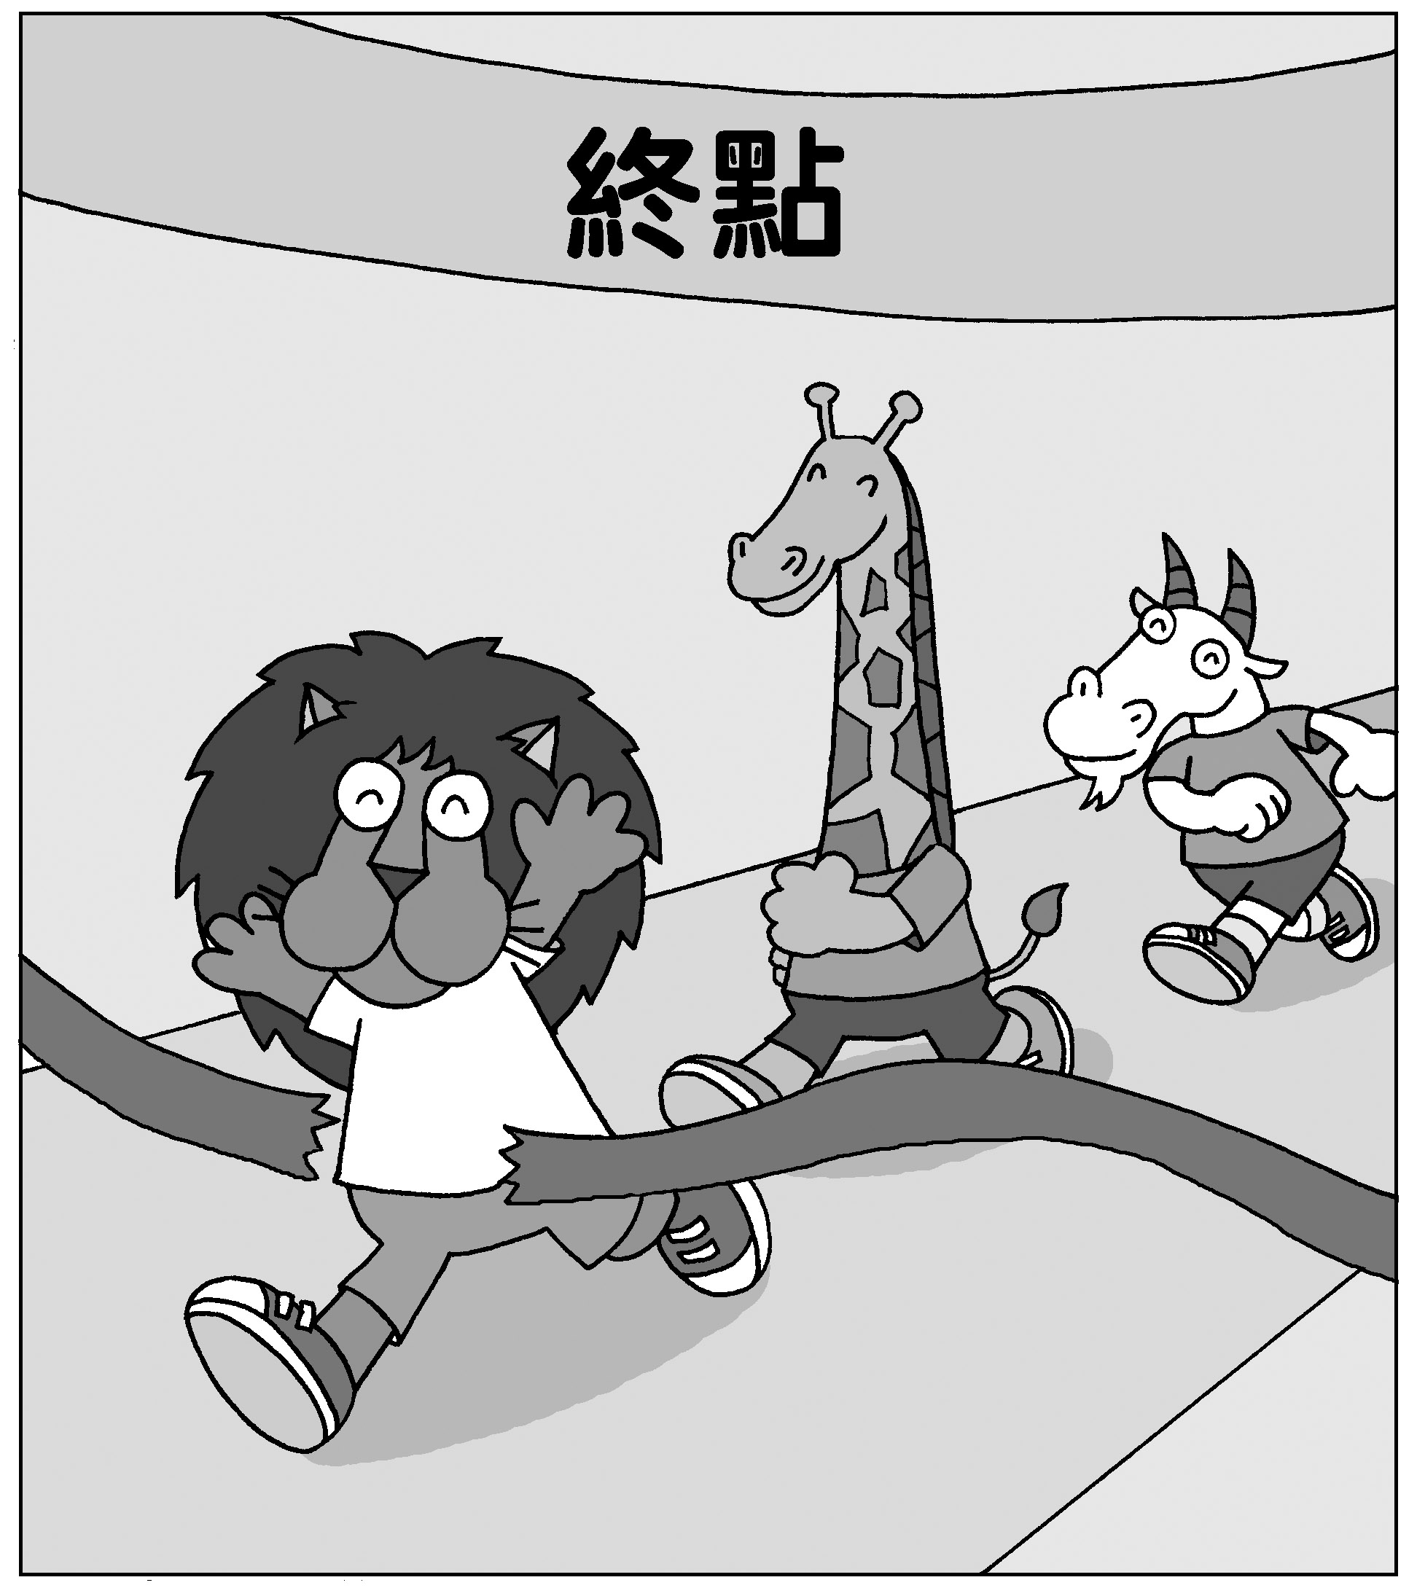
Finish
Picture File “1N2_02”

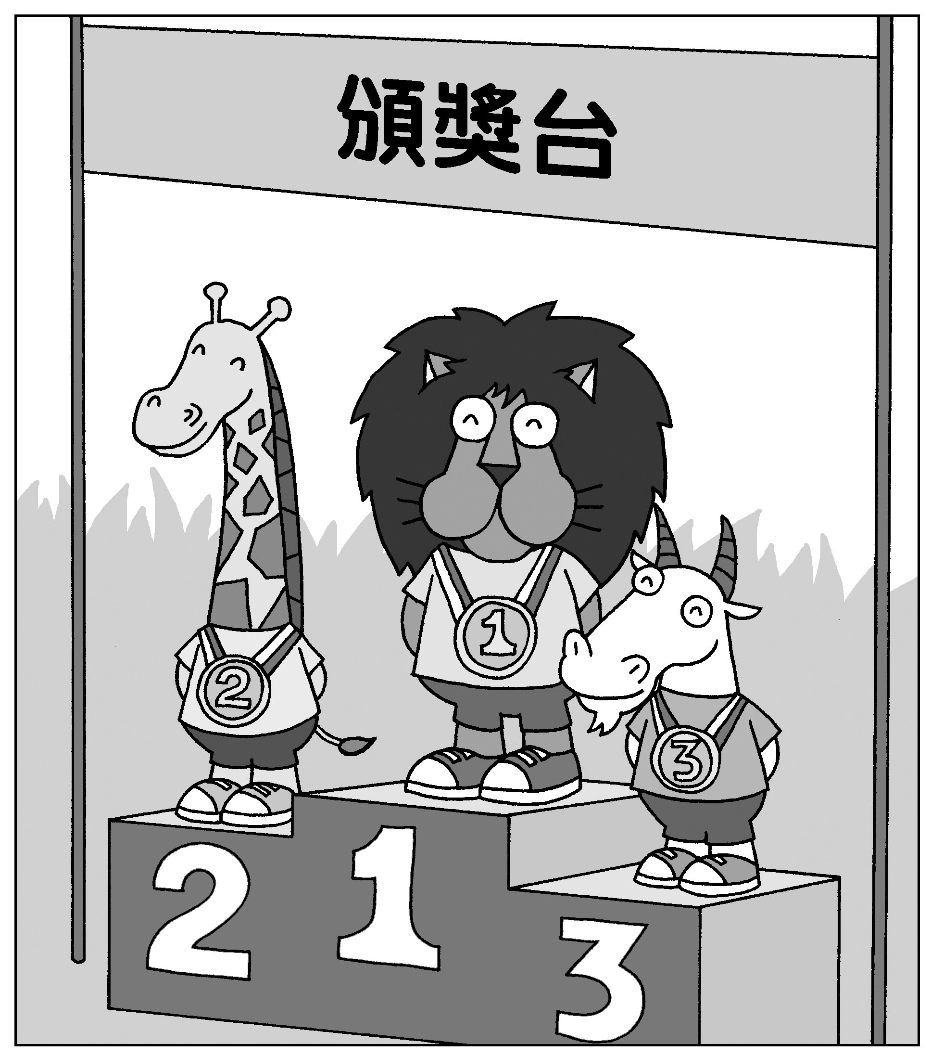
Award Stage
Picture File “1N2_03”

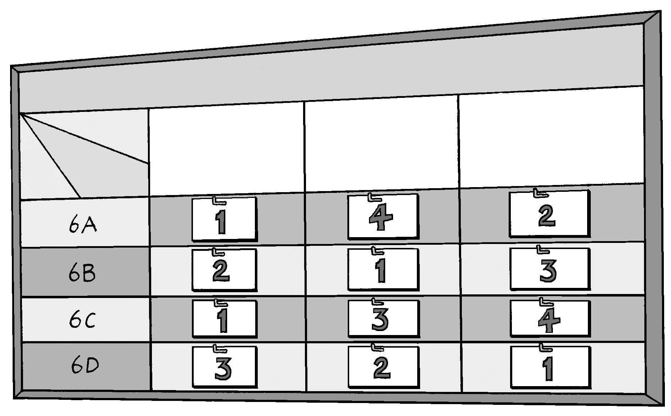
1st
2nd
3rd

