Unit : 1N2 Numbers to 20
Topic : Numbers to 20
Key Stage : 1

Learning Objective：
Understand the composition of two single-digit numbers

Prerequisite Knowledge：
- Understand the numbers 11 - 18
- Understand the composition of numbers 1 - 10

Teaching Resources:
- Beads
- Worksheet — The Composition of Numbers 11 - 18


- Divide the class into groups of two. Each pupil takes 9 beads of the same colour.
- Pupils choose a number form 11 - 18, e.g.11.
- Each pupil of the same group takes out a certain number of beads so as to make the total number of beads to 11. After the pupils have taken the beads, they have to tell the composition of this number. For example, 9 red beads and 2 blue beads, altogether there are 11 beads.
- Repeat step 3. Pupils take out a different number of beads in order to have a total number of 11 beads.
- Pupils record the results by drawing on the Worksheet.
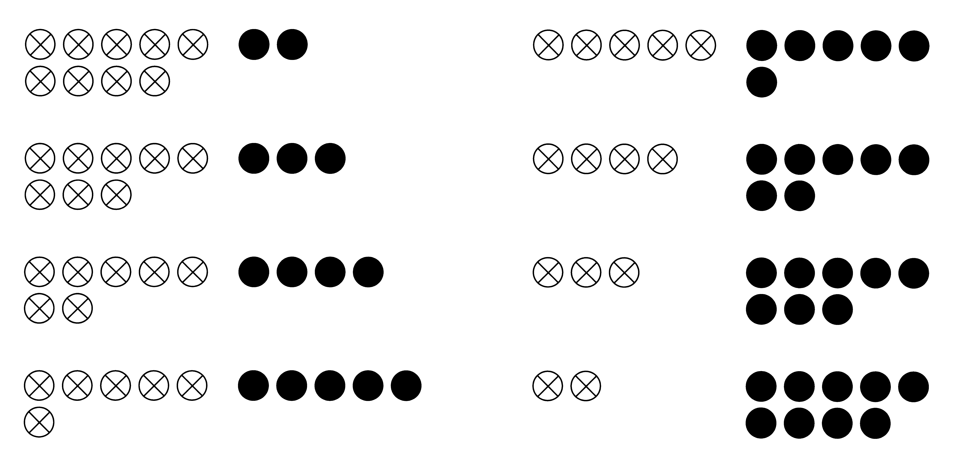
For example：

- Repeat the above activity by using the numbers 12 - 18. Find the basic composition of each number.

Questions for Discussion：
- What is (are) the similarity/ difference in the compositions of numbers among the groups?
- How can all the combinations be found systematically？
- If the total number of beads remains unchanged and one of the pupils decreases the number of beads he/ she takes out, what is the change in the number of beads taken out by the other pupil?

Remarks：
It is not appropriate to record the results with numbers at this stage. Only verbal expressions and drawings are to be used.

Generic Skills Fostered：
- Communication Skills
- Critical Thinking Skills
- Numeracy Skills

