Unit : 1N5 Addition and Subtraction (I)
Topic : Who Came First?
Key Stage : 1

Learning Objectives:
- Consolidate addition within two places
- Consolidate subtraction within two places, excluding decomposition

Prerequisite Knowledge:
- Recognise addition within two places, including carrying
- Recognise subtraction within two places, excluding decomposition

Teaching Resources:
- Rectangular Strip with 18 Blocks
- Chess-men (can be replaced by other objects)
- A set of number cards (from 1 to 9)

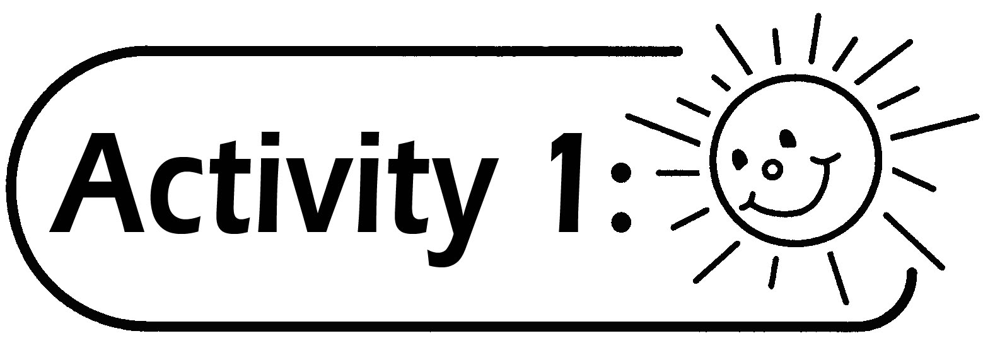
- Four pupils form a group and each pupil takes a chess-man. Each group takes a Rectangular Strip with 18 Blocks (see Figure 1) and a set of number cards (see Appendix).

1 Start | 2 | 3 | 4 | 5 | 6 | 7 | 8 | 9 | 10 | 11 | 12 | 13 | 14 | 15 | 16 | 17 | 18 Finish
Figure 1
- All the chess-men are placed at the Start position. Pupils take turns to draw a number card. They move their chess-men according to the number drawn and then return the number card to the pack of cards. The pupil express in words the mathematical expression before moving the chess-man. For example, if a pupil’s chess-man sits at Block ‘9’ and draws the number ‘4’, he should say ‘9 plus 4 is equal to 13’.

- The pupil moves the chess-man according to the number drawn and checks if the answer is correct. If the answer is wrong, the pupil has to express in words the correct mathematical expression again. For example, the pupil wrongly says ‘9 plus 4 is equal to 12’, he moves the chess-man 4 Blocks forward from ‘9’. He turns over the cover and finds the correct answer is 13, he then has to say ‘9 plus 4 is equal to 13’.
- Continue the game in a similar way. The pupil who first reaches the Finish position is the winner.

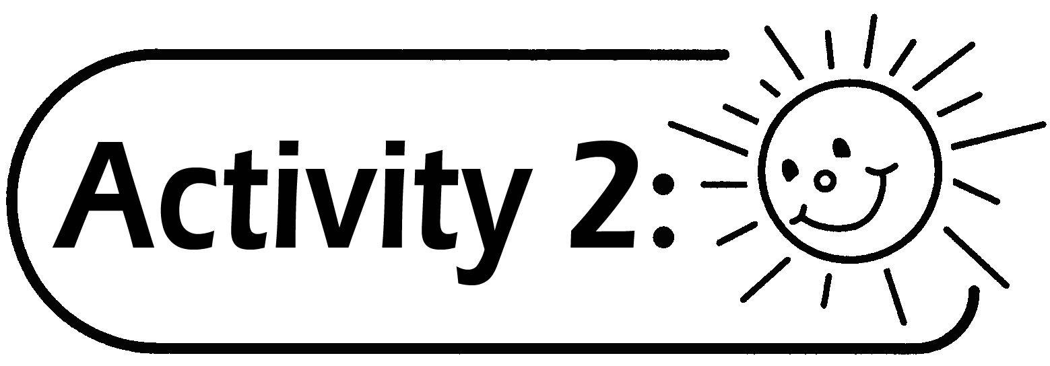
- Same as Activity 1, four pupils form a group. All the chess-men are placed at the Finish position. Pupils take turns to draw a number card. The chess-man is moved from the Finish position towards the Start position according to the number drawn.
- The pupils express in words the mathematical expression before moving the chess-man. For example, if the pupil’s chess-man sits at Block ‘9’ and draws the number ‘4’, he should say ‘9 subtract 4 is equal to 5’. The pupil moves the chess-man according to the number drawn and checks if the answer is correct. If the answer is wrong, the pupil has to express in words the correct mathematical expression again. For example, the pupil wrongly says ‘9 subtract 4 is equal to 3’, he moves the chess-man 4 Blocks backward from ‘9’ towards the Start position. He turns over the cover and finds the correct answer is 5, he then has to say ‘9 subtract 4 is equal to 5’.
- Continue the game in a similar way, the pupil who first reaches the Start position is the winner.

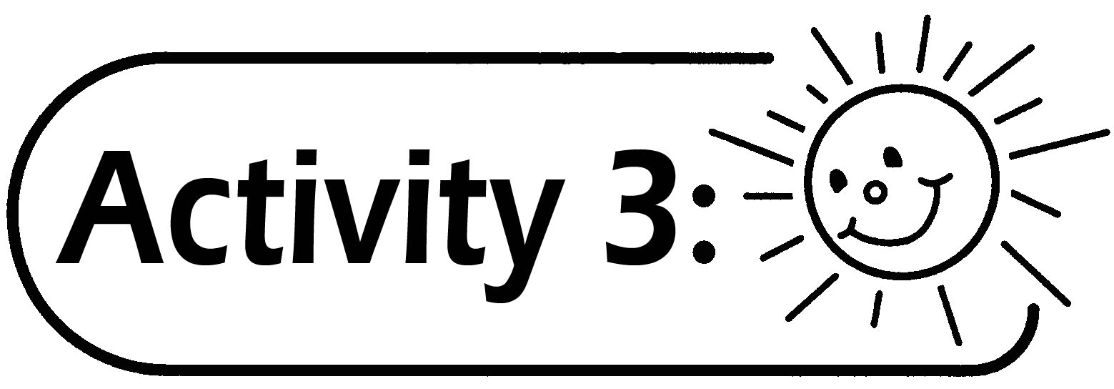(Suitable for more able pupils)
- Repeat Activity 1. Add some instructions on the Rectangular Strip, e.g. Honest, move 2 blocks forward; Throwing rubbish, move 1 block backward; Losing things, go to Block “4”, etc. (see Appendix)
- The rule of the activity is changed as follows: The one who can get to the Finish position exactly is the winner. If the number drawn cannot allow the chess-man to move to the Finish position, the chess-man should remain at the original block and wait for the next turn.

- The pupil has to express in words the mathematical expression as he said in Activity 1 and Activity 2. For example, if a pupil’s chess-man sits at Block ‘8’ and the instruction in ‘8’ is ‘Honest, go 2 blocks forward’, the pupil then says ‘8 plus 2 is equal to 10’. If originally the chess-man is at ‘10’ and the instruction in ‘10’ is ‘Throwing rubbish, go 1 block backward’, the pupil then says ‘10 subtract 1 is equal to 9’.
- If there is an instruction for the chess-man to move, the pupil needs to find out the number of blocks that the chess-man has to move and express in words the mathematical expression. For example, if the chess-man is at ‘12’ and the instruction in ‘12’ is ‘Losing things, go to Block “4” ’, the pupil then says ’12 subtract 4 is equal to 8’ and moves the chess-men backward for 8 blocks. If the chess-man is at ‘5’ and the instruction in ‘5’ is ‘Honest, go to Block ‘7’, the pupil then says ‘7 subtract 5 is equal to 2’ and moves the chess-man 2 blocks forward.

Questions for Discussion:
- The instruction in ‘17’ is ‘Polite, go to Block ‘18’. How many block(s) does the chess-man move?
- If the chess-man is at Block ‘15’, what number should be drawn so that it can reach the Finish position?

Remarks:
- Pupils could first do the addition and subtraction orally and then mentally if they are able to.
- Pupils may use Rectangular Strip with different number of blocks. Also, the number on the number cards and the instructions in the blocks could be changed.
- Teachers may enlarge the paper strip if needed. Softcopy of the coloured paper strips is included in the CD.

Generic Skills Fostered:
- Collaboration Skills
  - Communication Skills
  - Creativity
  - Numeracy Skills

