Rectangular Strips with 18 Blocks（For Activities 1 and 2）

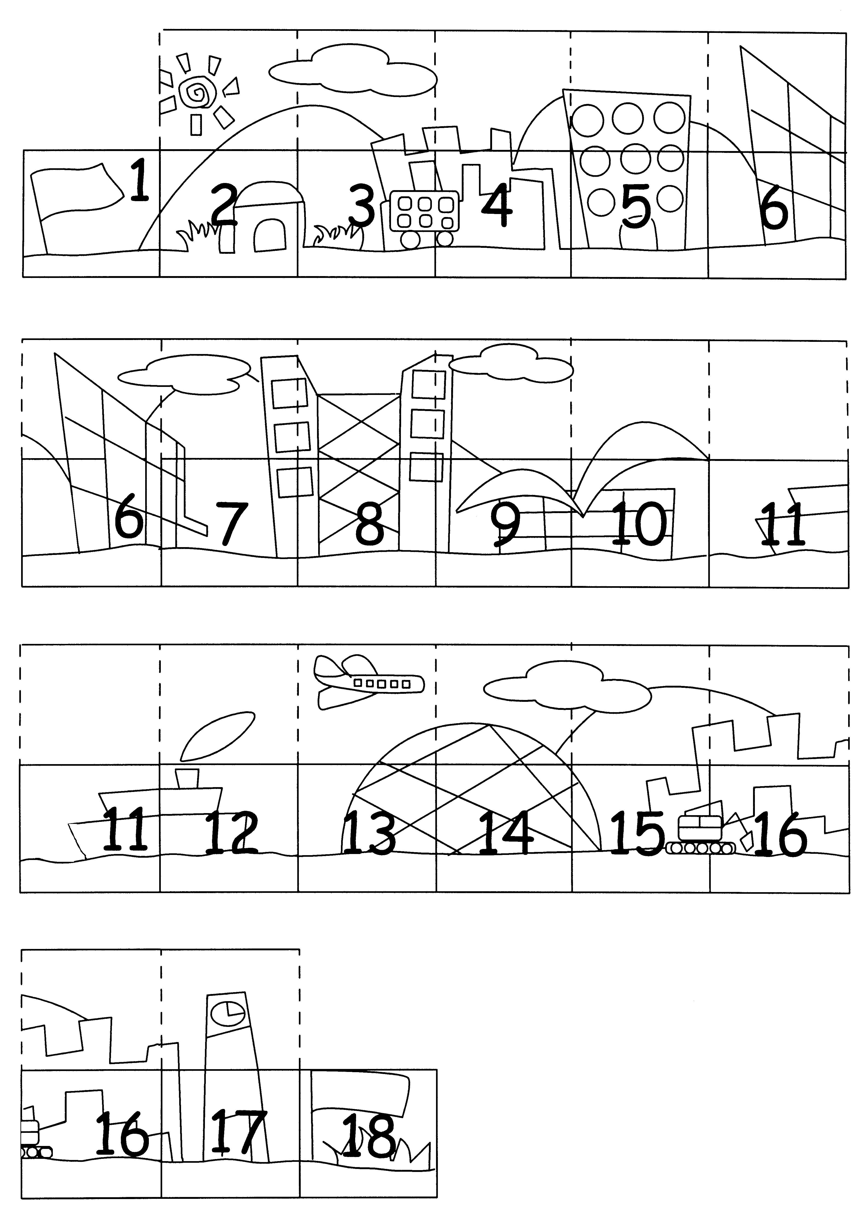
Cut and join the strips together.
Cut the upper parts along the dotted lines and fold to cover the numbers.
Rectangular Strips with 18 Blocks（For Activity 3）

Cut and join the strips together.
Cut the upper parts along the dotted lines and fold to cover the numbers.
Honest, go to Block ‘7’
Honest, 2 blocks forward
Throwing rubbish, 1 block backward
Losing things, go to Block ‘4’
Polite, go to Block ‘18’
Number Cards

