Unit : 1S1 3-D Shapes (I)
Topic : Recognise Prisms, Pyramids and Spheres
Key Stage : 1

Learning Objectives:
- Identity prisms, pyramids and spheres intuitively
- Find the 3-D shapes according to descriptions

Prerequisite Knowledge:
Arrange objects in groups

Teaching Resources:
Prisms, pyramids and spheres (objects, blocks or 3-D models) of different shapes and sizes

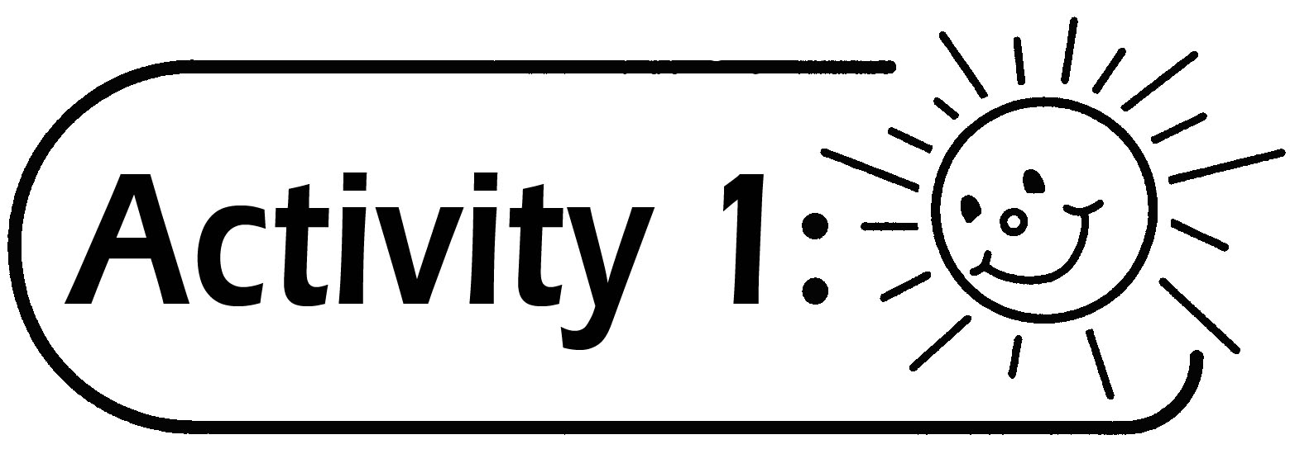
- Pupils are given different shapes of prism, pyramid and sphere (pupils can collect these objects in advance).
- Pupils group the 3-D shapes according to the criteria they choose and report to the class. They can group the 3-D shapes according to their shape, size, colour, thickness or hardness, etc.
- The teacher selects the most appropriate grouping criteria chosen by the pupils to introduce the 3-D shapes of prism, pyramid and sphere.

Questions for Discussion:
- What are the characteristics of a prism? (For example, the size and shape of the top and bottom of a prism are the same)
- What are the characteristics of a pyramid? (For example, a pyramid has pointed ends)
- What are the characteristics of a sphere? (For example, a sphere can roll)

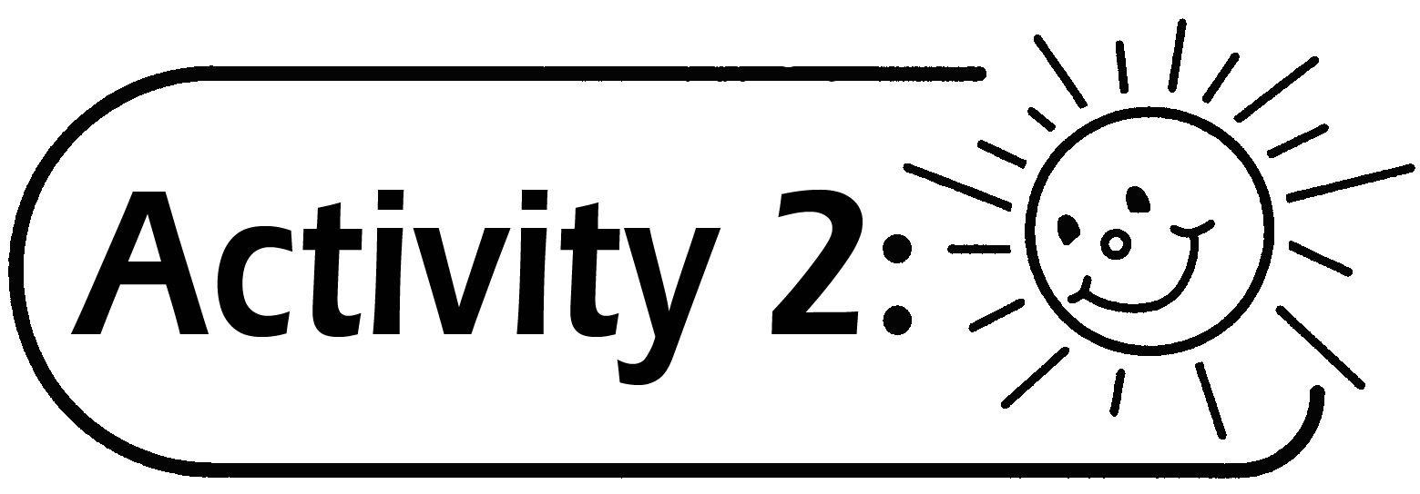
- The teacher puts different objects on a table, selects one of them and describes it with three or more sentences. The class guesses the object chosen.
Example: The teacher chooses a cylindrical tin and describes it as follows:
- It looks like a pillar.
- Its top and bottom are circular in shape.
- It can roll.
- When pupils are familiar with the rules of the game, they can take turns to describe the object chosen and let their classmates guess what the shape is. It can be conducted as a group activity.

Generic Skills Fostered:
- Communication Skills
- Critical Thinking Skills
- Numeracy Skills

