Unit : 1S3 2-D shapes
Topic : Lines and Faces
Key Stage : 1

Learning Objectives:
- Draw pictures with straight lines and curves
- Understand the relationship between lines and shapes

Prerequisite Knowledge:
- Recognise straight lines and curves
- Recognise triangles, quadrilaterals, pentagons and hexagons

Teaching Resources:
Graphics software package, for example: Microsoft Paint (This activity can also be done with paper and pencil.)


- The teacher explains and demonstrates the basic use of Microsoft Paint, including “Straight Line”, “Pencil”, etc. The teacher uses “Straight Line” to draw straight lines and “Pencil” to draw curves randomly (as shown below). After drawing, the teacher discusses with pupils about the picture.
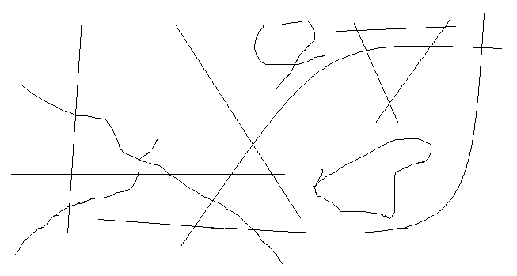

- Pupils randomly draw a picture with straight lines and curves.
- The teacher discusses with pupils about the picture, and asks them to describe the picture.
Questions for Discussion:
- In your picture, which ones are curves? Which ones are straight lines?
- What shapes are drawn in your picture?
- What types of lines, straight lines or curves, are used to form the shapes?


- Using the picture drawn in Activity 1 as an example, the teacher discusses with pupils the lines that are intersecting each other, and asks pupils to find the intersecting lines in the picture.
- The teacher shows how to draw 6 intersecting straight lines randomly (as shown below).
- Pupils randomly draw 6 intersecting straight lines. The teacher encourages pupils to maximize the number of intersection.
- The teacher uses “Fill With Colour” to fill the shapes with colour. Pupils fill the shapes formed by 3 straight lines with red, 4 straight lines with blue, 5 straight lines with green, and 6 straight lines with yellow.

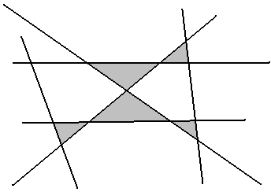

Questions for Discussion:
- What are the shapes filled with red? With blue? With green? With yellow?
- What is the relationship between the lines and the shapes?
- Repeat the Activity above with 8 straight lines.

Remarks:
- This Activity can be done with paper and pencil.
- Before using the computer for this Activity, the teacher should consider the ability of pupils on using graphics software such as Microsoft Paint and operating a computer (including controlling the mouse). Otherwise, this activity could be done with paper and pencil.

Generic Skills Fostered:
- Communication Skills
- Creativity
- Critical Thinking Skills
- Information Technology Skills

