Unit : 1S3 2-D Shapes
Topic : Recognise 2-D Shapes
Key Stage : 1

Learning Objectives:
- Recognise a 3-D shape has different faces
- Identify 2-D shapes intuitively
- Describe 2-D shapes briefly

Prerequisite Knowledge:
- Arrange objects in groups
- Recognise 3-D shapes

Teaching Resources:
- Daily life objects (e.g. books, coins, leaves)
- 3-D shapes (objects, blocks or 3-D models)

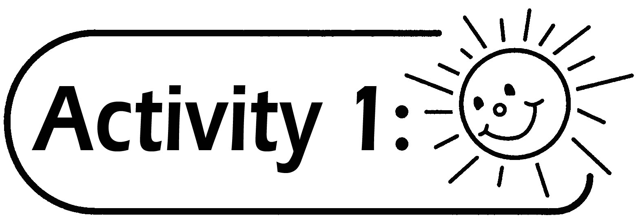
- Pupils are grouped into 4 to 5. The teacher gives each group some daily life objects, e.g. books, coins and leaves, etc.
- Each group discusses how to stamp or trace the faces of the given objects (pupils can use various methods, for example, trace along the edges of the face of the object and draw the outline on a paper, use paper and color pencil to pencil shade the shape of the faces of the object, spread colour paint on the object and stamp the faces of the object on a piece of paper).
- Pupils stamp the faces of the object on a piece of paper after the discussion.
- Pupils briefly describe the 2-D shape they have traced, for example, is it a circle or a square? How many sides does it have? Any angles?
Example: | The face of the book is a square; it has 4 sides and 4 angles.
 | The coin is a circle in shape.
 | The leave has the shape of a heart.

Questions for Discussion:
- Which method(s) did you use to draw the outline of the object?
- Do all the faces of the object traced have the same shape?

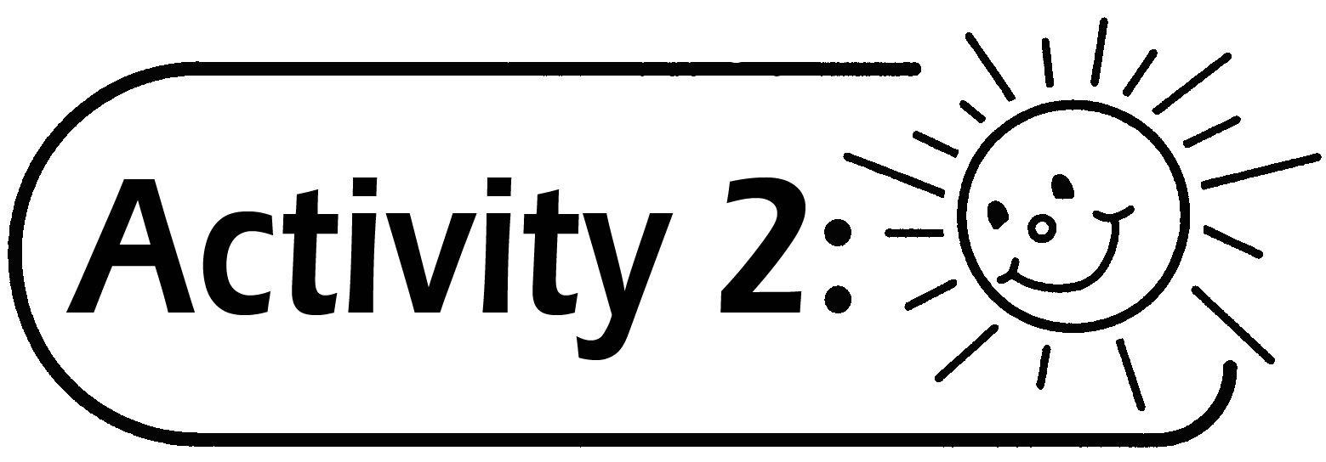
- Each group of pupils gets some 3-D shapes, including prisms and pyramids.
- Pupils use different methods to trace all the faces of a 3-D shape.
- Pupils briefly describe the 2-D shapes they traced.
- Pupils cut and group the 2-D shapes, and then report the grouping criteria to the class.
- The teacher introduces the names of the 2-D shapes, including triangle, quadrilateral, pentagon, hexagon, circle, square and rectangle.

Questions for Discussion:
- Which method(s) did you use to trace the outline of the shape?
- Do all the outlines of the different faces of the object have the same shape?
- How many sides are there for the shape(s) traced? What shape(s) is it?

Generic Skills Fostered:
- Communication Skills
- Critical Thinking Skills
- Numeracy Skills

