Unit : 2S2 Angles (I)
Topic : Use Various Ways to Make Angles
Key Stage : 1

Learning Objectives:
Make angles in various ways

Prerequisite Knowledge:
- Understand angles and right angles
- Able to compare the size of angles

Teaching Resources:
Different materials for making angles (collected by pupils and supplied by the teacher), for example, straws, paper strips, ice-cream sticks, circular paper, artwork paper.
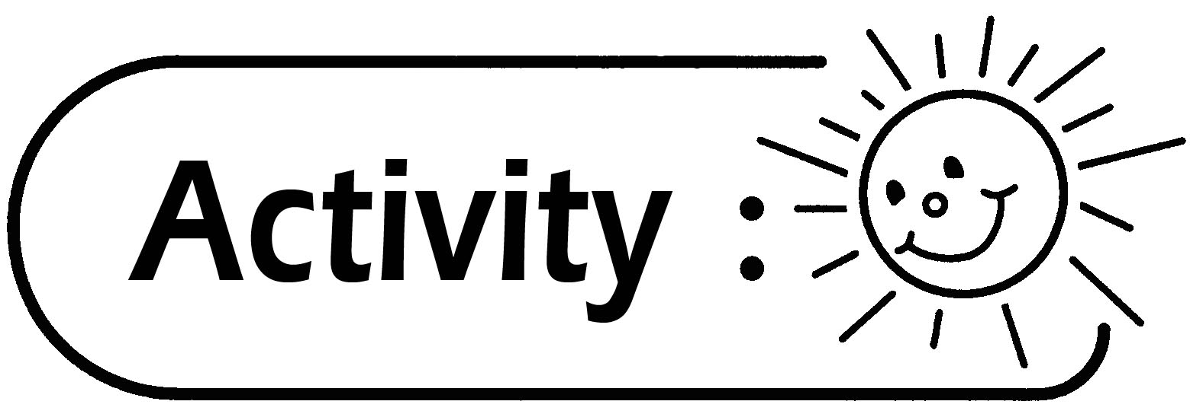

- Pupils collect different materials for making angles.
- Pupils discuss the various ways in making angles.
- Pupils try to use the materials collected by themselves and those supplied by the teacher to make angles in various ways.
- Pupils describe how they make the angles, indicate the angle and the two arms which form the angle.

Questions for Discussion:
- In addition to the above method, what any other ways can you think of to make angles?
- If you rotate the arm(s) of the angle, what would happen to the size of the angle? (The size of the angle would change with the rotation of the arm(s)).
- If you extend the length of the arm(s) of the angle, what would happen to the size of the angle? (There is no relation between the size of the angle and the length of the arms.)
Remarks:
- When discussing the questions, let pupils study the angles that they have made.
- Below are some examples of making angles for reference.
- Bend a straw to form angles of different sizes.
- Fold a paper strip to form angles of different sizes (as shown below).

- Use two rods, for example, ice-cream sticks or rattans used in the lesson of Physical Education to form angles of different sizes (as shown below).

- Use two pieces of identical circular paper of different colours to make an angle ring.

- Prepare two pieces of identical circular paper of different colours (as shown below).

- Cut the pieces of paper towards the centre (as shown below).



- Overlap the two pieces of paper (as shown below).

- Rotate the two pieces of paper to form angles of different sizes (as shown below).
- Pupils fold the artwork paper to form angles of different sizes (as shown below).

- Pupils are grouped into pairs. They form angles of different sizes by holding hands together (as shown below).
Represent a pupil with open arms.

Generic Skills Fostered:
- Communication Skills
- Creativity
- Problem Solving Skills

