Unit : 2S1 3-D Shapes (II)
Topic : Cones and Cylinders
Key Stage : 1

Learning Objectives:
- Recognise curved faces
- Explore the curved surfaces of cones and cylinders
- Explore the cut-open shapes of cones and cylinders

Prerequisite Knowledge:
- Recognise prisms and pyramids
- Identify 2-D shapes

Teaching Resources:
- Toilet paper tubes
- Conical cup
- Cylinder and cone (objects or models)
- Scissors
- Paint

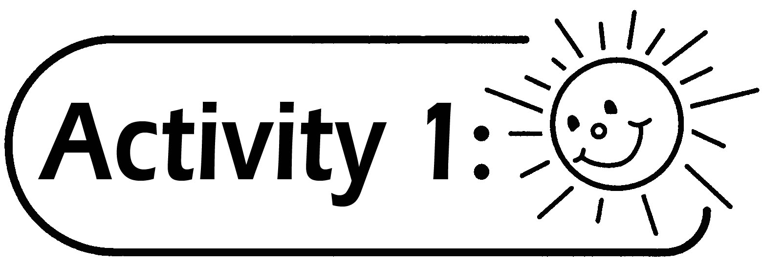
- Pupils trace the top and the bottom of a toilet paper tube on a piece of paper to see what kind of shape they get.
- The teacher puts some paint on the curved surface of a cylindrical model or the toilet paper tube, rolls it on a piece of paper and lets pupils observe the shape formed by the paint.
- Before putting the paint on the curved surface, the teacher can let pupils roll the toilet paper tube on their desks first and guess the shape that can be obtained.

Questions for Discussion:
- What is the shape of the top and the bottom of the toilet paper tube?
- When the toilet paper tube is rolled on the piece of paper, what is the shape formed by the paint?

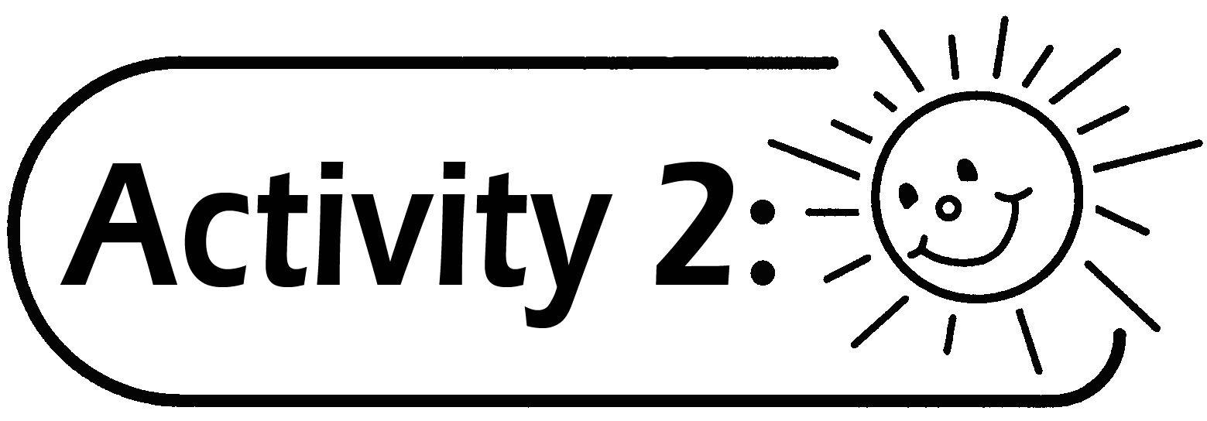
- Pupils trace the bottom of a conical cup on a piece of paper to see what kind of shape they get.
- The teacher puts some paint on the curved surface of a conical model or a conical cup, then rolls it on a piece of paper and lets pupils observe the shape formed by the paint.
- Before putting the paint on the curved surface, the teacher can let pupils roll the conical cups on their desks first and guess the shape that can be obtained. Pupils can also use a thread to fix the tip of a conical cup on a card, then roll the cup around the tip (as shown in the figure below), and observe the path formed by rolling the cup.

Affix the thread inside the cup.

Stick the thread through the card and fix it at the bottom of the card.

Questions for Discussion:
- What is the shape of the bottom of a conical cup?
- If the conical cup is rolled around its tip, will it return to its starting position?
- When the conical cup rolls on the paper, what is the shape formed by the paint?

Remarks:
- In conducting Activity 1 and Activity 2, pupils can try to predict the results first.
- In conducting Activity 1 and Activity 2, pupils with higher ability can put the paint on the curved surface of the cone and stamp the shape by themselves.

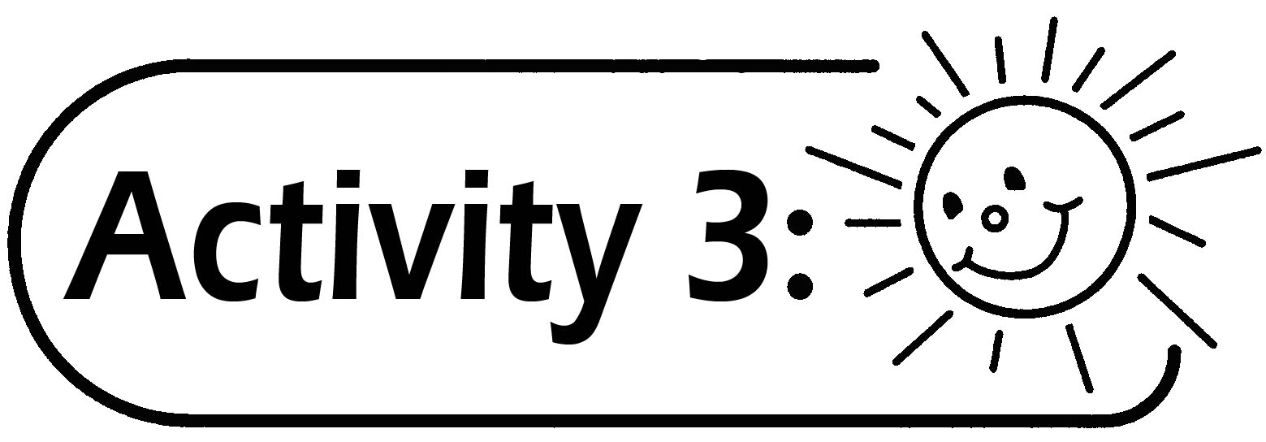
- Pupils observe the toilet paper tube and the conical cup. If the toilet paper tube and the conical cup are cut open as shown in the figures, and then lay flat on the table, what will the shape be? (Before cutting them out, pupils need to draw their predicted figures on a piece of paper and explain, and then cut the tube and the cup for comparison.)



- Pupils use a piece of paper to make a cylindrical tube of size different from the toilet paper tube provided.
- Pupils use a piece of paper to make a conical cup with the size different from the conical cup provided.

Questions for Discussion:
- How do you know the shape of the cut-open figure? With no real object provided, can you imagine the shape?
- What is the difference between the two cut-open shapes? Why?

Generic Skills Fostered:
- Communication Skills
- Creativity
- Critical Thinking Skills
- Numeracy Skills

