Unit : 5S2 3-D shapes (III)
Topic : Fitting Shapes
Key Stage : 2

Learning Objectives:
- Look for rules to generate different nets
- Identify the nets that can be folded to form a cube

Prerequisite Knowledge:
Tell the shape of the faces of 3-D shapes

Teaching Resources:
- Square cards (five for each pupil)
- Grid paper (two for each pupil) (see Appendix)
- Worksheet ─ Fitting Shapes (I) and Fitting Shapes (II)

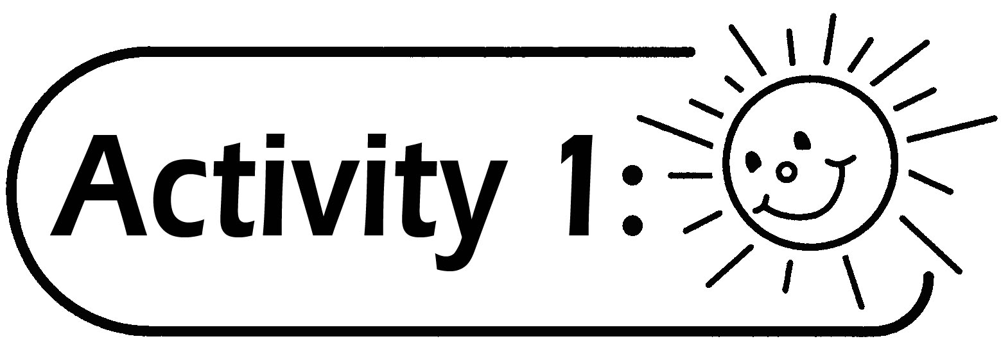
- Pupils use 4 square cards to form figures of different shapes of net and record them on the grid paper.
- Let pupils discuss the skills and patterns used in fitting the shapes, and see who can find the maximum number of ways to fit the shapes.

Questions for Discussion:
- How many different shapes of net can be formed by using 4 square cards? (5 different shapes of net can be formed)
- How to find out all the different shapes of net?
- Are the following 4 shapes of net different? Why? (They are the same because they can be overlapped after rotation.)

- Are the following 2 shapes of net different? Why? (They are the same because they can be overlapped after flipping.)

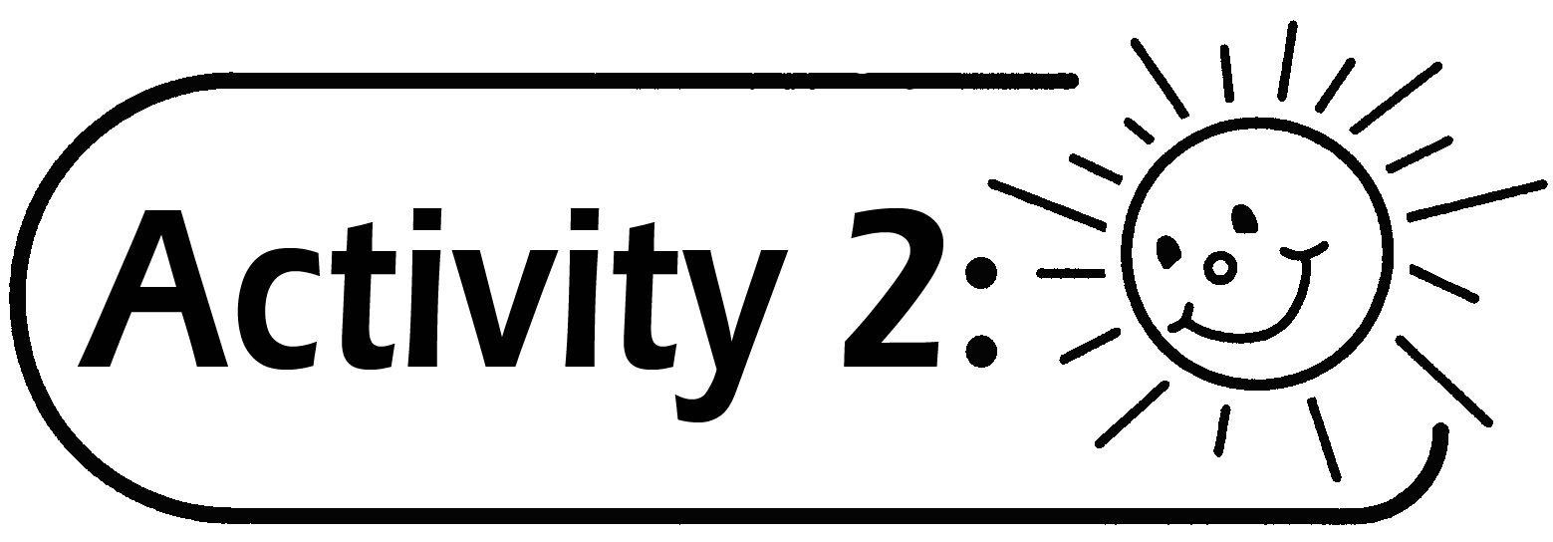
- Pupils use 5 square cards to form different shapes of net and record them on the grid paper. See who can find the maximum number of ways in fitting the shapes of net. (12 different shapes of net can be formed)
- Let pupils discuss the skills and patterns in fitting the shapes of net.
- From the nets formed, find out which can be folded to form a cube without a lid. Pupils can cut the nets out and test which nets can be folded to form a cube without a lid.
- Record the nets which can be folded to form a cube without a lid on the Worksheet — Fitting Shapes (I)

Questions for Discussion:
- How many different shapes of net can be formed by using 5 square cards?
- How to find out all the different shapes?
- How many square cards should be used in order to form a cube with a lid?

Remark:
- The answer of Question 1 in Activity 1:

The 12 nets in the Worksheet ─ Fitting Shapes (I) are the answers to Question 1 in Activity 2.
- If two nets can be overlapped after rotation or flipping, they are considered to be the same.

For example:
and are the same.

- Pupils who have better spatial sense can complete the Worksheet — Fitting Shapes (I) first, then fold the nets for verification.
- Pupils can record the nets on the grid paper in the Appendix. For convenience, the teacher can use a visualiser to display the grid paper for discussion with pupils.

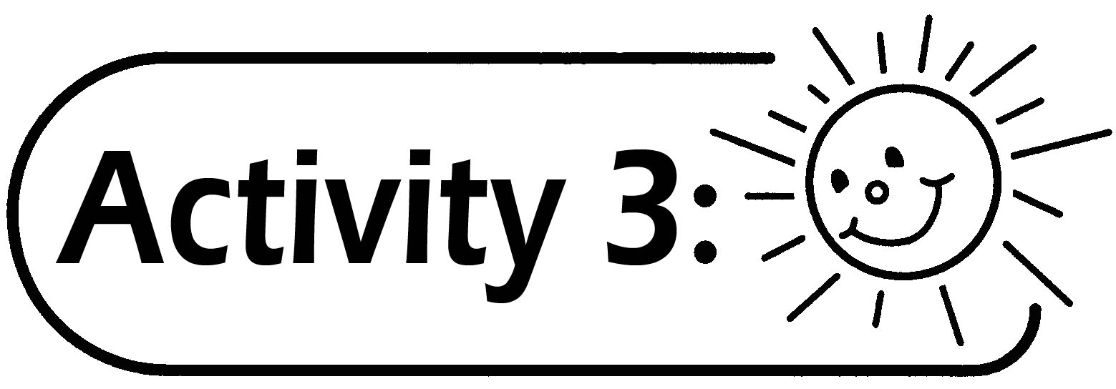
Study the nets in the Worksheet — Fitting Shapes (II), and see which nets can be folded to form a cube with a lid.

Remark:
- For pupils who are interested in the task, the teacher can let them find out all the nets that can be formed by using six square cards.
- In this exemplar, besides using the square cards to form the nets, pupils can use computer software to form the nets. For example, use “Drawing Tools” to draw a square, then copy and move the squares to form the nets. Also, pupils can use Cabri Geometry II to draw the squares, then use “Reflection” to duplicate the squares and form nets. Pupils print the nets formed, cut them out and test whether they can be folded to form a cube or not.

Generic Skills Fostered:
- Critical Thinking Skills
- Information Technology Skills
- Numeracy Skills
- Problem Solving Skills

