Unit : 6S1 3-D shapes (IV)
Topic : Sections of 3-D Shapes
Key Stage : 2

Learning Objectives:
Explore the sections of 3-D shapes

Prerequisite Knowledge:
- Identify different 3-D shapes
- Identify different 2-D shapes

Teaching Resources:
- Straws and other materials which can be cut
- Nets (see Appendix)
- Scotch tapes
- Clay
- Thread

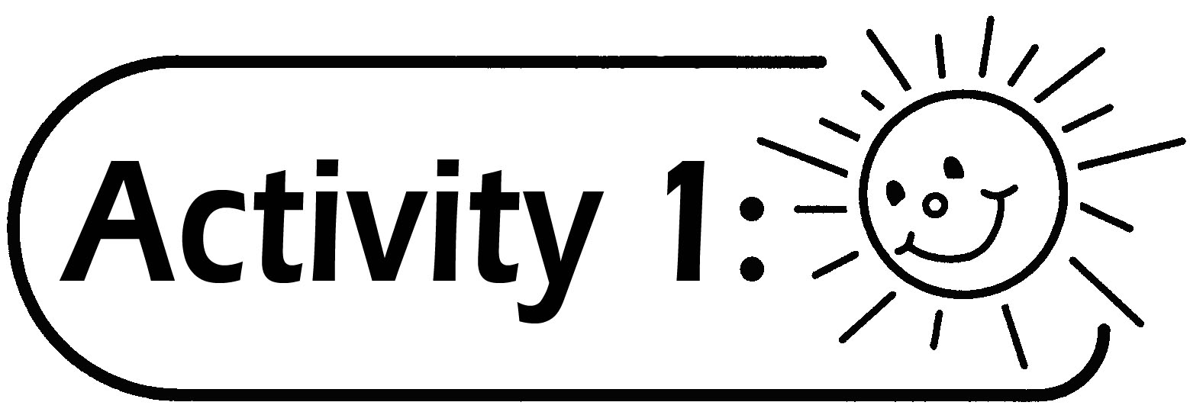
- The teacher shows a straw and demonstrates how to cut the straw vertically with a pair of scissors (as shown below). The teacher introduces section. The teacher can also use cylinders, cones and spheres which can be cut to conduct this activity, e.g. cylindrical glue stick, carrot, cake or orange.
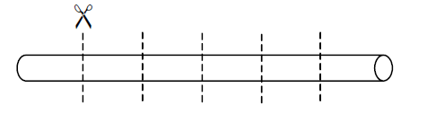

- The pupils repeat the above activity. The pupils study the shapes of each section and draw them on the blackboard.

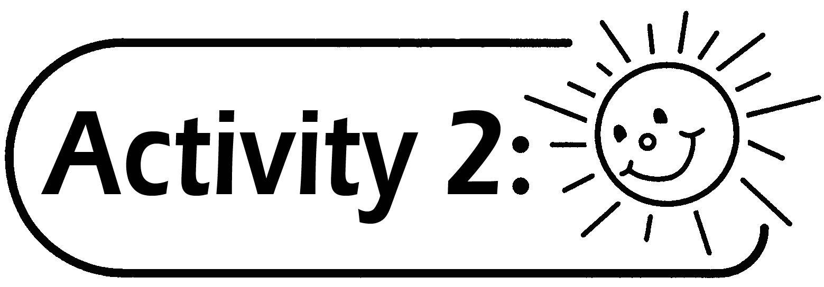

- The pupils make cylinders by using Figure 1 in the Appendix and scotch tape, then cut the cylinders along the dotted lines (as shown below).
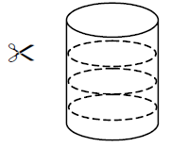

- The pupils study the shapes of all the sections which are parallel to the base (as shown below).
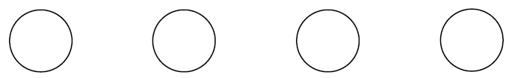

- The pupils make cones by using Figure 2 in the Appendix and scotch tape, then cut the cones along the dotted lines (as shown below).
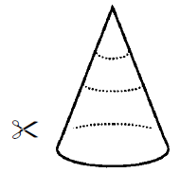

- The pupils study the shapes of all the sections which are parallel to the base (as shown below).
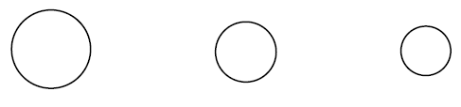

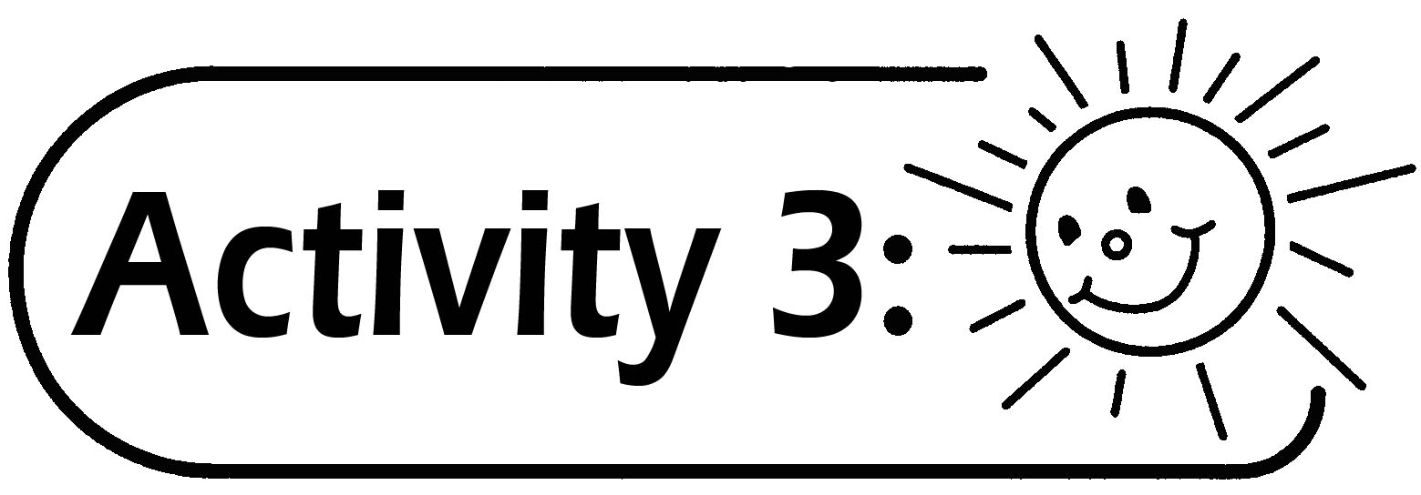

- The pupils are divided into groups of two. They make cylinders, cones and spheres with clay.
- Cut the clay with a piece of thread. Study the sections, which are parallel to the base of the cylinder, cone and sphere (as shown below). Record the result by colouring and stamping the sections on paper or outline the sections along the edges.
For example:
  - Cut the cylinder and observe the section which is parallel to the base.

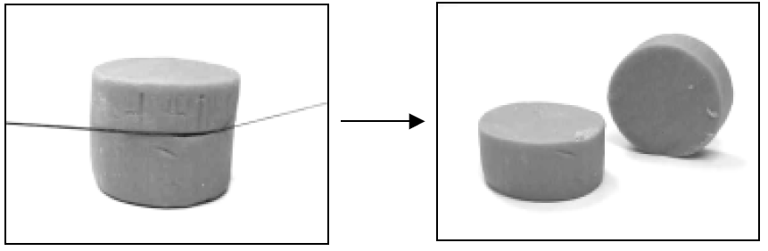

  - Cut the sphere and observe the section.
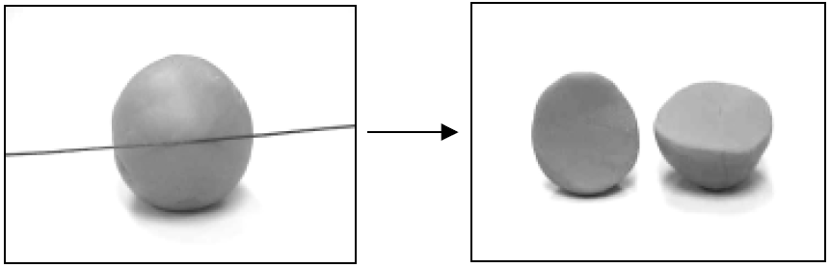

Questions for Discussion:
- Cylinder: Are the shapes and sizes of all the sections which are parallel to the base the same?
- Cone: Are the shapes and sizes of all the sections which are parallel to the base the same?
- Sphere: Are the shapes and sizes of all the sections the same?


(For more able pupils)
- The pupils are divided into groups of two. They make cylinders, cones and spheres with clay.
- Cut the clay with a piece of thread (as shown below). Study the different sections of the cylinder, cone and sphere. Record the result by colouring and stamping the sections on a piece of paper or outline the sections along the edges. The pupils can guess the shapes of the sections before cutting the clay.
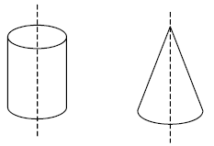
For example:
  - Cut vertically.

  - Cut randomly.
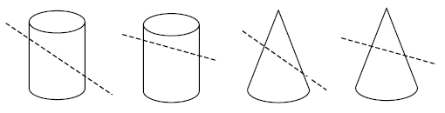

Generic Skills Fostered:
- Collaboration Skills
- Communication Skills
- Creativity
- Critical Thinking Skills

