HONG KONG DIPLOMA OF SECONDARY EDUCATION
EXAMINATION

MATHEMATICS
Compulsory Part

SCHOOL-BASED ASSESSMENT

Sample Assessment Task

Basketball Team
Marking Guidelines

The assessment scale for tasks on Data Handling is shown in the following table.

Level of Performance | Marks | Mathematical Knowledge and Data Handling Skills | Marks | Mathematical Communication Skills
Very good | 13–16 | The student demonstrates a complete understanding of the underlying mathematical knowledge and data-handling skills which are relevant to the task, and is consistently competent and accurate in applying them in handling the task. Typically, the student can use statistical measures or charts to present data. The student interprets the results reasonably and critically, and evaluates the results. | 4 | The student communicates ideas in a clear, well organised and logically valid manner through coherent written/verbal accounts, using appropriate forms of mathematical presentation to compare and analyse statistical data in making decisions.
Good | 9–12 | The student demonstrates a substantial understanding of the underlying mathematical knowledge and data-handling skills which are relevant to the task, and is generally competent and accurate in applying them in handling the task. Typically, the student uses statistical measures or charts to present data and interprets the results reasonably. | 3 | The student is able to communicate ideas properly through written/verbal accounts, using appropriate forms of mathematical presentation such as statistical terminology, diagrams, tables and charts to present and interpret statistical data.
Fair | 5–8 | The student demonstrates a basic understanding of the underlying mathematical knowledge and data-handling skills which are relevant to the task, and is occasionally competent and accurate in applying them in handling the task. Typically, the student attempts to use statistical measures or charts to present data and attempts to interpret the results. | 2 | The student is able to communicate ideas with some appropriate forms of mathematical presentation such as statistical terminology, diagrams, tables, charts etc.
Weak | 1–4 | The student demonstrates a limited understanding of the underlying mathematical knowledge and data-handling skills which are relevant to the task, and is rarely competent and accurate in applying them in handling the task. Typically, the student attempts to use statistical measures or charts to present data. | 1 | The student attempts to communicate ideas using mathematical symbols and notations, diagrams, tables, charts etc., but with limited success.

- The full mark of a SBA task on Data Handling submitted should be scaled to 20 marks, of which 16 marks are awarded for the mathematical knowledge and Data Handling skills while 4 marks are awarded for the communication skills.

- Teachers should base on the above assessment scale to design SBA tasks for assessing students with different abilities and to develop the marking guidelines.

Part A
Evidence:
1. The answers
2. The box-and-whisker diagram

Weak: Only the value of x is correct

Fair: All answers are correct

Good: All answers and the box diagram for Question 1 are correct

Very good: All answers and box diagrams are correct

1. Minimum = 175 cm
Maximum = 215 cm
Lower quartile = 188.5 cm
Median = 191.5 cm
Upper quartile = 196.5 cm

The box-and-whisker diagram of the heights of the players:

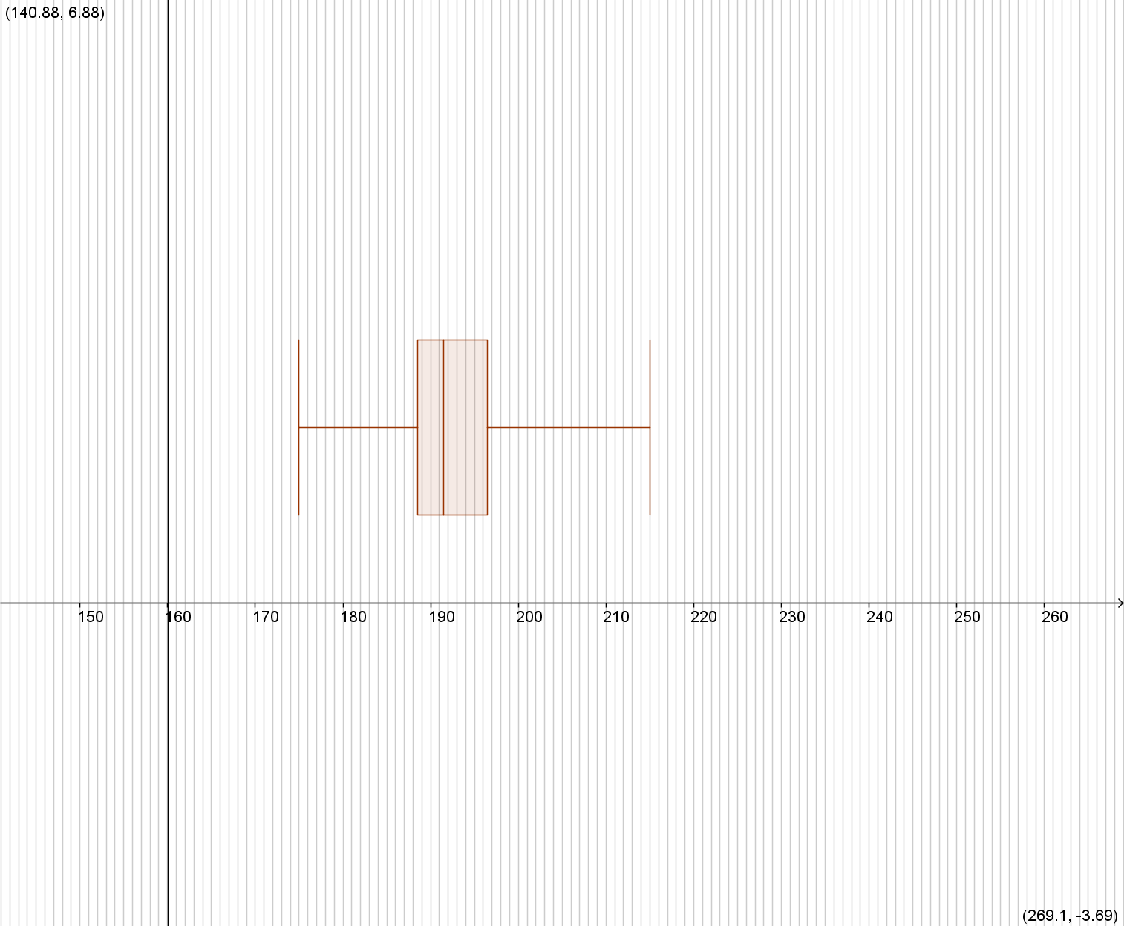

2.

The box-and-whisker diagram of the weights of the players:

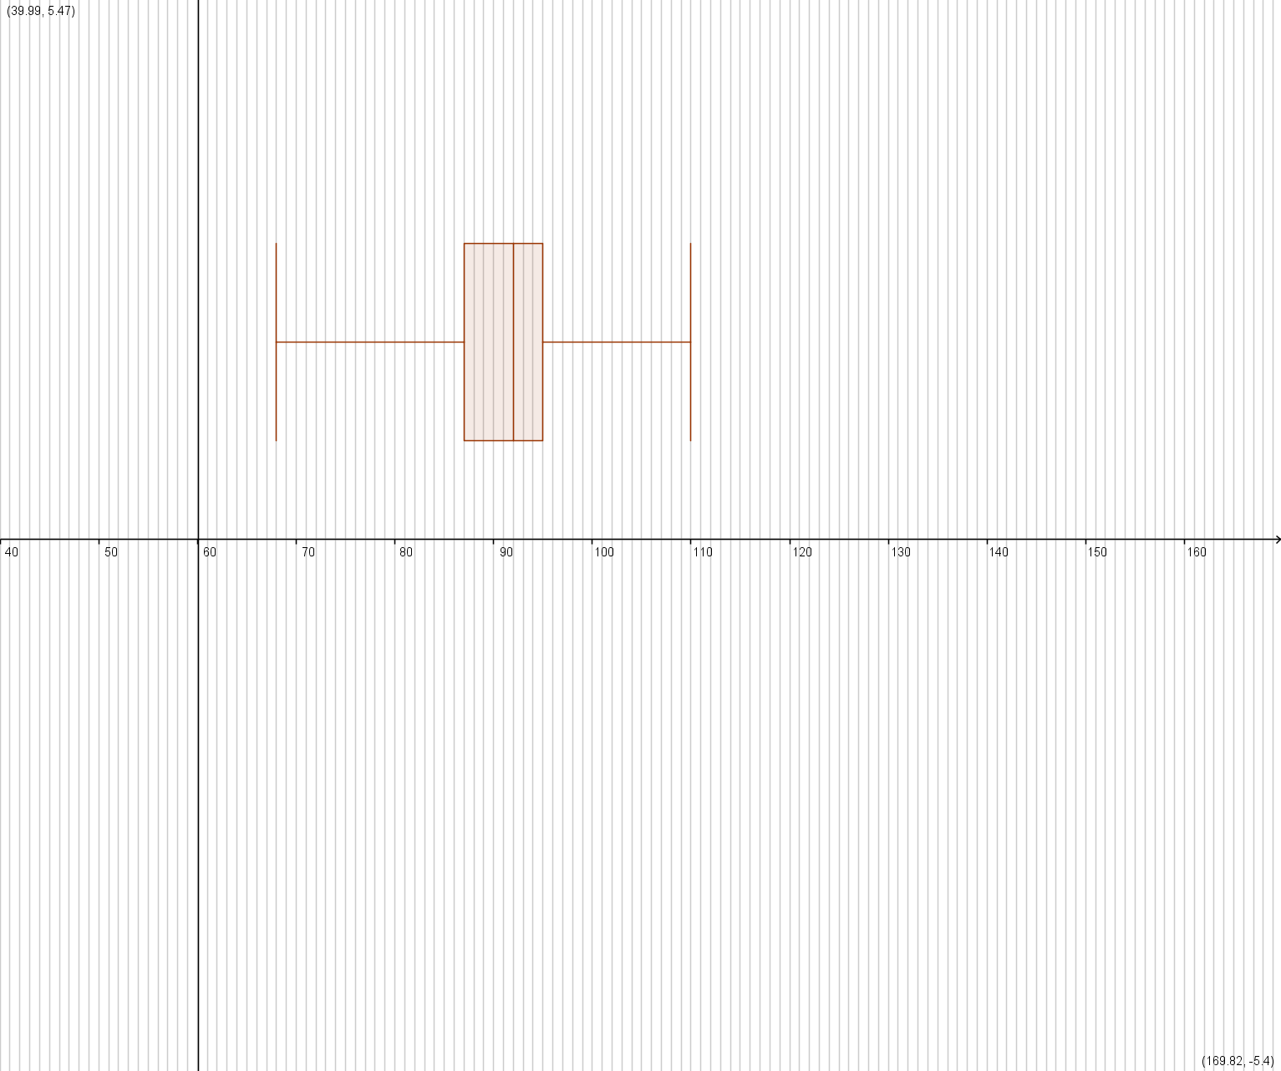

Part B
Evidence:
1. The box-and-whisker diagram
2. The explanation

Weak: The box diagram is not correct

Fair: The box diagram is correct

Good: The box diagram and the answer regarding the difference in shape are correct

Very good: The box diagram and the answer regarding the difference in shape are correct, and the explanation is valid

1. The box-and-whisker diagram of the new weights of players:

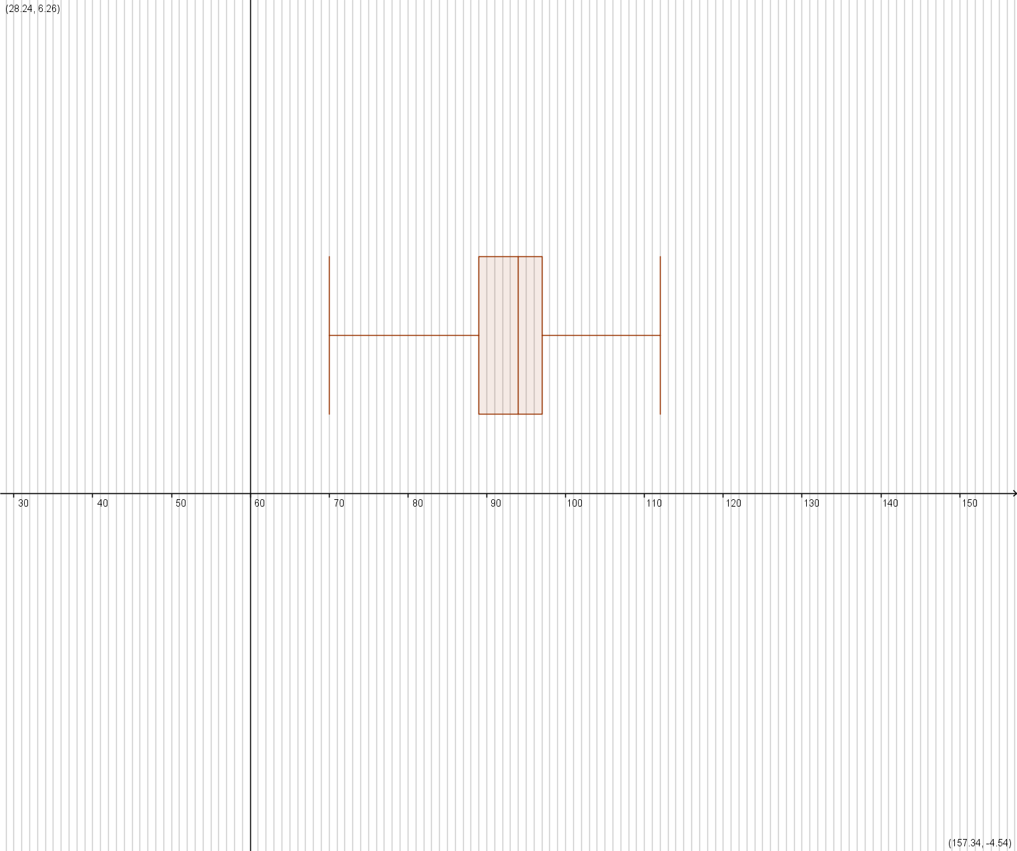

2. There is no difference in shape for the two box diagrams. Actually, the box-and-whisker diagram in Part B Question 1 is obtained by shifting the box diagram in Part A Question 1 to the right by 2 units.

Because all the data in Part A Question 1 ​​have been increased by 2 , the values of the minimum, the maximum, the lower quartile, the median and the upper quartile in Part B Question 1​​are increased by 2 accordingly.

Part C

1. The box-and-whisker diagram of the heights of players after T’s leave:
Evidence:
1. The box-and-whisker diagram
2. The explanation

Weak: The box diagram is not correct

Fair: The box diagram is correct

Good: The box diagram and the answer regarding the difference in shape are correct

Very good: The box diagram and the answer regarding the difference in shape are correct, and the explanation is valid

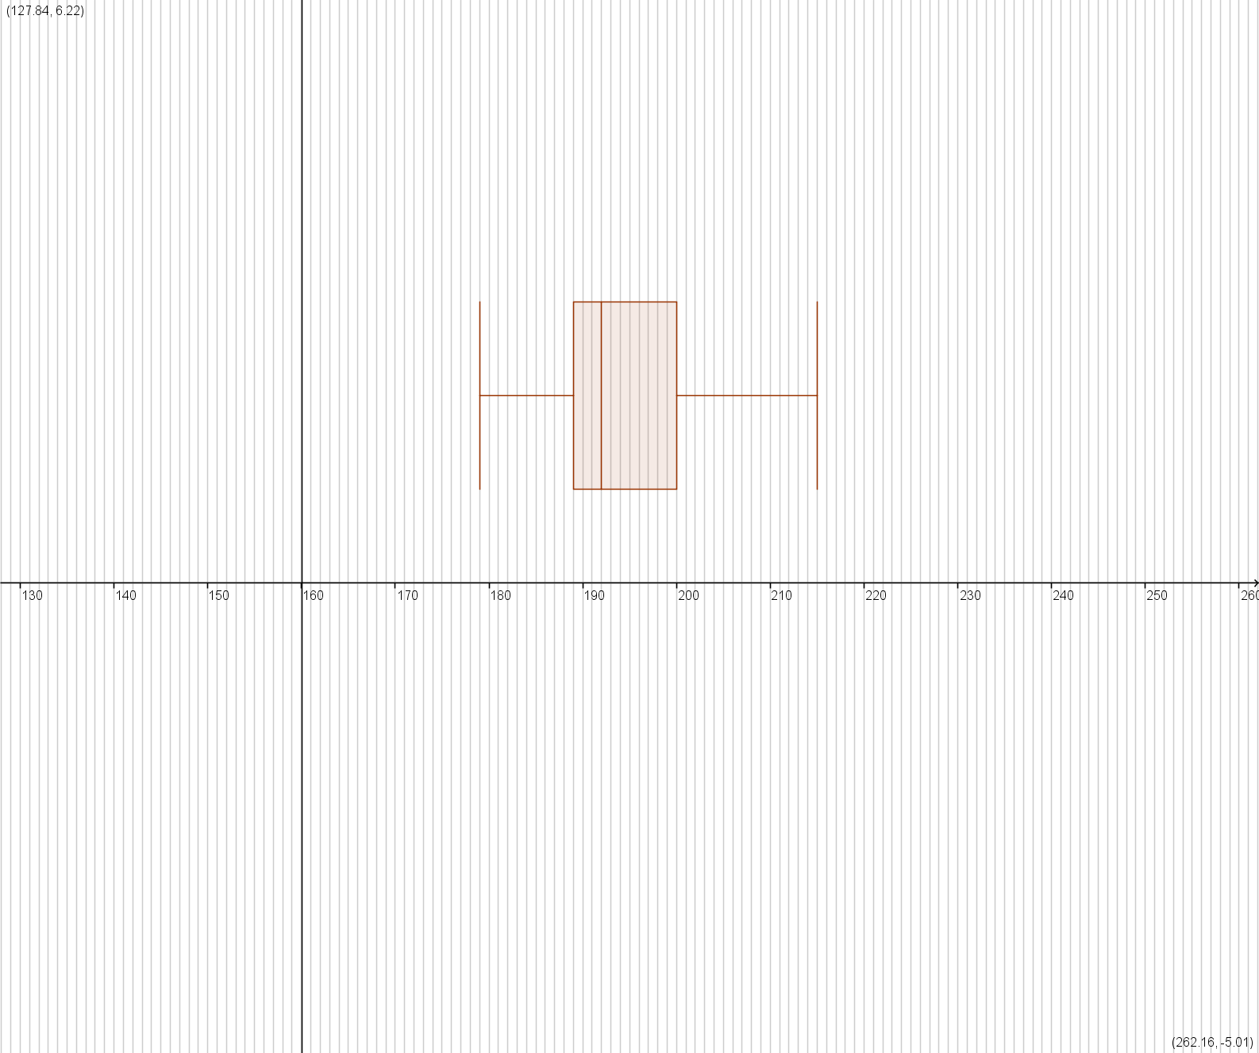

2. There is a difference in shape for the two box diagrams.

Most of the data in Part A Question 1 have been changed following T’s leave - the minimum increases from 175 cm to 179 cm, the lower quartile increases from 188.5 cm to 189 cm, the median increases from 191.5 cm to 192 cm , the upper quartile increases from 196.5 cm to 200 cm but the maximum remains unchanged.

Hence the shapes of the two box diagrams are different.

Part D
Evidence:
1. The inequalities established
2. The solutions of inequalities
3. The choice of applicant and the related explanation

Weak: No inequality established is correct

Fair: One inequality established as well as its solution is correct

Good: All inequalities established as well as their solutions are correct

Very good: All inequalities established as well as their solutions are correct. The choice of applicant is appropriate and the related explanation is valid

1. Let the height ,weight and age of new player be a cm, b kg and c respectively.

(a) The average age decreases by at least 0.7 year.
i.e.

(b) The average height increases by at least 1 cm.
i.e.

(c) The average weight is between 92 kg and 95 kg.
i.e.

So, the new player must be 195 cm tall or more, weigh between 91 kg and 151 kg (both 91 kg and 151 kg are inclusive) and not be older than 22. Only applicants X and Y can meet these requirements. As the transfer fee of applicant Y is less than that of applicant X , applicant Y will be chosen.

