HONG KONG DIPLOMA OF SECONDARY EDUCATION
EXAMINATION

MATHEMATICS
Compulsory Part

SCHOOL-BASED ASSESSMENT

Sample Assessment Task

Complex Number and Geometry
Marking Guidelines

The assessment scale for tasks on Mathematical Investigation is shown in the following table.

Level of Performance | Marks | Mathematical Knowledge and Investigation Skills | Marks | Mathematical Communication Skills
Very good | 13–16 | The student demonstrates a complete understanding of the underlying mathematical knowledge and investigation skills which are relevant to the task, and is consistently competent and accurate in applying them in handling the task. Typically, the student recognises patterns, and states a conjecture which is justified by a correct proof. | 4 | The student communicates ideas in a clear, well organised and logically true manner through coherent written/verbal accounts, using appropriate and correct forms of mathematical presentation to present conjectures and proofs.
Good | 9–12 | The student demonstrates a substantial understanding of the underlying mathematical knowledge and investigation skills which are relevant to the task, and is generally competent and accurate in applying them in handling the task. Typically, the student recognises patterns, draws inductive generalisations to arrive at a conjecture and attempts to provide a proof for the conjecture. | 3 | The student is able to communicate ideas properly through written/verbal accounts, using appropriate and correct forms of mathematical presentation such as algebraic manipulations and geometric deductions.
Fair | 5 – 8 | The student demonstrates a basic understanding of the underlying mathematical knowledge and investigation skills which are relevant to the task, and is occasionally competent and accurate in applying them in handling the task. Typically, the student recognises patterns and attempts to draw inductive generalisations to arrive at a conjecture. | 2 | The student is able to communicate ideas with some appropriate forms of mathematical presentation such as algebraic formulae and geometric facts.
Weak | 1 – 4 | The student demonstrates a limited understanding of the underlying mathematical knowledge and investigation skills which are relevant to the task, and is rarely competent and accurate in applying them in handling the task. Typically, the student manages to recognise simple patterns and organises results in a way that helps pattern identifications. | 1 | The student attempts to communicate ideas using mathematical symbols and notations, diagrams, tables, calculations etc.

- The full mark of a SBA task on Mathematical Investigation submitted should be scaled to 20 marks, of which 16 marks are awarded for the mathematical knowledge and investigation skills while 4 marks are awarded for the communication skills.
- Teachers should base on the above assessment scale to design SBA tasks for assessing students with different abilities and to develop the marking guidelines.

Part A

Evidence:
The solutions
Weak:Attempted the question but all answers are incorrect
Fair:Some mistakes are found in the working and not all the answers are correct
Good:All answers are correct but minor mistakes are found in the working
Very good:All answers and working are correct

1. (a)

(b) In $Δ\text{ABD}$,

------------------(1)

Regarding the similar triangles $Δ\text{XTD}$ and $Δ\text{YTB}$,

.
------------------(2)

In $Δ\text{ADX}$, and using the results (1) and (2),

$∵$ $∴$

(c) In ,
---------------(1)
Evidence:
The solutions
Weak:Attempt the question but the working is incorrect
Fair:Some mistakes are found in the working and not all the answers are correct
Good:All answers are correct but minor mistakes are found in the working
Very good:All answers and working are correct
In , using (1),

(d) Since
--------(1)

Since
---------(2)

Weak:Attempt the question but fail to use the formulas in Question 1(d)
Good:The proof is correct but minor mistakes are found in the working
Very good:The proof is correct
Fair:Some mistakes are found in the working and the proof is not totally correct
Evidence:
The proof
Part B

2. (a) With the results in Question 1(d),

put a = x and b = x into formulas (1) and (2), we get,

and

Weak:Attempt the question but fail to use the formulas in Part A(d)
Good:The proof is correct but minor mistakes are found in the working
Very good:The proof is correct
Fair:Some mistakes are found in the working and the proof is not totally correct
Evidence:
The proof
(b) With the results in Question 1(d),

put a = x and b = x into formulas (1), we get,

put a = x and b = x into formulas (2), we get ,
Weak:Attempt the question but fail to expand the given expression
Good:All answers are correct but minor mistakes are found in the working
Very good:All answers and working are correct
Fair:Some mistakes are found in the working and not all answers are correct
Evidence:
The solutions
Part C

3. (a)

(b)
by (a)
by (a)

Evidence:
The formula proposed
The verification
Weak:Attempt the question but the formula proposed is incorrect
Good:The formula proposed is correct but minor mistakes are found in the verification
Very good:The formula proposed and the verification are correct
Fair:The formula proposed is correct but the verification is not completed
(c) (i)

(ii) Yes, it does.

Part D
Weak:Attempt the question but all the answers are incorrect
Good:All the answers are correct but minor mistakes in marking the points are found
Very good:All are correct
Fair:Not all answers are correct
Evidence:
The coordinates of points
The distances
The positions of points in the coordinate plane

4. (a) (i) Let the point be A.
Coordinates of .
Distance from the origin to the point =

(ii) Let the point be B.
Coordinates of .
Distance from the origin to the point B =

(iii) Let the point be C.
Coordinates of .
Distance from the origin to the point C =

4. (b)

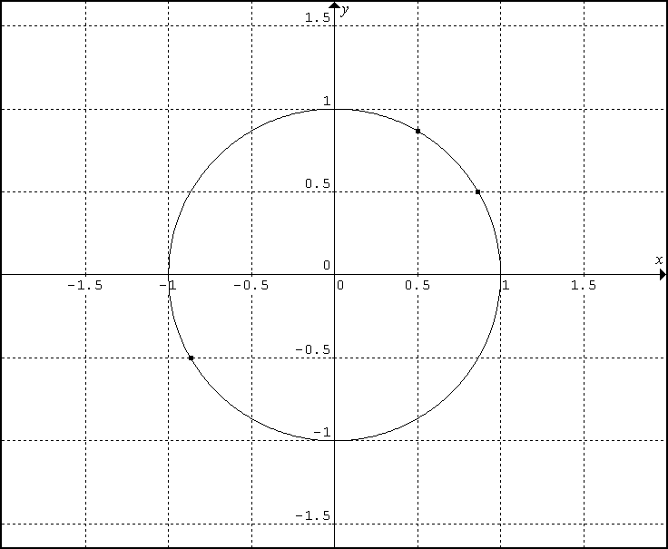
30°
30°
60°
A
B
C

Weak:Attempt the question but fail to give any feature
Good:Give two relevant features
Very good:Give three or more relevant features
Fair:Give one relevant feature
Evidence:
Geometric features (other than the one given in the example
Let the origin be O.

The following are some of the geometric features required:

(1) Points A, B and C are on the circle with centre at the origin and the radius being 1 unit.

(2) Points A and C are the end points of the diameter of the circle.

(3) If the circle cuts the positive x-axis and negative x-axis at D and E respectively, ∠AOD and ∠COE are vertically opposite angles.

