HONG KONG DIPLOMA OF SECONDARY EDUCATION
EXAMINATION

MATHEMATICS
Compulsory Part

SCHOOL-BASED ASSESSMENT

Sample Assessment Task

Complex Number and Geometry

Instructions

1. This task consists of FOUR parts, Part A to Part D. Students are required to attempt ALL parts.

2. Numerical answers should be exact or correct to 3 significant figures.

3. All working must be clearly shown.

Teacher Guideline

- This task requires students to

(a) prove trigonometry formulas ;

(b) use trigonometric formulas to solve problems in complex numbers ;

(c) interpret the complex numbers geometrically.

- It is anticipated that in general students will be able to complete the task in 1.5 hours. However, teachers can exercise their professional judgment to adjust the time allowed to cater for the ability level of their students.

- Teachers may feel free to modify the question and the marking guidelines to cater for the ability level of their students.

- Feedback should be provided to students after marking the task. For instance, teachers can discuss different approaches of handling each part of the task with students.
Figure 1

Part A

1. Figure 1 shows the quadrilateral ABCD . Given that , $∠\text{ABY}=c$, $∠\text{ABD}=a$, and $∠\text{DBY}=b$.

(a) Find the length of AY and BY in terms of c .

(b) Considering , find the lengths of AX and CY in terms of a and b .

(c) Considering , find the lengths of XY and CB in terms of a and b .

(d) Using the above results, find the formulas for and .

Part B

2. Using the results of Question 1(d), show that

(a) and .

(b) and .

Part C

3. It is known that the complex number i satisfies the condition .

(a) Expand in terms of and .

(b) Expand in terms of and .

(c) (i) Hence, guess the formula for .

(ii) Is the above formula correct when n = 3 ? Verify your assertion.

Part D

4. It is given that the complex number is represented by the point P(a, b) in the rectangular coordinate system. is the distance from the origin to P .

(a) Regarding the complex numbers below, find the corresponding coordinates (in surd form) and their distances to the origin. Also, mark the points in Figure 2 below.

(i)

(ii)

(iii)

(b) State the geometric features relating to the 3 points (corresponding to the 3 complex numbers in (a)).

(Hint: “Two of the points and the origin are on the same straight line” is an example of the said geometric features.)

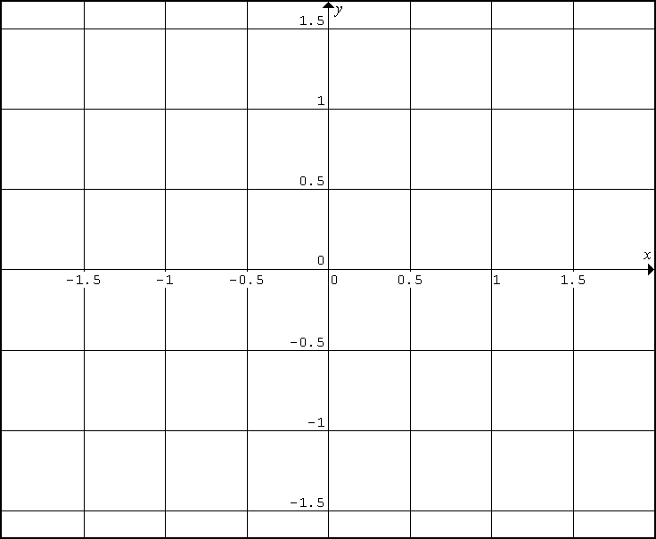
Figure 2

END OF ASSESSMENT TASK

