HONG KONG DIPLOMA OF SECONDARY EDUCATION
EXAMINATION

MATHEMATICS
Compulsory Part

SCHOOL-BASED ASSESSMENT

Sample Assessment Task

Geometric Construction
Marking Guidelines

The assessment scale for tasks on Mathematical Investigation is shown in the following table.

Level of Performance | Marks | Mathematical Knowledge and Investigation Skills | Marks | Mathematical Communication Skills
Very good | 13–16 | The student demonstrates a complete understanding of the underlying mathematical knowledge and investigation skills which are relevant to the task, and is consistently competent and accurate in applying them in handling the task. Typically, the student recognises patterns, and states a conjecture which is justified by a correct proof. | 4 | The student communicates ideas in a clear, well organised and logically true manner through coherent written/verbal accounts, using appropriate and correct forms of mathematical presentation to present conjectures and proofs.
Good | 9–12 | The student demonstrates a substantial understanding of the underlying mathematical knowledge and investigation skills which are relevant to the task, and is generally competent and accurate in applying them in handling the task. Typically, the student recognises patterns, draws inductive generalisations to arrive at a conjecture and attempts to provide a proof for the conjecture. | 3 | The student is able to communicate ideas properly through written/verbal accounts, using appropriate and correct forms of mathematical presentation such as algebraic manipulations and geometric deductions.
Fair | 5 – 8 | The student demonstrates a basic understanding of the underlying mathematical knowledge and investigation skills which are relevant to the task, and is occasionally competent and accurate in applying them in handling the task. Typically, the student recognises patterns and attempts to draw inductive generalisations to arrive at a conjecture. | 2 | The student is able to communicate ideas with some appropriate forms of mathematical presentation such as algebraic formulae and geometric facts.
Weak | 1 – 4 | The student demonstrates a limited understanding of the underlying mathematical knowledge and investigation skills which are relevant to the task, and is rarely competent and accurate in applying them in handling the task. Typically, the student manages to recognise simple patterns and organises results in a way that helps pattern identifications. | 1 | The student attempts to communicate ideas using mathematical symbols and notations, diagrams, tables, calculations etc.

- The full mark of a SBA task on Mathematical Investigation submitted should be scaled to 20 marks, of which 16 marks are awarded for the mathematical knowledge and investigation skills while 4 marks are awarded for the communication skills.
- Teachers should base on the above assessment scale to design SBA tasks for assessing students with different abilities and to develop the marking guidelines.

Part A
Evidence:
1.The construction steps
2.The figures constructed
Weak:No figures are constructed correctly and the construction steps are not clearly shown
Fair:Only 1 figure is constructed correctly and the related construction steps are clearly shown

Good:2 figures are constructed correctly and the related construction steps are clearly shown
Very good:All the figures are constructed correctly and the related construction steps are clearly shown

1. (a)
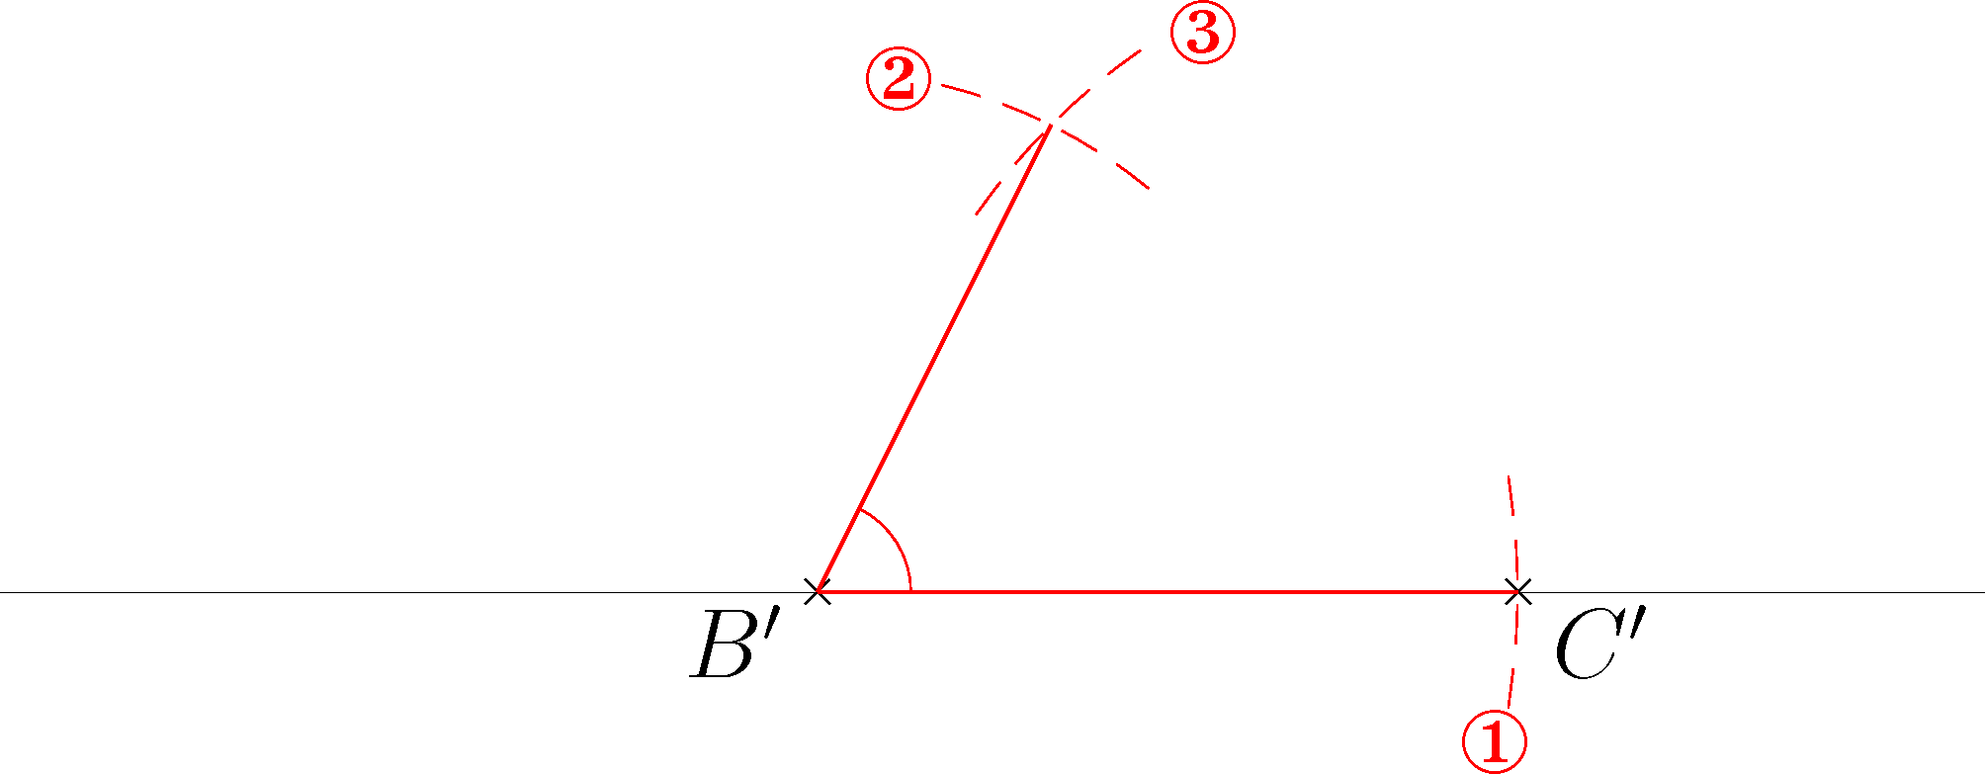
(b)
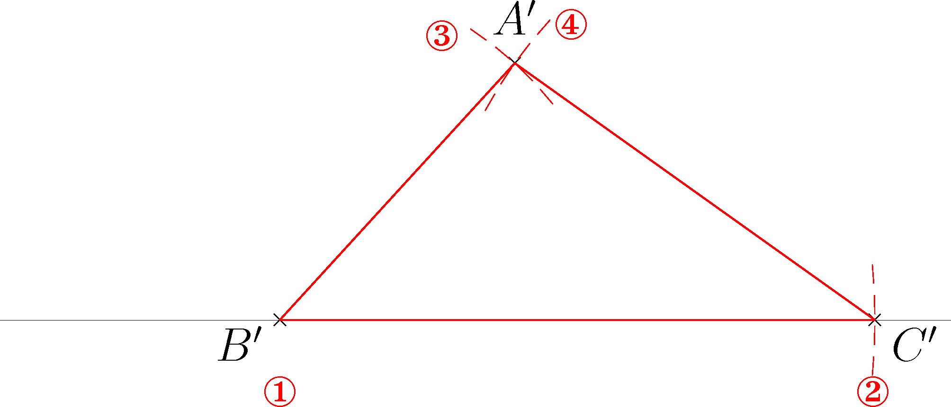
(c)
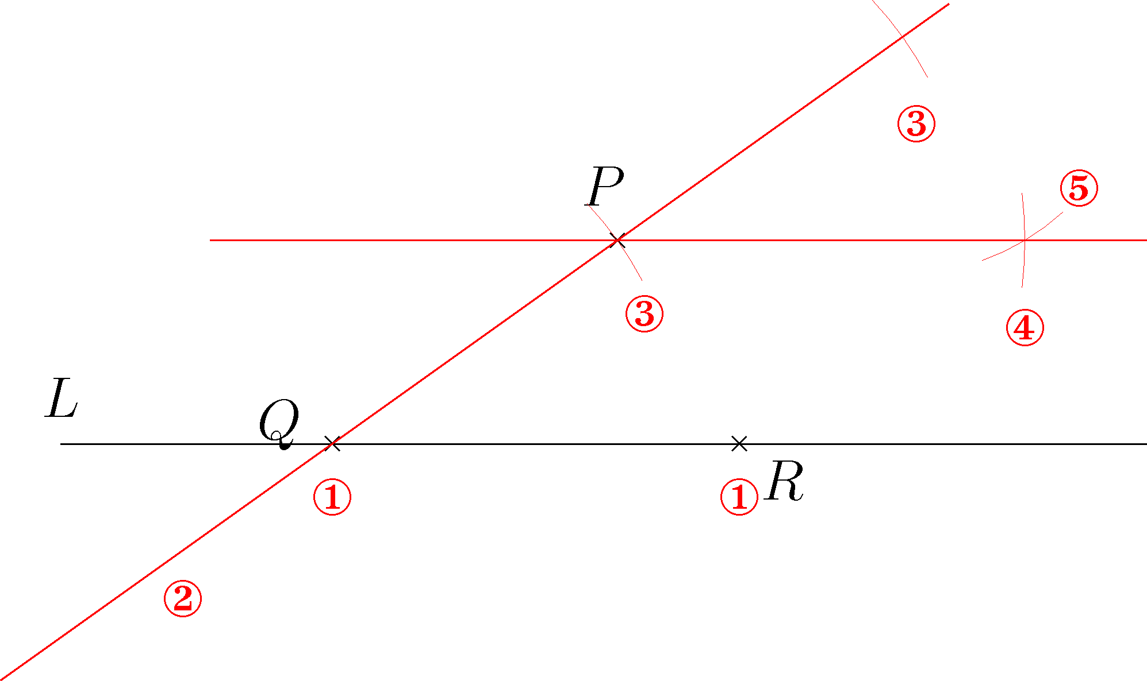

2. (a)
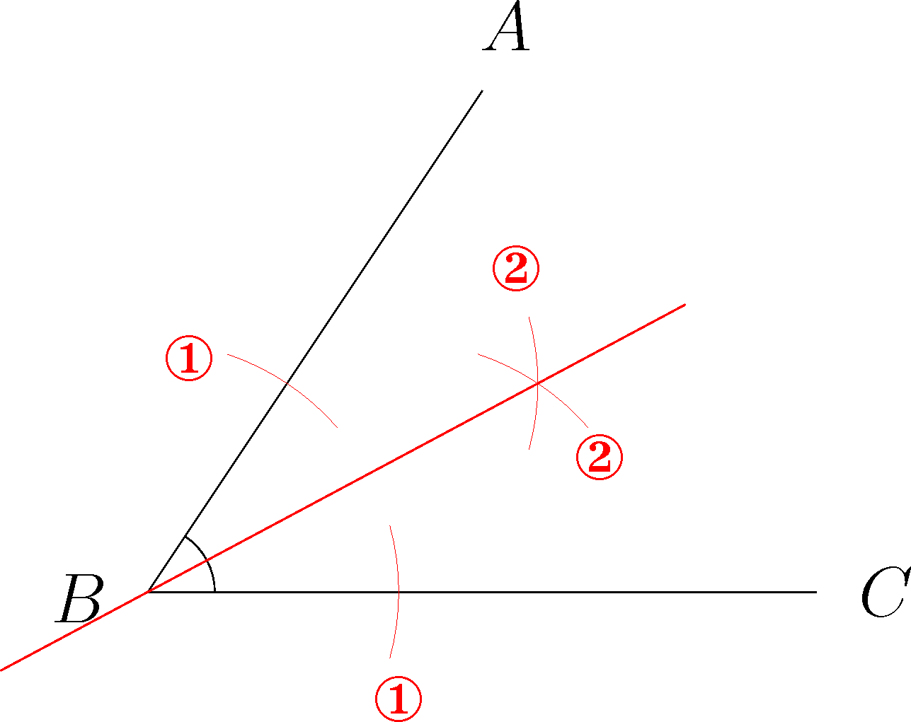
Evidence:
1.The construction steps
2.The figures constructed
Weak:Only 1 figure is constructed correctly and the related construction steps are clearly shown
Fair:2 figures are constructed correctly and the related construction steps are clearly shown

Good:3 figures are constructed correctly and the related construction steps are clearly shown
Very good:All the figures are constructed correctly and the related construction steps are clearly shown

P
Q
R
(b)
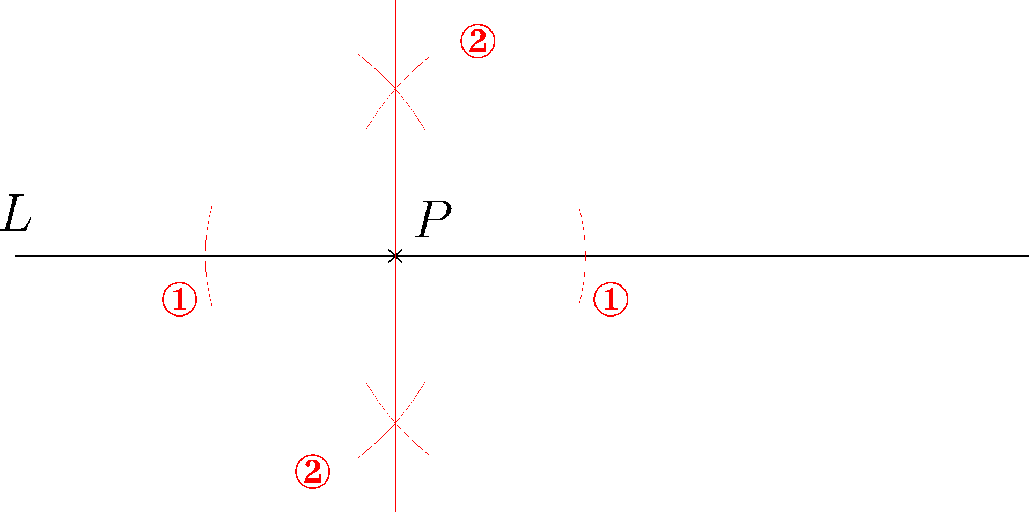

(c)
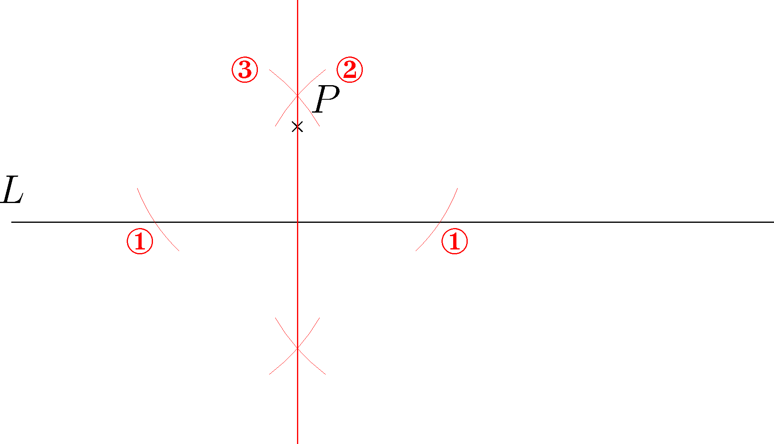

(d)
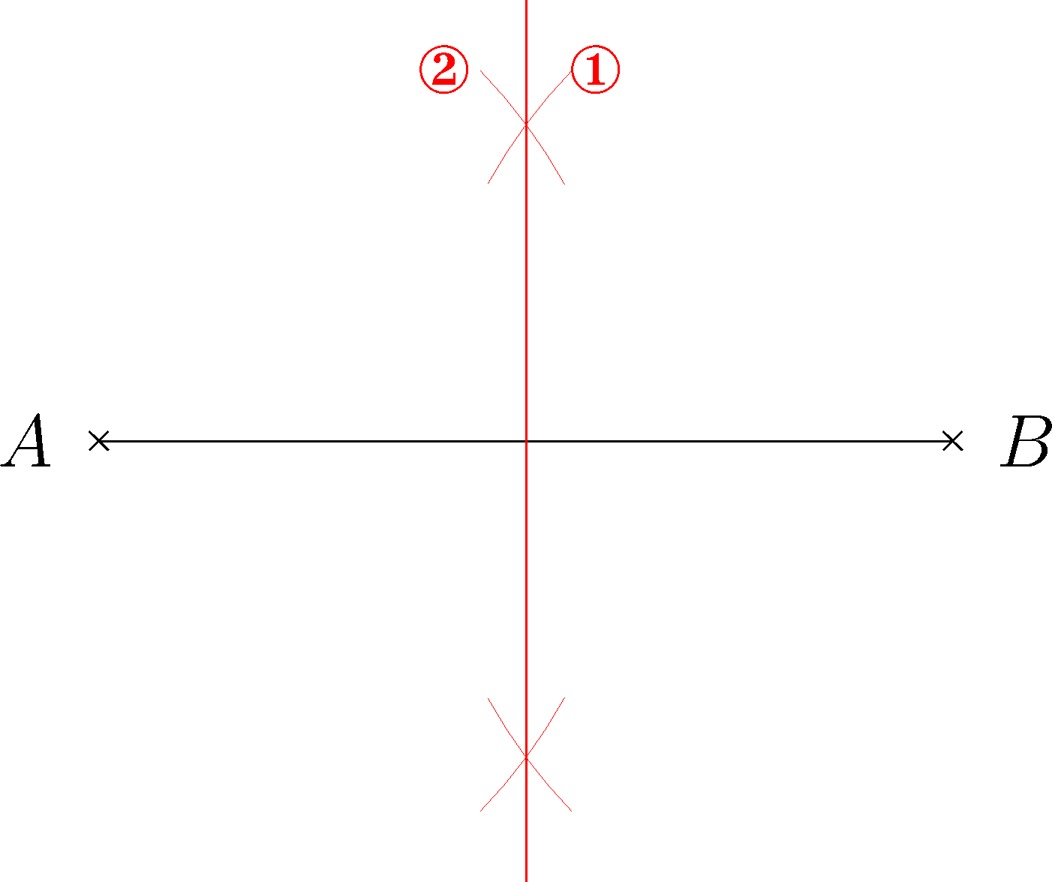
Evidence:
1.The construction steps
2.The figure constructed
Weak:No step is correctly carried out
Fair:Only 1 step is correctly carried out

Good:2 steps are correctly carried out
Very good:All steps are correctly carried out and the figure is correctly constructed

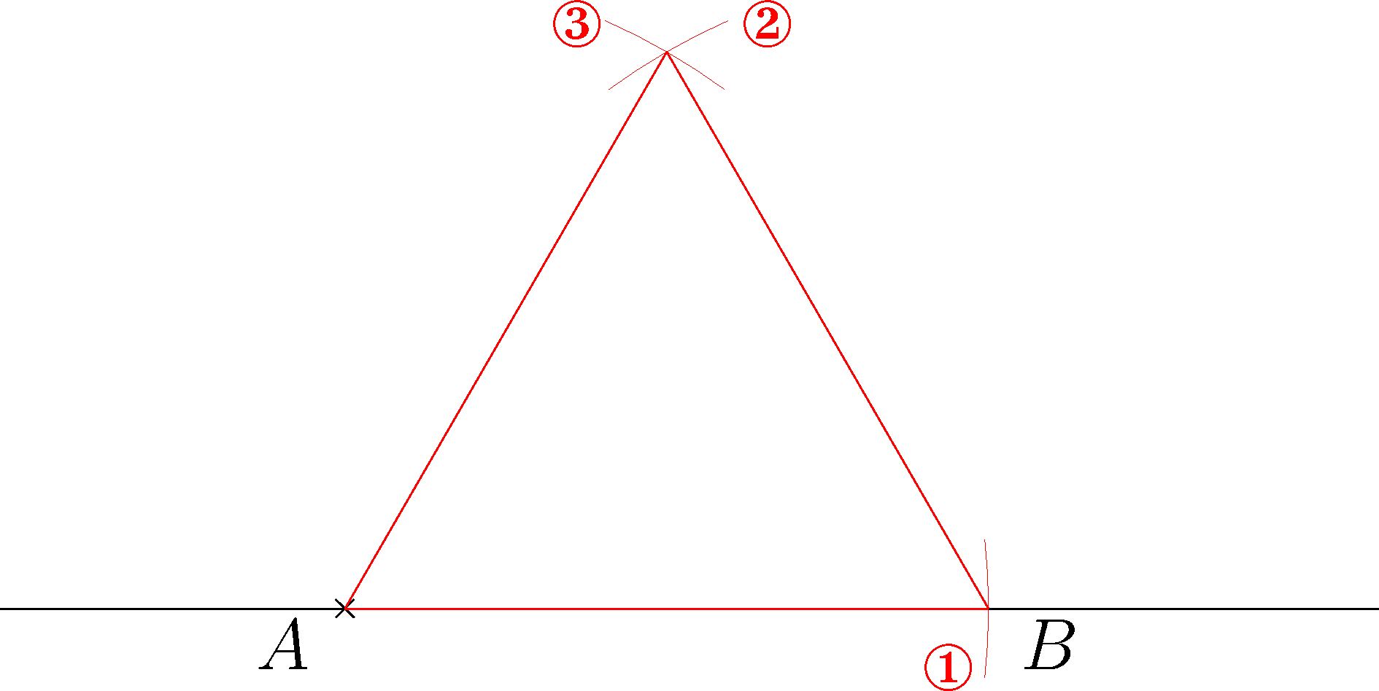

Part B
Evidence:
1.The constructions steps
2.The figure constructed
Weak:No step is correct
Fair:The figure in (a) is constructed correctly with steps clearly shown

Good:The figure in (a) is constructed correctly with steps clearly shown. Some steps for (b) are correct
Very good:All figures are correctly constructed with steps clearly shown

1. (a) Method
(i) Copy the line segment BC. ①
(ii) Copy the angle θ with B as vertex. ②③
(iii) Copy the line segment AB. ④

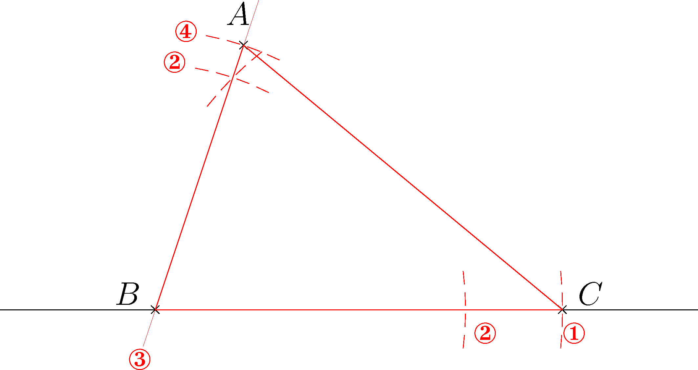

(b) Method
Bisect the line segment BC and mark the mid-point of BC as P.

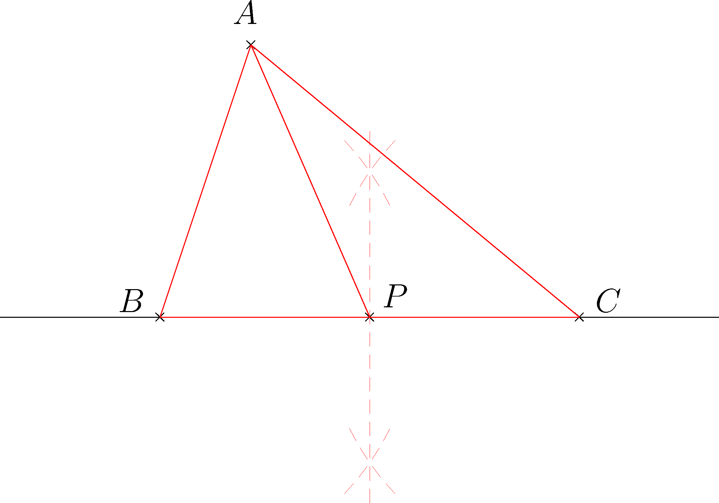

Evidence:
1.The constructions steps
2.The figure constructed
Weak:No step is correct
Fair:Only 1 figure is constructed correctly with steps clearly shown

Good:Only 1 figure is constructed correctly with steps clearly shown. Some steps for constructing another figure are correct
Very good:All figures are correctly constructed with steps clearly shown

2. (a) Method
(i) Pick B as centre and AB as radius, draw a semi-circle and meet the straight line at A and T₁. ①

(ii) Pick A and T₁ as centres, AT₁ as radius, draw two arcs. Mark the intersection of the two arcs as C. ②

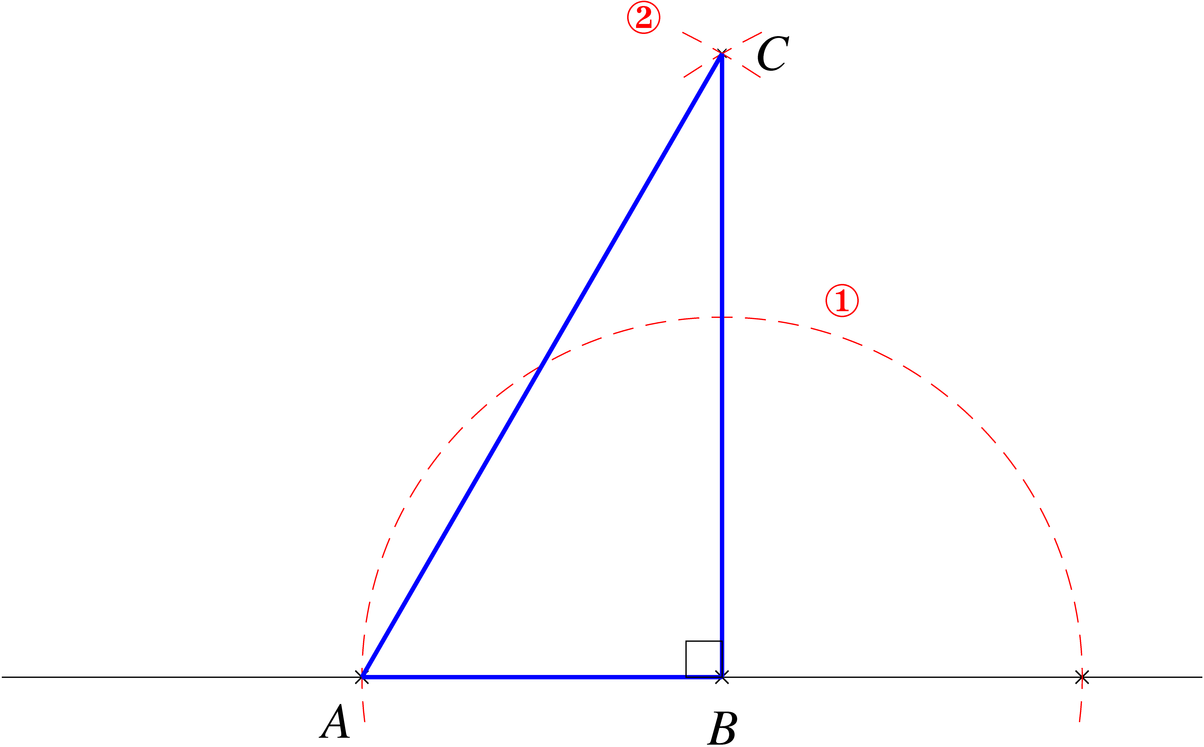
T₁

(b) Method 1

(i) Pick A and B as centres, AB as radius, draw two arcs. Mark the intersection of the two arcs as T₁. ①

(ii) Bisect : Pick A and T₁ as centre, AT₁ as radius, draw two arcs. Mark the intersection of the two arcs as T ₂. ②

(iii) Join B and T₂. The intersection point of BT₂ and T₁A is C.

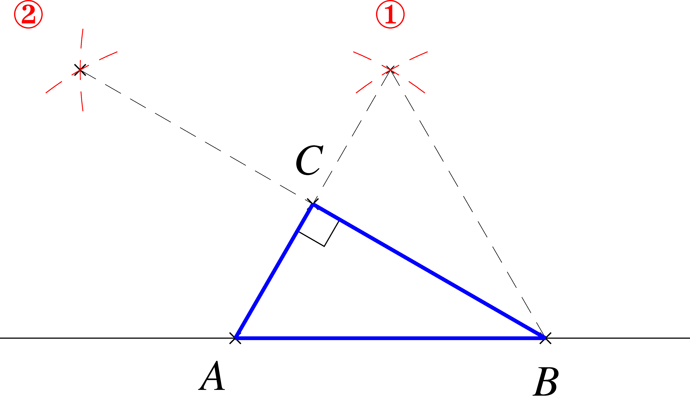
T₁
T₂

Method 2

(i) Pick A and B as centres, AB as radius, draw two arcs. Mark the intersection of the two arcs as T₁. ①

(ii) Bisect : Pick B and T₁ as centre, BT₁ as radius, draw two arcs. Mark the intersection of the two arcs as T₂. ②

(iii) Join A and T₂. The intersection point of AT₂ and T₁B is C.

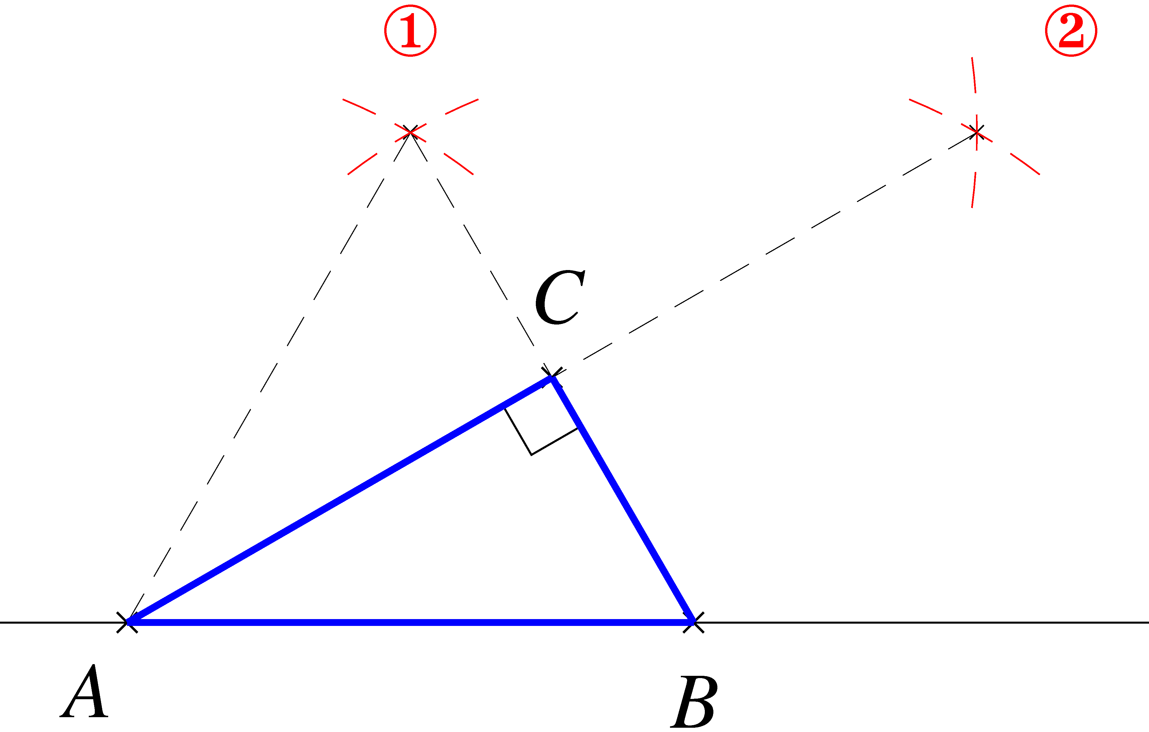
T₁
T₂

Method 3

(i) Construct the perpendicular bisector of AB. Pick A and B as centre, AB as radius, draw arcs above and below AB. Mark the two intersection points of the arcs as T₁ and T₂ . Then, the mid-point of AB (point M) is the intersection point of T₁T₂ and AB . ①
(ii) Pick M as centre and MA as radius, draw a semi-circle. ②
(iii) Join A and T₁. The intersection point of AT₁ and the semi-circle is C .
T₁
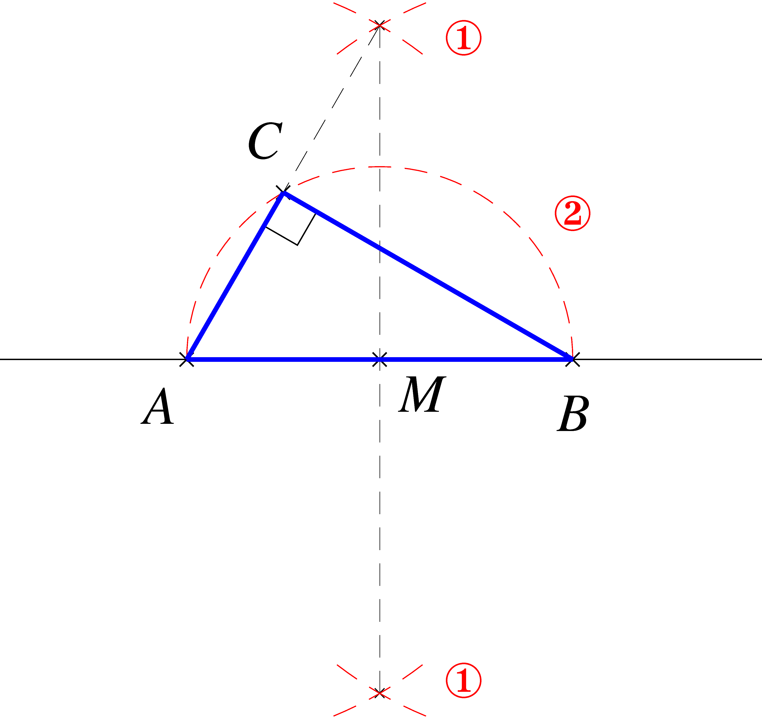
T₂

Part C
Evidence:
1.The construction steps
2.The figure constructed
Weak:No step is correct
Fair:Only 1 step is correct

Good:2 steps are correct
Very good:The figure is correctly constructed with steps clearly shown

1. Method
(i) Construct the angle bisectors of angle A and angle B. Mark the intersection point of the two angle bisectors as P, where P is the in-centre. ①② ③④
(ii) Draw a perpendicular line from point P to AC. Mark the intersection point of the perpendicular line and AC as Q.⑤⑥
(iii) Pick P as centre and PQ as radius, draw an inscribed circle.

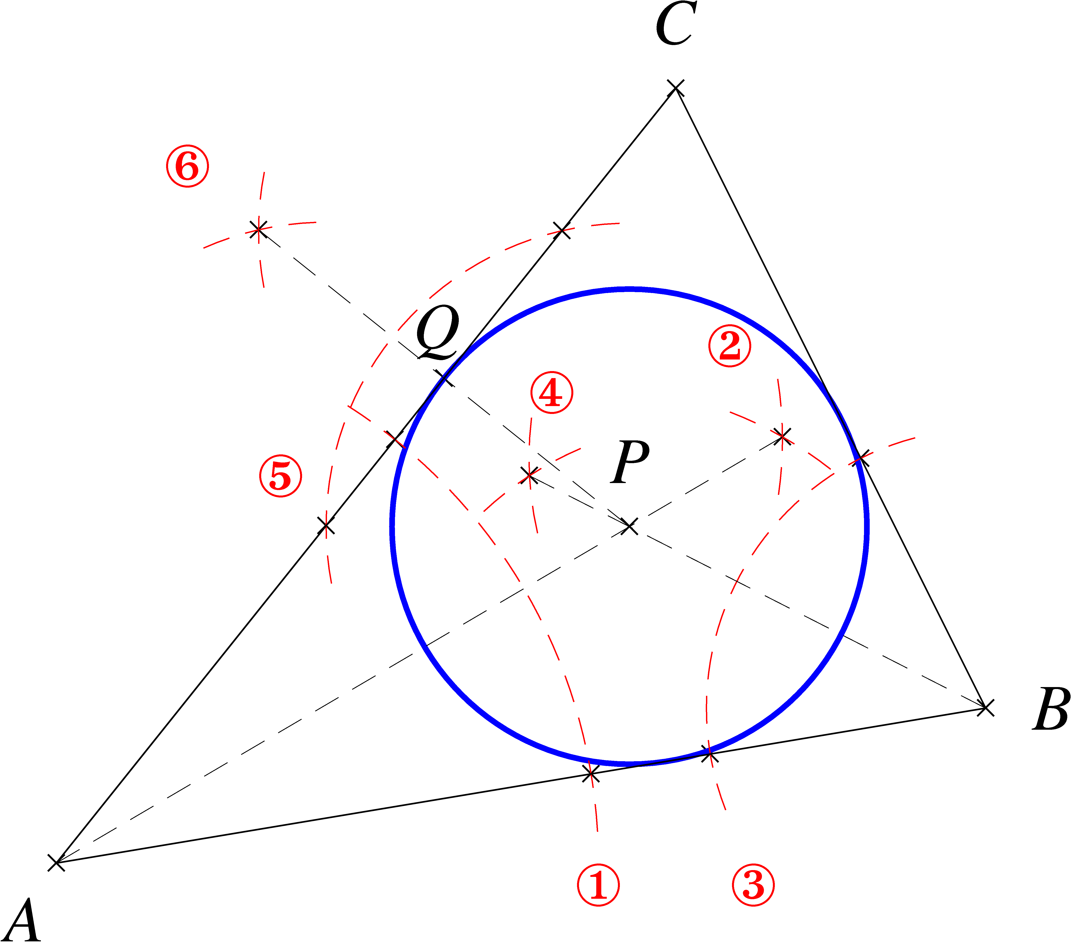
Figure 2

2. Method
(i) Construct the perpendicular bisectors of AC, AB and BC. Mark the mid-points of the three sides as M₁, M₂ and M₃ respectively. ①
Evidence:
1.The construction steps
2.The method of dividing the land
Weak:No step is correct
Fair:Only 1 step is correct

Good:2 steps are correct
Very good:The method of dividing the land is correct and all the steps are clearly shown

(ii) Draw the medians AM ₃, BM ₁ and CM₂, mark the intersection point of the three medians as G (centroid).②
(iii) GM₁, GM₂ and GM₃ divide triangle ABC into 3 parts of equal area.

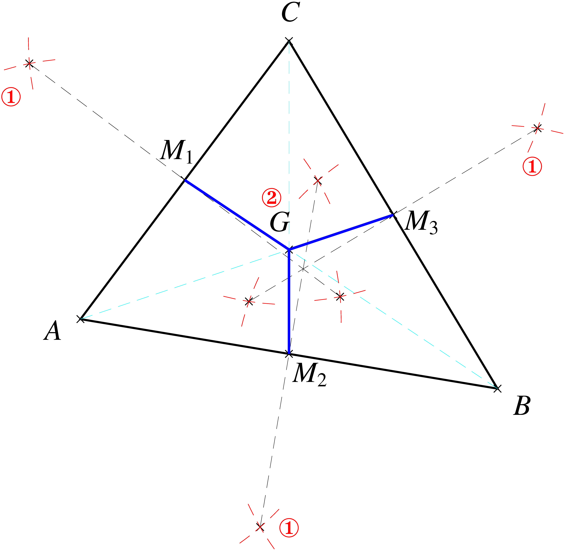
Figure 4

