HONG KONG DIPLOMA OF SECONDARY EDUCATION
EXAMINATION

MATHEMATICS
Compulsory Part

SCHOOL-BASED ASSESSMENT

Sample Assessment Task

Geometric Construction

Instructions

1. This task consists of THREE parts, Part A to Part C. Students are required to attempt ALL parts.

2. All working must be clearly shown.

Teacher Guidelines

- This task requires students to

(a) use compasses and straightedges as tools for carrying out investigation and solving problems, and

(b) understand and apply geometric theorems.

- It is anticipated that, in general, students can complete the task in 2 hours. However, teachers can exercise their professional judgment to adjust the time allowed to cater for the ability level of their students.

- Teachers may feel free to modify the questions and the marking guidelines to cater for the ability level of their students.

- Feedback should be provided to students after marking the task. For instance, teachers can discuss different approaches of handling each part of the task with students.

Part A

Example Copy a line segment

Copy the above line segment AB to the space provided below.

Steps (Refer to the diagram below)
(i) Draw a line segment L (longer than AB) and mark any point C on the line segment.
(ii) Use C as centre and AB as radius, draw an arc to meet L at P. PC is the required line segment.
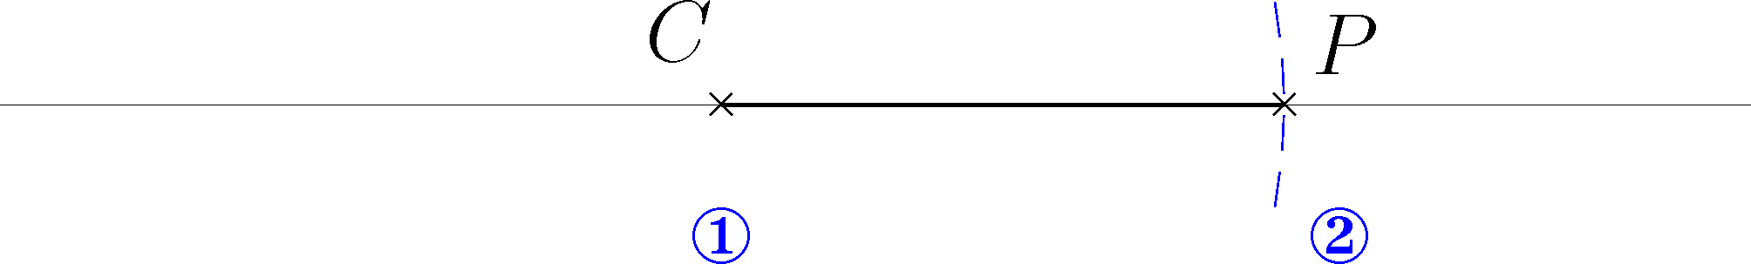 line segment L

1. (a) Copy an angle

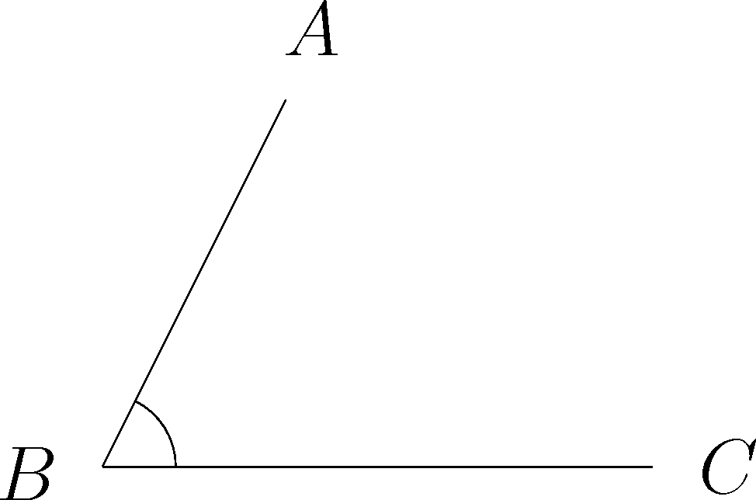

Copy ∠ABC in the above figure into the space provided below.

Steps
(i) Draw a line segment L. Apply the method given in the Example to copy BC on the line segment L, named as B′C′.
(ii) Use B′ as the centre and BA as radius, draw an arc.
(iii) Use C′ as the centre and CA as radius , draw another arc.
(iv) Mark the intersection of the two arcs as A′, ∠A′B′C′ is the angle to be copied.

(b) Copy a triangle
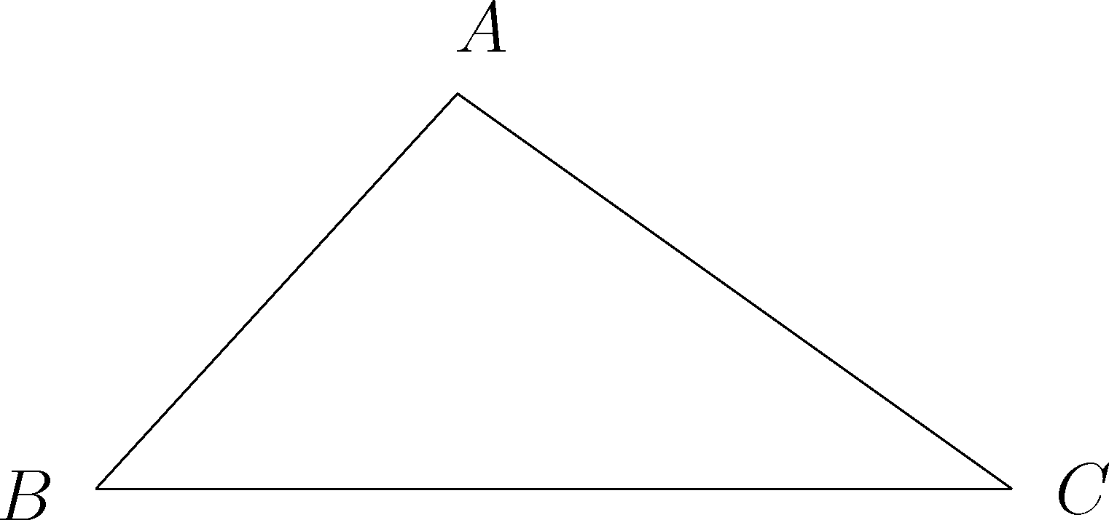

Apply the methods introduced in the Example and 1 (a) to copy ΔABC into the space provided below.

(c) Construct parallel lines
In the space provided below, construct a line that passes through P and is parallel to L.

Steps
(i) Mark a point on L as Q. Draw a straight line passing through P and Q.
(ii) Mark another point on L as R. Copy ∠PQR such that the vertex of the copied angle is P and one of the two arms is along the line QP . By the property of corresponding angles of parallel lines, a line that is parallel to L can be obtained.

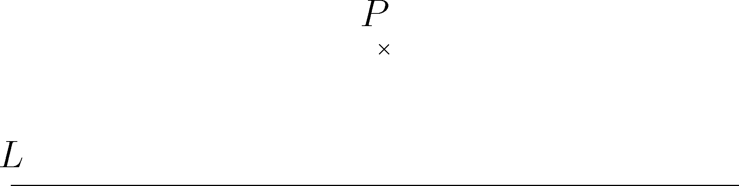

2. (a) Construct an angle bisector
In the space provided below, construct the angle bisector of ∠ABC .

Steps
(i) Use B as the centre, draw an arc intersecting both line segments AB and BC.
Mark the two intersecting points as P and Q.
(ii) Draw two arcs with the same radius using P and Q as the centre respectively.
Mark the intersection point of the arcs as R.
(iii) Join BR, which is the angle bisector of ∠ABC.

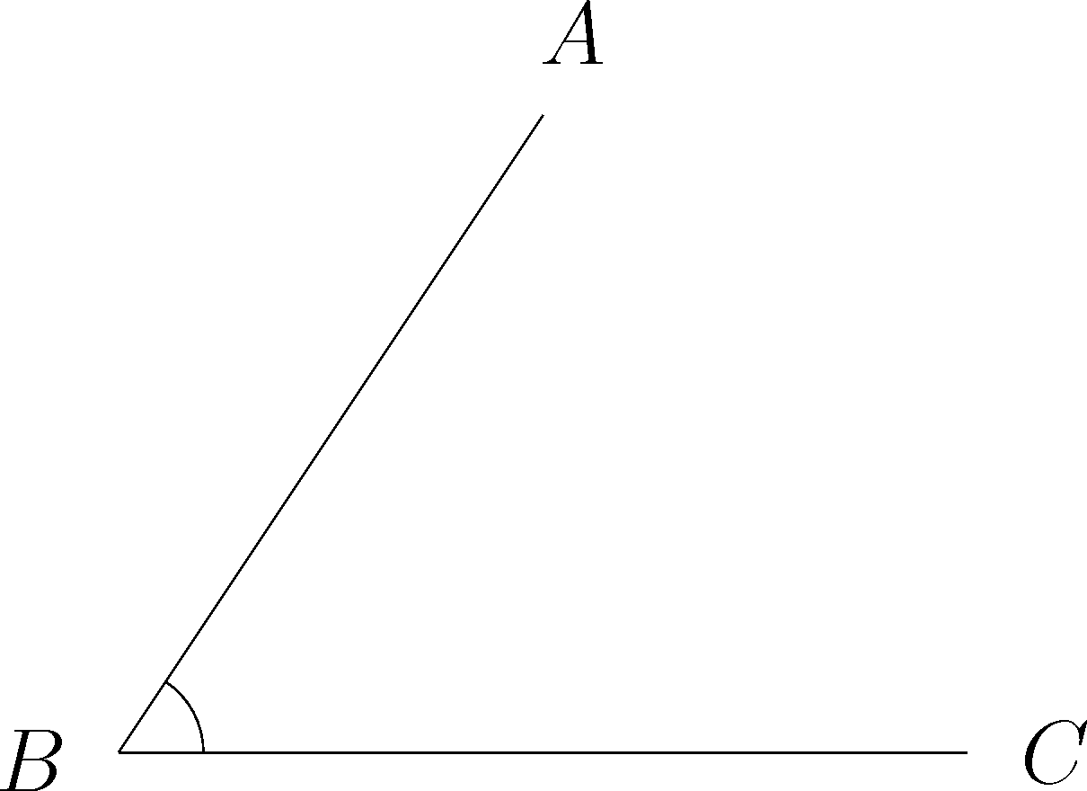

- Construct a perpendicular at a point on a line segment
In the space provided below, construct a line passing through P and perpendicular to L.

Steps
Apply the method in 2(a) to draw a perpendicular through P.

- Construct a perpendicular to a line through an external point
In the space provided below, construct a line perpendicular to L and through the point P.

Steps
(i) Use P as the centre and a suitable radius to draw an arc intersecting L at two distinct points.
(ii) Apply the method in 2(b) to draw a line perpendicular to L and through the point P.

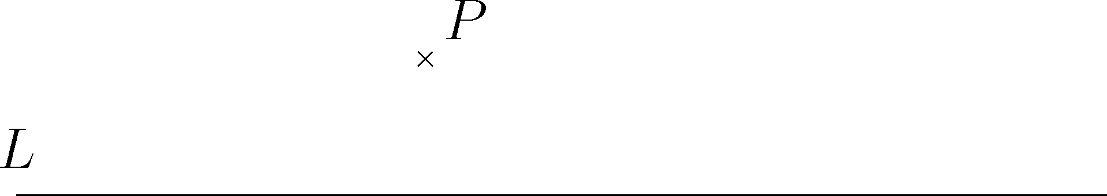

(d) Bisect a line segment
In the space provided below, bisect the line segment AB.

Steps
Apply the methods in 2(a) and 2(b) to draw the perpendicular bisector of AB.

3. Construct an equilateral triangle

Construct an equilateral triangle with the line segment AB as a side.

Steps
(i) In the space provided below, copy the line segment AB. Use A and B as centres with AB as radius, draw two arcs respectively.
(ii) Join the intersection point of the two arcs to the two end-points (that is A and B) of the line segment respectively. The triangle obtained is the required triangle.

Part B

Use compasses and straightedges as tools and apply the basic geometric construction techniques introduced in Part A, complete the following problems.

      - (a) Given that AB and BC are the two sides of triangle ABC and ∠ABC = θ.

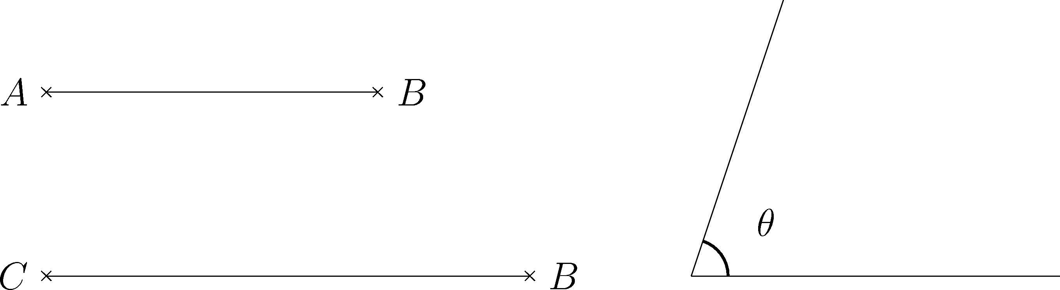

If C is on the right of B along the given line segment, construct triangle ABC in the space provided below.

(b) In the above figure, mark a point P on BC such that the line segment AP divides triangle ABC into two halves of equal area.

      - In the space provided below, construct a triangle ABC such that the three interior angles are 30°, 60° and 90°.
The following conditions should also be satisfied.

- ∠B = 90°

- ∠C = 90°

Part C

You are a clever man in a village and are keen on solving land survey problems. Though there is no accurate measuring equipment provided, you can still use a rope and a pen as tools to solve problems.
[Hints: To draw a circle or an arc, you can use the pen to locate a fixed point, and then rotate the rope about the fixed point.

To draw a straight line, you can join any two points on the extended rope.]

You are now invited to solve the following problems for the people living in the village.

- Mr Ho has a land in triangular shape right outside his house (as shown in Figure 1). He decided to build a circular pond with maximum area.

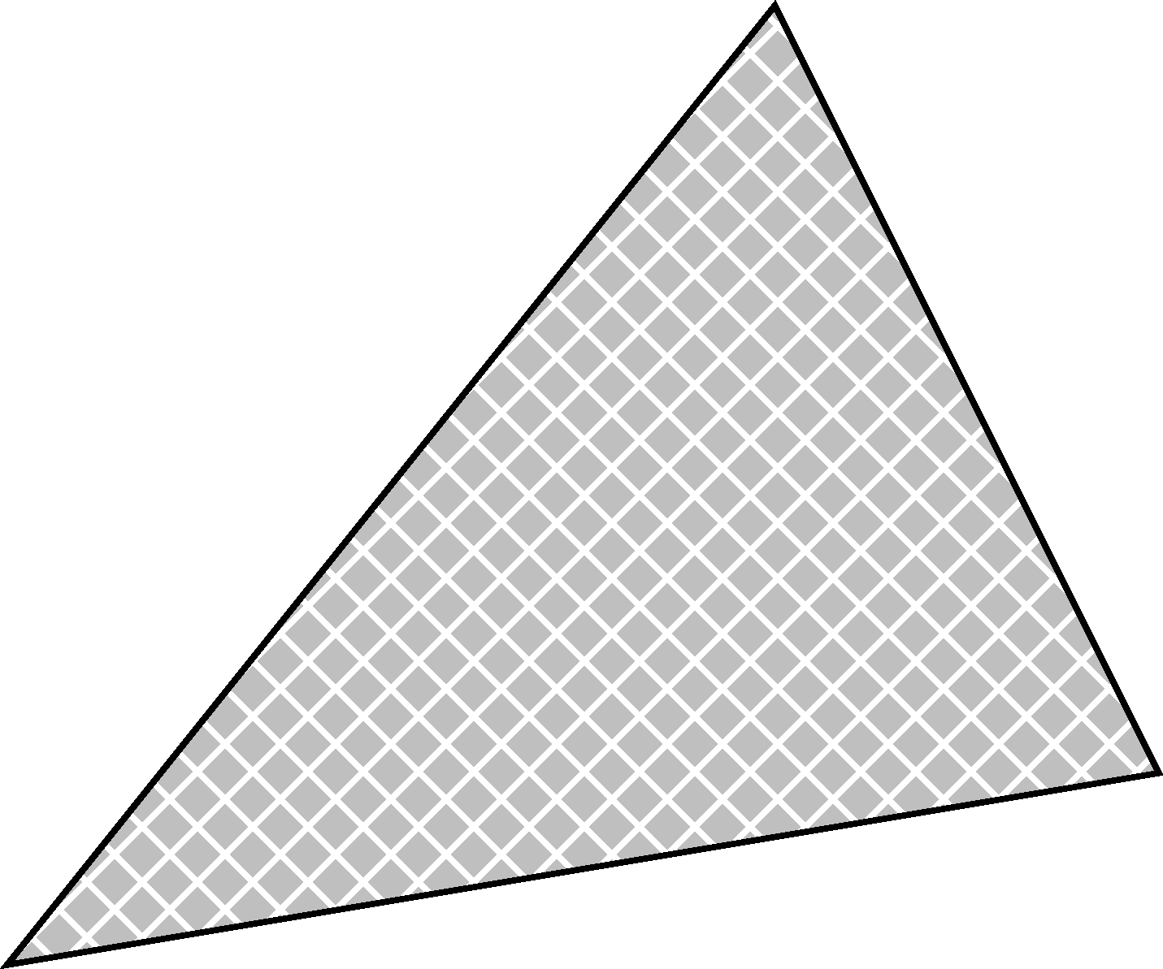
Mr Ho’s House
Land

Figure 1

If ΔABC in Figure 2 represents Mr Ho’s land, construct a circle with maximum area inside ΔABC.

A
B
C

Figure 2
2. Mr Chan, Mr Lee and Mr Cheung have decided to share a field in triangular shape outside their houses (as shown in Figure 3). To be fair to each other, they agreed to divide the field into three parts of equal area. They seek your help to complete the task.

Field
Mr Ho’s House
Mr Chan’s House
Mr Cheung’s House

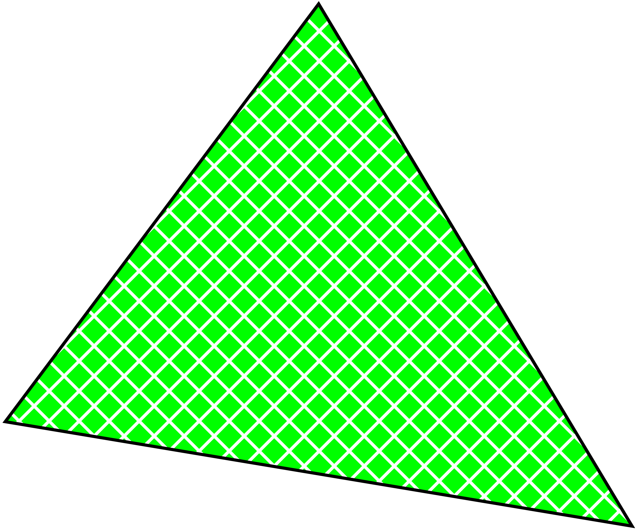

Figure 3

If ΔABC in Figure 4 represents the field, divide ΔABC into three parts of equal area.

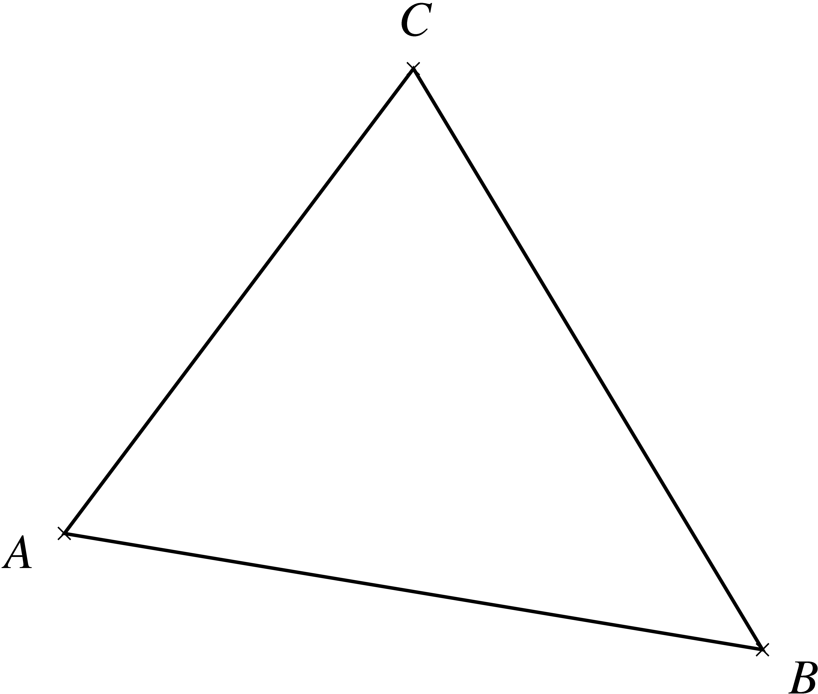

Figure 4

END OF ASSESSMENT TASK

