HONG KONG DIPLOMA OF SECONDARY EDUCATION
EXAMINATION

MATHEMATICS
Compulsory Part

SCHOOL-BASED ASSESSMENT

Sample Assessment Task

Peeling a Pineapple

Instructions

1. This task consists of THREE parts, Part A to Part C. Students are required to attempt ALL parts.

2. Numerical answers should be exact or correct to 3 significant figures.

3. All working must be clearly shown.

Teacher Guidelines

1. This task requires students to

(a) investigate the ways of peeling;

(b) find an economical way of peeling using relevant mathematical skills.

2. It is anticipated that, in general, students can complete the task in 1.5 hours. However, teachers can exercise their professional judgment to adjust the time allowed to cater for the ability level of their students.

3. If necessary, teachers may give a brief description of the task and provide some hints for their students.

4. Feedback should be provided to students after marking the task. For instance, teachers can discuss with students different approaches of handling the task.

Introduction

Have you ever eaten a pineapple? When we buy a pineapple from a supermarket or a stall, we may request the shopkeeper to peel off the pineapple’s skin for us. Do you discover that after a pineapple is peeled off, some spirals are left behind on the surface? Why does the pineapple get peeled in this way?

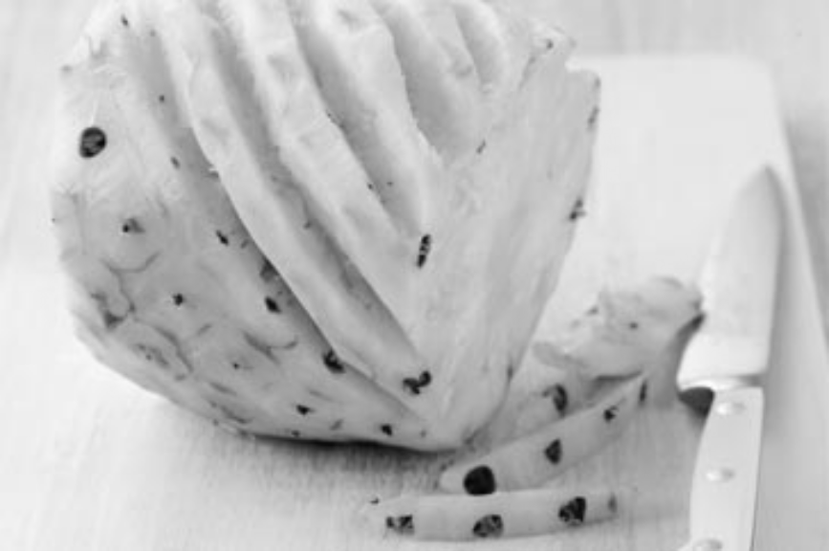
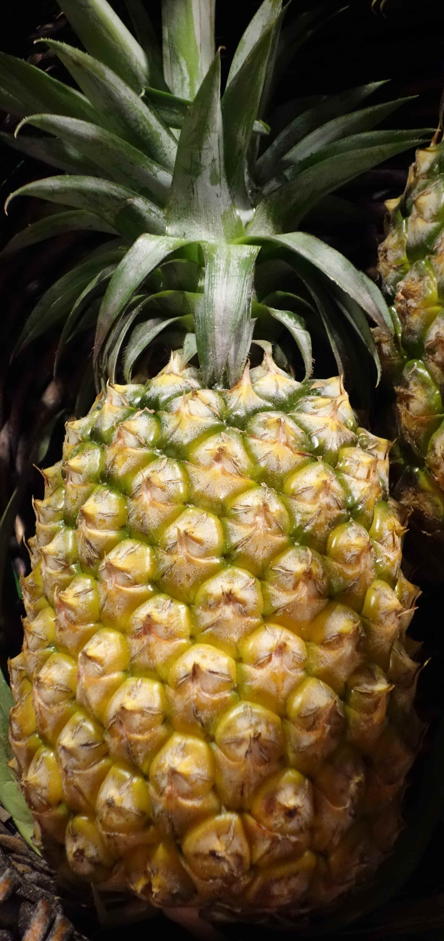

Figure 1 shows a model of a pineapple (which comprises a cylinder with black dots).

Figure 1

Figure 2 shows the flattened curved surface of the model (which is rectangular in shape). Let the distance between any two closest dots be 1 cm .
1 cm
1 cm

Figure 2

For simplicity, in Figures 3 to 7, the dotted lines represent the peeled skin.

Part A

1. If a pineapple is peeled off horizontally along the dotted lines as shown in Figure 3, what is the total length of the skin removed?
1 cm
1 cm

Figure 3

2. If a pineapple is peeled off at 45° to the horizon along the dotted lines as shown in Figure 4, what is the total length of the skin removed?
1 cm
1 cm
45°

Figure 4

3. If the peeling speeds in the situations described in Questions 1 and 2 are the same, which way of peeling is more economical in terms of the time used?

4. Suggest another way of peeling off a pineapple that is more economical than the ways in Questions 1 and 2.

Part B

Figure 5 shows a second model of the flattened curved surface of a pineapple. Under the model, the distance between any two adjacent dots is 1 cm.

1 cm
1 cm
1 cm

Figure 5

1. What is the total length of the skin removed when a pineapple is peeling off horizontally?

2. (a) If a pineapple is peeled off at an angle θ to the horizon along the dotted lines as shown in Figure 6 , what is the magnitude of θ ?

(b) Find the total length of the skin removed by this method.

1 cm
1 cm
1 cm
θ

Figure 6

3. If the peeling speeds in the situations described in Questions 1 and 2 are the same, which way of peeling is more economical in terms of the time used?

4. Is peeling off a pineapple vertically more economical than the ways in Questions 1 and 2?

Part C
1 cm
r cm
1 cm
θ

Figure 7

Figure 7 shows a third model of the flattened curved surface of a pineapple. Under this model, the distance between any 2 adjacent dots at the same horizontal level is r cm, while the distance between a dot and its closest dot at the adjacent level is 1 cm.

1. If the skin of pineapple is peeled off horizontally, what is the total length of the skin removed? Express your answer in terms of r .

2. Given that .

(a) What is the range of θ such that the “horizontal peeling” method is not better than the method of peeling off pineapple skin at the angle θ to the horizon along the dotted line as shown in Figure 7?

(b) Hence, find the minimum length of skin removed by the “horizontal peeling” method.

END OF ASSESSMENT TASK

