HONG KONG DIPLOMA OF SECONDARY EDUCATION
EXAMINATION

MATHEMATICS

Compulsory Part

SCHOOL-BASED ASSESSMENT

Exemplar

How long is your shoelace?

Instruction

1. This task consists of THREE parts, Part A to Part C. Students are required to attempt ALL parts.

2. Numerical answers should be exact, or correct to 3 significant figures.

3. All working must be clearly shown.

Teacher Guidelines

1. This task requires students to

(a) solve simple permutation and combination problems;

(b) calculate the required shoelace length for different lacing methods.

2. It is anticipated that, in general, students can complete the task in 1 hour. However, teachers can exercise their professional judgment to adjust the time allowed to cater for the ability level of their students.

3. If necessary, teachers may give a brief description of the task or request students to collect the relevant information. For example, students may be asked to

(a) observe the number of pairs of eyelets for different shoes;

(b) measure the distances between the neighbouring eyelets (in the same horizontal and vertical directions) of students’ own shoes or other people’s shoes.

Students and teachers may prepare sufficient number of shoes for measuring the lengths between eyelets and that of the shoelace when tying a butterfly knot.

4. Teachers may feel free to modify the questions and the marking guidelines to cater for the ability level of their students.

5. The Appendix shows grids of eyelets. Teachers may ask students to make use of the grids to investigate the lengths of shoelaces for different shoe lacing methods.

6. Feedback should be provided to students after marking the task. For instance, teachers can discuss different approaches of handling each part of the task with students.

Reference:
Ian’s shoelace site: http://www.fieggen.com/shoelace/

Introduction

Usually a shoe consists of 2 – 10 pairs of eyelets for feeding shoelace, and there are various ways of shoe lacing.

Figure 1 shows different shoelacing methods for a shoe with 6 pairs of eyelets. The region around the bottom of the figure is near to our toes, while the one around the top is the place where a butterfly knot is tied.

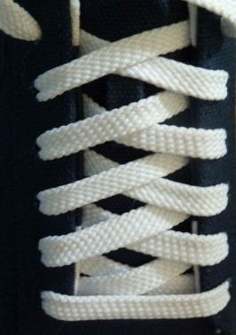 | 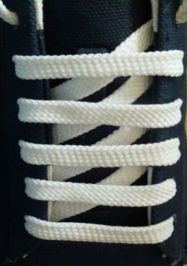 | 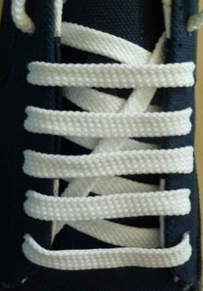
Criss-cross Lacing | Straight Lacing | Diagonal Straight Lacing

Figure 1

Part A

There is a shoe with 3 pairs of eyelets (as shown in Figure 2). The shoelace can only feed into each eyelet once and all eyelets should be fed.

Top pair of eyelets

Figure 2

1. Show two different lacing methods such that both ends of the shoelace should be fed into the top pair of eyelets.

2. Find the number of feeding methods for the following cases:

(a) Both ends of the shoelace must be fed into the top pair of eyelets.

(b) The shoelace can be fed arbitrarily, which means that both ends of the shoelace need not be fed into the top pair of eyelets.

Part B

Let w be the distance between the eyelet on the left hand side and the corresponding eyelet on the right, d be the distance between two consecutive eyelets on the same side, and l be the length of the section at each end of the shoelace for tying a butterfly knot, where d < w < l (refer to Figure 3).

w
Top pair of eyelets

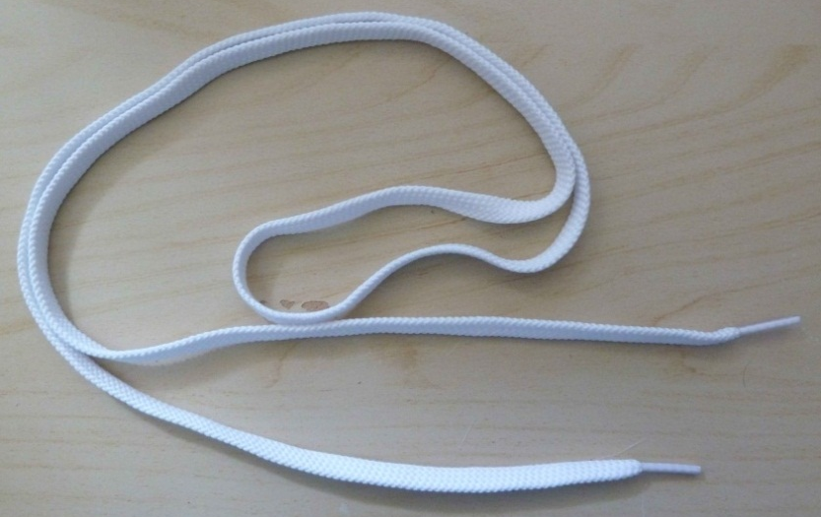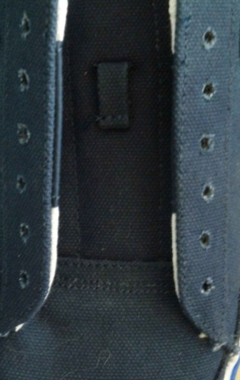
d
l

Figure 3

1. Express the shoelace length for each type of lacing in Figure 1 in terms of d , w and l .

2. Let w = 5 cm , d = 1 cm and l = 3 cm . Among the 3 types of lacing methods, which one requires the longest shoelace?

Part C

There is a shoe with 6 pairs of eyelets (as shown in Figure 3). If the shoelace can only fed into each eyelet once, all eyelets should be fed and both ends of the shoelace must be fed into the top pair of eyelets, then

1. propose one lacing method (other than the 3 methods given in the “Introduction”);

2. if the shoelace length for the lacing method given in Part C Question 1 is D, express D in terms of d , w and l (refer to Part B for the meaning of d , w and l .)

END OF ASSESSMENT TASK
Appendix

Teachers may ask students to make use of the grids below to investigate the lengths of shoelaces for different shoe lacing methods.

Appendix

