HONG KONG DIPLOMA OF SECONDARY EDUCATION
EXAMINATION

MATHEMATICS
Compulsory Part

SCHOOL-BASED ASSESSMENT

Sample Assessment Task

Transformations
Marking Guidelines

The assessment scale for tasks on Mathematical Investigation is shown in the following table.

Level of Performance | Marks | Mathematical Knowledge and Investigation Skills | Marks | Mathematical Communication Skills
Very good | 13–16 | The student demonstrates a complete understanding of the underlying mathematical knowledge and investigation skills which are relevant to the task, and is consistently competent and accurate in applying them in handling the task. Typically, the student recognises patterns, and states a conjecture which is justified by a correct proof. | 4 | The student communicates ideas in a clear, well organised and logically true manner through coherent written/verbal accounts, using appropriate and correct forms of mathematical presentation to present conjectures and proofs.
Good | 9–12 | The student demonstrates a substantial understanding of the underlying mathematical knowledge and investigation skills which are relevant to the task, and is generally competent and accurate in applying them in handling the task. Typically, the student recognises patterns, draws inductive generalisations to arrive at a conjecture and attempts to provide a proof for the conjecture. | 3 | The student is able to communicate ideas properly through written/verbal accounts, using appropriate and correct forms of mathematical presentation such as algebraic manipulations and geometric deductions.
Fair | 5 – 8 | The student demonstrates a basic understanding of the underlying mathematical knowledge and investigation skills which are relevant to the task, and is occasionally competent and accurate in applying them in handling the task. Typically, the student recognises patterns and attempts to draw inductive generalisations to arrive at a conjecture. | 2 | The student is able to communicate ideas with some appropriate forms of mathematical presentation such as algebraic formulae and geometric facts.
Weak | 1 – 4 | The student demonstrates a limited understanding of the underlying mathematical knowledge and investigation skills which are relevant to the task, and is rarely competent and accurate in applying them in handling the task. Typically, the student manages to recognise simple patterns and organises results in a way that helps pattern identifications. | 1 | The student attempts to communicate ideas using mathematical symbols and notations, diagrams, tables, calculations etc.

- The full mark of a SBA task on Mathematical Investigation submitted should be scaled to 20 marks, of which 16 marks are awarded for the mathematical knowledge and investigation skills while 4 marks are awarded for the communication skills.

- Teachers should base on the above assessment scale to design SBA tasks for assessing students with different abilities and to develop the marking guidelines.
Part A
Evidence:
The answers
Weak:Try to find the locations of the images, but all answers are incorrect
Fair:Try to find the locations of the images, but only 1 answer is correct

Good:Try to find the locations of the images, and 2 answers are correct
Very good:All answers are correct

- (a)
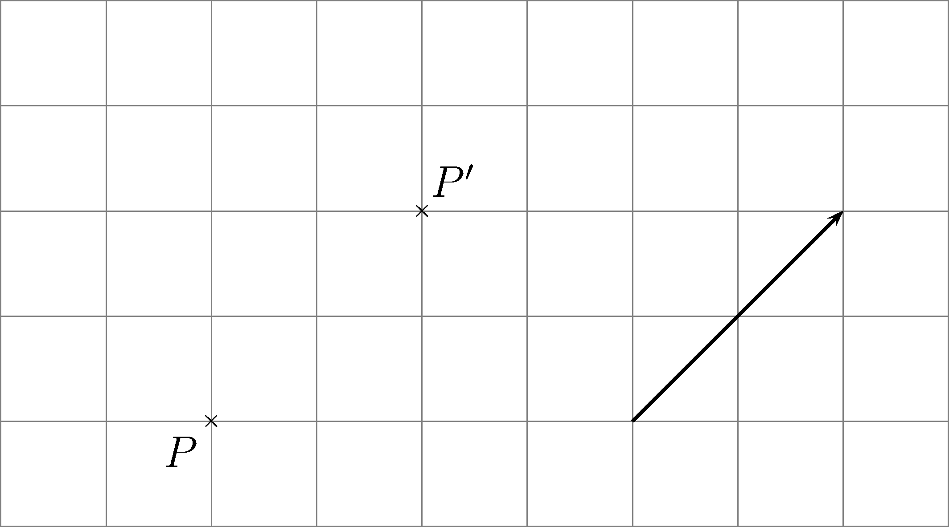
Figure 1

(b) (i)
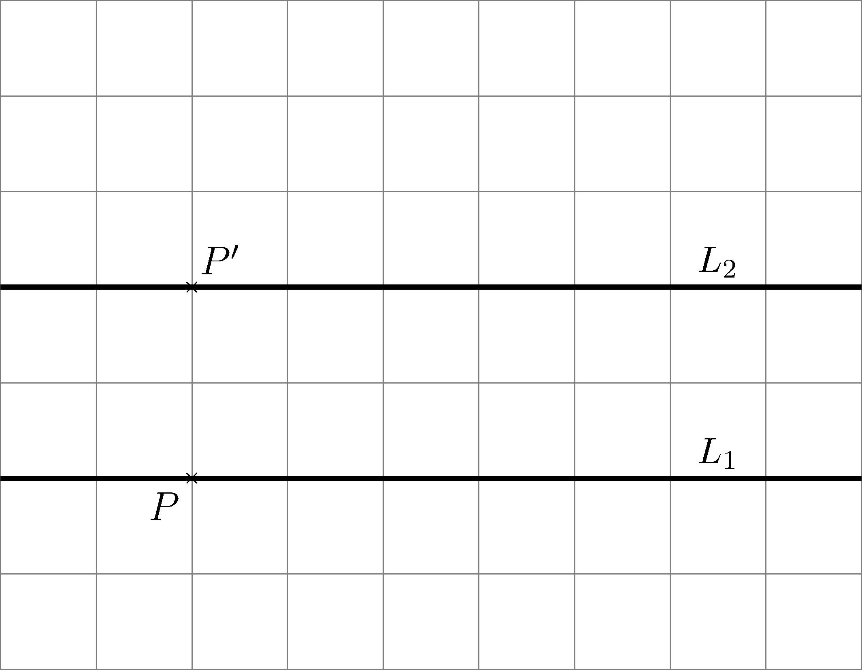
Figure 2

(ii)
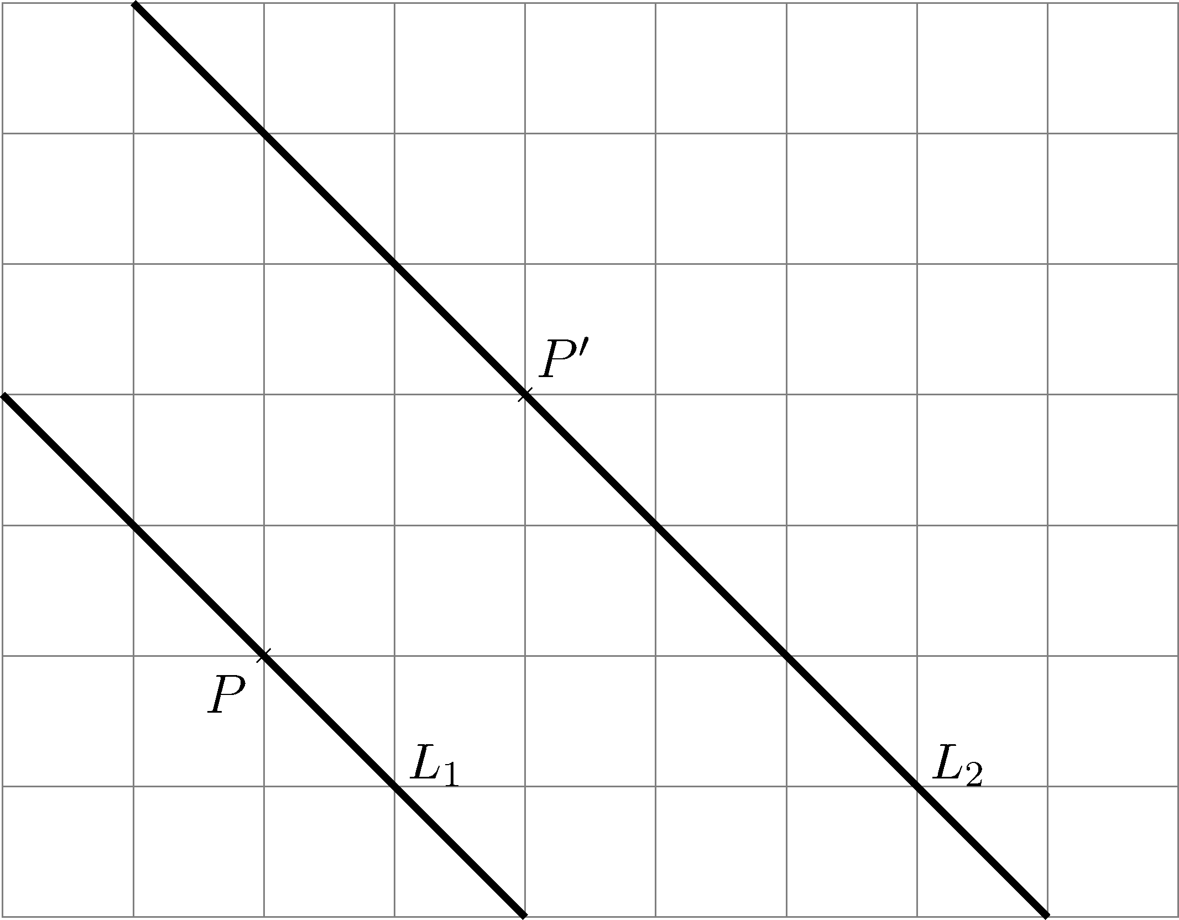
Figure 3

- (a)
Evidence:
The answers
Weak:Try to find the locations of the images, but all answers are incorrect
Fair:Try to find the locations of the images, but only 1 answer is correct

Good:Try to find the locations of the images, and 2 answers are correct
Very good:All answers are correct

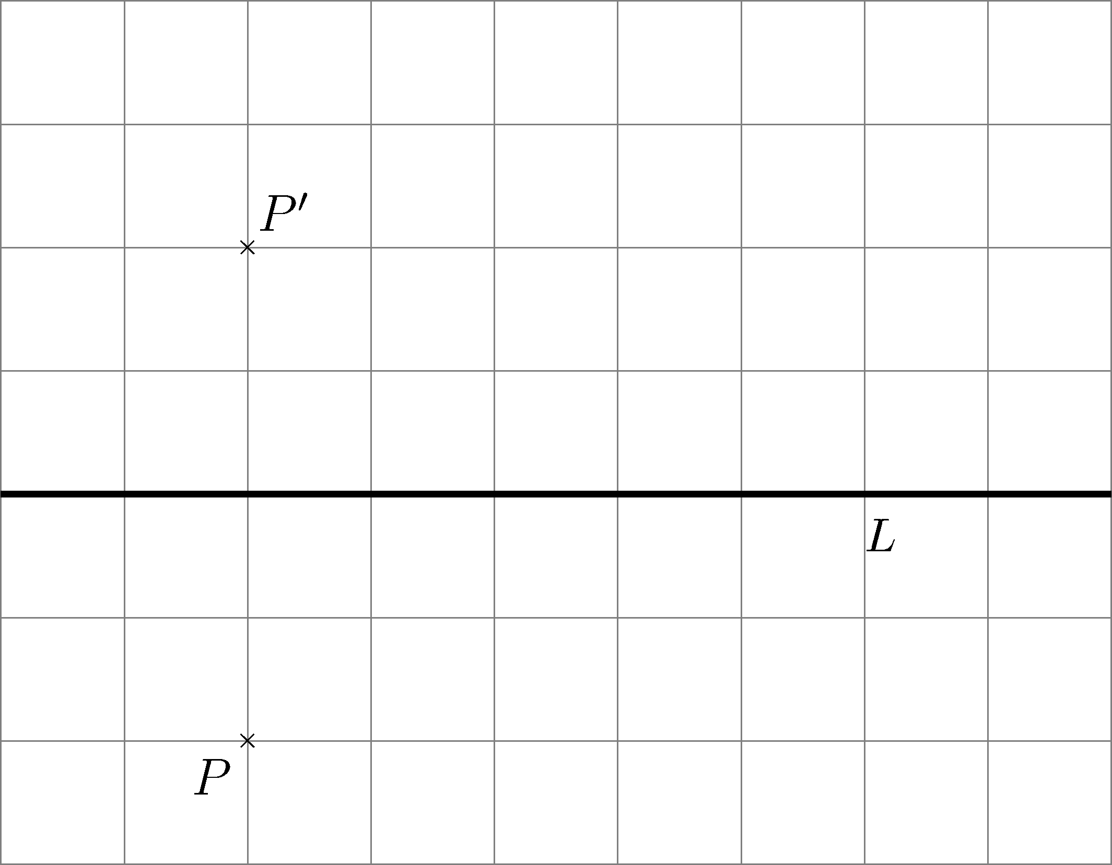
Figure 4

(b)
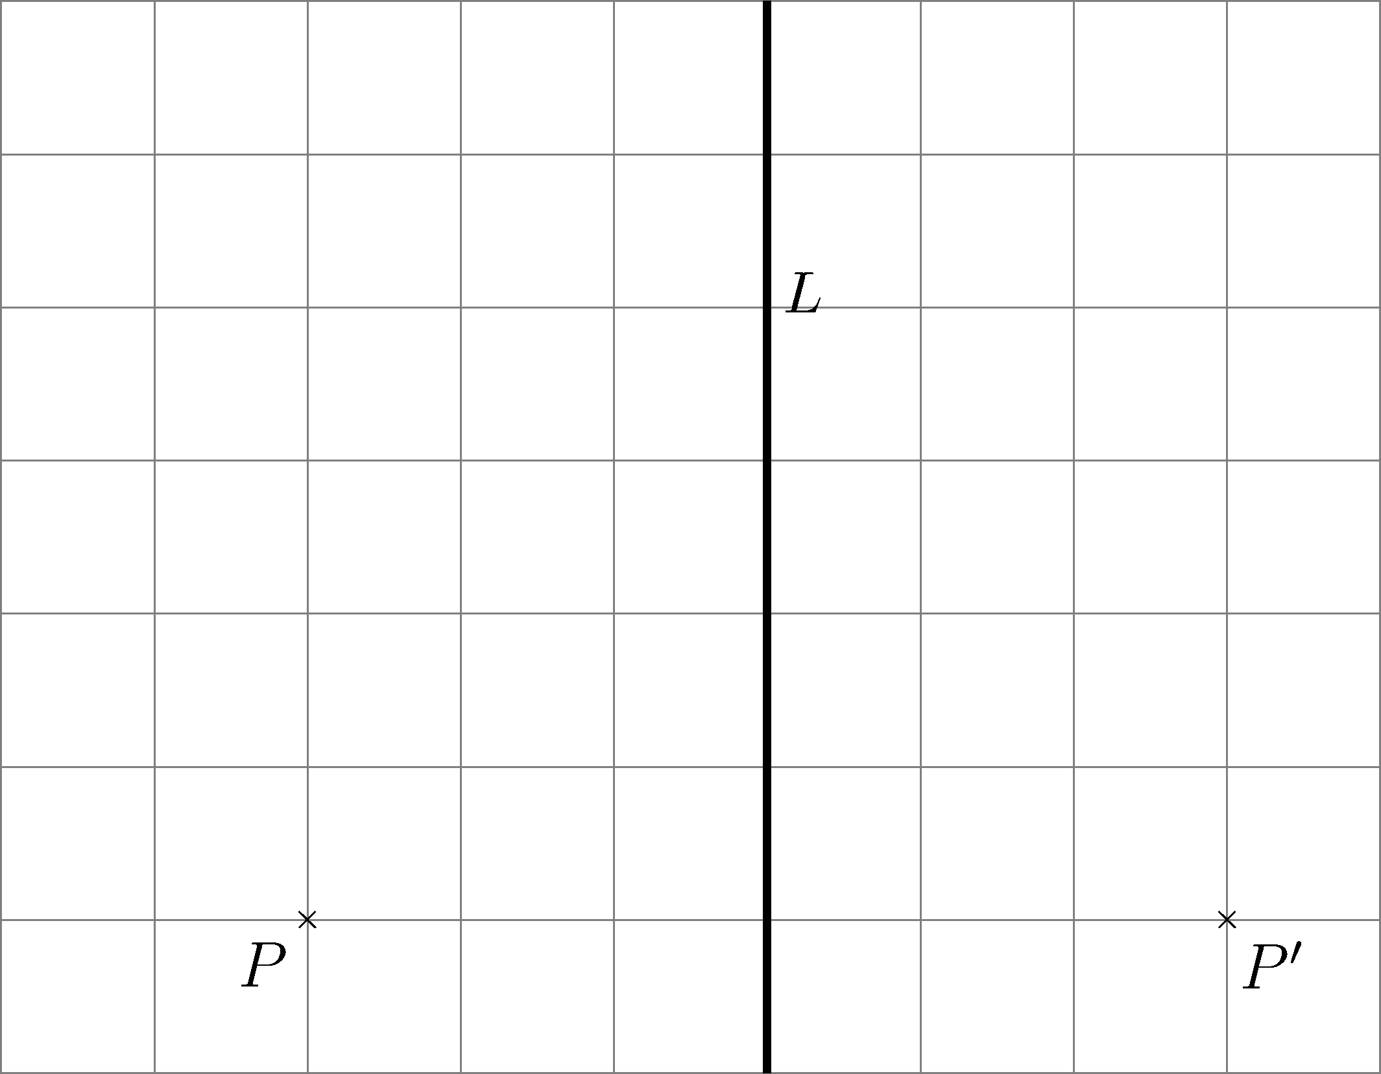
Figure 5

(c)
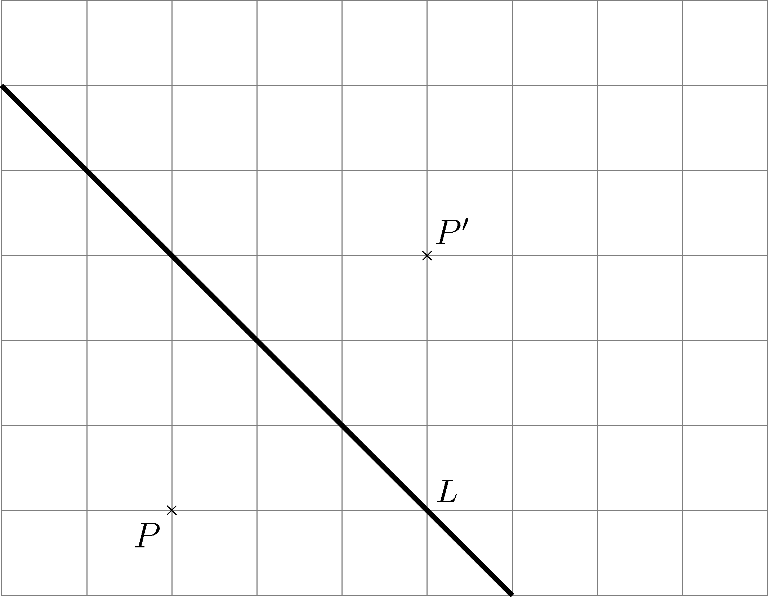
Figure 6

- (a) (b)
Evidence:
The answers
Weak:Try to find the location of P′, but the answer is incorrect
Fair:The location of P′ is correct, but the location of P’’ is not indicated

Good:The location of P′ is correct. Try to find the location of P′′, but the answer is incorrect
Very good:All answers are correct

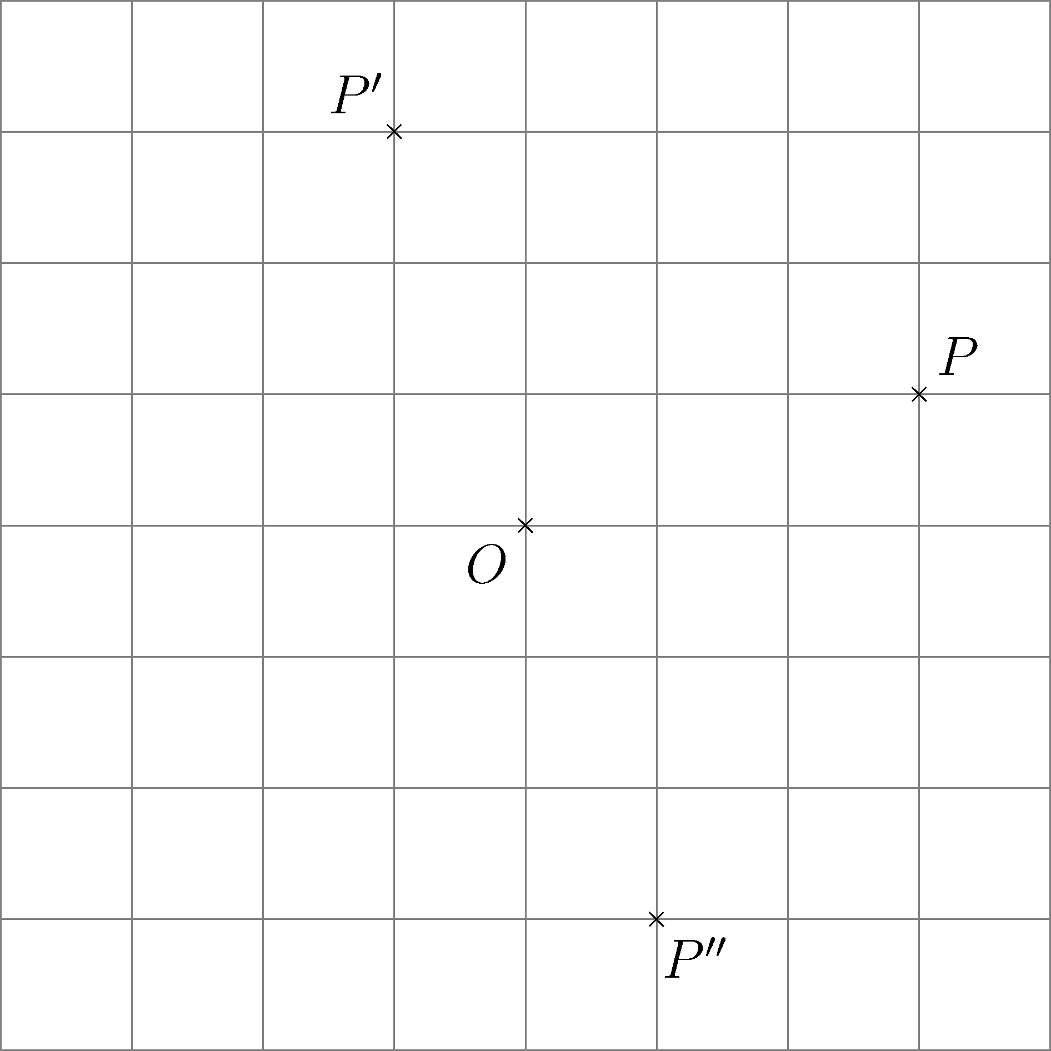
Figure 7

Part B
Evidence:
1.The description on how to find the location of the bridge
2.The working procedures
3.The location of the bridge
Weak:The description is irrelevant
Fair:The description is related to translation
Good:The description is correct but the working procedures are not clearly shown
Very good:The description and the location of bridge are correct. The working procedures are also clearly shown

1.
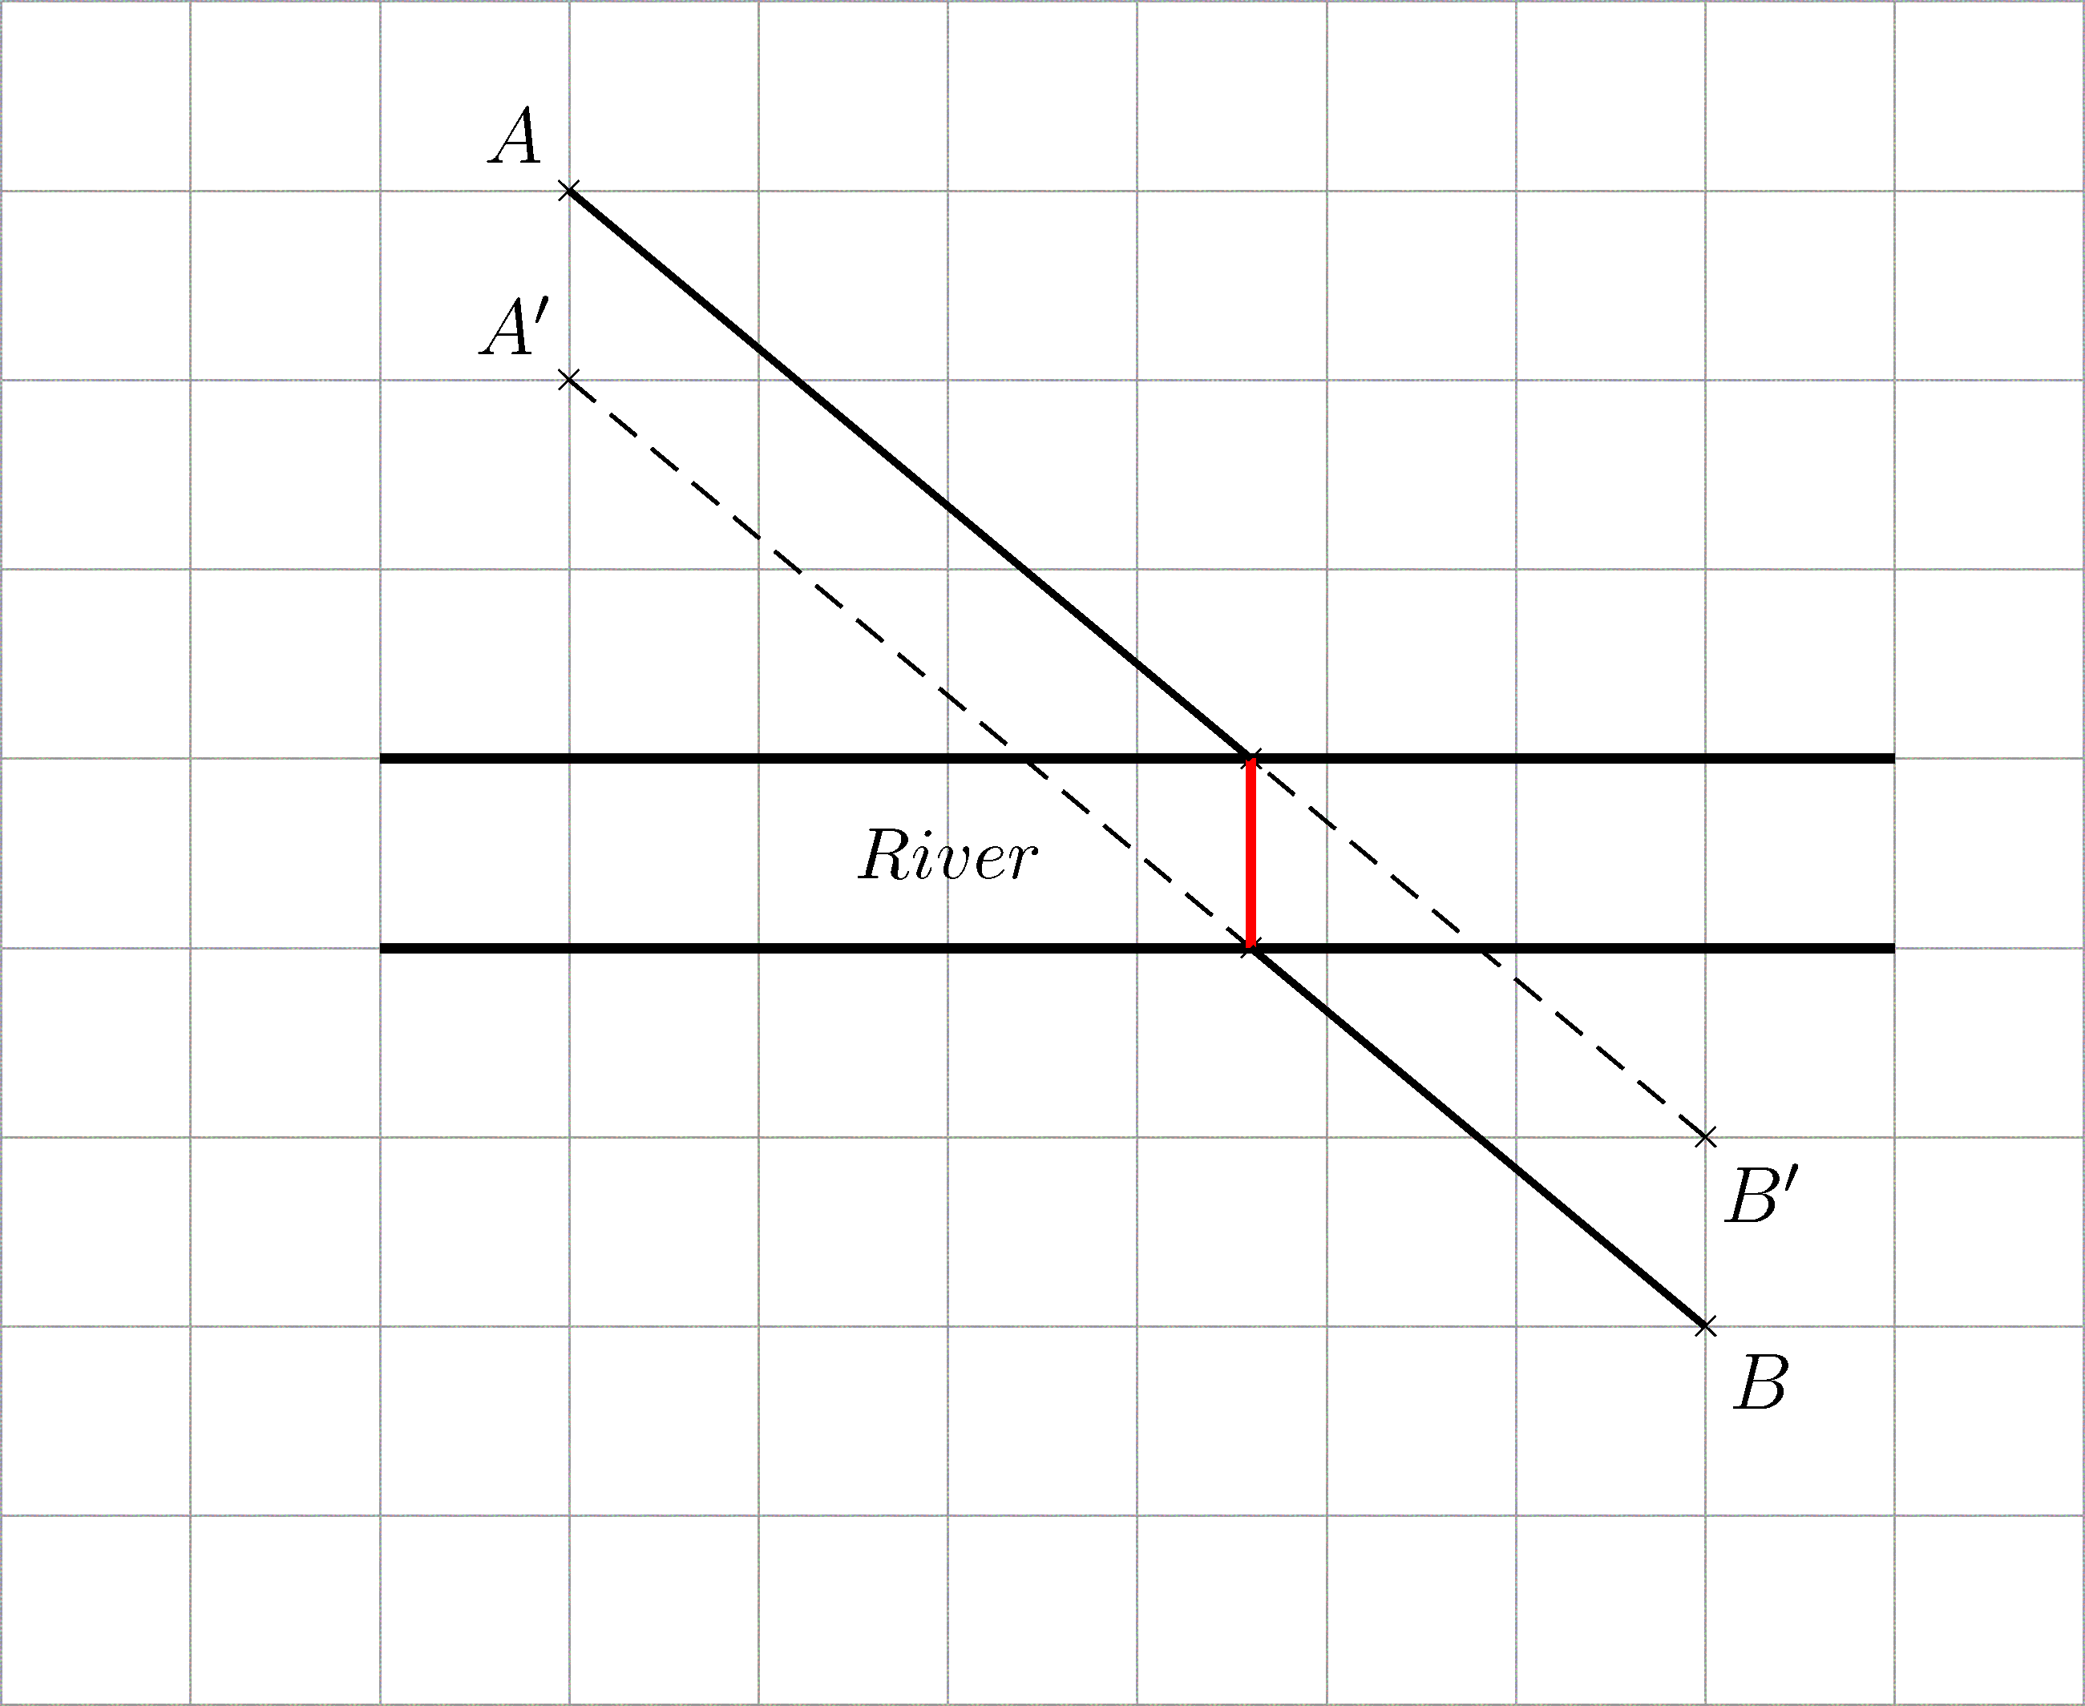
Figure 9

Translate point A 1 unit downwards and obtain A′.
Translate point B 1 unit upwards and obtain B′.
Join AB′ and A′B. The location of the bridge is obtained by joining the points of intersection of the two lines with the sides of the river (as shown in Figure 9 above).

2.
Evidence:
1.The description on how to locate of the power station
2.The working procedure
3.The location of power station
Weak:The description is irrelevant
Fair:The description is related to reflection
Good:The description is correct but the working procedure is not clearly shown
Very good:The description and the location of bridge are correct. The working procedure is also clearly shown
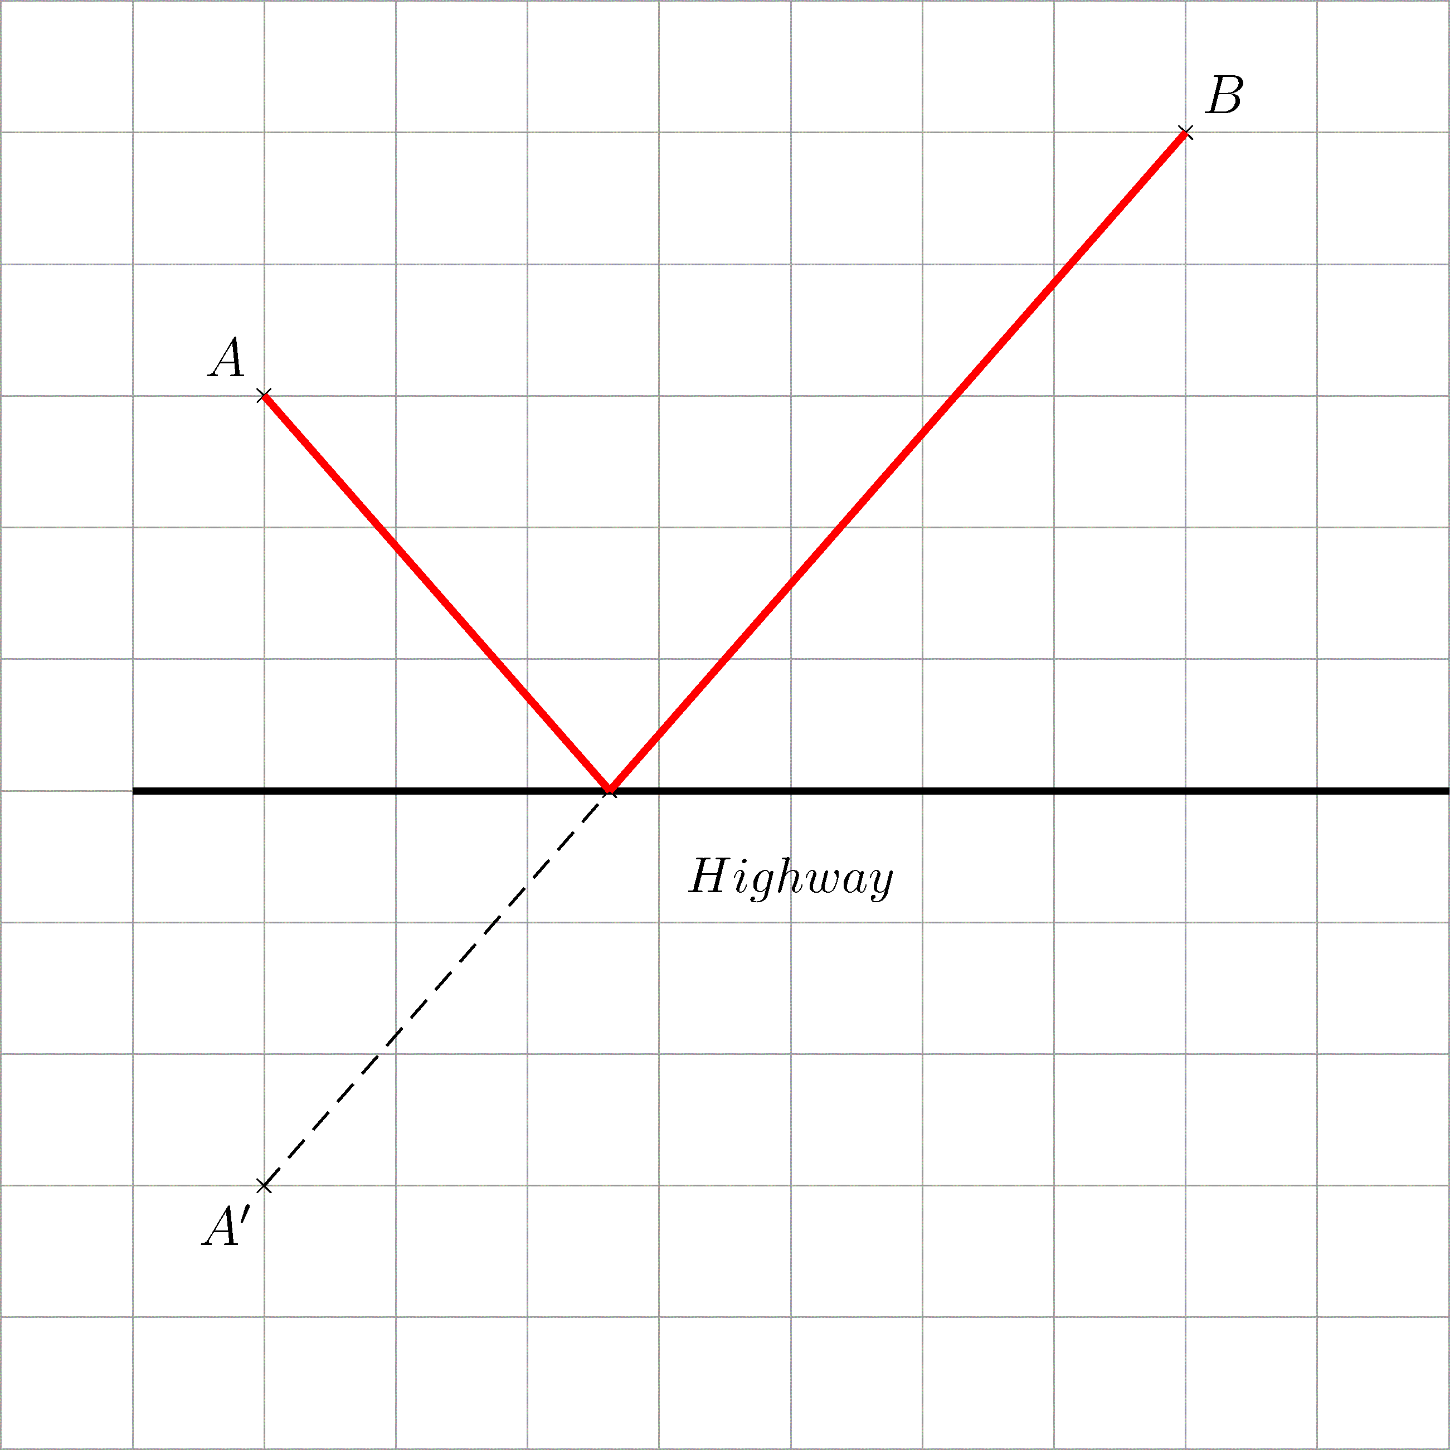
Figure 11

Reflect A along the highway to obtain the image A’ . Join A’B . The location of the
power station is at the intersection between the highway and A’B .

Part C
Evidence:
1.The answers
2.The explanation
Weak:Only the answer for Part (i) or Part (ii) is correct
Fair:Only the answers for Parts (i) and (ii) are correct
Good:Both the answers for Parts (i) and (ii) are correct. Only the answer for Part (iii) or Part (iv) is correct and clear explanation is also given to that part

Very good:All answers are correct and clear explanation is given

1. (a) (i)
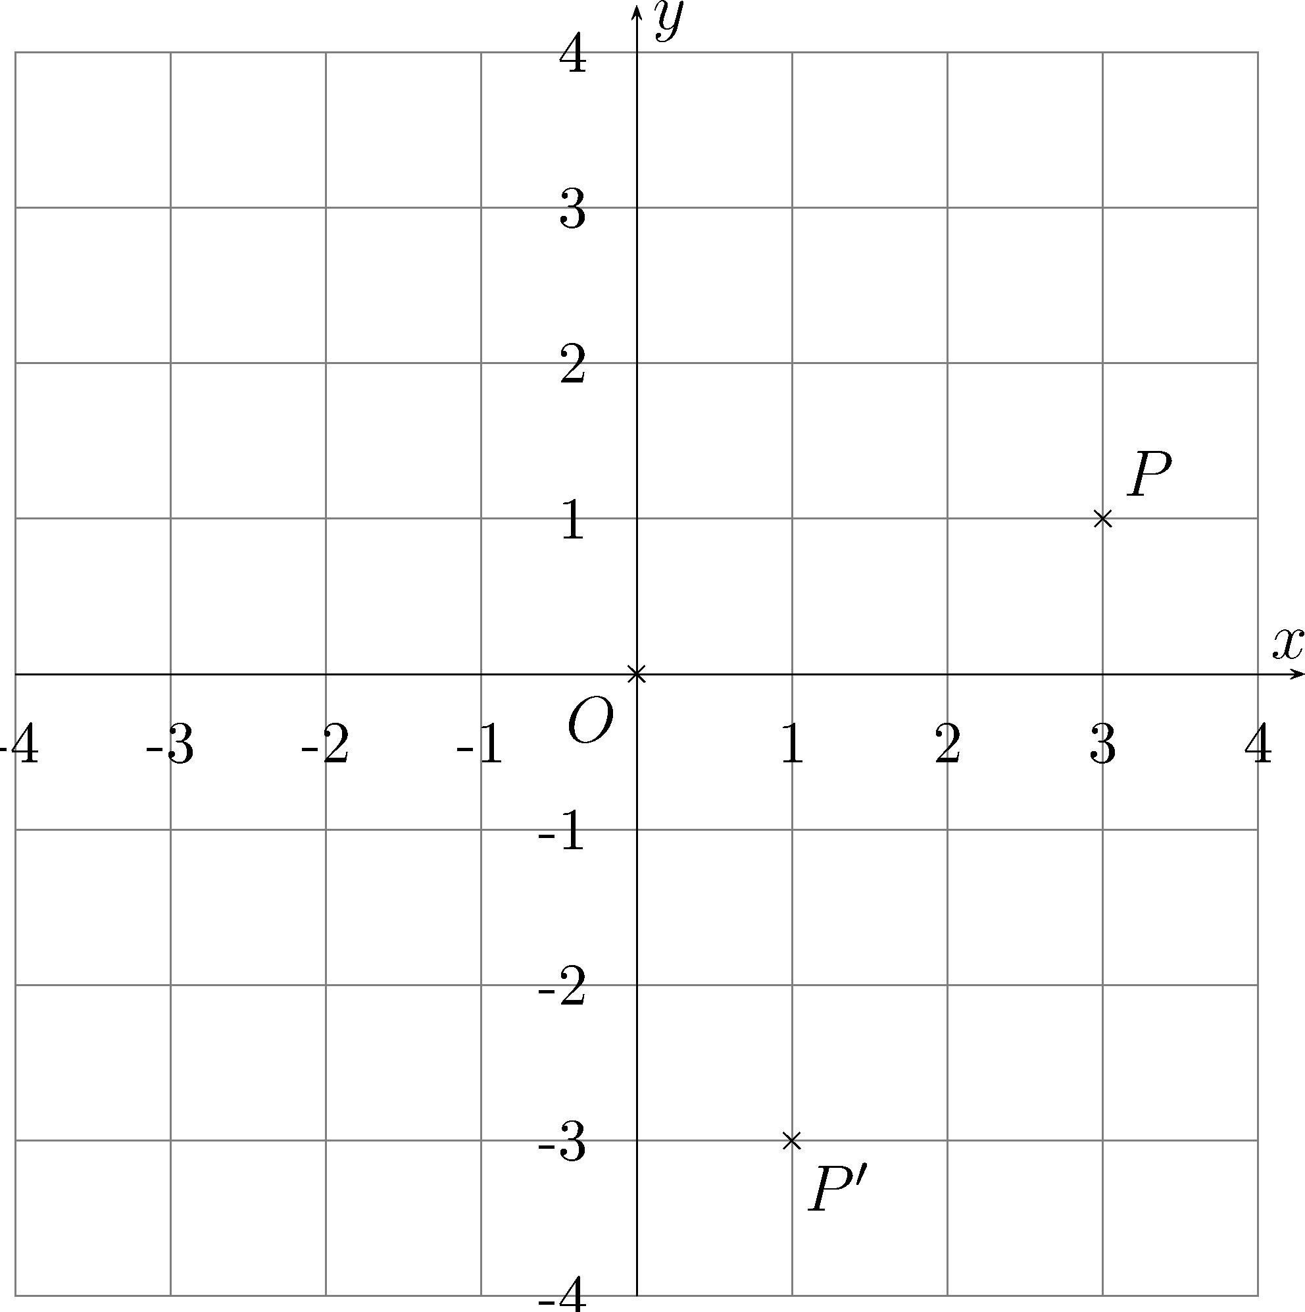
Figure 12

The image P’ is (1, -3).

(ii)
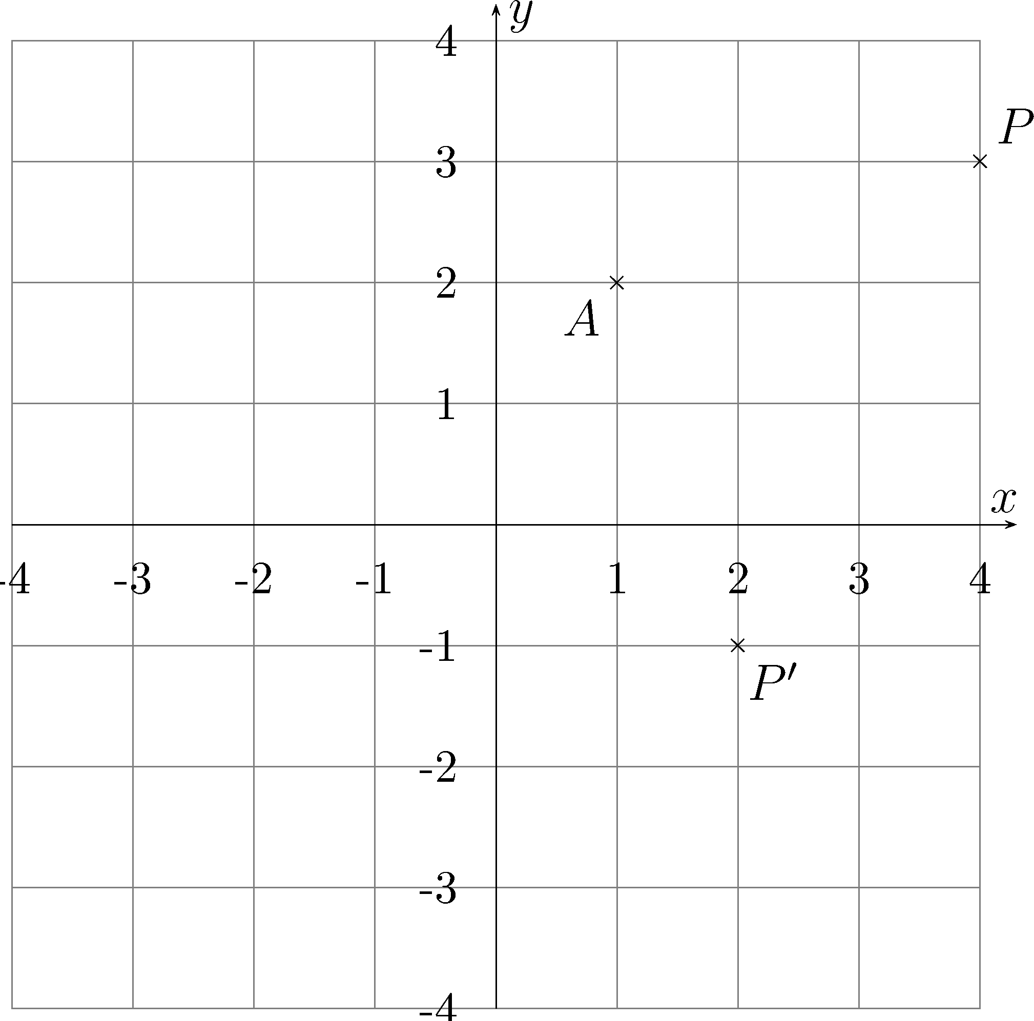
Figure 13

The image P’ is (2, -1).

(iii) First, translate P to the left by a units and downwards by b units, and obtain (x₀ – a, y₀ – b). Then rotate about the origin O by 90° in a clockwise direction, and obtain (y₀ – b, a – x₀). Finally, translate to the right by a units and upwards by b units, and obtain P′(y₀ – b + a, a – x₀ + b).

(iv) First, translate P to the left by a units and downwards by b units, and obtain (x₀ – a, y₀ – b). Then rotate about the origin O by 90° in an anti-clockwise direction, and obtain (b – y₀, x₀ – a). Finally, translate to the right by a units and upwards by b units, and obtain P′( b – y₀ + a, x₀ – a + b).

Evidence:
1.The answers
2.The explanation
Weak:Only the coordinates of A_{S} or A_{T} are correct
Fair:Only the coordinates of A_{S} and A_{T} are correct
Good:The coordinates of A_{S}, A_{T} and the location of the treasure are correct. But only some of the equations of lines are correct
Very good:All answers are correct. The pair of perpendicular lines is discovered and the relevant explanation is given
(b) (i) Let A_{S} and A_{T} be the two marked points.
Rotate A about T by 90° in a clockwise direction.
Using the result of (a)(iii), put a = k, b = 0, obtain A_{T} (y₀ + k, k – x₀).
Rotate A about S by 90° in an anti-clockwise direction.
Using the result of (a) (iv), put a = –k, b = 0, obtain A_{S} (–y₀ – k, x₀ + k).

(ii) The treasure is located at the mid-point of A_{S} and A_{T}:
= (0 , k)

(iii) The line AM is
The line SM is
The line TM is
Since slope of SM × slope of TM = −1
Line SM is perpendicular to line TM .

