HONG KONG DIPLOMA OF SECONDARY EDUCATION
EXAMINATION

MATHEMATICS
Compulsory Part

SCHOOL-BASED ASSESSMENT

Sample Assessment Task

Transformations

Instructions

1. This task consists of THREE parts, Part A to Part C. Students are required to attempt ALL parts.

- All working must be clearly shown.

Teacher Guidelines

1. This task requires students to understand and apply transformations in investigation and solving problems.

2. It is anticipated that, in general, students can complete the task in 1.5 hours. However, teachers can exercise their professional judgment to adjust the time allowed to cater for the ability level of their students.

3. Teachers may feel free to modify the questions and the marking guidelines to cater for the ability level of their students.

4. Feedback should be provided to students after marking the task. For instance, teachers can discuss different approaches of handling each part of the task with students.

Reference:
蕭文強(1993).《1,2,3,...以外─ 數學奇趣錄》. 三聯書局(香港), 178-179.

Part A

1. (a) In Figure 1, translate point P according to the direction and magnitude indicated by the arrow. Mark the image P′ obtained after translation in the figure.
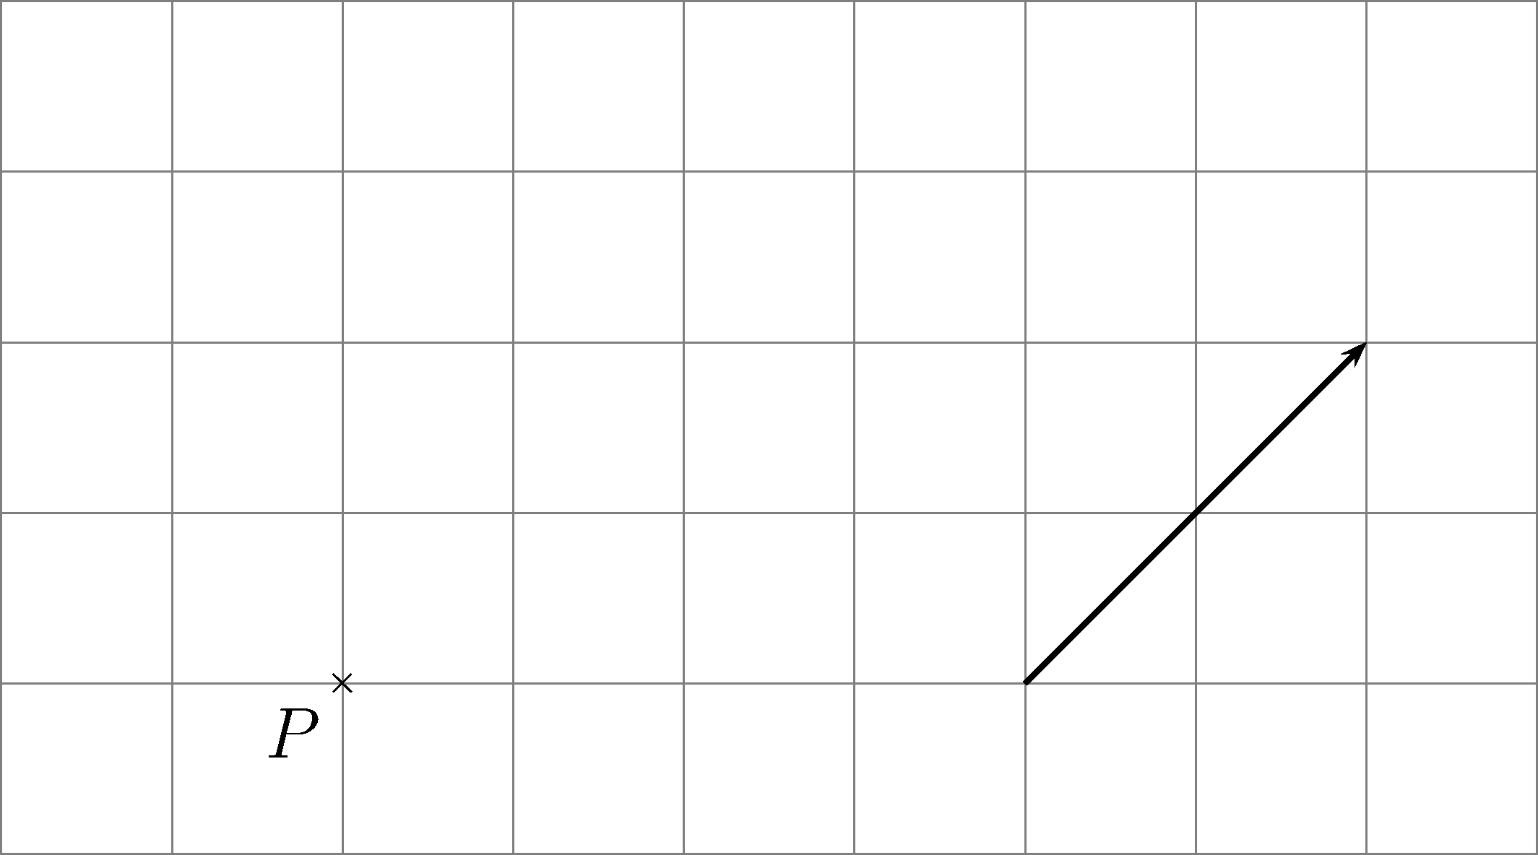
Figure 1

(b) In Figures 2 and 3, L₁ is parallel to L₂. P is a point on L₁. Translate point P to the line L₂ in the direction perpendicular to L_{1.} Mark the image P′ obtained after translation in each figure.
(i)
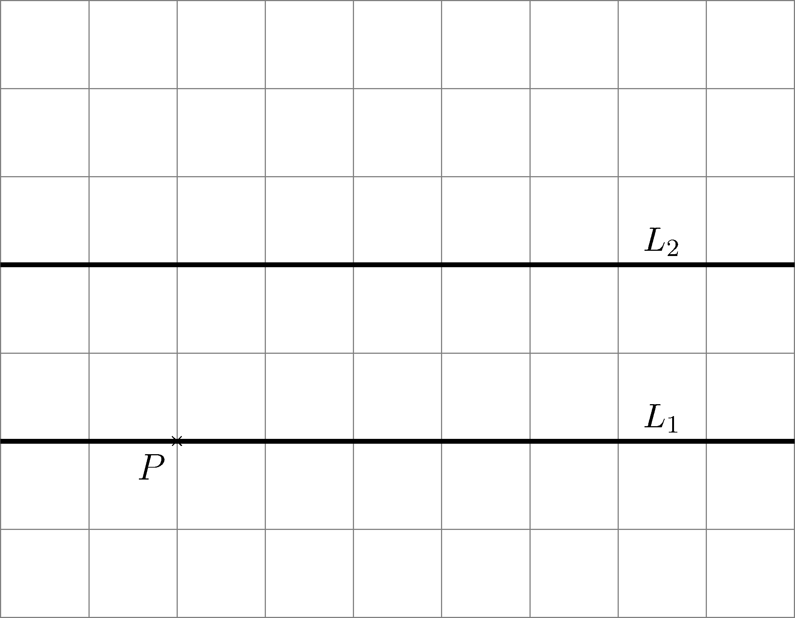
Figure 2

(ii)
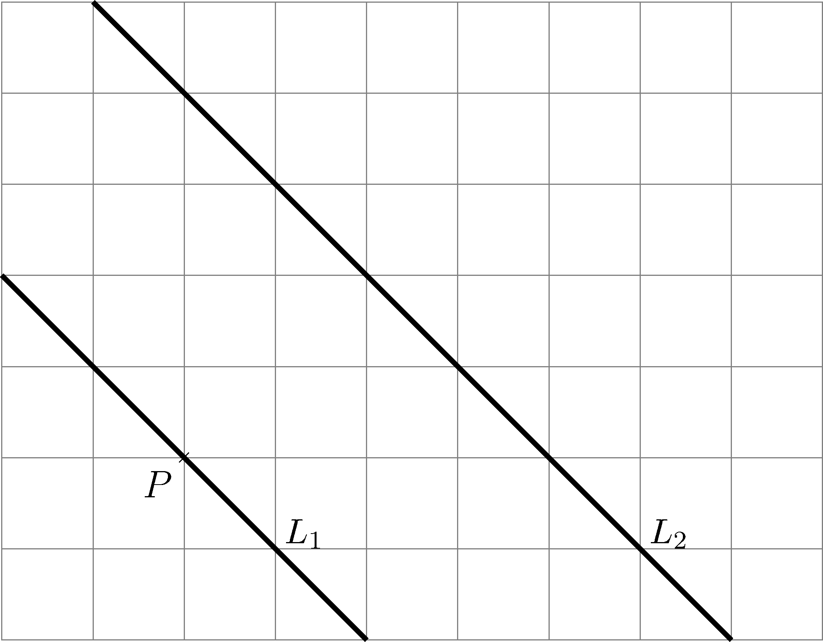
Figure 3
2. In Figures 4 – 6, reflect point P along straight line L. Mark the image P′ obtained after reflection in each figure.
(a)
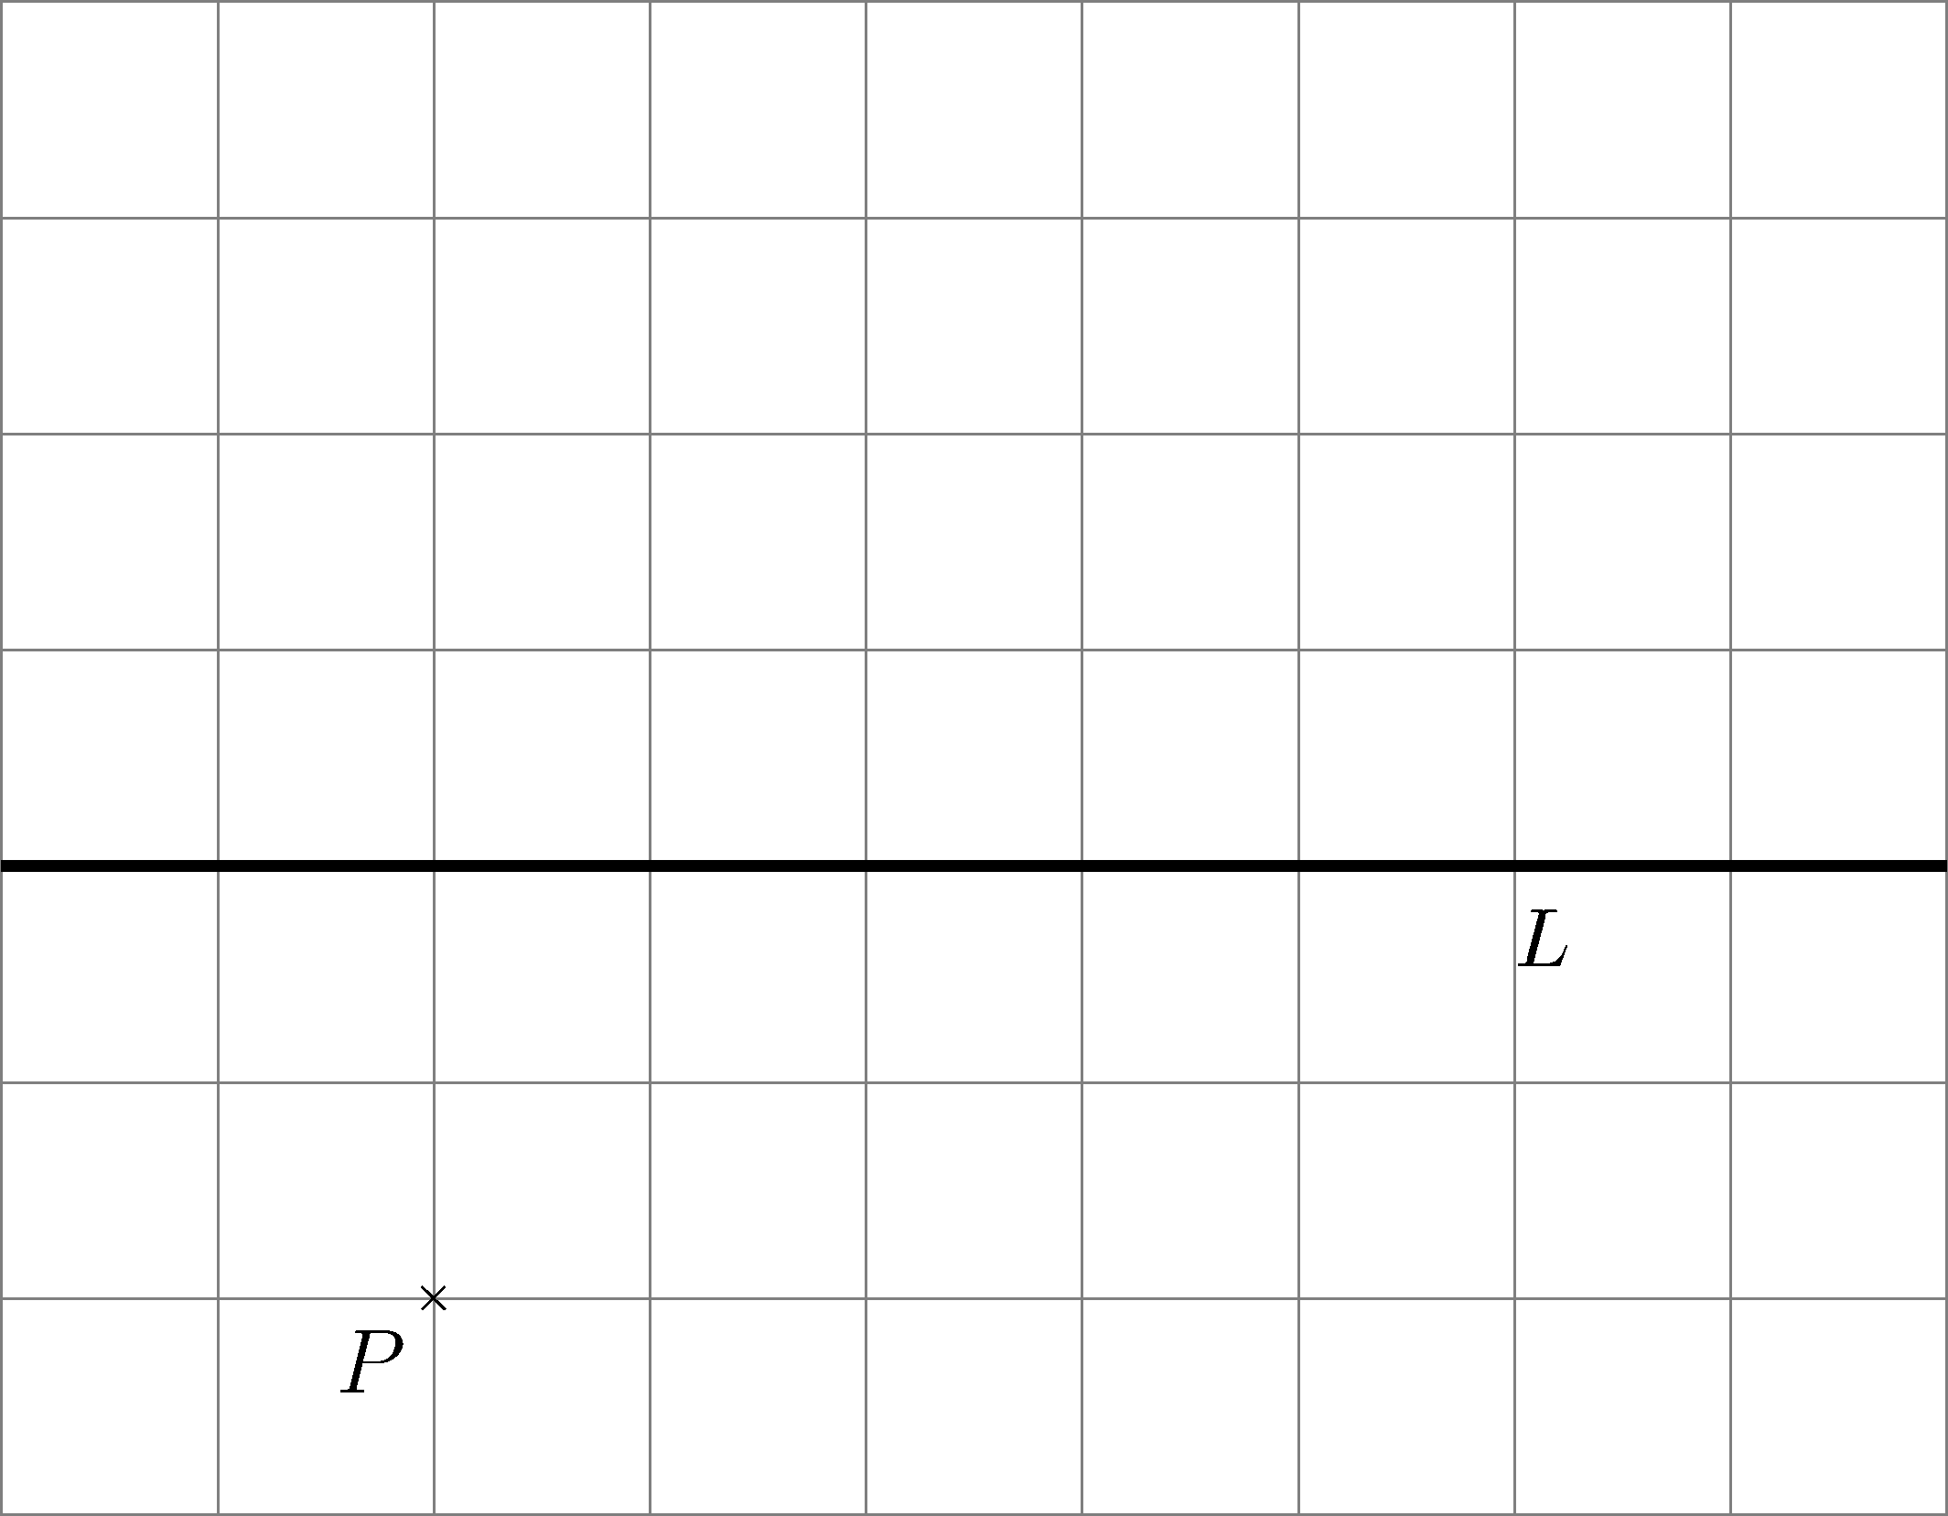
Figure 4
(b)
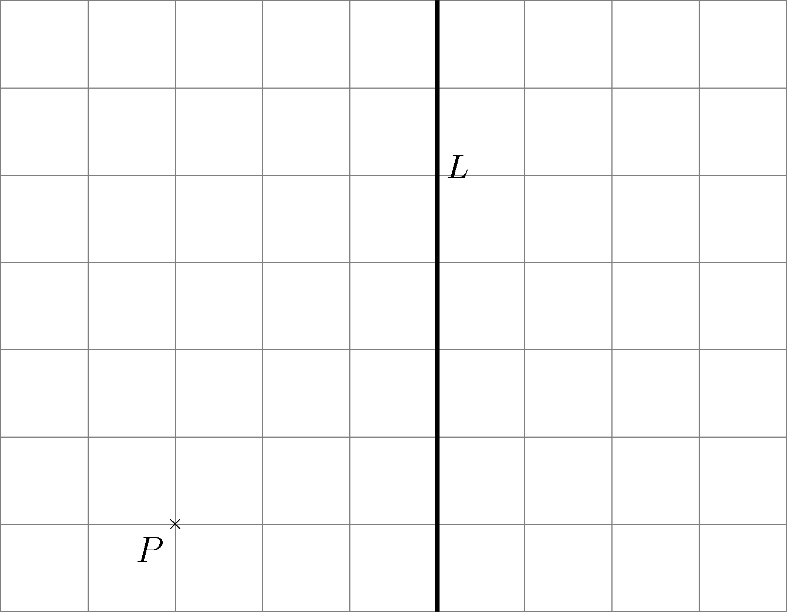
Figure 5
(c)
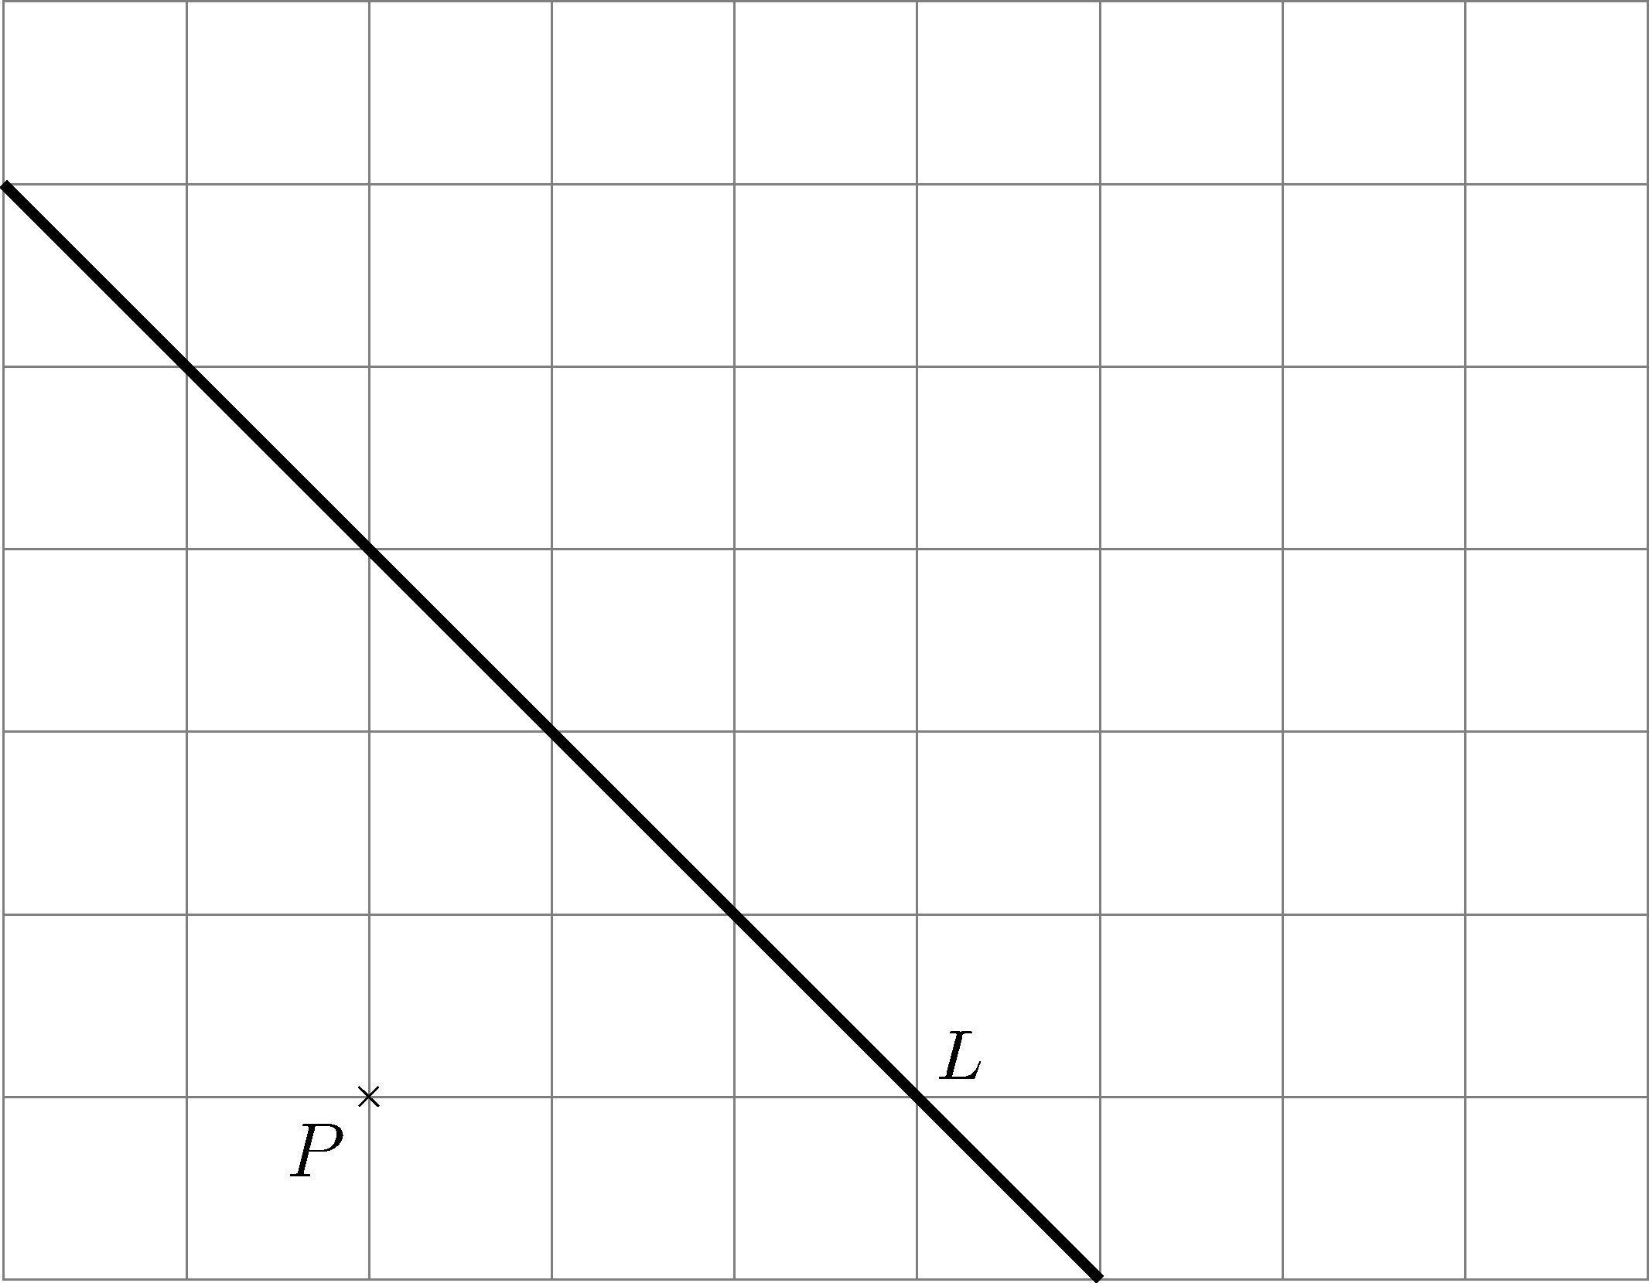
Figure 6

3. (a) In Figure 7, rotate point P about O by 90° in a clockwise direction. Mark the image P′ obtained after rotation in the figure.
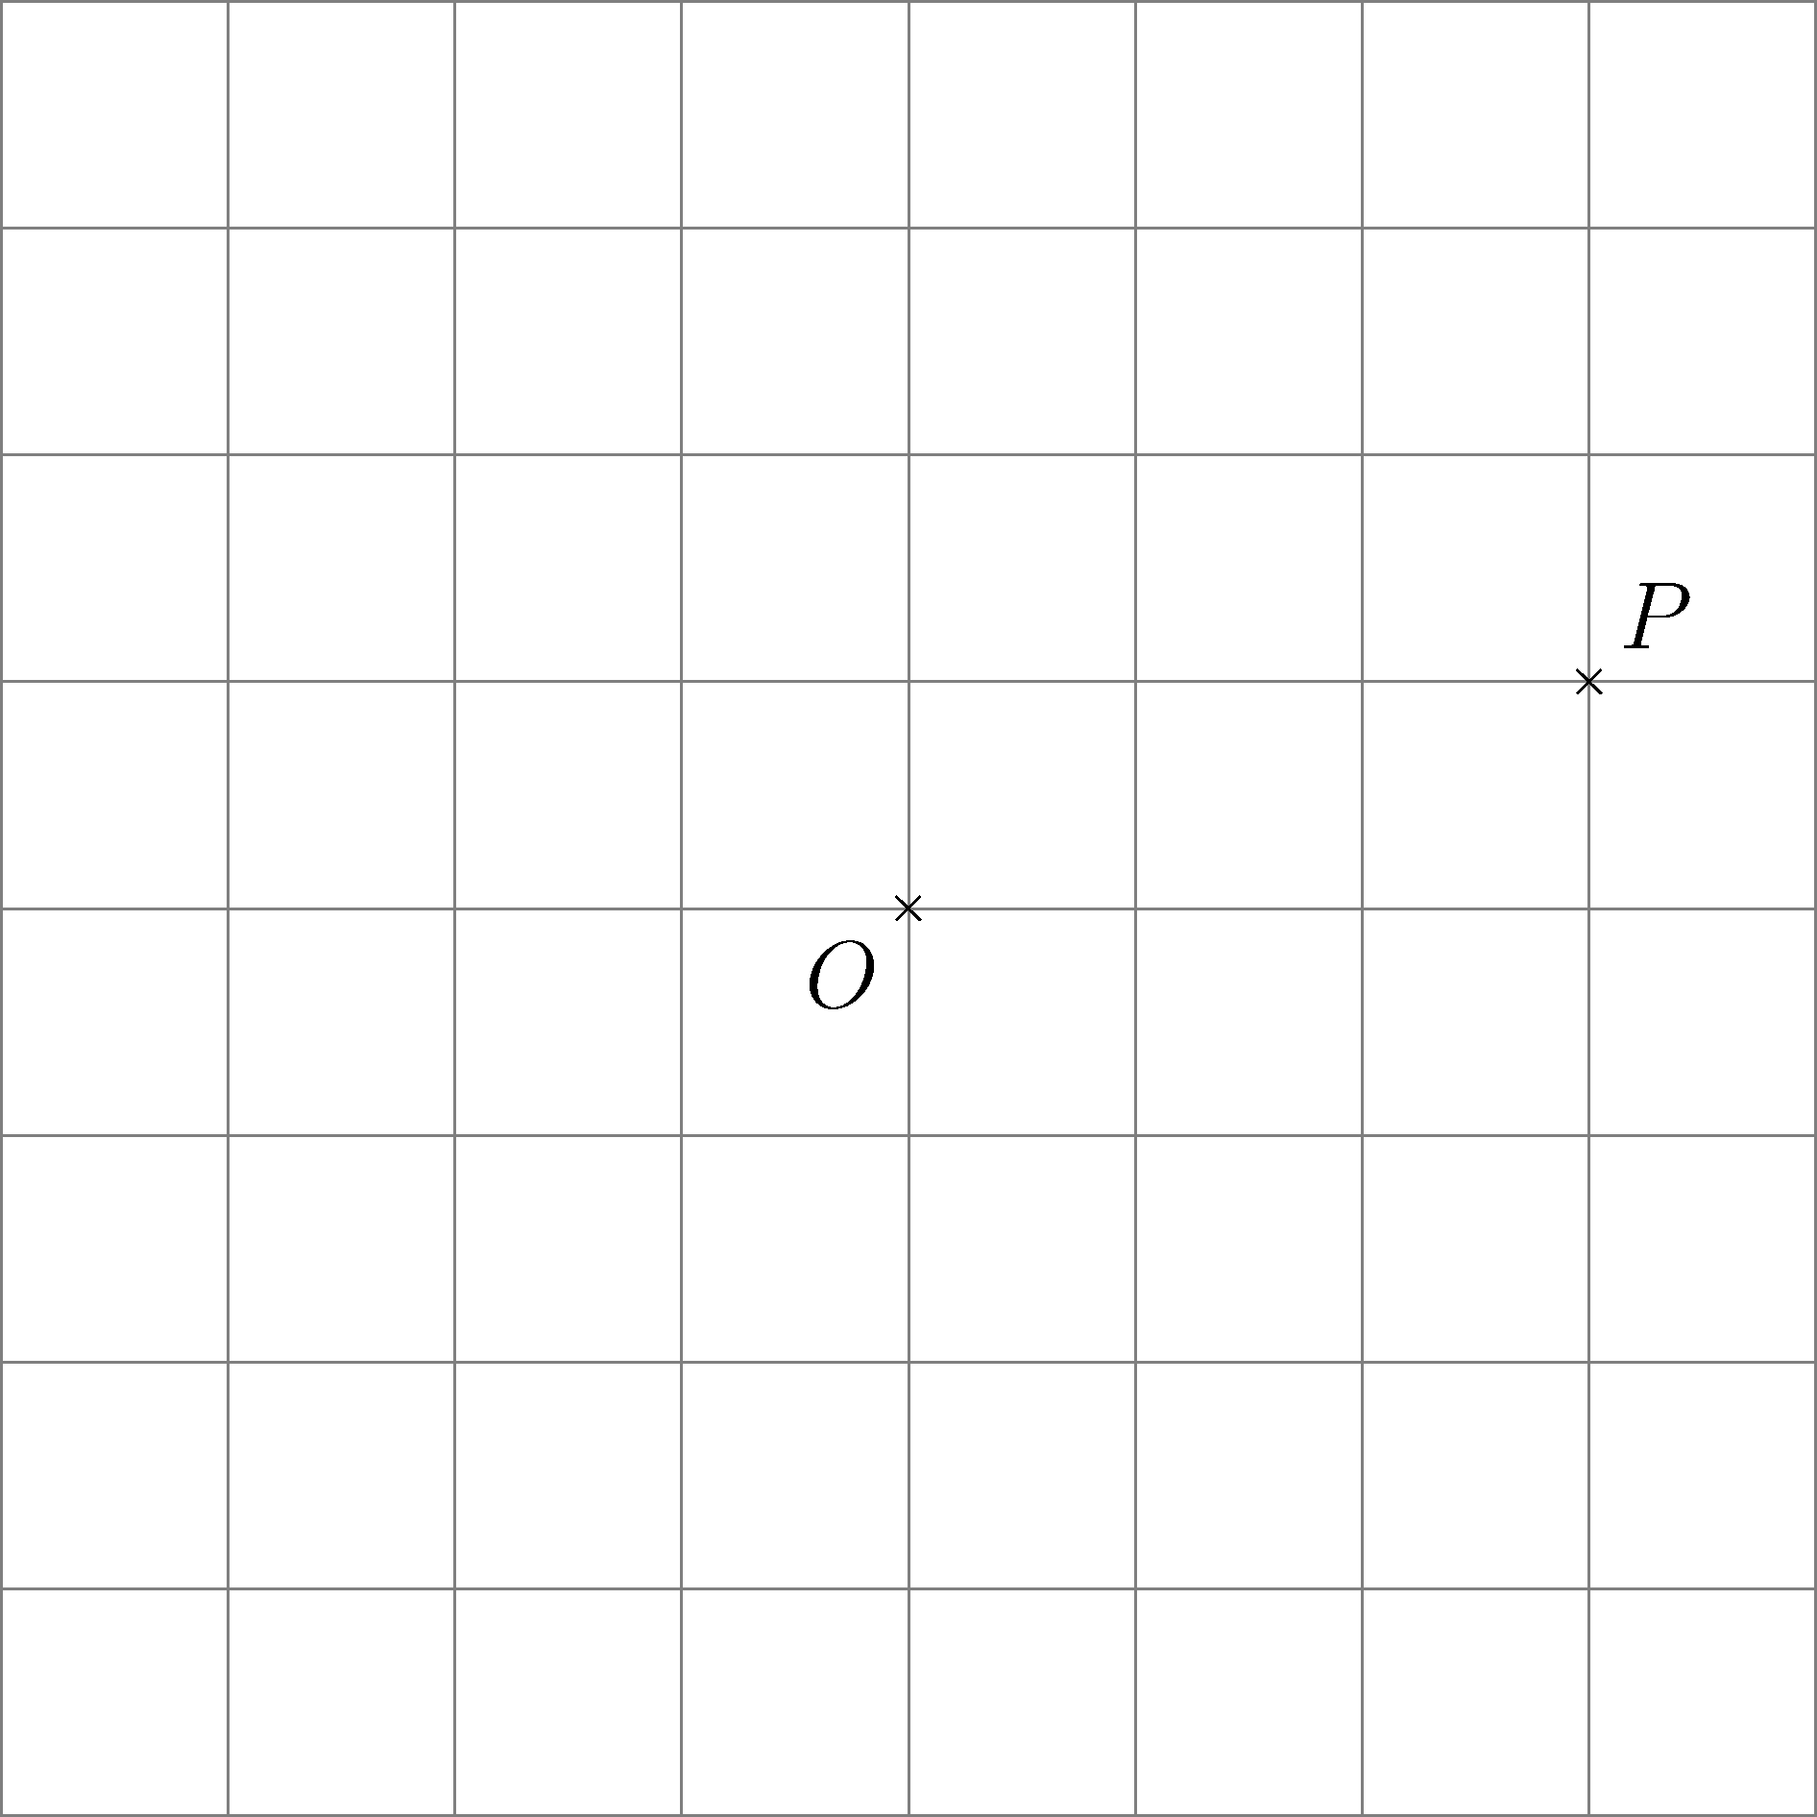
Figure 7

(b) In Figure 7, rotate point P about O by 90° in an anti-clockwise direction. Mark the image P″ obtained after rotation in the figure.

Part B

1.
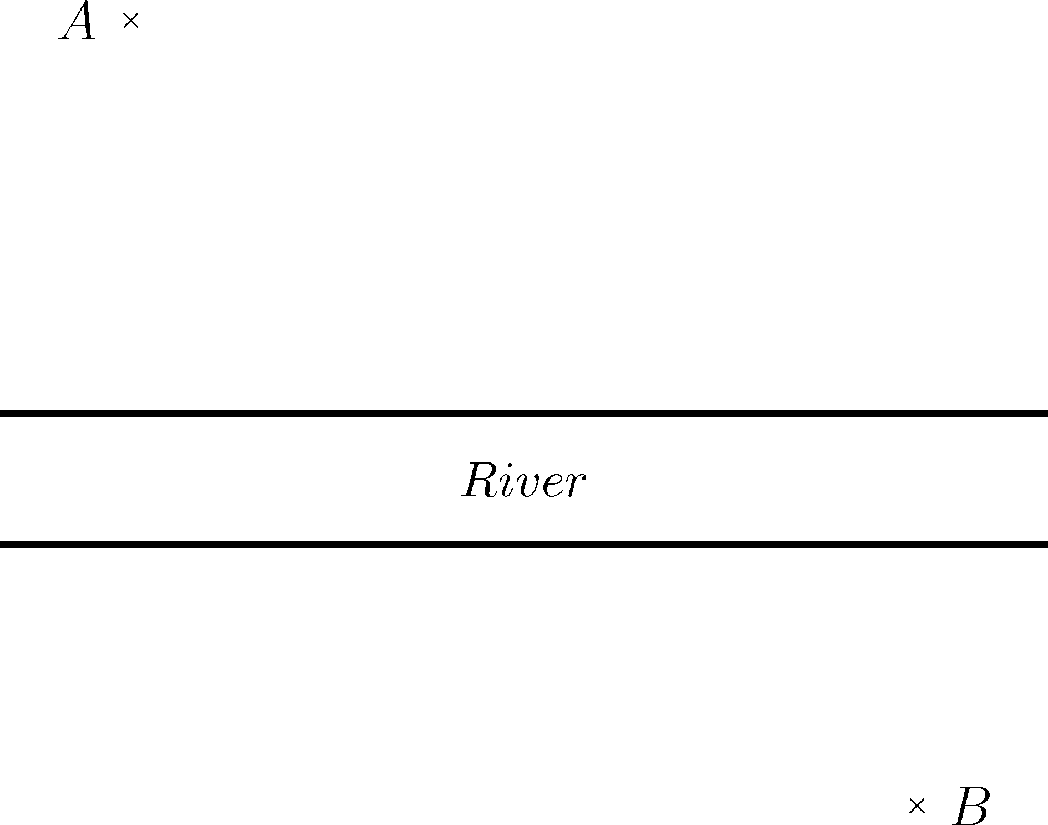
Figure 8
In Figure 8, A and B represent two villages which are located on the opposite sides of a river. A bridge is planned to be built across the river. As the chief architect, you are responsible to set the points where the bridge will pass through, so that the distance travelling from A to B is the shortest.
(Assume that both sides of the river are parallel to each other and the bridge is perpendicular to both sides of the river.)

Locate the bridge using the grid provided in Figure 9. Describe how the location can be obtained.

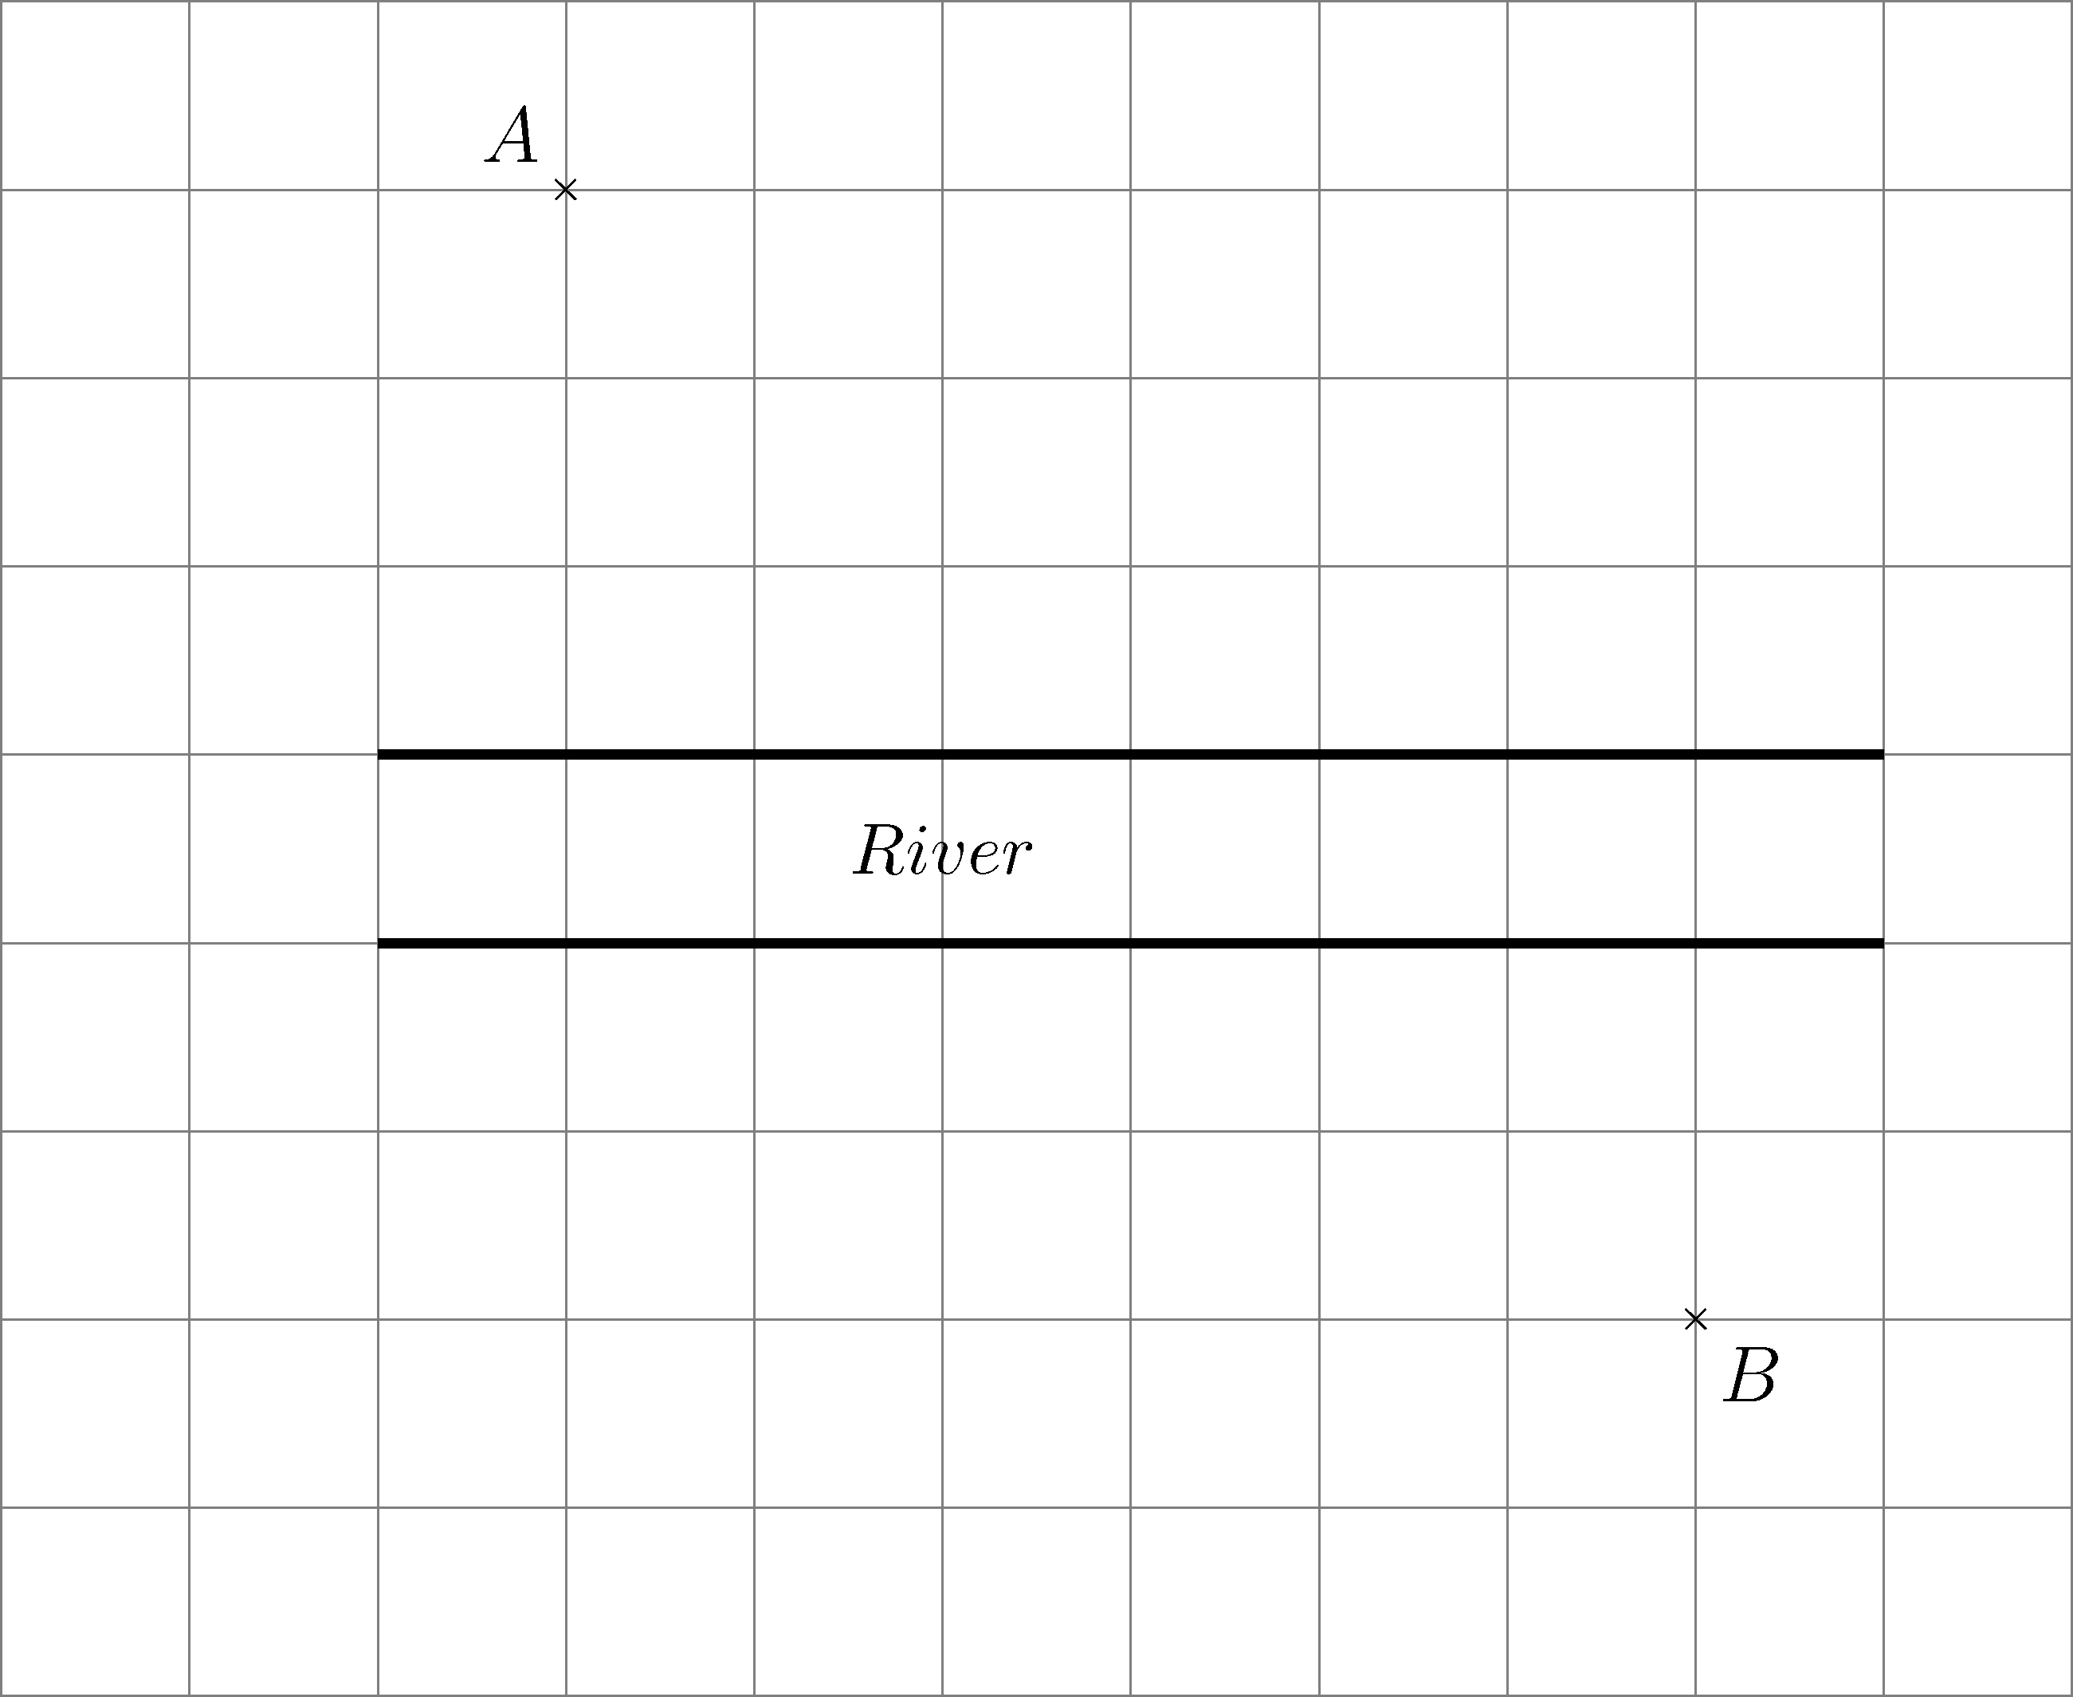
Figure 9

[Hint: Try to overlap the two sides of the river, then translate A and B in an appropriate direction.]

2. The electricity provider decided to build a power station on the side of a highway in order to transmit electricity to villages A and B (as shown in Figure 10). Find the location of the power station such that electric cable connecting the power station to A and B is the shortest.
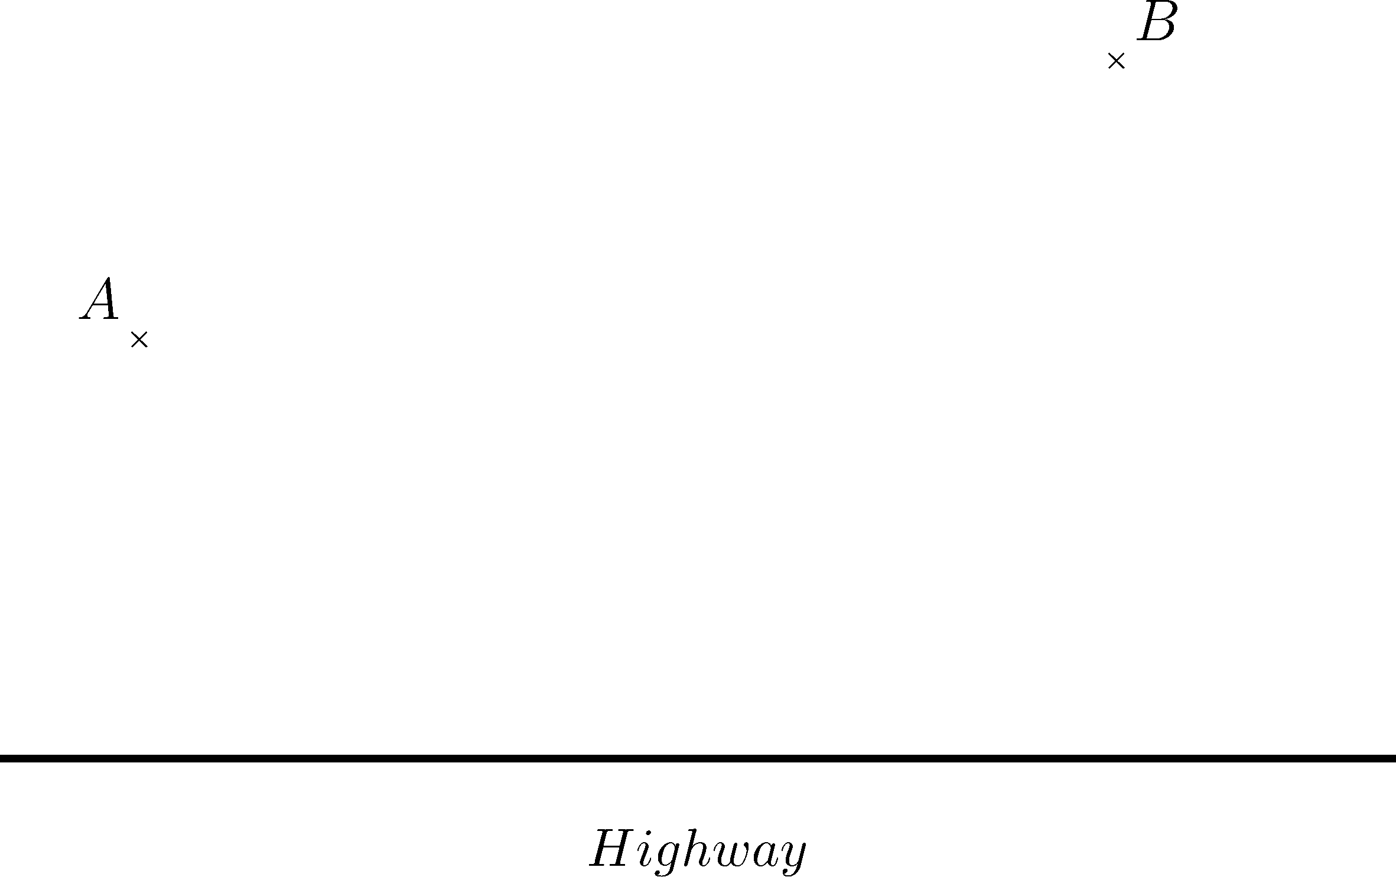
Figure 10

Locate the power station and the electric cable using the grid provided in Figure 11. Describe how the location can be obtained.
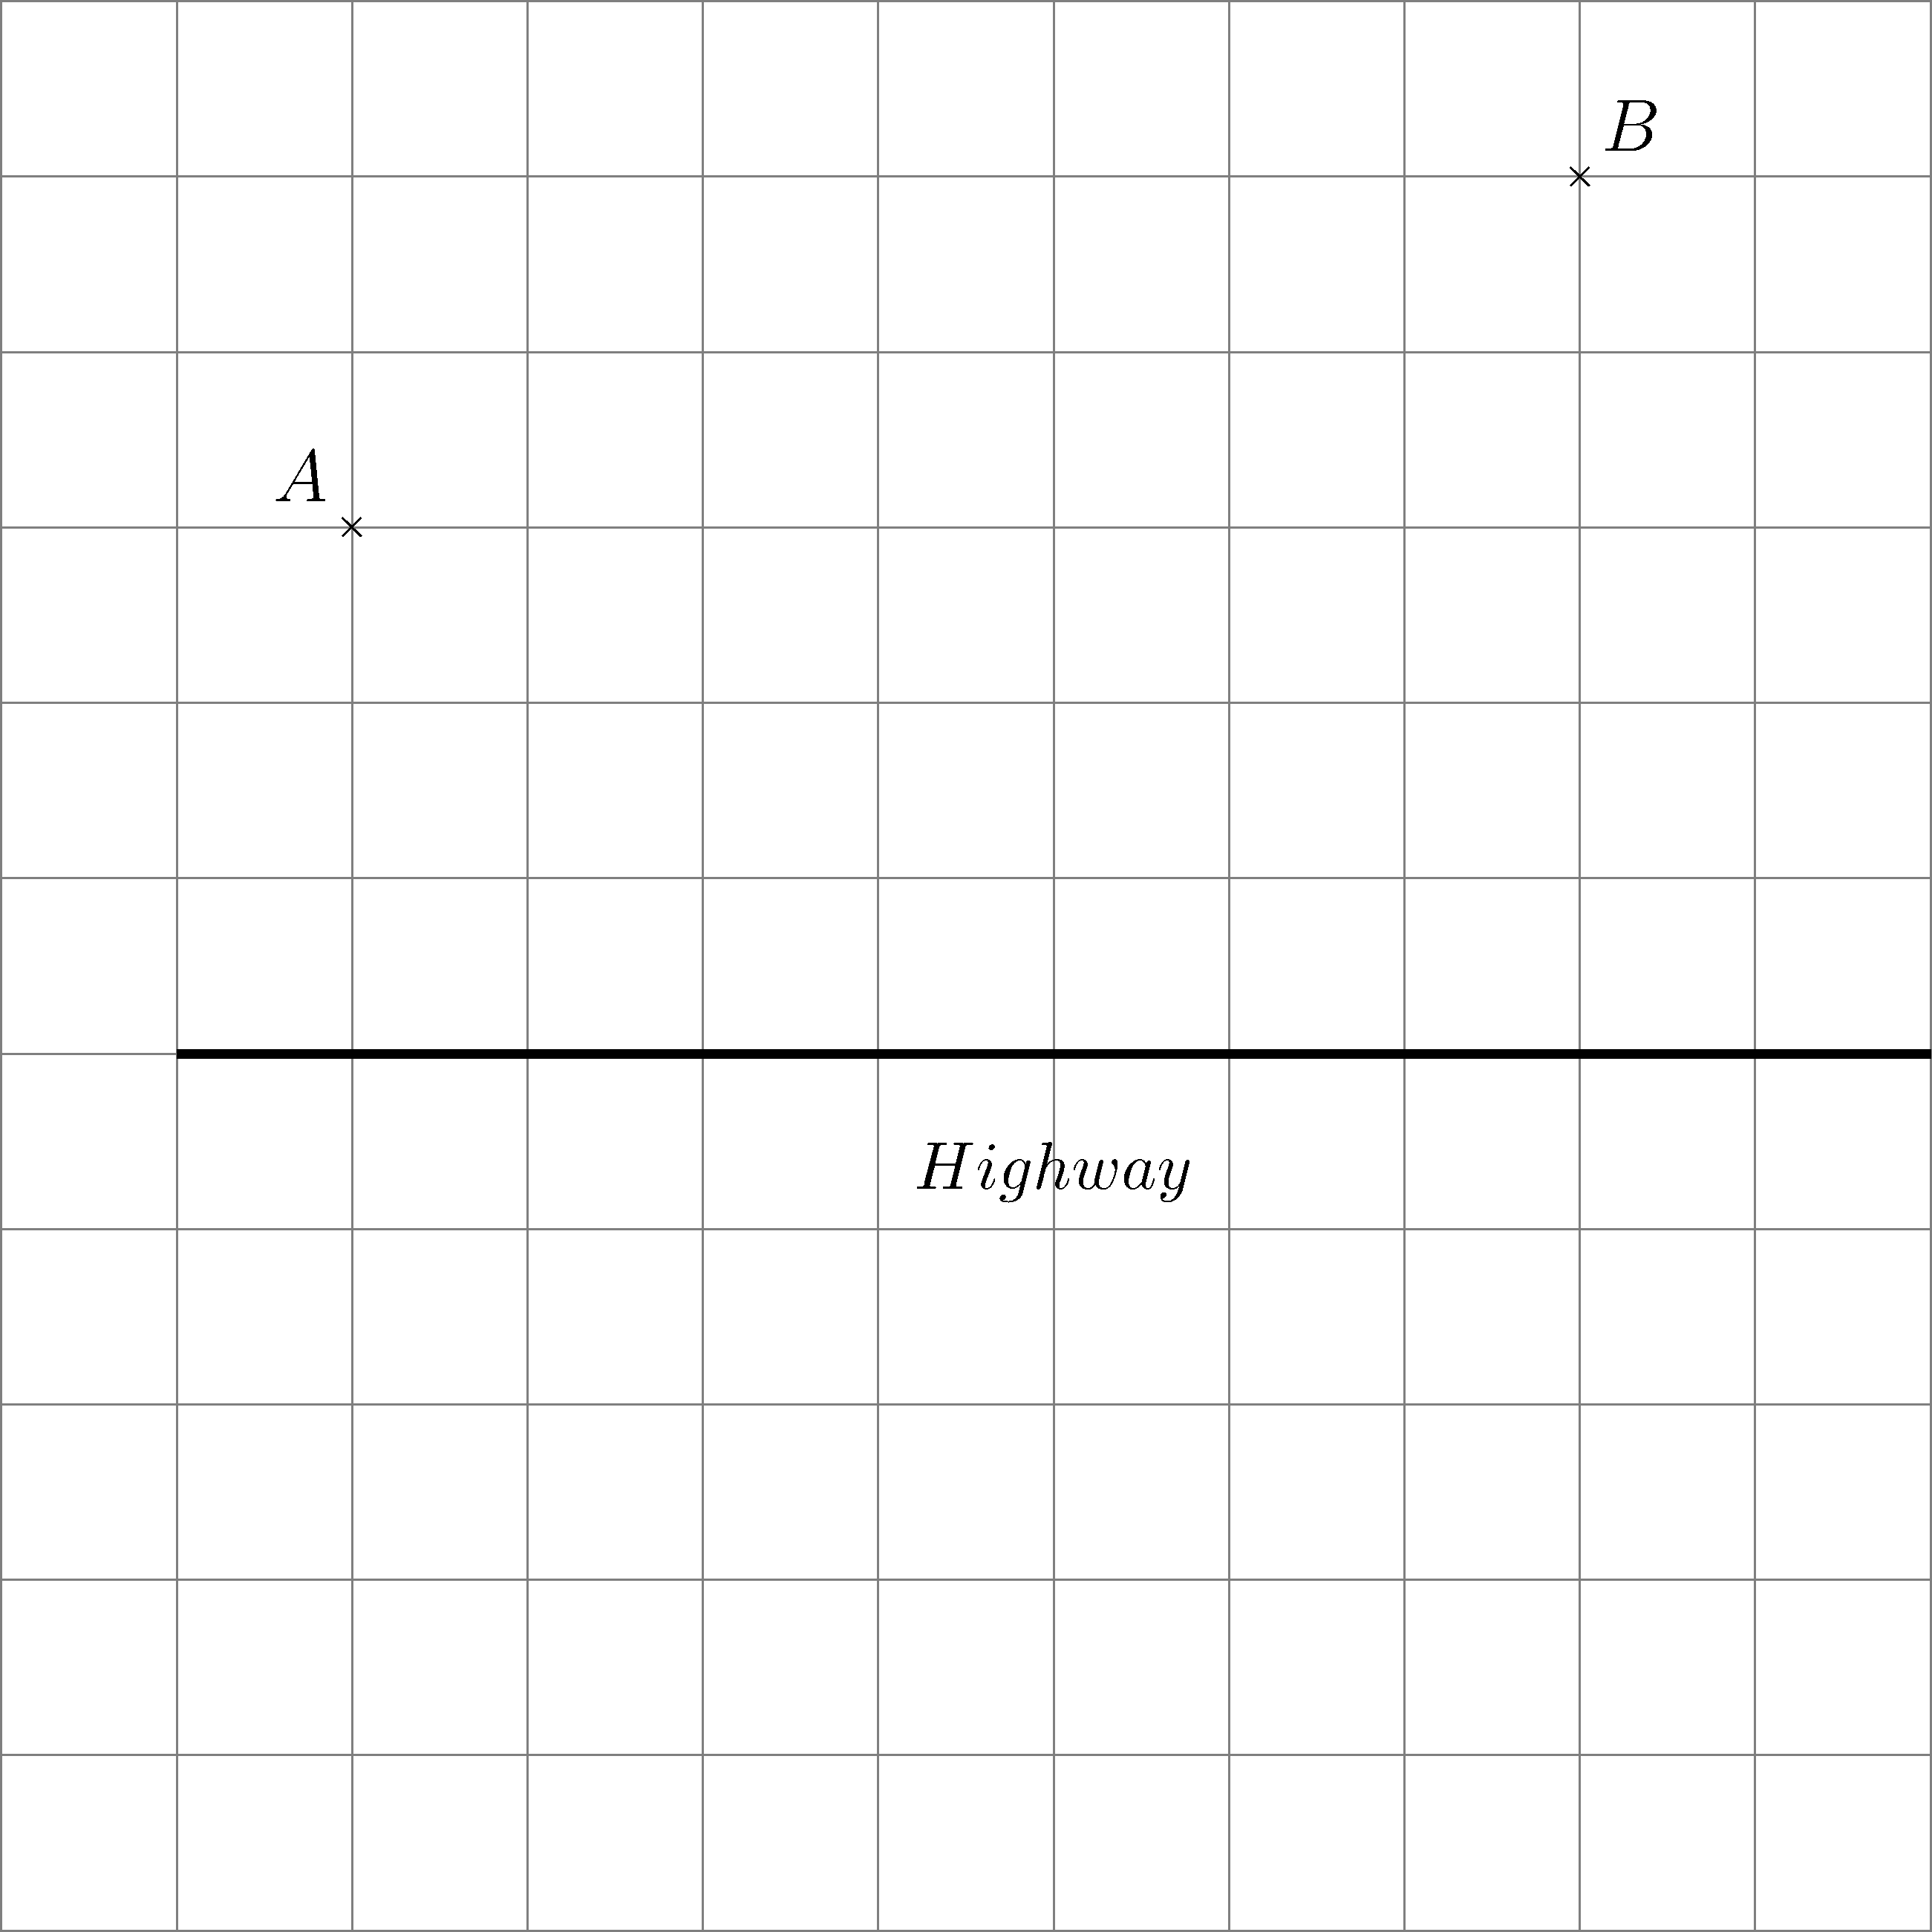
Figure 11
[Hint: Imagine that A and B are on the opposite sides of the highway.]
Part C

1. (a) (i) In Figure 12, rotate point P about the origin O by 90° in a clockwise direction.
Mark the image P′ obtained after rotation in Figure 12 and write down its coordinates.
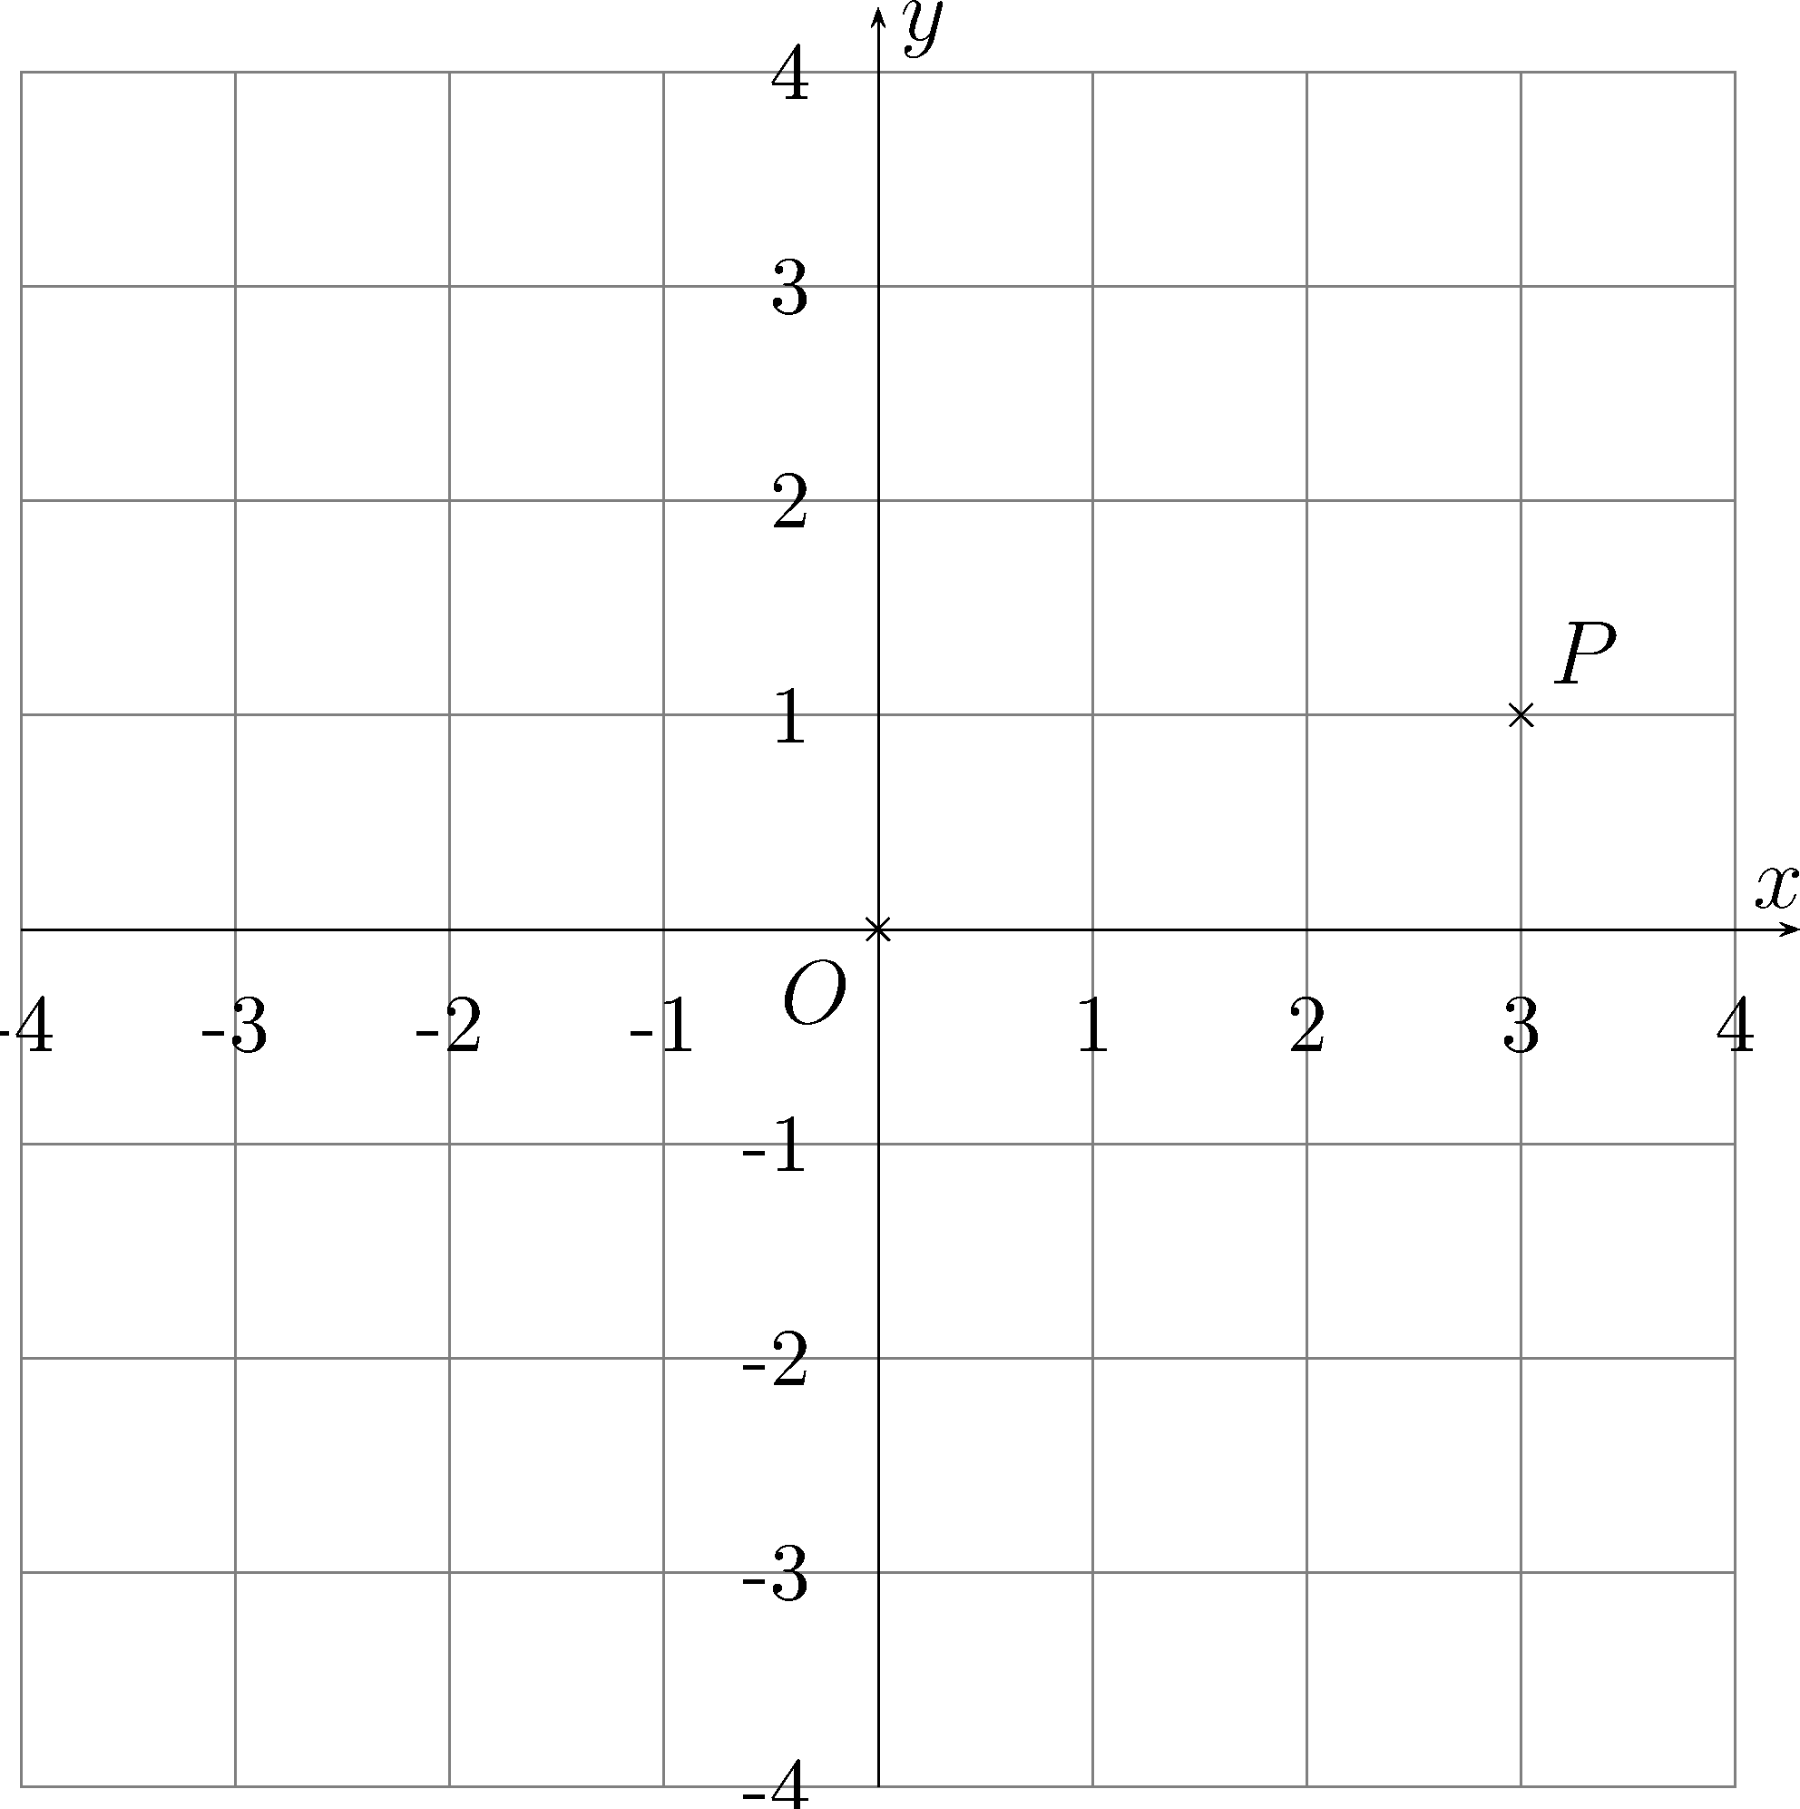
Figure 12

(ii) In Figure 13, rotate point P about point A by 90° in a clockwise direction.
Mark the image P′ obtained after rotation in Figure 13 and write down its coordinates.
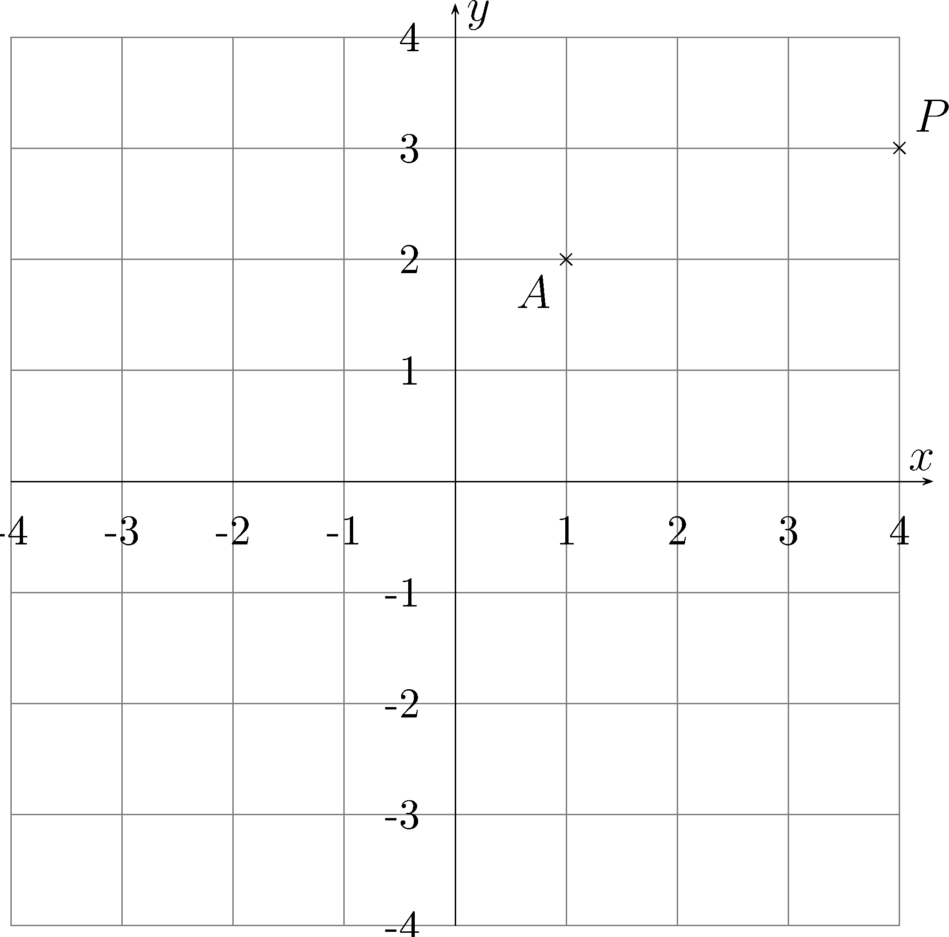
Figure 13

(iii) Rotate P(x₀ , y₀) about A(a , b) by 90° in a clockwise direction. Find the coordinates of the image obtained after rotation. Explain how the result can be obtained.

(iv) Rotate P(x₀ , y₀) about A(a , b) by 90° in an anti-clockwise direction. Write down the coordinates of the image obtained after rotation. Explain how you can obtain the result.

(b) Mr Cheung found a letter left behind by his great-grandfather. The letter indicated that some pirates buried their treasure on an island. The letter showed the location and the way to find the treasure.

The following is an extract of the letter:
There are an oak tree, a pine tree and an observatory in the north side of the island. Start walking from the observatory to the oak tree and record the number of steps that you have taken. When you reach the oak tree, turn right by 90° and go forward with the same number of steps. Stop and mark the location. Go back to the observatory. Start walking from the observatory to the pine tree and record the number of steps that you have taken. When you reach the pine tree, turn left by 90° and go forward with the same number of steps. Stop and mark the location. The mid-point between the two marked points is the location of the treasure.

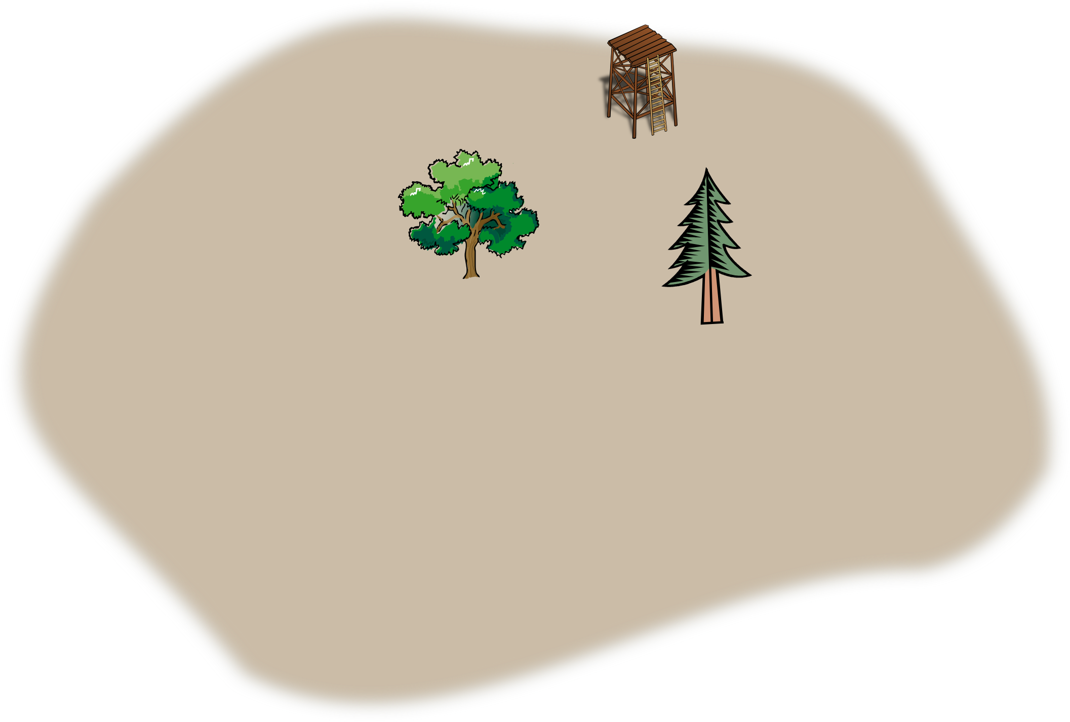
Oak Tree
Pine Tree
Observatory

Unfortunately, when Mr Cheung reached the island, he could not find the observatory because it had been destroyed by typhoon. He could only find the oak tree and the pine tree. You are asked to help Mr Cheung to find the location of the treasure.

To help Mr Cheung to find the treasure, a rectangular coordinate system is introduced to locate the oak tree, the pine tree and the observatory.

Suppose the coordinates of the oak tree and the pine tree are S(–k , 0) and T(k , 0) respectively, and the coordinates of the observatory are A(x₀ , y₀).

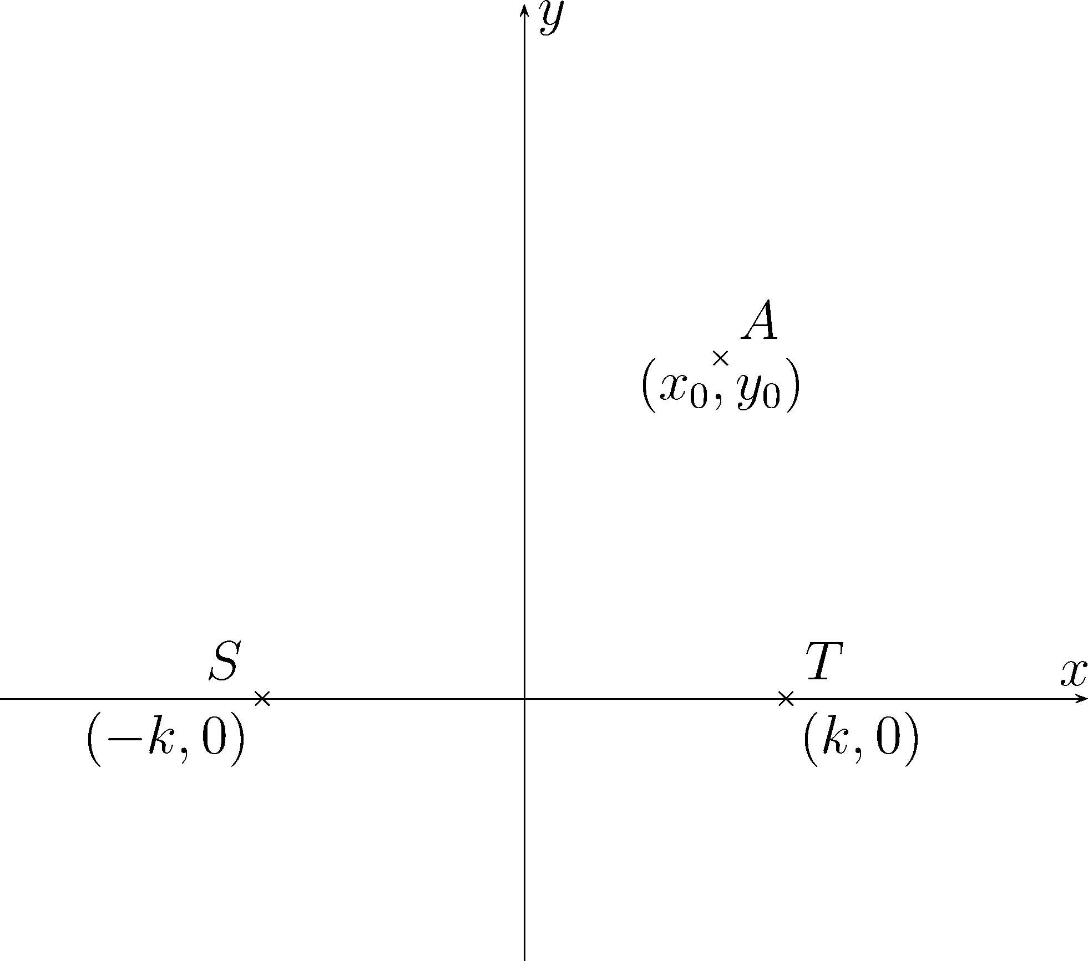

(i) Find the coordinates of the two marked points that are mentioned in the letter. Express the answers in terms of x₀ and y₀.

(ii) Find the coordinates of the location of the treasure.

(iii) If point M is the location of the treasure, find the equations of the lines AM , SM and TM .
Can you find any pair(s) of parallel or perpendicular lines? Explain your answer.

END OF ASSESSMENT TASK

