Economics Data-response Question

Income inequality

Personal, Social and Humanities Education Section
Curriculum Development Institute
Education Bureau
2021

Preface
It is our honour to have Dr. Lee Shu Kam, Director of Business, Economic and Public Policy Research Centre, Hong Kong Shue Yan University to design this DRQ for the Education Bureau.

The primary users of this DRQ are teachers and students. It aims to support the learning and teaching of the Economics curriculum (Secondary 4-6). Teachers may provide appropriate supplementary notes/explanations or arrange students’ pre-lesson/extended learning activities to meet the learning and teaching needs. Teachers are welcome to share suggestions for improvement, and provide updated information to enrich the content for all teachers’ reference. If you have any comments or suggestions about this DRQ, please send them to:

Chief Curriculum Development Officer (Personal, Social and Humanities Education) 1
Curriculum Development Institute
Education Bureau
Room 1319, 13/F., Wu Chung House
213 Queen’s Road East, Wanchai, Hong Kong
E-mail: info_pshe@edb.gov.hk

Income inequality
Income inequality has been a concern in Hong Kong in recent years.

Source A: Gini coefficients in Hong Kong
 | 2001 | 2006 | 2011 | 2016
Gini coefficient (based on original monthly household income) | 0.525 | 0.533 | 0.537 | 0.539
Gini coefficient (based on post-tax post-social transfer monthly household income) | 0.470 | 0.475 | 0.475 | 0.473

Source: HKSAR Government (2017) Thematic Report: Household Income Distribution in Hong Kong 2016, Census and Statistics Department of HKSAR Government.
Note: Gini coefficient (original) is calculated by household income without any tax and social benefits. Gini coefficient (post-tax post-social transfer) is calculated by household income after taking tax and social benefits into account.

Source B: The population aged 65 or above in Hong Kong
projection

Source: Thematic Report: Household Income Distribution in Hong Kong, (Various issues) & Hong Kong Population Projections (2020-2069), Census and Statistics Department of HKSAR Government.

Source C: Situations of three citizens in Hong Kong.
  An early retired man | Though I am retired at the age of 50, I can still support my living with the interest returns earned from my investment. I enjoy my retirement life and do not want to find a job.
  A food courier | After a serious illness, I was unable to work full-time. I can only take up a part-time job as a food courier.
  A supporting staff in a hotel | I am a graduate of secondary school. I need to work for long hours a day but earn very little income.

Source D: Some facts and views about minimum wage in Hong Kong
Nowadays, a lunch box without drinks is charged HK$39. That means we cannot even afford a lunch box with an hour’s salary under the current minimum wage rate.
An increase in minimum wage rate will lead to more people get unemployed.
In alleviating the problem of low-income, Statutory Minimum Wage (SMW) has come into force since 1 May 2011. With effect from 1 May 2019, the SMW rate is raised to $37.5 per hour. Members of a commission set up to review the minimum wage level have failed to reach a consensus on a new level recently. Commission members from the labour sector called for an increment to at least HK$39, business sector representatives insisted it stay at HK$37.5 or be raised to just HK$38.


A representative of
labour sector


A representative of the employer sector
Adapted from: https://www.scmp.com/news/hong-kong/society/article/3102924/hong-kong-commission-members-fail-reach-consensus-minimum

Source E: Suggestions on a change of fiscal policy for alleviating income inequality
Recently, an economist wrote in a financial magazine claiming that Asia needs higher taxes to help its poor to prosper. More than 80 per cent of Asians live in countries where inequality is widening.

He argues that fiscal policy can play an important role. First, governments should invest more in improving access to education and health care. Second, governments should change to use more progressive tax to raise more revenue and to fund the increases in public spending to reduce inequality.

Adapted from: https://www.scmp.com/comment/article/1581091/hong-kong-should-reform-its-tax-structure-redistribute-wealth

Questions and suggested answers:
(a) Refer to Source A,
(i) Describe how income inequality in Hong Kong changed from 2011 to 2016 in terms of Gini coefficient based on original monthly household income. (2 marks)
Ans: The Gini coefficient based on original income increased during this period. It means the situation of income inequality got worsened.
(ii) Compare the Gini coefficient (based on original monthly household income) and Gini coefficient (based on post-tax post-social transfer monthly household income), do you think the government intervention (i.e. tax and social transfer) can alleviate income inequality? If yes, explain how it works. (4 marks)
Ans: Income redistributive policies such as tax and social transfer play a significant role in mitigating income inequality over time.
For example, comparing the Gini coefficient (original monthly household income) with that of post-tax post-social transfer monthly household income, they were reduced from 0.537 to 0.475 in 2011 and 0.539 to 0.473 in 2016.
The “post-tax post-social transfer” policy can reduce income inequality because the disposable income of the high income group will reduce after tax, and the disposable income of the low income group will increase after they receive the social transfer.

(b) Refer to Sources A and B,
- State the relationship between the change of Gini coefficient (original monthly household income) and the trend of population aged 65 or above in Hong Kong. Suggest ONE possible reason for this observation. (2 marks)
Ans: There is a positive relationship between these two sets of figures. One possible reason is that when the proportion of the elderly over 65 increases, the number of people get retired increases. Hence their original household income is considerably reduced and an increase in the Gini coefficient is resulted.

- With reference to the information shown in Source B and your answer in (b)(i), predict the possible change of income inequality in Hong Kong in the future. State ONE assumption behind your prediction. (3 marks)
Ans: Future income inequality may become more severe because of the proportion of population aged over 65 will increase. They are the group of people who are retired and with low monthly household income. The assumption behind this prediction is that the income distribution among different age groups remains the same in the future.
(c) Refer to Source C, suggest any two sources of income inequality in Hong Kong. (2 marks)
Ans:
- Endowment (unequal ownership of capital)
- Human capital (differences in labour qualities e.g. health condition, education level)
(d) Refer to Source D,
(i) Suppose the minimum wage rate is raised to HK$39 per hour (i.e. the wage rate urged by the labour sector). Which group of workers will benefit after the implementation of the new rate? (2 marks)
Ans: Those workers who are receiving the minimum wage rate now and able to keep the job after the implementation of the new rate will benefit.
Or
Workers whose wage rate are higher than the minimum wage rate and they enjoy an immediate pay raise due to the spillover effect of minimum wage adjustments.
- Illustrate the view of the representative of the employer sector with a supply-demand diagram. (4 marks)
Ans:
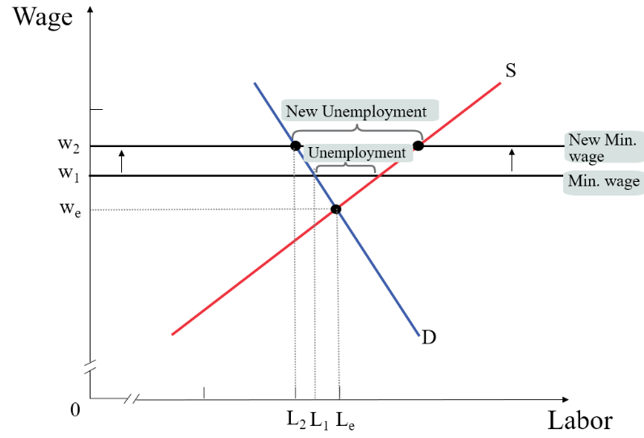

For part (e), students are required to present their answers in an essay form. Criteria for marking will include the use of sources and economic theories, relevant content, logical presentation and clarity of expression.

- To alleviate the problem of income inequality, some politicians raised the following proposals:

Proposal 1 : raise the minimum wage rate
Proposal 2 : increase the progressivity of income tax
Proposal 3 : issue Health Care Voucher for the poor and the elderly

With reference to the above sources and your own knowledge in economics, evaluate the above proposals in terms of equity and the effect on aggregate output. (14 marks)

Ans:
In terms of equity, Proposal 1 “raising the minimum wage rate” can on one hand increase the income of the low income workers and improve income equality if other things remain constant. However, an increase in minimum wage rate may increase the number of unemployed people, particularly those who are less productive e.g. the disabled and unskilled workers. The problem of income inequality may be worsen. Hence, its overall effect on equity by equalizing income is uncertain. From the perspective of output level, Proposal 1 would reduce the aggregate output level when the number of unemployed people increase.

For equity, Proposal 2 “increasing the progressivity of income tax” can reduce the income gap (since the high income group need to pay more tax) and equalize the income. Nevertheless, in terms of output level, this proposal would reduce disposable income and consumption of labour, and thus aggregate demand, resulting in a drop in aggregate output. Moreover, it would also create disincentive effects for taxpayers which might reduce the labour supply and thus reduce aggregate output.

In terms of equity, Proposal 3 “Health Care Voucher for the poor and the elderly” specifies the usage and hence is more targeted at the needy from medical cost. This helps improve their productivity and therefore their income-earning power, which would improve equity by equalizing opportunity. For the effects on aggregate output, other things equal, issuing Health Care Voucher would increase government expenditure (or consumption expenditure if the voucher is regarded as a kind of “transfer payment”), leading to an increase in aggregate demand and thus aggregate output. Besides, this proposal can improve the health of some of the labour which can boost the aggregate output.

For equity, Proposal 2 and Proposal 3 may be more favourable than Proposal 1. It is because Proposal 2 would narrow the income gap and Proposal 3 would help the lower income group by improving their health, giving them more opportunities to increase their income. However, Proposal 1 may result in unemployment of the low-skilled or disabled workers whose income would be reduced.
In terms of aggregate output, Proposal 3 may be more advantageous than Proposals 1 and 2. Proposal 3 would result in an increase in total output level but Proposal 1 may induce higher unemployment rate and Proposal 2 would lead to a reduction in labour supply and these would cause the total output level to decrease.

Remarks:
- Students may apply their knowledge in economics to make a reasonable explanation to support their views.
- For Proposal 1, there are empirical studies in foreign countries suggested that raising the minimum wage rate would have a minor effect on employment level while having a significant impact on those benefiting from the policy. Teachers may further discuss this perspective with students when evaluating the proposal.

