Farming in Hok Tau – Fieldwork Worksheets

- Objectives

This set of learning and teaching materials aims at helping you to:
- go through the five stages of fieldwork investigation.
- investigate the agricultural land use, farming systems and their characteristics in a suitable area.
- apply geographical fieldwork skills.
- understand the limitations of the investigation and suggest ways to improve it.

-------------------------------------- Stage 1: Planning and Preparation ------------------------------------

Topic: | To investigate the agricultural land use, farming systems and characteristics of an area
Study area: | Hok Tau Area, Fanling (refer to the map provided)

- Why Hok Tau is chosen as the fieldwork site?

- With reference to the map, what are the favourable locational factors for the agricultural activities in Hok Tau?
Favourable locational factors | Map evidence

- To investigate the agricultural land use, farming systems and characteristics in Hok Tau, what data should be collected and how to collect them?
Data to be collected  （list the types of first-hand data that needs to be collected in the column below） |  | Data collection method  ( , can choose more than one) |  |  |  |  | Equipment / tools (if needed)
 |  | Measurement | counting | Observation | interview | others
Weather | e.g. RH
Water source
- Prepare some interview questions that you will ask the farmers in the fieldwork site.

- When do you think is the best time for fieldwork? Why?

-------------------------------------------- Stage 2: Data Collection ----------------------------------------------

Date of fieldwork: | ___________________________ (Monday to Friday/ Saturday/ Sunday & Public Holiday)
Time of fieldwork: | _____________________________________________

Fieldwork Task

- Identify the types of agricultural land use of the study area. Record the types of agricultural land use on the map by using the following code.
Type of agricultural land use | Code
Commercial farming | Com
Subsistence farming | Sub
Leisure farming | Le
Abandoned land | Ab

- By applying appropriate data collection methods, collect and record the characteristics of farming system of the three selected farms on the map. (Refer to Information Sheet 1)

- Collect water and soil samples.
  - Collect a bottle of soil sample from each selected farm.
  - Collect a bottle of water sample from each selected sampling point.

- Interview farmers with the questions that you have prepared.

Data record sheets: Write down the data you collected (including quantitative e.g. result of measurement and qualitative e.g. main points from interview) in the table below and take photos as fieldwork evidence.
(Please mark “unknown” if you are unable to collect data of the specific items during fieldwork.)
Characteristics |  | Data collection method(s) | Equipment / tools  (if need) | Selected farm
 |  |  |  | Farm A | Farm B | Farm C
Farming inputs
Weather | Sunlight  (Lux) | Measurement | lux meter
 | Air temperature  (ºC) | Measurement | weather meter
 | Relative humidity (%) | Measurement | weather meter
 | Wind direction & wind speed (m/s) | Measurement | weather meter
Water supply (e.g. quality, stability) |  | Observation, interview | NA
Land | Relief | Measurement | abney level
 | Field size | Measurement | mobile app / measuring tape / estimation
 | Field shape | Observation | NA
 | Tenure | Interview | NA
Soil | Texture  (refer to P.8) | Measurement | NA
 | pH value  (refer to P.9) | Measurement | pH paper
 | Fertility  (refer to P.9-10) | Measurement | soil NPK test kit
Seed |  | Interview | NA
Labour |  | Observation, interview | NA
Machines and technology |  | Observation, interview | NA
Market |  | Interview | NA
Transportation |  | Observation | NA

Characteristics | Data collection method(s) | Equipment / tools  (if need) |  | Selected farm
 |  |  |  | Farm A | Farm B |  | Farm C
Farming processes
Cropping pattern  (e.g. multiple cropping, crop rotation, fallowing) | Observation, interview |  | NA
Irrigation | Observation, interview |  | NA
Ploughing | Observation, interview |  | NA
Soil protection and weed control | Observation, interview |  | NA
Applying fertilizer and soil conditioner | Observation, interview |  | NA
Pest and disease control (e.g. physical, chemical and biological control) | Observation, interview |  | NA

Farming outputs
Useful | Types of farm products | Observation, interview | NA
 | Market price | Observation, interview | NA
 | Major uses (e.g. for sale) | Interview | NA
 | Other uses | Observation, interview | NA
Useless | Waste water  (pollution level)  (refer to P.11-12) | Observation, Measurement | dissolved oxygen meter, testing kit | Sample point 1:  Sample point 2:
 | Other wastes | Observation | NA

Characteristics | Data collection method(s) | Equipment / tools  (if need) |  | Selected farm
 |  |  |  | Farm A | Farm B |  | Farm C
Other characteristics (please specify e.g. infrastructures)

---------------------------------Stage 3: Data processing, presentation & analysis----------------------------

- Show the distribution of different kinds of agricultural land use on the map by using the following colour scheme.
Type of agricultural land use | Code | Colour
Commercial farming | Com | Red
Subsistence farming | Sub | Blue
Leisure farming | Le | Green
Abandoned land | Ab | Grey

- Complete the data record sheets on P.4-6 for easy comparison of farming system on the three selected farms.
  - Classify the soil texture by EITHER method below.
    - Field method (P.8)
    - Sedimentation (P.15)

  - Assess the soil fertility according to the assessment scores on P.9.

  - Assess the water pollution level according to assessment scores on P.11.

-------------------------------------- Soil Quality Assessment ---------------------------------------
- Soil texture --Field method (Information sheet 3)
Equipment: | - Sampling bottle
Procedures:
- Collect soil sample three inches from the top of the soil.
- Identify the soil texture by feel test. Write down the result on P.4.
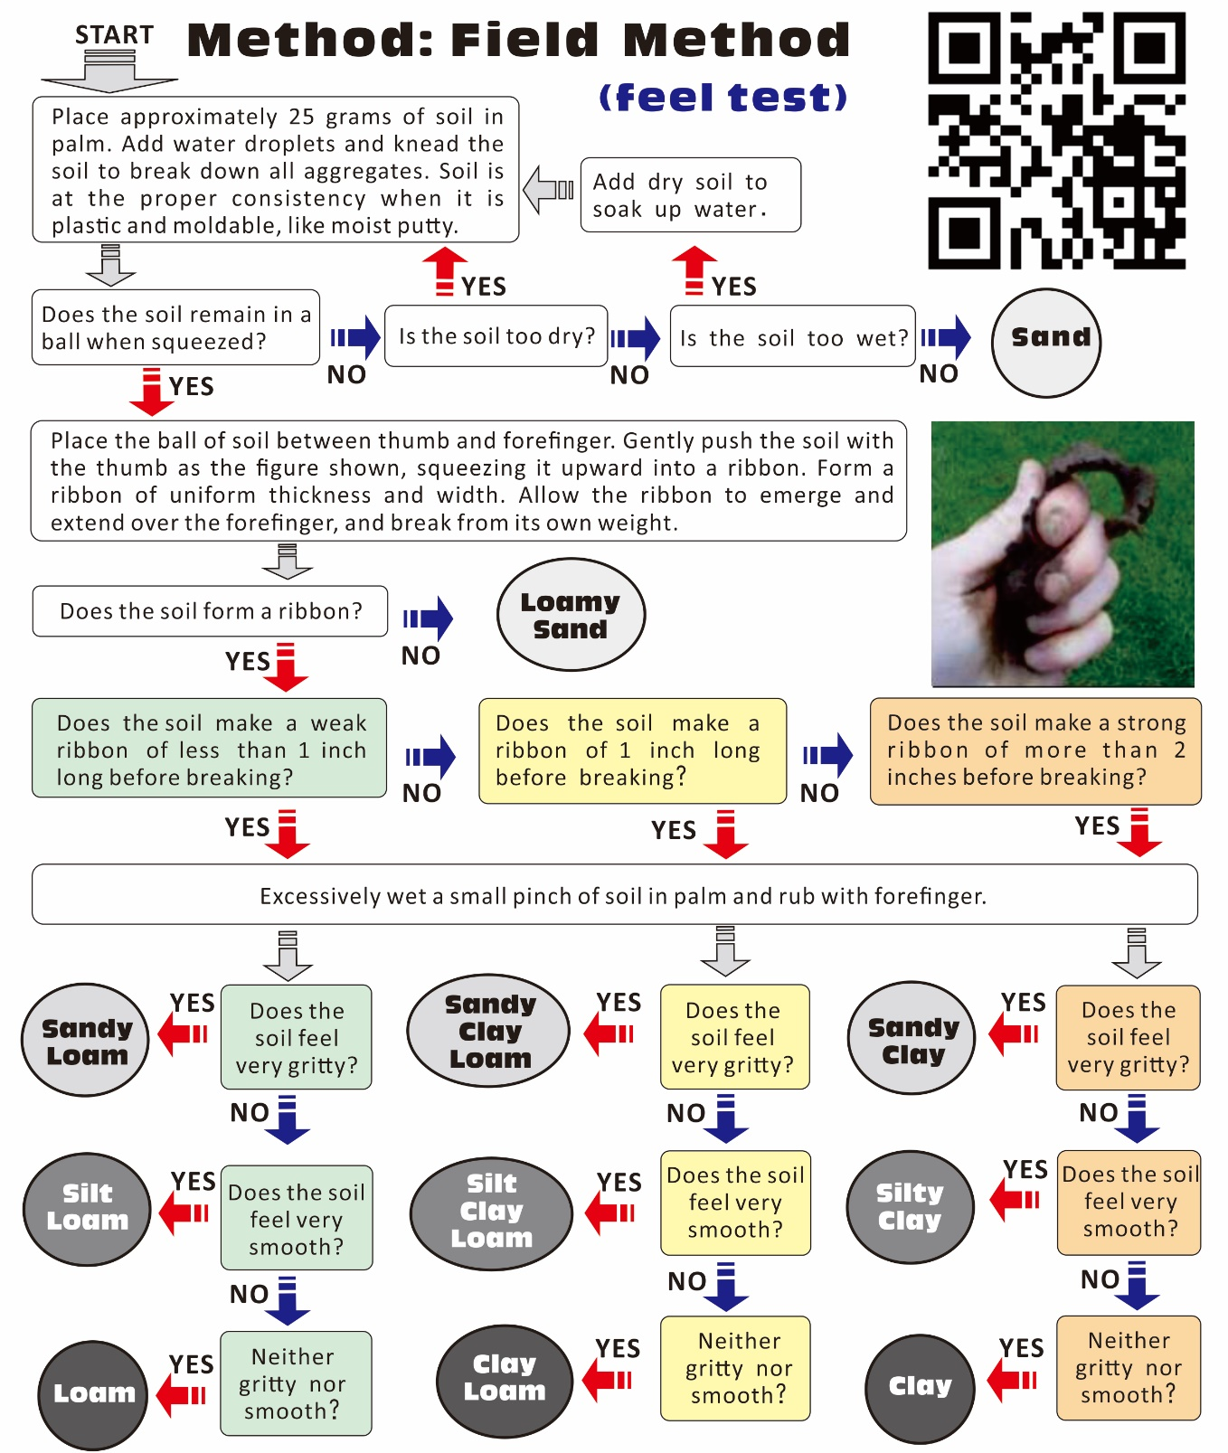
Adapted from United States Department of Agriculture Natural Resource Conservation Service Program Aid Number 1619 “Estimating Soil Moisture by Feel and Appearance.” April 1998, reprinted June 2005

- Soil pH test
Equipment: | - Filter funnel  - Filter paper | - pH paper  - beaker | - distilled water
Procedures:
- Mix 1 teaspoon of soil sample with distilled water.
- Put the filter paper on top of the filter funnel. Put the funnel on top of the beaker. Pour the mixture of soil water into the funnel to separate the residue from the soil water (filtration).
- Put a pH paper into the filtered water for 2 seconds, then take it out.
- Determine the pH value immediately according to the colour chart attached.

- Soil fertility (NPK)
Refer to the instruction of soil nutrient test on P.10, calculate the total assessment score and determine the fertility for the soil samples.
Assessment score | 0 | 1 | 2
Nitrogen (N) | L | M | H
Phosphorus (P) | L | M | H
Potassium (K) | L | M | H

Total assessment score | 0 – 1 | 2 – 3 | 4– 6
soil fertility | Low | Medium | High

 | Farm A | Farm B | Farm C
soil fertility

Soil Nutrient Test (N--Nitrogen, P--Phosphorus and K--Potassium) (Information sheet 4)
Equipment: | - NPK Soil test kit:  Test tube, test tablets, pipette, colour chart | - plastic teaspoon  - distilled water | - aluminum foil
Preparation for soil nutrient test (EXTRACTION):
- Fill a test tube with 30 ml distilled water.
- Add TWO Floc-Ex tablets. Cap the test tube and mix the solution until the tablets dissolve.
- Remove the cap. Add one teaspoon of soil.
- Cap the tube and shake it for one minute.
- Let the tube stand until the soil settles out. The clear solution above the soil will be used for the Nitrate, Phosphorus and Potassium test.

Procedure of NITROGEN test:

- Use the pipette to transfer 10 ml clear solution (from Extraction) above the soil into a test tube.
- Add ONE Nitrate Tablet. Immediately cover the whole test tube by aluminum foil to avoid the reaction with UV light.
- Cap and mix the solution by inverting the test tube for 2 minutes to dissolve the tablet. Bits of materials may remain in the sample.
- Wait for 5 minutes. Remove the aluminum foil. Compare the PINK colour of the solution with the Nitrogen Colour Chart.
- Write down the result on P.9.
AND
Procedure of PHOSPHORUS test:

- Use the pipette to transfer 25 drops of clear solution (from Extraction) above the soil into a test tube.
- Fill the test tube with distilled water to the 10 ml mark.
- Add ONE Phosphorus Tablet. Cap and mix the solution until the tablet dissolves.
- Wait for 5 minutes.
- Compare the BLUE colour of the solution with the Phosphorus Colour Chart.
- Write down the result on P.9.
AND
Procedure of POTASSIUM test:

- Use the pipette to transfer 10 ml clear solution (from Extraction) above the soil into a test tube.
- Add ONE Potassium Tablet. Cap and mix the solution until the tablet dissolves.
- Compare the CLOUDINESS of the solution with the Potassium Colour Chart.
Hold the tube over the black boxes at the left column and compare it to the colour in the right column.
- Write down the result on P.9.
**Remarks: The testing procedure may vary with different testing kit used.
-------------------------------- Stream Water Quality Assessment --------------------------------Investigate the physical and chemical properties of stream water in the two sampling points marked on the map. Write down the data in the table below.
Items | Data collection method | Sample point 1 | Sample  point 2
Floating matter (None/ Some/ Plentiful/ Abundant) | Observation
Water colour (Clear/ Turbid / Brown / Black) | Observation
Smell (None / Slight / Moderate/ Strong) | Smell
Dissolved oxygen level (mg/L)  (Very high [>7.0] / High [5.1-7.0] / Low [3.0-5.0] / Very low [<3.0]) | Measurement
*pH value | Measurement
*Phosphate PO₄³⁻ content (mg/L) | Measurement
*Ammonia NH₃ / NH₄⁺ content (mg/L) | Measurement
*refer to P.12 for the instruction of pH and nutrient tests

According to the following assessment items, calculate the total assessment score and determine the pollution level for the water samples.
Assessment score | 0 | 1 | 2 | 3
Floating matter | None | Some | Plentiful | Abundant
Water colour | Clear | Turbid | Brown | Black
Smell | None | Slight | Moderate | Strong
Dissolved oxygen level (mg/L) | Very high (>7.0) | High (5.1-7.0) | Low (3.0-5.0) | Very low (<3.0)
pH value | Neutral  (6.75-7.24) | Slightly acidic  (4.95 – 6.74)  Slightly alkaline  (7.25 – 8.04) | Acidic  (4.05 - 4.94)  Alkaline  (8.05 - 9.04) | Strongly acidic  (< 4.04)  Strongly alkaline  (> 9.05)
Phosphate content(mg/L) | 0 – 0.50 | 0.51 – 2.00 | 2.01 – 5.00 | >5.00
Ammonia content (mg/L) | 0 – 0.50 | 0.51 – 2.00 | 2.01 – 4.00 | >4.00

Total assessment score | 0 – 4 | 5 – 9 | 10 – 15 | 16 – 21
Pollution level | Clean | Slightly polluted | Moderately polluted | Severely polluted

 | Sample point 1 | Sample point 2
Pollution Level
Stream Water Quality Test
- Water pH test
Equipment: | - Filter funnel  - Filter paper | - pH paper  - beaker
Procedures:
- Put the filter paper on top of the filter funnel. Put the funnel on top of the beaker. Pour the water sample into the funnel to separate the residue from the water (filtration).
- Put a pH paper into the filtered water sample for 2 seconds, then take it out.
- Compare the colour of the pH paper with the pH Colour Chart.
- Write down the result on P.11.
P.S. Filtration is not necessary if no significant residue is found.

- Water nutrient test (ammonia and phosphate) (Information sheet 5)
Equipment: | - Filter funnel  - Filter paper  - beaker | - Testing kit (ammonia and phosphate) :  test tube, test fluid, syringe, colour chart
Preparation for water quality test:
Use filtration to separate residue from the water sample. At least 25 ml of filtered water sample is needed for the following procedures.
P.S. Filtration is not necessary if no significant residue is found.

Procedure of AMMONIA test:
- Use a syringe to transfer 5 ml filtered water sample into a test tube.
- Add 5 drops of test fluid 1 (NH3-1).
- Cap and agitate it well. (Make sure that the test fluid is thoroughly mixed with the water sample before adding the next test fluid).
- Add 5 drops of test fluid 2 (NH3-2). Cap and agitate it well.
- Add 5 drops of test fluid 3 (NH3-3). Cap and agitate it well.
- Wait for 15 minutes. Compare the colour of the solution with the Ammonia Colour Chart.
- Write down the result on P.11.
AND
Procedure of PHOSPHATE test:
- Use a syringe to transfer 20 ml filtered water sample into a test tube.
- Add 10 drops of test fluid 1 (PO4-1).
- Cap and agitate it well. (Make sure that the test fluid is thoroughly mixed with the water sample before adding the next test fluid).
- Add 2 drops of test fluid 2 (PO4-2). Cap and agitate it well.
- Wait for 10 minutes. Compare the colour of the solution with the Phosphate Colour Chart.
- Write down the result on P.11.
P.S. Make sure that the test tube is cleaned before testing another water sample.
**Remarks: The testing procedure may vary with different testing kit used.
------------------------------------------Stage 4: Interpretation & Conclusion ---------------------------------

Summarize the agricultural land use of the area, and the farming system and characteristics of the three selected farms by answering the following questions.

- Describe the agricultural land use pattern in the area.

- Identify the types of farming system respectively.

- What are the characteristics of the farming system of these three farms?

 | Farm A | Farm B | Farm C
Types of farming system
Characteristics

-------------------------------------------------Stage 5: Evaluation ----------------------------------------------

During the data collection, what factors may affect the validity and reliability of the data? What suggestions can be made to improve it?

Factors | Problems and limitations | Suggested improvement methods
Time of fieldwork
Fieldwork site
Data collection method
Types and quantity of data
Others (please specify)

Additional Task: To test Soil texture by sedimentation
Equipment: | - Mini measuring tube x 1
Procedures:
- Place the soil into the mini measuring tube until it reaches the 20 ml line.
- Add water up to 50 ml. Cap the tube.
- Gently shake for around 30 seconds. Make sure the soil sample and water are thoroughly mixed.
- Settle it for at least 2 hours.
- Measure the total length of soil column.
- Calculate the percentage of sand, silt and clay.
- Classify the soil sample with the Soil Texture Triangular Graph. Record the type of soil on P.4.
Items |  | Farm A | Farm B | Farm C
Total length of soil column | ［T］
Length of clay column | ［A］
Length of silt column | ［B］
Length of sand column | ［C］
Clay (%) | ［A / T x 100 %］
Silt (%) | ［B / T x 100 %］
Sand (%) | ［C / T x 100 %］
Soil texture [according to the below graph]
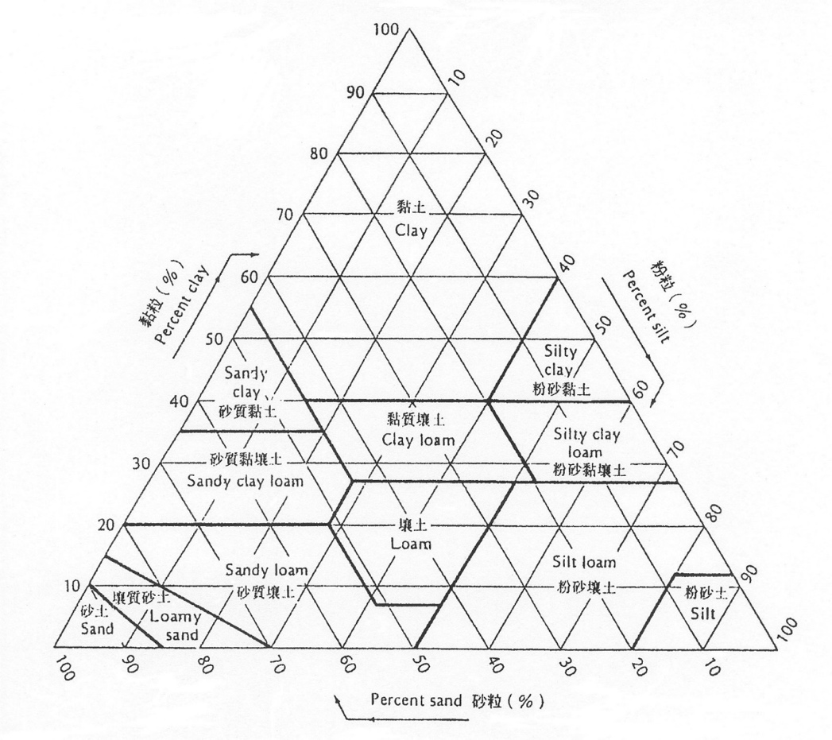
Soil Texture Triangular Graph

