**Teaching Manual for Enhancing English Writing Skills**

**through Language across the Curriculum**

**in Life and Society (Secondary 1-3)**

**Bullying**

**Reading & Writing Unit**

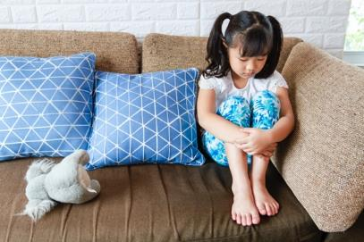

|  |
| --- |
|  |
| ***­*** | | |

Hong Kong secondary school students studying subject contents in English typically find it challenging to express what they want to say in writing. This is especially the case for subjects where language competences are an integral part of learning, such as Life and Society (Secondary 1-3) in the PSHE KLA.

The “Teaching Manual for Enhancing Students’ English Writing Skills through Language across the Curriculum in Life and Society (Secondary 1-3)” (the Manual) aims to demonstrate how the learning of subject contents and development of academic writing skills can be interweaved in carefully designed scaffolding activities and tasks. The Manual contains 10 sample units. Educationally sound practices such as “Catering for Learner Diversity”, ”Peer Evaluation” and “Assessment as Learning” are incorporated in these sample units to facilitate learning and teaching. Upon completion, students are expected to develop an enhanced understanding of the topics taught, sharper writing skills for answering questions and better knowledge of the language functions covered.

For Life and Society teachers, we hope that the Manual will provide them with useful teaching resources for direct, selective or adaptive use. For other PSHE subject teachers, we hope that the Manual will demonstrate one possible way of how Language across the Curriculum practices can bring greater benefits to learning and teaching.

Edward Y.W. Chu

April Liu

The Open University of Hong Kong

**Unit Overview**

**Bullying**

|  |  |
| --- | --- |
| **Strand** | 1 |
| **Module** | ➂ Human relationship (I): Building friendships |
| **Target Class Level** | S1 |
| **Learning Objectives** | **Contents:**  Students can:   1. tell the nature of bullying 2. explain why bullying takes place   **Language functions**:  Students can:   1. tell and use the key terms about bullying and related misbehaviours 2. use the following language functions correctly and appropriately: 3. justifying by giving reasons 4. giving examples |

Module 3

Human Relationship (I):

Building Friendships- Bullying

Contents

**Part 1: The nature of bullying**

**Task 1 Bullying – what is it?**

***Language support I: Justifying by giving reasons***

**Task 2 Is it bullying?**

**Task 3 Which type of bullying is it?**

***Language support II: Giving examples***

**Part 2: What are the reasons for bullying?**

**Task 1 Possible causes of bullying: Personal factors**

**Task 2 Possible causes of bullying: External factors**

**Part 3: Dealing with bullying**

**Task 1 What (not) to do when being bullied**

**Task 2 Giving suggestions for the victim**

**Part 4: My vocabulary bank and learning record**

**Task 1 Finding useful expressions for “Bullying”**

**Task 2 My choice of the most useful words and expressions**

**Task 3** **My learning record of “Bullying”**

**Part 1: The nature of bullying**

**Bullying** is a type of unwanted interpersonal behaviour that affects many students in the world. Everyone dislikes it and wants to prevent it for a safe school environment. To avoid bullying, you have to distinguish between bullying behaviours and those that are not, because some incidents may only involve conflicts or violence but not bullying.

***Task 1 Bullying – what is it?***

Read the passage below and answer the following questions.

**What is bullying?**

One in every three teenagers in Hong Kong has had experience of being bullied, as reported in a survey in 2018a. The problem is not unique to Hong Kong; there are reports showing more and more children and teenagers are falling victim to bullying around the worldb.

Bullying occurs when someone 1hurts or frightens 2the weaker one with words or actions 3over and over again 4on purpose. Sometimes the bully may force this less powerful one to do something they do not want to. This causes long-term effects on the victims and bystanders.

aChan, N. (2018, May 23). One in three HK students has experienced bullying in the past six months, survey says. *South China Morning Post*.

bTÜRKMEN, D. N., DOKGÖZ, M. H., AKGÖZ, S. S., EREN, B. N. B., VURAL, H. P., & POLAT, H. O. (2013). Bullying among high school students. *Maedica*, *8*(2), 143.



Do you know…

BULLY

1. A noun:

* Jack is a big bully! (A person who bullies others.)
* Bullying is a negative behaviour. (A negative behaviour)

2. A verb:

* Jack bullies Sam. (An action of hurting or frightening the weaker one)

1. Who are involved in bullying? Label the following persons in the picture with the words below.

|  |
| --- |
| Bully Bystander Victim |

Bully

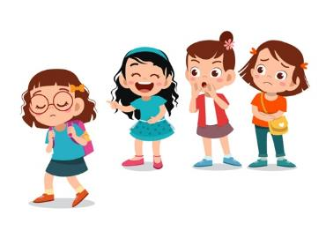

Bystander

Victim

Source: <https://newmoon.com/last-chance-back-to-school-anti-bullying-feature/>

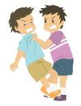(2) The **four main characteristics of bullying** discussed before are rephrased in more formal words labeled as A to D in Column II below. Match them with the phrases in Column I which are also highlighted in Task 1 passage.

**Four main characteristics of bullying**

Column II

Column I

1. hurts or frightens

A. repeated behaviours

2. the weaker one

B. imbalance of power

C. behaviours that cause harm

3. over and over again

D. deliberate behaviour

4. on purpose

For students of stronger ability, teacher may delete the words in Column I and ask the students to fill in the appropriate words from the passage instead.



1. Find words in the passage that mean the following.

Over and over again

(i) repeatedly (adv.)_____________________________________________

1. deliberately (adv.) ___________________________________________

On purpose

1. What are the characteristics of ‘bullying’?

Bullying occurs when people involved have an imbalance of ____________. The bullies use their power to control or __________ others through ______________ and ___________ negative behaviours.

power

deliberate

repeated

harm

**Language support I: Justifying by giving reasons**

Giving reasons is about providing acceptable explanations. Here is an example:

An acceptable explanation

Bullying is unacceptable because it is against the school rules.

For giving reasons, a number of conjunctions can be used as follows:

|  |  |  |
| --- | --- | --- |
| **Opinion**  **(stated in the main clause)** | **Conjunction** | **Reason connected with established rules or moral values**  **(stated in the subordinate clause)** |
| Bullying is unacceptable | *because*  *as*  *since* | it is against the school rules.  it hurts the victims’ feelings |

The positions of the main clause and subordinate clause can be altered for variations:

|  |  |  |
| --- | --- | --- |
| **Conjunction** | **Reason connected with established rules or moral values**  **(stated in the subordinate clause)** | **Opinion**  **(stated in the main clause)** |
| *Because*  *As*  *Since* | it is against the school rules, | bullying is unacceptable |

***Task 2 Is it bullying?***

Can you tell which of the following behaviours are bullying and which are not? With reference to Question (2) of Task 1 “Four main characteristics of bullying”, complete the table below and give reasons. Some have been done as examples.

Bullying Conflict Friendly jokes

Hint:

Provide your justification with the stem and conjunction.

|  |  |
| --- | --- |
| **Behaviour** | **Name of behavior** |
| 1. Every student is joking around and is having fun in the Christmas party.   Hint:  Notice the stem “It is (not) bullying” and the conjunction ‘since’  Bullying / Not bullying (circle where appropriate)  Justification:  Example: It is not bullying since everyone is having fun and it does not cause any harm.  ______________________________________________  ______________________________________________ | Friendly jokes  ____________ |
| 1. On the Picnic Day, Sam saw Mary ate a big sandwich and teased her for being fat. Mary was very upset.   Bullying / Not bullying (circle where appropriate)  Justification:  It is bullying since/because/as it caused harm to Mary.  _____________________________________________  _____________________________________________ | Bullying  _____________ |
| 1. Peter and John have a lot of disagreements while doing their group projects.   Bullying / Not bullying (circle where appropriate)  Justification: _____________________________________________  It is not bullying since/because/as there is not an imbalance of power between Peter and John.  _____________________________________________ | Conflict  _____________ |
| 1. Tom forces Ivan to buy lunch boxes for him every day.   Bullying / Not bullying (circle where appropriate)  Justification: _____________________________________________  It is bullying since/because/as there is an imbalance of power. Tom uses power to force Ivan to do something he does not want to. The repeated and deliberate negative behaviours also cause pressure on Ivan.  _____________________________________________  _____________________________________________  _____________________________________________ | Bullying  _____________ |

***Task 3 Which type of bullying is it?***

Bullying can be classified into four types based on different behaviours. They include physical bullying, verbal bullying, social bullying and cyber bullying.

➀ **Physical bullying** occurs when bullies hurt someone through physical action or their belongings are taken away or damaged.

➁ **Verbal bullying** occurs when bullies hurt others’ feelings through saying or writing unkind words and name-calling.

➂ **Social bullying** occurs when bullies exclude someone from the group, play nasty jokes to embarrass him/her, spread rumours or share images that harm his/her social status.

**Cyber bullying** occurs whenverbal and social bullying happens online.

**1. Types of bullying**

1. Table 1 shows pictures of bullying behaviours commonly found in schools and Table 2 shows a list of bullying behaviours. Match the bullying behaviours in Table 2 with the corresponding pictures in Table 1.

Table 1

|  |  |  |
| --- | --- | --- |
| 12  3  5  6  2  8 |  |  |
|  |  |  |
| 9  10  7 |  |  |
| 4  1  11 |  |  |

Table 2

|  |
| --- |
| **Bullying behaviours** |
| ➀ name-calling = insulting someone by calling them rude names  ➁ kicking someone  ➂ taking things away from another person  ➃ shoving (i.e. pushing someone forcefully)  ➄ sending offensive texts to insult someone online  ➅ hitting  ➆ stealing money from another person  ➇ gossiping about someone (i.e. spreading rumours about someone)  ➈ excluding someone from groups or events  ➉ extorting something from another person (i.e. obtaining something by force or threats)  damaging someone’s belongings  teasing someone about his / her appearance |

1. For each behaviour listed in Question (a), classify them in the table below by putting their numbers. The first has been done for you as an example.

|  |  |  |  |
| --- | --- | --- | --- |
| **Physical bullying** | **Verbal bullying** | **Social bullying** | **Cyber bullying** |
| 2, 3, 4, 6, 7, 10, 11 | 1, 5, 12 | 8, 9 | 5 |

**Language support II: Giving examples**

**Giving examples using “for example”, “for instance”, “include” and “such as”**

In writing, we often need to give examples to make things clear. The phrase “for example” or “for instance” are commonly used:

There are many places where bullying can occur. For example / For instance, it can take place at home, in schools, in public areas, etc.

If the examples are given within the same sentence, the words **“for example”**, **“for instance”**, **“include”** and **“such as”** can be used. Notice that the examples followed by these words are nouns (e.g. kicking) or noun phrases (e.g. at home, stealing the money from another person):

Examples given within the same sentence using the words ‘for example/for instance/such as’

Bullying can occur in many places, for example/for instance/such as at home, in schools, in public areas, etc.

Examples given within the same sentence using the word ‘include’

Physical bullying includes kicking, shoving and stealing money from another person.

A common mistake is using verbs instead:

X

X

X

* Physical bullying includes kick, shove and steal money from another person.

Adding ‘ing’ to a verb is a quick way to turn it into a noun. Hence, ‘kick**ing**’, ‘shov**ing**’ and ‘steal**ing** the money from another person’.

**2. Examples of bullying behaviours**

With the help of Question 1, answer the following questions:

1. What are the examples of physical bullying?

kicking, taking things away from another person, shoving, hitting, stealing money from another person, extorting something from another person and damaging someone’s belongings.

Examples of physical bullying are_____________________________ ______________________________________________________________________________________________________________________________

Hint:

Use “noun” for examples.

_______________________________________________________________

1. Give three examples of the verbal bullying commonly found in schools by using “such as”.

Verbal bullying includes behaviours such as name-calling, sending offensive texts to insult someone online and teasing someone about his / her appearance.

Hint:

What part of speech shall follow ”such as”?

______________________________________________________________________________________________________________________________

_______________________________________________________________

1. What does social bullying include?

Hint:

Answer this question using the pattern ‘…includes…’ in (b).

Social bullying includes gossiping about someone and excluding someone

from groups or events.

______________________________________________________________________________________________________________________________

1. Which behaviour listed in Question (a) belongs to cyberbullying?

Sending offensive texts to insult another person online (No. 5) belongs to cyberbullying.

______________________________________________________________

______________________________________________________________

**3. Case study: Lisa’s story**

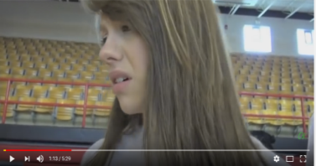**Visit the following website to watch a video clip [0:00 – 3:00] entitled ‘Bullying – Gym Class Bully’:**



<https://www.youtube.com/watch?v=pQg50hu7W-A>

**In the video, Lisa was bullied in a gym class (i.e. physical education lesson).**

1. While watching the video, make notes about how Lisa was bullied in the gym class and complete the table below. [Hint: The behaviours listed in Question 1(a) may be helpful.]

Types of bullying

physical social

verbal

physical

physical

(1)

(2)

(3)

(4)

(5)

(1) given the gum being chewed

|  |  |  |
| --- | --- | --- |
| Lisa | was  (be) |  |
| (2) excluded from the team |
| (3) insulted |
| (4) shoved in the court |
| Her belongings | were  (be) | (5) taken away in the washroom |



**Do you know…**

When we talk about bullying, this focus is usually on the victim. As such, we need to ‘thematise’ the victim, i.e. Lisa. Thematising the victim means putting the victim (i.e. Lisa) in the subject rather than the object position. This requires the use of passive voice like the following:

|  |  |  |  |  |
| --- | --- | --- | --- | --- |
| **Subject** | **‘be’** | **Past participle** | **Object (optional)** | **Place adverbial**  **(optional)** |
| Lisa | *was* | *bullied* | by Jordyn | in the gym class. |

Notice the passive voice verb consists of two parts: ‘be’ and past participle. You may have learnt this in your English grammar lesson before.

(b) Refer to your notes in Question 3(a). What types of bullying occurred in the gym class? Give examples to help illustrate your answer.

The types of bullying include physical bullying, social bullying and verbal bullying.

First, physical bullying occurred because Lisa was given the gum being chewed and was shoved in the court. Also, her belongings were taken away from her in the washroom. Second, social bullying occurred because she was excluded from the team. Third, verbal bullying occurred because she was insulted.

________________________________________________________________________________________________________________________________________________________________________________________________________________________________________________________

Hint:

Thematise Lisa the victim by using passive voice.

Hint:

Use sequencing words such as *first, second,* to link the points.

______________________________________________________________

______________________________________________________________

______________________________________________________________

______________________________________________________________

______________________________________________________________

______________________________________________________________

**Part 2: What are the reasons for bullying?**

Bullying occurs at home, in schools and in public areas. Why does it happen? What factors contribute to the development of potential bullies and victims?

***Task 1 Possible causes of bullying: Personal factors***

*Jordyn, the girl who bullied Lisa, wrote a diary entry. Read it and answer the questions which follow.*

Dear Diary,

Dad and mum had a fight in the middle of the night last night and I didn’t have a good night sleep. It was not the first time and I am sure it would not be the last. Lisa has been a sore in my eyes because she didn’t play well in the basketball team. Boys like her because she is pretty and petite. But she moves far too slowly when competing in the match. Whenever playing with the strong teams, she looked anxious and became nervous, making her play even worse. Some teammates occasionally talked to her but she was too shy to respond. She is just far too introverted to be a good team member.

1. Fill in the table below with the personal factors which may have made Lisa more prone to Jordyn’s bullying.

**Personal factors which may be prone to bullying**

|  |  |  |
| --- | --- | --- |
| **Appearance** | **Personality** | **Emotion** |
| Pretty  Petite | Introverted  Shy  Slow | Anxious  Nervous |

List some more personal factors that you can think of which may lead to bullying.

[Student answer] Suggested answer: Submissive, isolated, quiet, gentle

________________________________________________________________

________________________________________________________________

|  |  |  |  |  |  |
| --- | --- | --- | --- | --- | --- |
| ***Task 2 Possible causes of bullying: External factors***  Apart from the personal factors, there are external factors leading to bullying. Match those factors with their explanations and complete the box with appropriate alphabets. | | | |  | |
| ***External Factor*** |  |  | ***Explanation*** | |
| **1.** Peer influence |  |  | **A.** Aggression and bullying behaviors are common on television programmes, movies and video games. Exposure to mistaken presentation of bullying in the media may give teenagers a false impression that bullying makes them look smart and powerful. | |
| **2.** Ineffective school policy to curb bullying problems |  |  | **B.** Aggressive behaviors can be learned when teenagers are beaten up by older siblings or when they are physically punished by parents. They may wrongly believe that using violence is the right way to get what they want. | |
| **3.** Uninvolved Parents |  |  | **C.** Teenagers who tend to bully make friends with other teenagers who bully. Consequently, these teenagers support each other’s bullying behaviors. | |
| **4.** Bullies’ mutual support |  |  | **D.** Teenagers who watch passively and do nothing to stop bullying may send a wrong message to the bullies that they approve the bullying behaviours. | |
| **5**. Media Models |  |  | **E.** Teenagers who bully may not be receiving enough attention, love and warmth from their parents. Therefore, they tend to bully others to attract attention and feel their importance. | |
| **6.** Aggression in the Family |  |  | **F.** Bullying is more likely to happen when schools are not effective in dealing with bullying problems. For example, the bullies are not punished or have any consequences for their negative behaviours. | |
| **7.** Role of Bystanders to Bullying |  |  | **G.** Some teenagers become bullies because they see their peers bully others and copy their bullying behaviours, or when they experience bullying as victims and copy the bullying behaviours. | |

|  |  |  |  |  |  |  |
| --- | --- | --- | --- | --- | --- | --- |
| **1** | **2** | **3** | **4** | **5** | **6** | **7** |
| *G* | *F* | *E* | *C* | *A* | *B* | *D* |

**Part 3 Dealing with bullying**

|  |
| --- |
| If bullying occurs to you, what are the possible ways to deal with it? |

***Task 1 What (not) to do when being bullied***

Put ticks for the proper ways and crosses for the improper things to do when being bullied. Briefly explain your answers. The first has been done for you as an example.

|  |  |
| --- | --- |
| 1. Talk to teacher or adults you trust.     They may give you good advice.  🗸  _______________________________  _______________________________  _______________________________ | 1. Give in to the bully’s demand     [Student answer] Suggested answer: People who easily give in are bullies’ favourite.  X  ________________________________  ________________________________  ________________________________ |
| 1. Cry loud in front of the bullies.     X  [Student answer] Suggested answer: People who easily cry in front of others are bullies’ favourite.  _______________________________  _______________________________  _______________________________ | 1. Fight back or scold the bullies     [Student answer] Suggested answer: It may result in physical attack easily.  X  ________________________________  ________________________________  ________________________________ |
| 1. Stay in the public area in break times     [Student answer] Suggested answer: You will not be easily bullied when there are people around you.  _______________________________  _______________________________  _______________________________ | 1. Stay calm and ask the bully to stop.     [Student answer] Suggested answer: You will not be easily bullied when there are bystanders.  ________________________________  ________________________________  ________________________________ |
| 1. Leave the scene at once if possible     [Student answer] Suggested  answer: You can avoid direct attack from the bully.  ______________________________  _______________________________  _______________________________ | 1. Keep the pain to yourself     [Student answer] Suggested answer: You will be bullied further and feel even sadder.  X  ________________________________  ________________________________  ________________________________ |

***Task 2 Giving suggestions for the victim***

Recently, Sam notices that Cherry seldom talks. He then chats with her. Read the cartoon strip and answer the questions which follow.

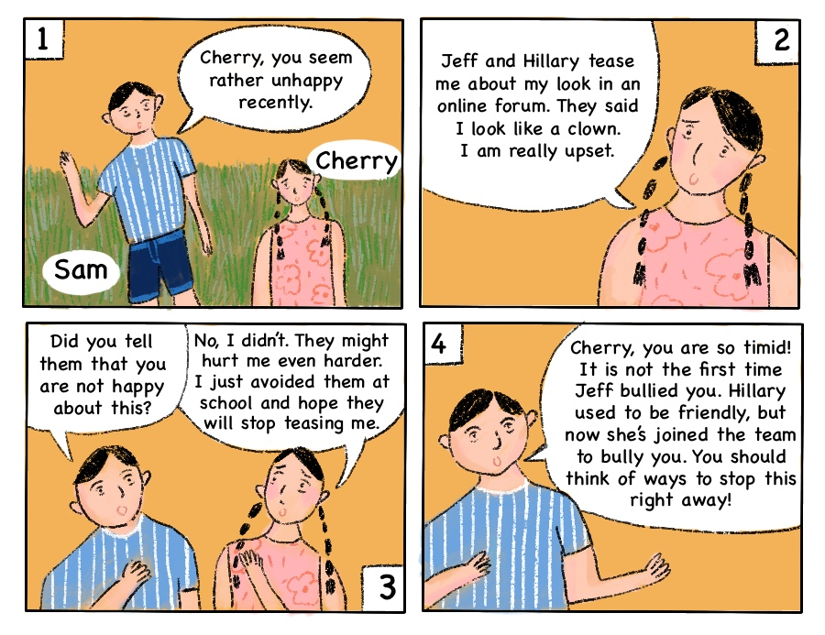

1. What types of bullying have occurred in Cherry’s case? Give reasons to support your answer.

Verbal bullying and cyberbullying have occurred because the bullies tease Cherry about her look in an online forum.

____________________________________________________________________________________________________________________________

1. Name two possible factors that cause bullying to occur on Cherry. Give reasons to support your answer.

The first possible factor is Cherry’s personality. Since Cherry is timid and always puts up with the bullying, this encourages Dave to bully her further. The second factor is peer influence. Hilary is influenced by Dave and joins him to tease Cherry.

____________________________________________________________________________________________________________________________

____________________________________________________________________________________________________________________________

1. What are the possible ways to deal with the bullying in Cherry’s situation? Give at least two more suggestions and provide reasons to support your answer. Write in about 80 words excluding the words given.

**Ways to deal with the bullies in Cherry’s situation**

From the cartoon strip, I understand Cherry has been feeling sad because of the bullies. If I were Cherry, I would do three things.

Hint:

Start by providing an explanation here.

For help, refer to Language support ‘Justifying by giving reasons’.

Hint:

Write two more ways with explanations here. Sequencing words like ‘Next’, and ‘In addition’ are helpful to link up suggestions.

First, I would tell the bullies that I am not happy and would ask them to stop teasing me on the forum. ________________________________________ _____________________________________________________________

It is because if I do not do so, they would just continue to think it is acceptable.

Next, I would block the bullies on the Internet. It is because when I do not read their negative comments, I would not feel bad.

In addition, I would inform my parents or teachers immediately. Parents and teachers are adults; they would be able to give good advice to me.

Finally, with the help of the teachers, the bullies and other classmates may stop teasing me again because teachers want the school to be a safe place for everyone and will deal with bullying seriously.

_____________________________________________________________

_____________________________________________________________

_____________________________________________________________

_____________________________________________________________

_____________________________________________________________

_____________________________________________________________

_____________________________________________________________

_____________________________________________________________

_____________________________________________________________

_____________________________________________________________

By facing the problem of bullying bravely, there is a better chance to stop it.

**Peer evaluation**

Give your essay to your neighbouring classmate and ask him/her to complete the peer evaluation form below. Remind your classmate to sign the form before returning it to you.

***Peer Evaluation Form***

|  |  |
| --- | --- |
| **Description** | **Feedback**  ***No star= minimum score; 5 stars = maximum score*** |
| Able to give at least two more effective ways to deal with bullying. |  |
| Able to provide good reasons for justifying each way to deal with bullying. |  |
| Able to use sequencing words such as ‘First’ and ‘Next’ to organise suggestions. |  |
| Optional: Do you want to give any written feedback* to your classmate? |  |
|  | Signature: |

***\**** You are encouraged to write down a few words to give encouragement and support to your classmate such as “Nice work!”, “Interesting”, “I like the way you write about ….”,“You are making good progress.”, “Your work will be better if you can ….”, “More effort is needed, especially in …”.

**Part 4:**  ***My vocabulary bank and learning record***

Notes to teachers:

Given the importance, this part will be included in every unit.

In this part, you will revise the topic vocabulary and assess your learning.

***My vocabulary bank***

|  |
| --- |
| Do you want to write better answers to questions in *Life and Society (Secondary 1-3)*?  Good writing comes from well-written paragraphs and sentences. And well-written paragraphs and sentences are built with proper English vocabulary. Generally, English vocabulary can be sorted into three groups: ***subject-specific***(專科的) **vocabulary**, **general academic vocabulary**, and **logical connectors** (linking words).   * *Subject-specific vocabulary*: key concepts specific to a subject, namely Life and Society or Integrated Humanities. * *General academic vocabulary*: Words that are used more often in written texts rather than informal conversations. They help us express ideas more precisely. * *Logical connectors* (linking words): conjunctions and phrases that connect ideas. |

***Task 1 Finding useful expressions for “Bullying”***

Fill in the blanks of the subject-specific vocabulary, general academic vocabulary and linking words from three parts in the unit. Some are already done as examples.

1. **The nature of bullying**

|  |  |  |
| --- | --- | --- |
| **Subject-specific**  **vocabulary** | **General academic vocabulary** | **Linking words** |
| Bullying (n.)  Conflict (n.)  Violence (n.)  **Types of bullying**  ber  sical  cial  bal  Cy_____bullying (n.)  Phy_______ bullying (n. ph.)  So______ bullying (n. ph.)  Ver_______ bullying (n. ph.) | ***Explaining causal relationship:***  to cause … (v. ph.)  ***Giving examples***   1. includes … (v.)   ***Characteristics of bullying* (subject-specific)**  behaviours that cause harm (n. ph.)  deliberate behaviours (n. ph.)  imbalance of power (n. ph.)  repeated behaviours (n. ph.)  **Bullying behaviours (subject-specific)**  lling    clude  tort  sty  mours  se  Name-ca_______ (n.)  To embarrass someone (v. ph.)  To ex________ someone from groups (v. ph.)  To ex_________ something from another person (v. ph.)  To gossip about someone (v. ph.)  To insult someone (v. ph.)  To play na ______ jokes (v. ph.)  To send offensive texts (v. ph.)  To spread ru_________ (v. ph.)  To tea_________ someone about his / her appearance (v. ph.)  Shove (v.) | ***Explaining/Justifying***  … because …  … because of …  ***Showing condition***  … when … |

**2. Reasons for bullying**

|  |  |  |
| --- | --- | --- |
| **Subject-specific vocabulary** | **General academic vocabulary** | **Linking words** |
| ***Possible causes of bullying***  **Personal factors:**  ressive  Agg___________ (adj.)  troverted  In___________ (adj.)  lated  Iso___________ (adj.)  tite  Pe___________ (adj.)  missive  Sub___________ (adj.)  **External factors:**  Agg___________ in the family (n. ph.)  ression  Bullies’ mutual  fluence  Peer in_________ (n. ph.)  standers  Role of By___________ (n. ph.)  pport  Su________ (n. ph.)  involved  Un_________ Parents (n. ph.) | ***Verbs (v.)***  rove  App___________  spond  Re___________  ***Adverbs (adv.)***  sionally  Occa___________  ssively  Pa___________  ngly  Wro___________  ***Nouns (n.)***  haviors  Aggressive be___________  ention  Att___________  sequences  Con_______________  portance  Im ___________  ers  Pe___________  agers  Teen___________  lence  Vio___________  ***Adjectives (Adj.)***  ective  Eff___________ | ***Giving example***  For ex__________  ample  ***Showing results***  Con___________  sequently  Ther__________  efore  ***Showing contrasts***  But  ***Showing time condition***  When__________  ever |

**3. Dealing with bully**

|  |  |  |
| --- | --- | --- |
| **Subject-specific vocabulary**  mand | **General academic vocabulary**  ults | **Linking words** |
| bully’s de________ (n.)  eak  br_______ times (n.)  give in (phrasal v.)  ave  le_____ the scene (v. phrase) | ad__________ (n.)  al  de______ with (prep. v.)  ur  occ____ (v.) | ***Expressing condition***  If  ***Giving examples***  In add__________  ition |

***Task 2 My choice of the most useful words and expressions***

In the space below, write:

1. FIVE top most useful subject-specific words,
2. FIVE general academic words, and
3. THREE linking words you have learnt in this unit.

Compare your choice with your neighbouring classmate; see if there are similarities and differences and discuss.

1. **Subject-specific words**

[Student answer]

**____________________________________________________________________________________________________________________________________**

**____________________________________________________________________________________________________________________________________**

**__________________________________________________________________**

1. **General academic words**

[Student answer]

**____________________________________________________________________________________________________________________________________**

**____________________________________________________________________________________________________________________________________**

**____________________________________________________________________________________________________________________________________**

1. **Linking words**

[Student answer]

**______________________________________________________________________________________________________________________________________________________________________________________________________**

***Task 3*** ***My learning record of “Bullying”***

*Put a tick (√) if you think you can manage the item in this unit.*

**Do I know …**

|  |  |  |
| --- | --- | --- |
|  | **Item:** | **Yes (√)/No (🗶)** |
| 1. | the characteristics of bullying? |  |
| 2. | different types of bullying? |  |
| 3. | common bullying behaviours? |  |
| 4. | the causes (personal and external factors) for bullying? |  |
| 5. | some possible ways to deal with bullies? |  |