Teaching Manual for Enhancing Students’ English Writing Skills through Language across the Curriculum
in Life and Society (Secondary 1-3)

Managing Cyber-friendship

Reading & Writing Unit




Hong Kong secondary school students studying subject contents in English typically find it challenging to express what they want to say in writing. This is especially the case for subjects where language competences are an integral part of learning, such as Life and Society (Secondary 1-3) in the PSHE KLA.

The “Teaching Manual for Enhancing Students’ English Writing Skills through Language across the Curriculum in Life and Society (Secondary 1-3)” (the Manual) aims to demonstrate how the learning of subject contents and development of academic writing skills can be interweaved in carefully designed scaffolding activities and tasks. The Manual contains 10 sample units. Educationally sound practices such as “Catering for Learner Diversity”, ”Peer Evaluation” and “Assessment as Learning” are incorporated in these sample units to facilitate learning and teaching. Upon completion, students are expected to develop an enhanced understanding of the topics taught, sharper writing skills for answering questions and better knowledge of the language functions covered.

For Life and Society teachers, we hope that the Manual will provide them with useful teaching resources for direct, selective or adaptive use. For other PSHE subject teachers, we hope that the Manual will demonstrate one possible way of how Language across the Curriculum practices can bring greater benefits to learning and teaching.

Edward Y.W. Chu
April Liu
The Open University of Hong Kong

Unit Overview
Managing Cyber-friendship

Strand | 1
Module | Human relationship (II): Managing cyber-friendship
Target Class Level | S1
Learning Objectives | Contents:  Students can:  - describe the characteristics, values and possible risks of cyber-friendship;  - suggest ways to deal with and develop cyber-friendship  Language functions:  Students can:  - tell and use the key terms about cyber-friendship (e.g. social networking websites, Internet fraud);  - use the following language functions correctly and appropriately:  - explaining reasons and results  - sequencing and linking ideas  - expressing likeliness  - making suggestions

Module 4
Human Relationship (II):
Managing Cyber-friendship
Contents

Part 1: Characteristics of cyber-friendship
Task 1 Do you have any cyber-friends?
Task 2 What are the characteristics of cyber-friendship?
Language support I: Explaining reasons and results
Language support II: Sequencing and linking ideas
Part 2: Values and possible risks of cyber-friendship
Task 1 What are the values of making cyber-friends?
Task 2 What are some possible risks of making friends online?
Language support III: Expressing likeliness using Type I conditional
Part 3: Ways to deal with and develop cyber-friendship
Task 1 How to avoid social media trap
Language support IV: Making suggestions using ‘should’, ‘ought to’ and the imperative form
Task 2 Should we have cyber-friends only and no other friends?
Part 4: My vocabulary bank and learning record
Task 1 Finding useful expressions for “Managing Cyber-friendship”
Task 2 My choice of the most useful words and expressions
Task 3 My learning record of “Managing Cyber-friendship”

Part 1: Characteristics of cyber-friendship
There has been a long tradition that people make friends and maintain friendship in person. However, with the improvement of information and communication technology, a new way of developing friendship - cyber-friendship - has emerged. Cyber-friendship is defined as a friendship that is established and developed based on communication only through the Internet or cyberspace. Then what are the characteristics of cyber-friendship?

Task 1 Do you have any cyber-friends?
- Below are different means of communication. Fill in the blanks. A few answers have been done as examples. Also, circle the numbers of pictures which show the means you use to communicate with your friends. [Student answer]
 |  | 
- face-to-face contact  face-to-face contact | - telephone  telephone | - mobile phone  mobile phone
 |  | 
- mail  mail | - Email  email | - Chatroom / forum  chatroom / forum
 |  |   social networking websites (e.g. Facebook / Weibo)
Message apps  (e.g. WhatsApp /  WeChat / LINE) | Video call (Skype)
- Refer to your answers in Question (1). In what ways do you communicate with your friends on the Internet?
I communicate with my friends through _________________________________
[Student answer] Suggested answer: I communicate with my friends on the Internet by messaging apps, social networking websites and (sending) emails

_________________________________________________________________
_________________________________________________________________
- How does the Internet help you to establish and maintain friendship?
[Student answer] Suggested answer: It helps me to expand my social network, make more friends, keep in touch with my friends and maintain friendship through sharing experience and feelings.
______________________________________________________________________________________________________________________________________________________________________________________________________
__________________________________________________________________
- Have you made any friends online and developed the friendship based on communication only through the Internet? If yes, do you want to meet them?
[Student answer] Suggested answer:
Yes, I have. I want / do not want to meet them.
Or No, I have not.

_________________________________________________________________
_________________________________________________________________
_________________________________________________________________
- Do you trust cyber-friends? Why or why not?

[Student answer] Suggested answer:
(for yes) we have built strong friendship.
(for no) we have not met in real life.

Yes / No, it is because _______________________________________________
_________________________________________________________________
_________________________________________________________________
_________________________________________________________________
Summary
Circle the correct words to complete the sentences below.

Cyber-friends are friends who meet only online / offline. Most of them have /
have no face-to-face contact in real life.

Task 2 What are the characteristics of cyber-friendship?
Traditionally, real friends share personal details, spend quality time and hang out with each other in person. However, with the use of online communication, people keep chatting with their virtual friends on the Internet almost every day. Can true friendship be nurtured in this way? By comparing the traditional friendship with cyber-friendship, we can find out the characteristics of cyber-friendship.
- Read the online text below and complete the chart which follows.

There is a debate about whether it is easier to make friends in social networking sites than face to face. Below are some of the opinions posted on the Internet.
Notes to teachers:
Teachers may introduce the term ‘social clues’ with the examples of facial expression and body language.
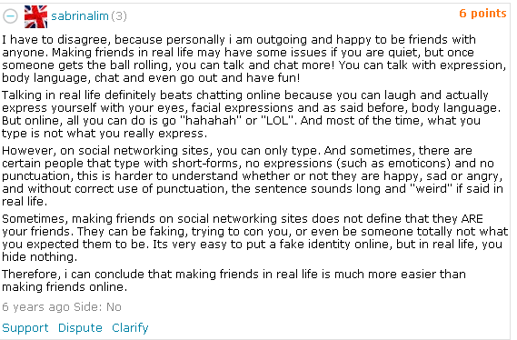
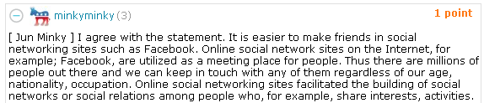


Notes to teachers:
Teachers may introduce the term ‘fake identity’.


Notes to teachers:
Teachers may introduce the term ‘nationality’ and ask students why people can make friends everywhere online. This can bring out the feature of no space and time limitation in making virtual friends.


Notes to teachers:
The excerpts are authentic materials extracted from the web. They are not written in perfect English, and obviously contains grammatical mistakes.

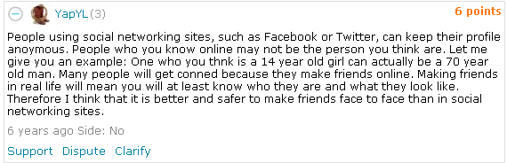


Notes to teachers:
Teachers may introduce the term ‘anonymous’ and ask students why it is not safe to make friends online.
Notes to teachers:
Teachers may introduce the term ‘anonymous’ and ask students why it is not safe to make friends online.

Source:
http://www.createdebate.com/debate/show/IT_IS_EASIER_TO_MAKE_FRIENDS_IN_SOCIAL_NETWORKING_SITES_SUCH_AS_FACEBOOK_THAN_FACE_TO_FACE

Language support I: Explaining reasons and results

Expressing reasons
Here is an example of how an idea is explained using linking words:
Statement | Linking words | Reason (Clause = subject + verb)
Talking in real life definitely beats chatting online | because  as  since | you can laugh and actually express yourself with your eyes, facial expressions and body language.

Adverb clause of reason or cause

- A common mistake involves using ‘so’ in addition to the linking word in a sentence:
Since you can laugh and express yourself with your eyes, facial expressions and body language, so talking in real life definitely beats chatting online.
- The correct way should be like this:
Since you can laugh and express yourself with your eyes, facial expressions and body language, talking in real life definitely beats chatting online.

Expressing results
Here is an example of how a result is expressed using a conjunctive adverb:
Statement | Conjunctive  adverb | Result (Clause = subject + verb)
Making friends in real life will mean you will at least know who they are and what they look like. | Therefore,  Thus,  As a result, | I think it is better and safer to make friends face to face than in social networking sites.

Adverb clause of result

Quick quiz:
- Go back to the online text on the previous page. Circle the words from the text which are used to express reasons.
- Go back to the online text. Underline the words from the online text which are used to express results
- Which conjunctive adverbs mentioned in the table above were not found in the text? ____________________________
Since, As a result
- To tell the differences between traditional friendship and cyber-friendship, complete the following chart by filling in the blanks and circling the correct words.

Differences between traditional friendship and cyber-friendship

Cyber-friendship
(Friends made on the Internet)
Traditional friendship
(Friends made with face-to-face contact)
Characteristics
Communication mainly through t____ or i______,

Communication through
_______________ contact

mages
ext
face-to -face
Mode of communication

Giving / Not giving social clues from facial expression, eye contact and gesture. Telling lies more difficult.

Not giving social clues. Telling lies ____________________.

Social clues
easier

Giving instant, delayed or no reply to the message
Giving instant / delayed / no reply to the message
Response time of message

Having no space and time limitation in making friends
Having large no space and time limitation in making friends
Space and time limitation


Having broad coverage of friends
ationalities
__________________________________ with different n____________, social classes or ages
Having broad / narrow coverage of friends
Coverage of friends

- Showing true /
faked identity
- Having the single /
multiple identity (ies)

- Showing nicknames or being a__________
- ___________________
- ____________________
- ___________________
____________________
Identity
nonymous
Showing faked identity Having multiple identities

Able / Unable to determine if personal information is true based on the appearance, gender and age

Unable to determine if personal information
is true
Personal information
- Disclosing true /faked personal information
- _________________________________________________________


Notes to teachers:
Teachers may encourage students of stronger ability to explain each of the characteristics of cyber-friendship.

Language support II: Sequencing and linking ideas

In argumentative (e.g. agreement or disagreement) and descriptive writing (e.g. describing serval characteristics of cyber-friendship), it is often necessary to present the statements orderly. The following linking words can be used at the beginning of each sub-point to connect ideas and sentences effectively:
- “firstly/first”
- “secondly/second”
- “thirdly/third”
- “finally/lastly”

- Based on the online text and the flowchart “Differences between traditional friendship and cyber-friendship” in Question (1), describe the characteristics of cyber-friendship. Hints are given in the margin to help you.
Hint 1:
What is the mode of communication? Is there any social clue?
communication with friends is mainly through text or images on the Internet. As people cannot see the facial expression, eye contact and gesture of their friends, no social clues are given.

There are several characteristics of cyber-friendship. First, __________________ ______________________________________________________________________________________________________________________________________________________________________________________________________
Hint 2:
What kind of reply can people give on the Internet?
people can give instant, delayed or no reply to the message.

Second, ___________________________________________________________ __________________________________________________________________Third, _____________________________________________________________ ____________________________________________________________________________________________________________________________________
Hint 3:
What are the backgrounds of cyber- friends? Why can there be such broad coverage of friends?)
since there is no space and time limitation in making friends on the Internet, people can make friends with different nationalities, social classes or ages far away from them at any time. Therefore, they have broad coverage of friends.
__________________________________________________________________
Hint 4:
Talk about identities on the Internet. Start with a linking word.
Fourth, people may only show nicknames or can be anonymous on the Internet. They may also show faked identity or have multiple identities.

Finally, people may disclose faked personal information, but we are unable to determine if the personal information is true or not on the Internet.

__________________________________________________________________ ___________________________________________________________________________________________________________________________________
Hint 5:
Talk about personal information on the Internet. Start with a linking word.
__________________________________________________________________ __________________________________________________________________

For students of weaker ability

The Characteristics of Cyber-friendship
There are several characteristics of cyber-friendship. First, communication with friends is mainly through text or images on the Internet. As people cannot see the facial expression and gesture of their friends and have eye contact, no social clues are given. Second, people can give instant, __________ or __________ reply to the message. Third, since there is no __________ and __________ limitation in making friends on the Internet, people can make friends with __________ nationalities, social classes or ages far away from them at any time. Therefore, they have __________ coverage of friends. Fourth, people may only show __________ or can be ____________ on the Internet. They may also show __________ identities or have __________ identities. Finally, people may disclose __________ personal information, but we are unable to __________ if the personal information is __________ or not on the Internet.
true

determine

faked

multiple

fakedd

nicknames

anonymous

broad

different

time

space

no

delayed


- Do you agree that it is easier to make friends in social networking site than face to face? Give three reasons to support your answer. [Hint: Refer to the characteristics of cyber-friendship in Question 2.]
I *agree / do not agree that it is easier to make friends in social networking sites than face to face. ___________ reasons can be put forward to explain this. First, ______________________________________________________________________________________________________________________________________________________________________________________________________________________________________________________________________________________________________________________________________________________________________________________________________________________________________________________________________________
[Student answer] Suggested answer: (Agreement) it is easier to make friends online because I can look for people of similar interests on social networking sites while in reality, I can only meet such people by chance. Second, there is less pressure in cyber-friendship since cyber-friends are usually anonymous to each other. Therefore, I can talk more freely with cyber-friends and do not have to worry that they will speak ill of me. Finally, there is more flexibility in cyber-friendship since there is no space or time limitation.

Three

Hint:
The previous language supports for “expressing reasons and results” and “sequencing” are helpful.
__________________________________________________________________
*delete where appropriate
First,____________________________________________________________________________________________________________________________________________________________________________________________________________________________________________________________________________________________________________________________________________________________________________________________________________________________________________________________________________________________________________________________________________
[Student answer] Suggested answer: (Disagreement) it is not easier to make friends online because I communicate with friends mainly through text or images on the Internet. The lack of social clues may lead to misunderstandings. Second, since people may only show faked identity or disclose faked personal information on the Internet, it will be difficult to make friends without trust. Third, they may give delayed or no reply to my messages. Without sharing, it is not easy to make friends online.
__________________________________________________________________

Part 2: Values and possible risks of cyber-friendship
From the activities in Part 1, we find that cyber-friendship is very different from traditional friendship. It has unique values of making online friends, but some people find developing friendship on the Internet risky.
Task 1 What are the values of making online friends?
True friendship is more about intimacy – the need to have warm and close relationship. Such relationship is built on mutual respect and support, common interests and shared feelings and ideas. Cyber-friends usually use concealed identity to communicate with one another on the Internet. In a way it is good as people are usually more willing to share their feelings and thoughts without much worry. Cyber-friends you met in certain chatrooms are also more likely to appreciate you as you share common interests with them. What is more, with interesting images and videos abound, sharing, the essence of friendship, is just a few clicks away. So there are indeed values of making friends online.

However, a cautionary note to make is that people should maintain cyber-friendship properly. For example, if they do not give a reply to the message from their cyber-friend due to the lack of time and energy, cyber-friendship is not going to last.
1. Refer to the text above. How is the true friendship developed?
True friendship can be developed when people can develop their intimate relationship through mutual respect and support, common interests and shared feelings and ideas.
____________________________________________________________________________________________________________________________________
__________________________________________________________________
2. The cartoon below shows the benefits of making cyber-friends.
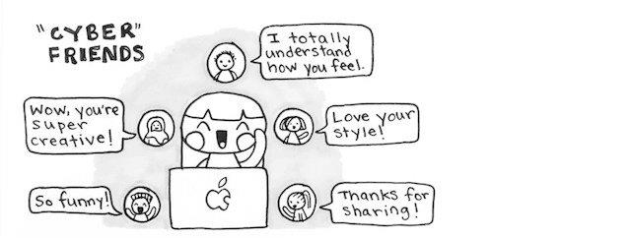
Source: https://www.elephantjournal.com/2017/10/the-inner-life-of-an-introvert-in-10-cute-drawings/

(a) Refer to the cartoon. Which dialogues support the following benefits of cyber-friendship?
Benefits of cyber-friendship | Evidence with dialogues
Gaining emotional support | I totally understand what you feel.
Gaining recognition and reconstructing self-image | Wow, you are super creative!  Love your style!  So funny!
Facilitating more exchange of ideas | Thanks for sharing!

(b) Refer to the text box in Task 1 of this part. Complete the table below to explain why making online friends brings the benefits mentioned in Question (2)(a).
Reasons | Benefits of cyber-friendship
Cyber-friends usually use concealed identity. In a way it is good as people are usually more willing to share their feelings and thoughts without much worry. | Gaining emotional support
Cyber-friends you met in certain chatrooms are also more likely to appreciate you as you share common interests with them. | Gaining recognition and reconstructing self-image
With interesting images and videos abound, sharing, the essence of friendship, is just a few clicks away. | Facilitating more exchange of ideas
(c) Do you agree with the cartoon about the benefits of making cyber-friends?
Why?
[Student answer] Suggested answer: (Agreement) making friends online can have emotional support, gain recognition, reconstruct self-image and facilitate more exchange of ideas.
Yes, I agree / No, I don’t agree because ________________________________
________________________________________________________________
________________________________________________________________
________________________________________________________________

__________________________________________________________________
[Student answer] Suggested answer: (Disagreement) The cyber-friends may give delayed or no reply to the messages and they may be mean. Therefore, we may not be able us to have emotional support, gain recognition, reconstruct self-image and facilitate more exchange of ideas.
ideas.
__________________________________________________________________
__________________________________________________________________
__________________________________________________________________

3. What else can people learn or gain from these cyber-friends? How? [Hint: Refer to minkyminky’s message in the online text in Part 1 Task 2.]
People can make friends with different ages, nationalities, or occupation. They can build social networks or social relations among people who share interests and activities.
________________________________________________________________________________________________________________________________________________________________________________________________________________________________________________________________________
4. Can true friendship be developed on the Internet? Give reasons to support your answer. [Hint: You may refer to the text in Part 2 Task 1 and answers in Question 1.]
[Student answer] Suggested answer: (Agreement) True friendship can be developed on the Internet because cyber-friends can develop their intimate relationship through mutual respect and support, common interests and shared feelings and ideas. However, it still depends on how people nurture and maintain cyber-friendship on the Internet. For example, if they do not give a reply to the message from their cyber-friend due to the lack of time and energy, true friendship cannot be developed.
______________________________________________________________________________________________________________________________________________________________________________________________________
__________________________________________________________________
__________________________________________________________________
__________________________________________________________________
__________________________________________________________________
[Student answer] Suggested answer: (Disagreement) True friendship cannot be developed on the Internet because the lack of social clues may lead to misunderstandings. Besides, since people may only show faked identity or disclose faked personal information on the Internet, it will be difficult to make friends without trust.
Task 2 What are some possible risks of making friends online?
On developing friendship on the Internet, people may meet those who take advantage of concealed identities to engage in Internet fraud or force their cyber-friends to involve in illegal or immoral activities. Let’s look at the possible risks of making friends online in this task.
- The following pictures show some possible risks of making friends online. Match the pictures with their suitable headings.
  (a) |  | Being addicted to the cyber world
  (b) |  | Threat of receiving hate speeches.
  (c) |  | Threat of fraud
  (d) |  | Threat of cyber pornography
2. Read the following article about the risks in making cyber-friends and complete the following tasks.

Some risks of cyber-friendship

In the last few years, the Internet has emerged as a major source of friendship. In real life, the number of friends may be less while in virtual life, the list of friends is longer since you can meet different people quickly. But you need to be very cautious about risks from making friends online:

1. Internet addiction
You may get addicted to the Internet, which can be very fatal. For example, it has been frequently reported that people are suffering from depression due to not chatting with cyber-friends for some time.

2. Loss of personal life
Your personal life offline may be negatively affected. If you indulge in making cyber-friends on the Internet, you will be isolated from family and friends in real life and the true social life may be lost.

3. Health
Cyber-friendship can spoil your physical health if you spend long time online every day. It is harmful to sit in one place for a long time, and sometimes we may also ignore hunger, thirst and fatigues.

4. Identity theft
Some online friends may give faked personal information and pretend to be your real friends. Since you are not vigilant against dangers and have weak self-protection abilities, you tend to share your personal information with friends on social media. This can lead to serious troubles. More often than not, you may become a victim of some big deception or fraud. If you trust someone online and share your personal photos, these photos can be used to spoil your image or steal your identity.

Adapted from:
https://www.chaigossips.com/this-friendship-day-be-careful-of-cyber-friendship-follow-these-tips/
Based on the article “Some risks of cyber-friendships” and your knowledge about characteristics of cyber-friendship, answer the following questions.
- How does developing cyber-friendship affect personal life and social life? (Hint: In addition to the article, refer as well to the online text on p.6 and the chart of traditional and cyber-friendship on p.8)
If people indulge in making cyber-friends on the Internet, they will be isolated from their family and friends in real life. They will lose their social life. Also, their health will be spoiled since they may ignore hunger thirst and fatigues.
____________________________________________________________________________________________________________________________________________________________________________________________________________________________________________________________
Through online chatting, people are not vigilant against dangers and have weak self-protection abilities. They share their personal information with their online friends easily. Also, since people do not have face-to-face contact on the Internet, they have no social clues that can tell them if their cyber-friends tell lies. In addition, online friends may give faked personal information. They may pretend to be real friends. As a result, they may be deceived.
- Why are people deceived by cyber-friends? ____________________________________________________________________________________________________________________________________________________________________________________________________________________________________________________________
______________________________________________________________________________________________________________________________
_______________________________________________________________
Language support III: Expressing likeliness using Type I conditional

You may have learnt Type I conditional sentence before. Here’s an example:
Structure: if-clause (Simple Present) + main clause (future tense)
If-clause (verb in simple present) | Main clause (modal verb)
If people face the threat of Internet fraud, | they will be hurt emotionally.
Type I conditional sentence is used to express that the action in the main clause is likely to happen if a certain condition (in the if-clause) is met.
There are different modal verbs showing different degrees of likeliness:
must will can may

Very likely Quite likely Somewhat likely


- Writing Task I
Your friend, Miranda, enjoys making friends online and even discloses very personal information to her cyber-friends. You are worried and would like to send her a text message. With your knowledge gained from “Some risks of cyber-friendship”, explain the consequences to Miranda if she discloses personal information online.


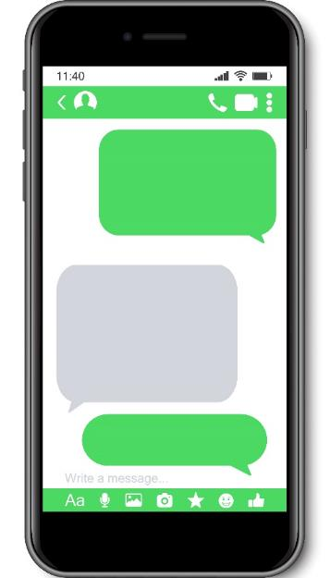
I’ll share very personal info
with my cyber-friends.
Okay. I won’t do it again.
Hi Miranda,
…
Hint:
The language support on “Expressing likeliness” and “Expressing reasons and results” are useful for this task.
Hi Miranda,
_________________________________________________________________ _________________________________________________________________ _________________________________________________________________ _________________________________________________________________ _________________________________________________________________ _________________________________________________________________
[Student answer]. Suggested answer: If you share personal information, you may face the threat of Internet fraud, which will hurt you emotionally or lead to financial loss. Your personal safety may also be threatened if school/home addresses are shared. In addition, you may be forced to do something illegal or immoral. Therefore, you should avoid sharing personal information online.
_________________________________________________________________
_________________________________________________________________
Part 3: Ways to deal with cyber-friendship
It is found that developing cyber-friendship on the Internet is risky. How should we deal with and develop cyber-friendship properly? First, we should be cautious and protect ourselves. We should also be the responsible netizens, stick to ethical principles and consider the possible long-term effects of our action. Finally, we should set suitable online time limit, so our daily lives are not adversely affected.
Task 1 How to avoid social media trap
To develop cyber-friendship, it is important that we do not fall into traps in the social networks.
- Watch a video clip about how to avoid social media trap [0:00 – 2:53].
https://www.youtube.com/watch?v=01Ec65JtNR8
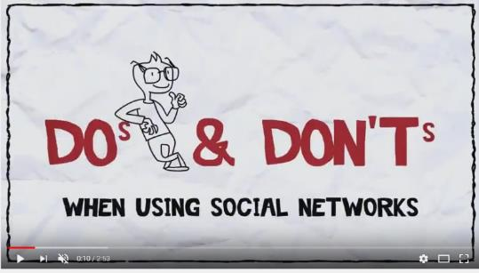

Language support IV: Making suggestions

- To give an opinion or make suggestions, we can use the modal verb ‘should’ or ‘ought to’:
 | Modal verb | Infinitive without to
We | should | be | the responsible netizens.
We | ought to | be | the responsible netizens.

- Another choice is using the imperative form. Imperatives are infinitives of a
verb without 'to':
e.g. Choose sensible, strong and hard-to-guess password.
To make a negative imperative, put "do not" or "don't" before the
imperative:
e.g. Don’t meet cyber-friends face-to-face alone.
According to the video, what advice is given to avoid falling into traps when we develop cyber-friendship on social media? Fill in the blanks while you are watching it. The first letter is given as the hints:
Principles | Advice  nformation
Be cautious and protect ourselves | - Don’t publish personal i_____________ online.  elective  - Be s___________ when adding cyber-friends  - S___________ and think before you click when there are so-called online miracles, e.g. winning prizes.  pload  top
Be responsible for our online behaviour | - Don’t u____________ inappropriate pictures  anguage  - Don’t use inappropriate l______________

- Read the passage about the safe ways of meeting cyber-friends.
Meeting cyber-friends safely
Bearing in mind that there are risks of cyber-friendship, the safest way, of course, is to keep your cyber-friends online. Learning some tips about meeting cyber-friends safely may also be useful. You never know if you or your friends may need them one day.
- Unless you already know the person offline, always assume the person you are dealing with on the Internet is not who they claim to be and conduct yourself accordingly.
- Never arrange to meet an Internet friend alone even if you think you know him/her very well. If you must meet them, do so in a very public and neutral place, bring along an adult or a few friends and tell your parents.
- Never arrange to travel great distances alone to see an online friend, even if you’ve already met face-to-face.
- Always tell your parents what you are up to, where you will be and when you will be back and don’t deviate from your plans without clearing it with them first.
- Once you’ve met an online friend never go anywhere private with them.
- Never ask another person to lie for you so you can meet an online friend. If your meeting has to start with a lie it can't possibly be good.

Adapted from: https://www.liveabout.com/meeting-people-online-online-safety-tips-for-teens-3196625
Writing Task II
Your classmate, Susan told you that she would meet her new cyber-friend face-to-face alone at his home.

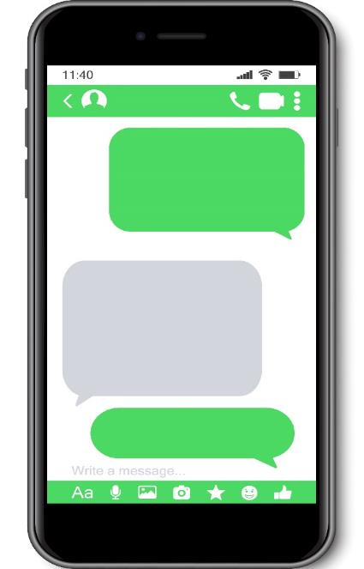

I am so happy that I can meet my new cyber-friend tonight.



Susan, where
will you meet
with him?
Anyone will go with you?

I will meet him alone at his home.

What three pieces of advice would you give her? [Hint: Refer to the reading passage in Question 2 and use the modal verb ‘should’ in your answers.]
[Student answer] Suggested answer:
I would give her three pieces of advice. First, she should not meet her new cyber-friend until she knows each other for a longer time. Second, she
should meet him in a public area where a lot of people walk around. Third,
she should go with an adult, such as her parent, when meeting with her cyber-friend or meet him in group activities.
____________________________________________________________________________________________________________________________________
____________________________________________________________________________________________________________________________________
__________________________________________________________________
__________________________________________________________________
__________________________________________________________________

Task 2 Should we have cyber-friends only and no other friends?
Writing Task III

Your classmate, Tom, indulges in making cyber-friends on the Internet. What advice would you give him so that he can avoid Internet addiction? Explain your answers with two reasons. [Hint: Refer to Part 2 Task 2 ‘Some risks of cyber-friendship and the language support on “Making suggestions” in Part 3 Task 1.]
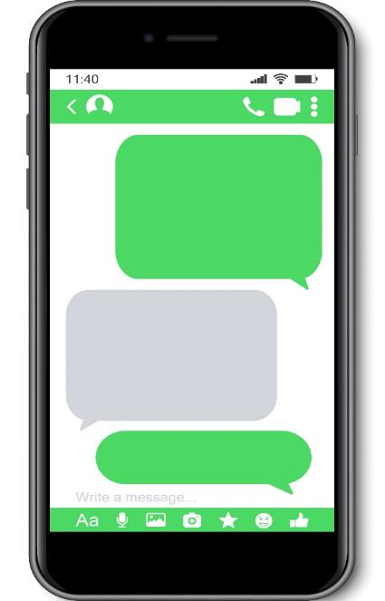


I chatted with many cyber- friends for 4 hours last nit.
We share a lot of common interests!
Tom, how can you ever get enough sleep for school the next day?
Well I just can’t help.

[Student answer] Suggested answer: First, he should set suitable online time limit for himself. Second, he ought to join a wide range of activities to make more friends and expand his social circle in real life. The reason behind is that indulging himself in the cyber world without interaction with families and friends leads to internet addition. It has been reported that people can suffer from depression due to not chatting with cyber-friends for some time.
__________________________________________________________________________________________________________________________________________
_________________________________________________________________________________________________________________________________________________________________________________________________________________________________________________________________________________________________________________________________________________________

Peer evaluation
Give your writing to your neighbouring classmate and ask him/her to complete the peer evaluation form below. Remind your classmate to sign the form before returning it to you.
Peer Evaluation Form
Description | Feedback  No star= minimum score; 5 stars = maximum score
Able to give at least two pieces of advice to avoid Internet addiction.
Able to use appropriate auxiliary verbs such as ‘should’ or ‘ought to’ when giving advice.
Able to explain the advice with two good reasons.
Optional: Do you want to give any written feedback* to your classmate?
 | Signature:

* You are encouraged to write down a few words to give encouragement and support to your classmate such as “Nice work!”, “Interesting”, “I like the way you write about ….”,“You are making good progress.”, “Your work will be better if you can ….”, “More effort is needed, especially in …”.


Part 3: My vocabulary bank and learning record
Notes to teachers:
Given the importance, this part will be included in every unit.

In this part, you will revise the topic vocabulary and assess your learning.
My vocabulary bank
Do you want to write better answers to questions in Life and Society (Secondary 1-3)?
Good writing comes from well-written paragraphs and sentences. And well-written paragraphs and sentences are built with proper English vocabulary. Generally, English vocabulary can be sorted into three groups: subject-specific (專科的) vocabulary, general academic vocabulary, and logical connectors (linking words).

- Subject-specific vocabulary: key concepts specific to a subject, namely Life and Society or Integrated Humanities.
- General academic vocabulary: Words that are used more often in written texts rather than informal conversations. They help us express ideas more precisely.
- Logical connectors (linking words): conjunctions and phrases that connect ideas.

Task 1 Finding useful expressions for “Managing Cyber-friendship”
Fill in the blanks of the subject-specific vocabulary, general academic vocabulary and linking words from three parts in the unit. Some are already done as examples.
- Characteristics of cyber-friendship
Subject-specific  Vocabulary  onymous | General academic vocabulary | Linking words
an___________ (adj.)  endship  berspace  cyber-fri____________ (n.)  cy____________ (n.)  ber-friend  cy____________ (n.)  layed  de___________ reply (n. ph.)  tact  face-to-face con_________ (n. ph.)  ked  fa________ identity (n. ph.)  rum  fo______ (n.)  stant  in____________ reply (n. ph.)  tities  multiple iden________ (n. ph.)  ues  social cl__________ (n. ph.)  social net_________ (n. ph.)  work  social net____________ website (compound n.)  working  tual  vir__________ friends (n. ph.) | Giving definitions:  - is defined as … (v. ph.)  Making comparison  by comparing (A) with (B) … (v. ph.)  em______ (v.)  erge  cial  fa___________ expression (n. ph.)  ture  ges______ (n.)  ng  ha______ out (phrasal v.)  information and com______________ technology (compound n.)  munication  in per______ (prep. ph.)  son  na_________ (n.)  tionalities  rture  nu__________ (v.)  lity  qua_______ time (compound n.)  itation  time lim__________ (compound n.)  dition  tra__________ (n.) | Explaining  Because (conj.)  Expressing results  Therefore,… (adv.)  Thus (adv.)  Showing contrast  However, … (adv.)  But (conj.)  Giving examples  For example, …  such as

- Values and possible risks of cyber-friendship
Subject-specific vocabulary  ict | General academic vocabulary  reciate | Linking words
add_____ (v.)  terests  common in_________ (n. ph.)  cealed  con_________ identity (n. ph.)  ography  cyber porn___________ (n.)  tional  emo_______ support (n. ph.)  change  ex_________ of ideas (n. ph.)  tity  iden_______ theft (n. ph.)  iction  internet add________ (n. ph.)  aud  internet fr____ (compound n.)  personal  inter_________ skills (n. ph.)  timacy  in______ (n.)  ss  lo____ of personal life (n. ph.)  spect  mutual re________ (n. ph.)  sonal  per_________ life (n. ph.)  cognition  re_________ (n.)  age  self-im______ (n.)  tection  self-pro___________ abilities (compound n.)  lings  shared fee_________ (n. ph.)  shared id______ (n. ph.)  eas  fe  social li_________ (n. ph.) | app__________ (v.)  ild  bu______ on (phrasal v.) …  ceive  de________ (v.)  legal  il______ activities (n. ph.)  moral  im______ activities (n. ph.)  decent  in_________ message (n. ph.)  dulge  in________ (v.)  scene  ob________ message (n. ph.)  vantage  take ad___________ of (v. ph.)  gilant  vi______ (adj.) | Showing contrast  but (conj.)  Showing effect  so (conj.)
- Ways to deal with cyber-friendship
Subject-specific vocabulary  viate | General academic vocabulary  utious | Linking words
de_______ one’s plan (v. ph.)  ternet  in________ friends (n.)  line  on_______ friends (n.)  blic  pu______ and neutral place (n.)  sponsible  re_________ netizens (n.)  ap  social media tr_____ (n. ph.) | ca_________ (adj.)  appropriate  in______________ language (n. ph.)  teraction  in_________ (n.)  lective  se__________ (adj.) | Adding ideas  first  also  finally

Task 2 My choice of the most useful words and expressions

In the space below, write:
- FIVE top most useful subject-specific words,
- FIVE general academic words, and
- THREE linking words you have learnt in this unit.
Compare your choice with your neighbouring classmate; see if there are similarities and differences and discuss.

- Subject-specific words
[Student answer]

____________________________________________________________________________________________________________________________________
____________________________________________________________________________________________________________________________________
__________________________________________________________________
- General academic words
[Student answer]

____________________________________________________________________________________________________________________________________
______________________________________________________________________________________________________________________________________________________________________________________________________
- Linking words
[Student answer]

______________________________________________________________________________________________________________________________________________________________________________________________________

Task 3 My learning record of “Managing Cyber-friendship”
Put a tick (√) if you think you can manage the item in this unit.

Do I know …

 | Item: | Yes (√)/No ()
1. | how to tell and use key terms about cyber-friendship?
2. | how to describe the characteristics of cyber-friendship?
3. | the values and possible risks of cyber-friendship?
4. | ways to deal with and develop cyber-friendship

