Teaching Manual for Enhancing Students’ English Writing Skills through Language across the Curriculum
in Life and Society (Secondary 1-3)

Module 23

Narrowing the Gap
between the Rich and the Poor

Reading & Writing Unit

Hong Kong secondary school students studying subject contents in English typically find it challenging to express what they want to say in writing. This is especially the case for subjects where language competences are an integral part of learning, such as Life and Society (Secondary 1-3) in the PSHE KLA.

The “Teaching Manual for Enhancing Students’ English Writing Skills through Language across the Curriculum in Life and Society (Secondary 1-3)” (the Manual) aims to demonstrate how the learning of subject contents and development of academic writing skills can be interweaved in carefully designed scaffolding activities and tasks. The Manual contains 10 sample units. Educationally sound practices such as “Catering for Learner Diversity”, ”Peer Evaluation” and “Assessment as Learning” are incorporated in these sample units to facilitate learning and teaching. Upon completion, students are expected to develop an enhanced understanding of the topics taught, sharper writing skills for answering questions and better knowledge of the language functions covered.

For Life and Society teachers, we hope that the Manual will provide them with useful teaching resources for direct, selective or adaptive use. For other PSHE subject teachers, we hope that the Manual will demonstrate one possible way of how Language across the Curriculum practices can bring greater benefits to learning and teaching.

Edward Y.W. Chu
April Liu
The Open University of Hong Kong

Unit Overview
Narrowing the Gap between the Rich and the Poor
Strand | 6
Module | Upholding the core values of our society:  Narrowing the Gap between the Rich & the Poor
Learning Objectives | Content:  Students can:  - tell some indicators available (e.g. Gini coefficient) for measuring the gap between the rich and the poor;  - describe the changes in the trend of the gap;  - describe the negative impacts of the wide gap;  - list the efforts as well as the constraints of the government, non-governmental organizations and individuals in narrowing the gap between the rich and the poor in Hong Kong  Language:  Students can:  - tell and use the key terms about the gap between the rich and the poor;  - use the following language functions correctly and appropriately:  - comparing and contrasting using “times”  - describing trends and changes using verbs and adverbs

Module 23
Upholding the Core Values of our Society:
Narrowing the Gap between the Rich and the Poor
Content

Part 1: The gap between the rich and the poor in Hong Kong
Task 1: Who are the poor?
Task 2: What indicators are used to measure the gap between the rich and the poor?
Language Support I: Comparing and contrasting using “times”
Task 3: Is the gap between the rich and the poor getting wider?
Language Support II: Describing trends and changes using verbs and
adverbs

Part 2: Narrowing the gap between the rich and the poor
Task 1: What is the impact of the wide gap between the rich and the poor?
Task 2: What efforts have been made to reduce the rich-poor gap in Hong Kong?
Task 3: Narrowing the rich-poor gap in Hong Kong: Some constraints and possible ways out

Part 3: My vocabulary bank and learning record
Task 1: Finding useful expressions for “Narrowing the Gap between the Rich and the Poor”
Task 2: My choice of the most useful words and expressions
Task 3: My learning record of “Narrowing the Gap between the
Rich and the Poor”

Part 1: The gap between the rich and the poor in Hong Kong

Many people living in Hong Kong have an acceptable living standard and have the basic things they need, such as food and daily necessities. However, images on television often highlight the differences that exist between different people in Hong Kong. Contrasts in their income, living conditions and everyday meals are very obvious. How wide do you think the gap is between the rich and the poor in Hong Kong?

Task 1: Who are the poor?
- Read the following story of two families in Hong Kong. Then answer the following questions.

A tale of two families

John Chan is a waiter working in a tea restaurant. His wife is on a two-way permit. He lives with his wife and very young daughter in a sub-divided flat in Sham Shui Po.

- John can only afford to rent a sub-divided flat with shared kitchen and toilet because he earns around HK$10,000 per month. His daughter has to study on her bunk bed after school.  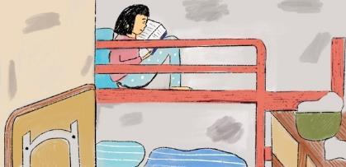 | 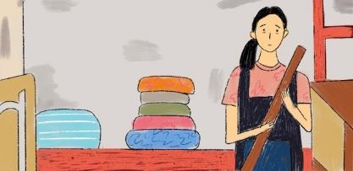  - His wife cannot work. She does all the housework and looks after her daughter most of the time.
(c) The family usually break a meal in batches for 2 days. They seldom dine out. As the electricity fee is high, they avoid switching on an air-conditioner even in hot summer.  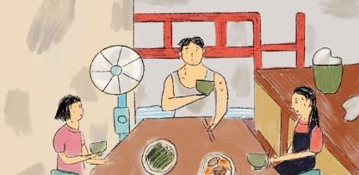 | 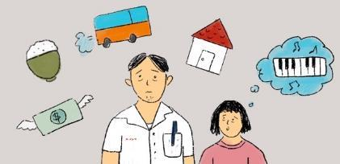  (d) The family spends most of their income on rent. The costs of food and transport are also high. John cannot spare much money for their daughter to join any tuition or interest classes.

t
Alvin Hau is a doctor in a private hospital. His wife is a senior manager in an international company. He lives with his wife and three children in the Mid-Levels, with a Filipino maid taking care of the chores.

- Alvin and his family own a modern two-storey apartment. It is comfortably furnished.  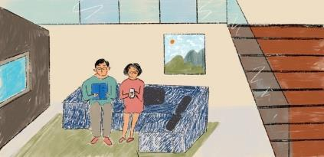 | 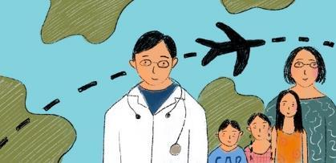  - Alvin earns $100,000 per month and the benefits include one month’s annual leave. He has a holiday trip with his family every year.
- The Filipino maid does all the housework. She prepares the breakfast for the family every morning. A private driver picks the children up to school.  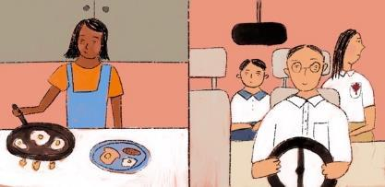 | - The family spends most of their income on children’s education, recreation and investments; and food takes up only a small portion of their income.  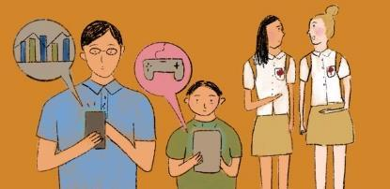

- Compare the way of life of the two families.
In the following table,
- circle the appropriate words in rows (a) – (g); and
- fill in the blanks or write sentences in rows (1)-(7).

Notes to teachers:
Teachers can highlight the importance of resources in the development of children.
have
 |  | John’s family | Alvin’s family
Types of job | (a) | (low-skilled / professional) (high-paid / low-paid) | (low-skilled / professional) (high-paid / low-paid)
 | (1) | John has a ______________ and _______________ job.  low-skilled  low-paid | Alvin __________________  has a professional  and high-paid job.  _______________________

 |  | John’s family | Alvin’s family
Spending patterns | (b) | (rent / food / recreation / investment / education) | (rent / food / recreation / investment / education)
 | (2) | John’s family spends most of their income on __________  of their income on recreation, investment and education.  rent.  ______________________________________________ | Alvin’s family ___________  spends most  _____________________________________________________________________
Leisure | (c) | (no / holiday) | (no / holiday)
 | (3) | John takes / does not take holiday trips with his family for leisure. | Alvin __________________  with his family for leisure.  takes holiday trips  _______________________
Adequacy of resources and access to quality education | (d) | (adequate / inadequate)  (more / less)  have adequate resources for | (adequate / inadequate)  (more / less)
 | (4) | John’s daughter has ____________ resources for improving her studies and gains ___________ access to quality education.  less  improving their studies and  gain more access to quality  education.  inadequate | Alvin’s children __________  ____________________________________________________________________________________________
Food quality | (e) | (higher / lower) | (higher / lower)
 | (5) | John’s family eats _________ quality food.  lower | Alvin’s family ____________  eats higher  quality food.  _______________________
Transport | (f) | (private / public) | (private / public)  use private transport.
 | (6) | John and his family use ___________ transport.  public | Alvin and his family _______  _______________________.
Living condition | (g) | (bad / excellent) (comfortably / poorly) | (bad / excellent) (comfortably / poorly)  is
 | (7) | Living condition is _____________ and the flat  poorly  bad  is ____________-furnished. | Living condition __________ _______________________  excellent and the flat is  comfortably-furnished.  _______________________.

- Which family has a poorer way of life? Give evidence to support your answer. [Hint: Refer to the table in (a).]
The phrase ‘As shown in the table’, and the connectives such as ‘first’ and ‘also’ are useful.
John’s family has poorer way of life. As shown in the table, John and his family do not take holiday trips for leisure. His daughter does not have adequate resources for improving her studies. Also, they eat lower quality food and use public transport instead of private transport. What is more, their living condition is bad and the flat is poorly-furnished.
_________________________________________________________________________________________________________________________________________________________________________________________________________________________________________________________________________________________________________________________________________________________________________________________________________________________________________________________

- Refer to the information in the story. Which factor has a major effect on their different ways of life?
The income levels lead to their different ways of life.
_______________________________________________________________

- If the factor mentioned in (c) is used as an indicator to classify whether the people are rich or poor, do you think that John is poor? Why or why not?
[Student answer] Suggested answer: Yes, John is poor because he has low income and cannot have enough resources to maintain the average living standard in Hong Kong.
No, compared with the people in the poor countries, John is not so poor as he still has enough income to afford the basic things that he needs, like food and shelter.
___________________________________________________________________________________________________________________________________________________________________________________________________________________________________________________________________________________________________________________________
_______________________________________________________________

Do you know…
Absolute poverty is a condition where household income is below a necessary level to maintain basic living standards (food, shelter, housing).
Relative poverty is a condition where household income is a certain percentage below median incomes.
Source: https://www.economicshelp.org/blog/glossary/definition-of-absolute-and-relative-poverty/

Notes to teachers:
For students of stronger ability, teachers may introduce the terms ‘absolute poverty’ and ‘relative poverty’ and ask students what kind of poverty indicator is being used in Hong Kong.

- How can we identify who are poor in Hong Kong?
The answer in Question 1(d) shows that there is no absolute answer as for one is rich or poor based on the income level only. We also need to consider if the income earned can meet the minimum level of basic needs. This minimum level of income varies in different countries or regions. In Hong Kong, it was set at 50% of the median household income. This is also called the poverty line. Anyone living below that line is considered to live in poverty. Refer to the box below for more information on the median household income and the poverty line.
Notes to teachers:
The median household incomes are calculated based on the income obtained before taxation or welfare. Foreign domestic helpers are excluded from the calculation.

Median household income refers to the household income that is in the mid-point of the data set arranged in order. Suppose there are only seven households in a region and their incomes are arranged in an ascending order:

$7,000 | $10.000 | $11,000 | $12,000 | $12,500 | $14,500 | $15,000

The fourth value is in the mid-point of the data set, so the median is $12,000.

Poverty line = median household income x 50% = $12,000 x 50% = $6,000

Refer back to the story of John’s family and the table below.
Poverty Line in Hong Kong in 2018
Types of household | Poverty line ($)
One-person household | 4,000
Two-person household | 10,000
Three-person household | 16,500
Source: https://www.censtatd.gov.hk/hkstat/sub/so461.jsp
Notes to teachers:
After students answer Question (a), teacher may point out that John is a working poor and his family belongs to a working poor household.

- Based on the information in Question 1, is John’s family living in poverty? Why or why not?
Yes, John’s family is living in poverty because their household income (around HK$10,000) is below the poverty line for a three-person household, i.e. $16,500.

_____________________________________________________________________________________________________________________________________________________________________________________________
- Do you think that poverty line is a good indicator to measure poverty in Hong Kong? Why or why not?
[Student answer] Suggested answer: Yes, it is because it can help predict the quality of life in low income households like John’s.
No, it is not because it does not consider the costs of living, such as travelling expenses and food expenses, which can be high.

___________________________________________________________________________________________________________________________________________________________________________________________________________________________________________________________________________________________________________________________

Do you know…
Working poor is the working people whose incomes are below the poverty line.
In Hong Kong, a working poor household refers to a household with at least one employed person (not including domestic helpers) that has income equal to or less than half of median household income.

3. Who are living in poverty in Hong Kong?
Read Source 1 and answer the following questions.

Source 1: Percentage of people/households living in poverty in terms of poverty rate
44.4%
of the elderly population (aged 65 or above)
12.6%
of the youth population (aged 18 to 29)
14.5%
of the ethnic minorities

48.1%
of the total single-parent households
34.4%
of the total new-arrival households
10.6%
of the total non-CSSA working households

https://www.censtatd.gov.hk/hkstat/sub/sp461.jsp?productCode=B9XX0005
https://www.povertyrelief.gov.hk/pdf/Hong%20Kong%20Poverty%20Situation%20Report%20on%20E
thnic%20Minorities%202016.pdf

Do you know…

Poverty rate is the ratio of the poor population to the total population living in domestic households.

CSSA households refers to domestic households that receive Comprehensive Social Security Assistance.

Source: https://www.statistics.gov.hk/pub/B9XX0005E2018AN18E0100.pdf

- Refer to Source 1. Which age group has a higher poverty rate?
The elderly has a higher poverty rate.

_______________________________________________________________

- Explain why single-parent households and new-arrival households have high poverty rates.
It is because due to constraints linked to family roles and responsibilities, these households are usually unable to work, engage in low-paid jobs or are even unemployed. The new-arrival households may also have the language barrier which is an obstacle for them to find a job.
____________________________________________________________________________________________________________________________________________________________________________________________________________________________________________________________
_______________________________________________________________

(c) Explain why some of the ethnic minorities live in poverty.
It is because some of the ethnic minorities are not well-educated, so they can only have low-paid jobs. Also, they may have the language barrier which is an obstacle for them to find a job.
____________________________________________________________________________________________________________________________________________________________________________________________________________________________________________________________

(d) Explain why there are working households living in poverty.
It is because these working households have low-paid jobs and earn low income.
_____________________________________________________________
_____________________________________________________________
_____________________________________________________________

Task 2: What indicators are used to measure the gap between the rich and the poor?

The gap between the rich and the poor refers to the difference in income among people. While Hong Kong is generally considered a rich city internationally, the distribution of income is unequal. It was reported that in Hong Kong, 1.4 million of people were below the poverty line in 2017. In other words, about one in five are living in poverty in this “rich city”. To understand more clearly the income inequality between the rich and the poor, the indicator “Gini Coefficient” is frequently used.

Gini Coefficient  Gini Coefficient is commonly used as an indicator to show the gap between the rich and the poor among various social strata. Some academics define that Gini Coefficient ranges from value 0 to 1. Greater value of Gini Coefficient means greater inequality in income distribution. |  | 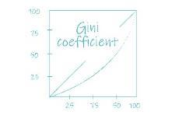
Generally, a value below 0.3 indicates a healthy situation, while a value greater than 0.4 reaches the “warning line” in developed countries. A value of 0.6 or above indicates a wide gap between the rich and the poor and a risk of social stability. It is a critical signal that the government concerned must note and take appropriate measures to address the problem. Read the following table for details.
Value of Gini Coefficient | Meaning
0 | Income is perfectly equal in a society. In other words, everyone receives the same income.
0.3 or below | Income distribution is good.
0.3-0.4 | Income distribution is normal.
Above 0.4 | Income distribution is unequal. This reaches the “warning line” of the developed countries.
Above 0.6 | Income distribution is extremely unequal. In other words, most of income is held by the one group of people and this may threaten social stability.
1 | Income distribution is perfectly unequal. In other words, a single individual has all the income in the economy.

In addition to the Gini Coefficient, “Income distribution by decile groups” is another indicator measuring income inequality. Refer to the box below for more information.

Income distribution by decile groups
Income distribution by decile groups refers to the practice of tracking the changes of the median household income over years among different income groups. First, the working population is evenly divided into 10 groups, with the lowest income group (called “1st decile group”) on one end and the highest income group (called 10th decile group) on the other. Then, calculate the median income of each decile group. By looking at the differences of the median income among different groups, one can tell how wide the gap is between the rich and the poor in the society.

The table below shows facts of the income distribution in Hong Kong in 2016.
Facts about the income distribution in Hong Kong
As in 2016:
Median income (all domestic households) = $25,000
Median income of the 1st decile group (i.e. the poorest 10% of the households) = $3,290
Median income of the 10th decile group (i.e. the top 10% of the households) = $114,500
The Gini Coefficient is 0.539.

Sources:
https://www.bycensus2016.gov.hk/en/bc-mt.html
https://www.bycensus2016.gov.hk/en/bc-mt.html?search=D110
https://www.bycensus2016.gov.hk/data/Press_release_income_distribution_09.06.2017_Eng_Tables.pdf
Language support I: Comparing and contrasting using “times”

We can compare the difference in the amount of two things using the word ‘times’.
e.g. The median income of the 10th decile group
Vs
The median income of the 1st decile group
Noun phrase with possession | Verb | Number of times | Noun phrase with possession
The median income of the 10th decile group | was | 27 times | that of the 1st decile group in Hong Kong in 2001.
Notice the use of the words ‘that of’ which replaces ‘the median income of’ in the second noun phrase with possession.

- What was the Gini coefficient (correct to 2 decimal places) in Hong Kong in 2016?
The Gini coefficient was 0.54 in Hong Kong at 2016.

__________________________________________________________________
__________________________________________________________________

- How many times is the median income of the 10th decile group that of the 1st decile group in Hong Kong in 2016? [Hint: Refer to Language Support I. Give figures correct to 1 decimal place.]
The median income of the 10th decile group is 34.8 times that of the 1st decile group in Hong Kong in 2016.

____________________________________________________________________________________________________________________________________
__________________________________________________________________

- How do you describe the gap between the rich and the poor in Hong Kong in 2016? Give evidence to support your answer. [Hint: Use figures from the two indicators.]
The gap between the rich and the poor in Hong Kong in 2016 was wide. In 2016, in terms of the household income distribution, the median income of the 10th decile group was 34.8 times that of the 1st decile group. Also, the Gini coefficient of Hong Kong reached 0.54, far above the warning level of 0.4. This implies that income distribution was unequal and the gap between the rich and the poor was wide.
____________________________________________________________________________________________________________________________________________________________________________________________________________________________________________________________________________________________________________________________________________________________________________________________________________
__________________________________________________________________

Task 3: Is the gap between the rich and the poor getting wider?

While many people living in Hong Kong can afford the basic necessities, Hong Kong actually faces the problem of income inequality. As shown in the indicators in Task 2, the gap between the rich and the poor is wide. The Gini Coefficient even reaches above the “warning line”. In this task, we will look at the changes in the trend of the gap between the rich and the poor in Hong Kong.

Read the following three sources and answer the questions.

Source 2
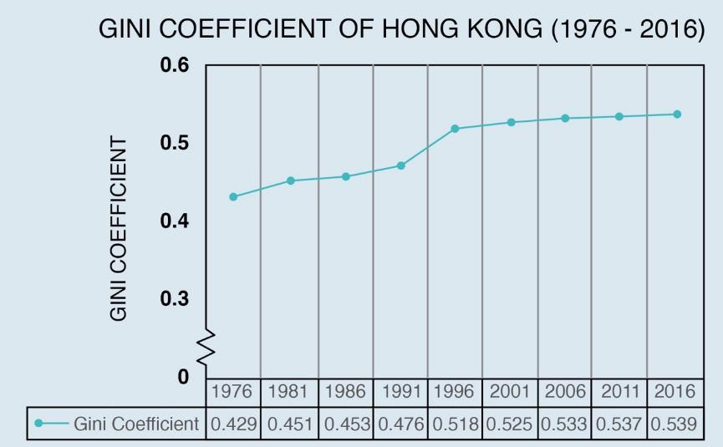

Source: Census and Statistics Department announces results of study on household income distribution in Hong Kong [9 Jun 2017]. Retrieved on 10 August 2017. http://www.censtatd.gov.hk/press_release/pressReleaseDetail.jsp?charsetID=1&pressRID=4180

Source 3
Median Household Incomes (HK$) per month in Hong Kong (1996-2016)
Decile Year  group | 1996 | 2006 | 2016
1st (the poorest 10% of households) | $3,000 | $2,400 | $3,290
10th (the richest 10% of households) | $70,000 | $78,000 | $114,500
Source: Census and Statistics Department

Source 4
Percentage change of the median household incomes (HK$) per month in Hong Kong (1996-2016)
Decile group | Percentage change of the median household income  (correct to 1 decimal place)
 | 1996-2006 | 2006-2016
1st (the poorest 10% of households) | -20.0% | +37.1%
10th (the richest 10% of households) | +11.4% | +46.8%
Difference of the percentage change of the two groups | +31.4% | +9.7%
Language support II:
Describing trends and changes using verbs and adverbs

There are many verbs describing an upward trend on a graph, such as increase, rise, grow and expand. Examples of verbs of opposite meaning that describe a downward trend are decrease, decline, fall and drop.
Adverbs can be used to describe different rates of change on a graph.
Now you can use a verb and an adverb to describe a change more accurately:
Subject | Verb  (showing the direction of change) | Adverb  (showing the rate of change) | Amount of difference | Time expression
The median household income | increased  grew  rose | rapidly  Fast change  sharply  steadily  gradually  slightly  Slow  change  slowly | by ________  (e.g. by 5%;  by $600)  from _____ to _____  (e.g. from $3000 to $2400) | from ______ (year) to ________ (year)  between ___  (year) and  _____ (year)  in the past  _____ years
decreased
declined
fell

e.g. The median household income decreased gradually by $600 in the past 10 years.
The median household income decreased gradually from $3000 in 1996 to $2400 in 2006.

1. Based on Source 2, describe the general trend in the Gini Coefficient of Hong Kong from 1976 to 2016. How do you describe the gap between the rich and the poor in the past 40 years?
______________________________________________________________________________________________________________________________________________________________________________________________________
The Gini Coefficient of Hong Kong increased gradually from 0.429 in 1976 to 0.539 in 2016. This shows an upward trend and the gap between the rich and the poor has been widening in the past 40 years.
__________________________________________________________________

2. Are the changes in the values of the Gini Coefficient the same or different over the years? [Hint: Compare the rate of change among three periods: 1976-1996, 1996-2006 and 2006-2016.]
______________________________________________________________________________________________________________________________________________________________________________________________________
The changes in the values of the Gini Coefficient are different over the years. The Gini Coefficient increased rapidly from 0.429 in 1976 to 0.518 in 1996. It rose gradually from 0.518 in 1996 to 0.533 in 2006, then grew slowly from 0.533 in 2006 to 0.539 in 2016.
__________________________________________________________________
__________________________________________________________________
3. Based on the answer in Question (2), circle the correct description of the changes in the trend of the gap between the rich and the poor in Hong Kong since 1976.
The gap between the rich and the poor has been widening at an increasing / a decreasing rate in Hong Kong since 1976.

4. Which period, 1996-2006 or 2006-2016, has a bigger difference of the percentage change of the median household income between the two decile groups? Support your answer with data.
The period of 1996-2006 has a bigger difference of the percentage change of the median household income between the two decile groups. It is because the difference of the percentage change of the median household income between the two decile groups in 1996-2006 is 31.4%, while that in 2006-2016 is 9.7% only.
____________________________________________________________________________________________________________________________________________________________________________________________________________________________________________________________________________________________________________________________________________________________________________________________________________

5. With the help of the answer in Question 4, describe the correct description of the changes the gap between the rich and the poor from 1996 to 2016. Circle where appropriate.
The gap between the rich and the poor widened at an increasing / a decreasing rate from 1996 to 2016. The reason is that _ ____________________ ___________________________________________________________________________________________________________________________________________________________________________________________________

the difference of the percentage change of the median household income between the two decile groups in 1996-2006 is 31.4%, while that in 2006-2016 is 9.7% only. So while the gap between the rich and the poor still exists, it has become smaller over the years.
__________________________________________________________________

Part 2: Narrowing the gap between the rich and the poor
In Part 1, we learnt that the gap between the rich and the poor increased at a decreasing rate in recent years, which is good news. However, the fact that the income of the top 10% of the households was 34.8 times that of the poorest 10% of the households in Hong Kong in 2016 shows that the rich-poor gap is enormously big. High income inequality is likely to bring negative impacts on the society, such as the lack of social harmony and social cohesion. In this part, we will study the possible negative impacts of the large rich-poor gap, and discuss the measures made to narrow it.

Task 1: What is the impact of the wide gap between the rich and the poor?
- The following are possible harmful effects brought by a wide rich-poor gap. With reference to “A tale of two families” in Part 1, fill in the boxes using the words in the box below.
High quality of life Low quality of life Intergenerational poverty
Disrupting social harmony and weakening social cohesion
Less competitive in the job market
Higher property price and cost of living

The Rich: can afford investment (e.g. property and stock) which may generate even more income.
Wide gap between the rich and the poor
High quality of life

Disrupting social harmony and weakening social cohesion
The Poor: can only afford the basic necessities because most of their income is spent on housing.

Low quality of life
Poor living condition and lack of resources for studying
Children’s academic performance may suffer
Less competitive in the job market
Intergenerational poverty

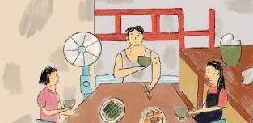
- Refer to “A tale of two families” in Part 1 and answer the following questions.

- Which social class does John’s family belong to, grass roots, middle-income group or high-income group? How do you know?
John’s family belongs to the ___________________________ because the monthly income of his family is ___________________ and he and his wife own / do not own any property.
around $10,000
grass roots

- Which social class does Alvin’s family belong to, grass roots, middle-income group or high-income group? How do you know? [Hint: Follow the structure of the answer in (a) above when answering the question]
Alvin’s family belongs to the high income group because the monthly income of his family is $100,000 and he and his wife own a property.
______________________________________________________________________________________________________________________________
- What is the quality of life that John’s family has? Explain how that kind of life may affect his daughter’s future. [Hint: Refer to Question 1.]
____________________________________________________________________________________________________________________________________________________________________________________________________________________________________________________________
Suggested answer:
John’s family has low quality of life. The poor living condition and lack of resources for studying is likely to make her daughter’s academic performance suffer. As a result, she may become less competitive in the job market.

- If John’s daughter has less opportunity to climb up the social ladder in the future, what social problem will occur?
_____________________________________________________________________________________________________________________________________________________________________________________________

Do you know…
Social harmony is defined as a process of valuing, expressing, and promoting love, trust, admiration, peace, harmony, respect, generosity and equity upon any other people in a society.
Source: Sharma, M. (2015). Social harmony for being social. Global Journal of Human Social Science: Sociology and Culture. 15(6):2.

Social cohesion is defined as the willingness of the citizens in the society to cooperate with each other so as to survive and prosper.
Source: https://www.jstor.org/stable/3341872?seq=1

Suggested answer:
If John’s daughter has less opportunity to climb up the social ladder, the intergenerational poverty is likely to occur.

Task 2: What efforts have been made to reduce the rich-poor gap in Hong Kong?

In the previous task, we have learnt that the wide gap between the rich and the poor may bring harmful effects to our society. In recent years, the government, non-governmental organizations (NGOs) and individuals have made efforts to reduce the rich-poor gap.

- The Hong Kong Government has introduced measures to reduce the rich-poor gap in different ways.
- In the table below, fill in the types of measures in the first column using the words given below.

Educational allowance Employment support Social security system

Medical and housing benefits Taxation

Types of measures | Examples of measures | Relevance to reducing the rich-poor gap
Social security system | - Comprehensive Social Security Assistance (CSSA) Scheme | Providing financial assistance  to the poor, the elderly and  the disabled to meet their basic and special needs
 | - Social Security Allowance (SSA) Scheme, e.g. Old Age Living Allowance
Educational allowance | (3) School Textbook Assistance Scheme and Student Travel Subsidy Scheme | Providing resources to students from the low-income families for their study
 | (4) Subsidy Scheme for Internet Access Charges
 | (5) Tertiary Student Finance Scheme - Publicly-funded Programmes
Medical and housing benefits | (6) Elderly Health Care Voucher Scheme | Reducing the poor’s expenditure in two key areas: health and housing
 | (7) Medical fee waiver
 | (8) Public housing
Employment support | (9) Work Incentive Transport Subsidy Scheme | Lowering employees’  expenditure on travelling to and  from work and encouraging  them to stay in employment
 | (10) Employment Programme for the Elderly and Middle-aged | Raising employability and job prospect for aged employees through training
 | (11) Manpower Development Scheme (including training courses) | Raising employability and job prospect for those who lack qualifications through training
 | (12) Setting up the Innovative and Technology Bureau | Creating new industries for better-paid jobs
 | (13) Setting the minimum wage | Helping to raise the poor’s living  standard
Taxation | (14) Progressive tax system (the higher the income, the higher the tax rate) | Collecting more tax from the high-income group for providing social welfare to the low-income group

- The measures (1)-(14) above can be classified into seven ways of reducing the gap between the rich and the poor. Complete the table using some of the ways in the box below. Insert numbers in the last column where appropriate.

Reducing income inequality
Helping the less privileged to climb up the social ladder
Reducing the cost of living of the low-income group

 | Ways of reducing the gap between the rich and  the poor | Measures (numbers)
1 | Raising the income of the low-income group through financial assistance | 1, 2
2 | Reducing the cost of living of the low-income group | 3, 4, 5, 6, 7, 8, 9
3 | Helping the less privileged to climb up the social ladder | 3, 4, 5, 11, 12
4 | Raising the income of the unemployed through employment | 10
5 | Raising the income of the working poor | 11, 13
6 | Reducing income inequality | 14

YouTube Link: https://www.youtube.com/watch?v=RuAseBCRhBI

- To know more about the efforts made by the government, NGOs and individuals, visit the following website to watch a video entitled ‘Rich City, Poor Kids’. | 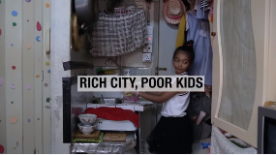
The video shows how three underprivileged children, namely Nadya (0’00-3’05), Alice (3’06”-4’14”) and Eric (4’55”-5’26’), are helped by different groups in Hong Kong.

- As you watch the video, put down the information about the assistance the children receive in the following forms.

Name: Nadya (0’00-3’05)
Sex: Female
Age: 8
Place of birth: Hong Kong
Nationality: Indian-Indonesian
sub-divided
Other information: She lives in a tiny ________________________flat.
She actively joins different programmes organised by NGOs.
Mission Bridge;
Organisation(s) that provide(s) assistance: ______________________
Home Centre for Ethnic Minorities
_________________________________________________________
Education classes and interest classes
She is allowed to join different interest
Assistance received: ________________________________________
(e.g. dancing, art, ukulele); hockey and sports
_________________________________________________________
From being weak and fragile, she has built
.becomes more active.
Improvement made: _____________________________________
her self-confidence by joining all those activities
__________________________________________________________

Name: Alice (3’06”-4’14”)
Sex: Female
Age: 8
Place of birth: Hong Kong
Nationality: Chinese
Other information: She comes from a single-parent family. She lives in a
cage house. Her mother is on a two-way permit and
* can / cannot work. She uses Alice’s welfare to make

a living. (*circle where appropriate)
Government
Organisation(s) that provide(s) assistance: ______________________
Social welfare
Assistance received: ________________________________________
Improvement made: Alice’s basic needs are supported.

Name: Eric (4’55”-5’26’)
Sex: Male
Age: 9
Place of birth: Hong Kong
Nationality: Chinese
Other information: He and his mother live in a public housing.
Government and individuals
Who provide(s) assistance? __________________________________
_________________________________________________________
Public housing, social welfare and private
Assistance received: ________________________________________
donations; after-school programmes
_________________________________________________________
He has the money to join the interest class.
Improvement made: ________________________________________

- From these three cases, we can find that different parties, namely, the government, non-governmental organisations (e.g. Mission Bridge) and individuals put a lot of resources to help the underprivileged children.
- What types of resources does each of the parties provide to the children in the video?
The government provides the social welfare and public housing. The non-governmental organisations provide the social services such as education and interest classes. The individuals give donations to the underprivileged children.
____________________________________________________________________________________________________________________________________________________________________________________________________________________________________

- How can the types of resources mentioned in (i) help to reduce the gap between the rich and the poor?
(Hint: Refer to the diagram “Wide gap between the rich and the poor” in Task 1 as well as the case of Nadya for ideas)
With the support of social services and private donations, low-income families have more resources that can be put into children’s education. Children from these families can join education and interest classes. This may improve their self-confidence, social skills and nurture their talents. Thus, they may be more competitive in the job market later. This may reduce the intergenerational poverty and help reduce the gap between the rich and the poor in future.
_________________________________________________________ _______________________________________________________________________________________________________________________________________________________________________________________________________________________________________________________________________________________________________________________________________________________________________________________________________________

Task 3 Narrowing the rich-poor gap in Hong Kong: Some constraints and possible ways out
- In Task 2, we understand that the Government has initiated a number of measures to narrow the rich-poor gap in Hong Kong. However, they do not come without constraints. Complete the table below using the words given. The first has been done as an example.

Decrease in the revenue of government Progressive tax system
Increasing labour costs for employers
Increase in government spending Setting the minimum wage
Work Incentive Transport Subsidy Scheme

Measure | Content | Potential constraints
① Providing more affordable public housing | The Government formulated the Long Term Housing Strategy (LTHS) in December 2014, aiming to provide more public rental housing (PRH) units and more subsidised sale flats (SSFs). | Lack of land in Hong Kong
②  Increase in government spending  Progressive tax system  Work Incentive Transport  Subsidy Scheme  Increasing labour costs for employers  Setting the  minimum wage  Decrease in the revenue of government decreases | This keeps the tax burden of the middle-lower income groups low.
③ | It is set at HKD37.5/hour as of 2020.  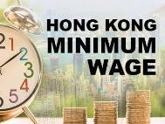
④ | 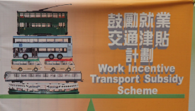  The low-income employees can reduce their cost of travelling to and from work after getting the subsidy.

- You feel rather strongly on the wide rich-poor gap in Hong Kong. Express your views on this in your personal page of a social media platform. Title your writing as ‘Narrowing the gap between the rich and the poor in Hong Kong: some constraints and possible ways out’. The content which you want to include are as follows:
Notes to teachers:
For a detailed discussion of NGOs, refer to Module 29 “Global Citizenship and Humanitarian Work”.

Part 1 Problem of income disparity in Hong Kong
[Hint: Refer to Task 2. Figures of Gini Coefficient and Median Income by decile groups are helpful.]

Part 2 Government measures and some constraints
[Hint: Refer to Task 2 and Task 3.]

Part 3 What NGOs and individuals can do to help
[Hint: Refer to Task 2 and the Data File on the page that follows.]

Data File
How we are helping

- In collaboration with other organisations, launch food support project to provide low-income families with nutritious meal kits
- Support a service centre to implement home improvement projects in subdivided flats in which low-income families live
- Raise the public awareness about local inequality through art and pop culture activities

Adapted from source: https://www.oxfam.org.hk/en/what-we-do/development-programmes/hong-kong/povertyinhongkongandoxfamsadvocacywork

Second, progressive tax system will decrease government’s revenue. Third, setting the minimum wage will increase labour costs for employers. Fourth, the work incentive transport subsidy scheme will increase Government spending.

Part 1
Figures of Gini Coefficient and Median Income by decile groups portray income disparity well.

Part 2
Government measures and some constraints: Refer to Task 6.1 for ideas

If you write more than one point or example, use connectives such as “first” or “also” for better organisation.

the Gini coefficient reaches 0.54, far above the warning level of 0.4. Also, the median income of the 10th decile group was 34.8 times that of the 1st decile group in Hong Kong. This implies that income distribution is highly unequal. The gap between the rich and the poor is wide.
Narrowing the gap between the rich and the poor in Hong Kong: some constraints and possible ways out
In recent years, the problem of wide rich-poor gap has become serious in Hong Kong. In 2016, _______________________________________________
________________________________________________________________________________________________________________________________________________________________________________________________________________________________________________________________

In fact, the Government faces many constraints when trying to implement measures to relieve the rich-poor gap. Here are some examples. First, providing more affordable public housing requires a lot of land, of which Hong Kong lacks. ______________________________________________________
________________________________________________________________________________________________________________________________________________________________________________________________________________________________________________________________

They can give donations to the low-income people. Also, the low-income people can join training courses to raise their employability and job prospect. Students from low-income families can join the education and interest classes provided by the Government or the NGOs to nurture their talents. Then, they may become more competitive in the job market in future.

education and interest classes. This may improve the self-confidence and social skills of children from low-income families and nurture their talents. This may reduce the intergenerational poverty and help to reduce the gap between the rich and the poor in future. Also, they can collaborate with other organisations to provide food support and implement home improvement in subdivided units. By raising public awareness about inequality in Hong Kong, NGOs can solicit public support and engage them in helping people in need.
Recognising the Government’s constraints in narrowing the rich-poor gap in Hong Kong, the non-governmental organizations (NGOs) have a role to play. The NGOs can provide social services such as __________________
________________________________________________________________________________________________________________________________________________________________________________________________________________________________________________________________________________________________________________________________________________________________________________________________________________________________________________________________________________________________________________

The individuals can also help to relieve the problems caused by the wide rich-poor gap in different ways. ________________________________
___________________________________________________________________________________________________________________________________________________________________________________________________________________________________________________________________________________________________________________________________________________________________________________
All these can help narrow the gap between the rich and the poor and reduce inequality in society.

Part 3
What individuals can do: Refer to Task 5.1 & 5.2 for ideas

Part 3
What NGOs can do: Refer to Task 2 and Data File for ideas

Peer evaluation
Give your essay in Question 2 to your neighbouring classmate and ask him/her to complete the peer evaluation form below. Remind your classmate to sign the form before returning it to you.

Peer Evaluation Form
Description | Feedback  No star= minimum score; 5 stars = maximum score
Accurate figures of Gini Coefficient and Median Income by decile groups portray income inequality in Hong Kong
Adequate examples of government measures and some constraints
Adequate examples of what NGOs and individuals can do
Good organization of the content
Optional: Do you want to give any written feedback* to your classmate?
 | Signature:

* You are encouraged to write down a few words to give encouragement and support to your classmate such as “Nice work!”, “Interesting”, “I like the way you write about ….”,“You are making good progress.”, “Your work will be better if you can ….”, “More effort is needed, especially in …

Part 4: My vocabulary bank and learning record
Notes to teachers:
Given the importance, this part will be included in every unit.
In this part, you will revise the topic vocabulary and assess your learning.
My vocabulary bank
Do you want to write better answers to questions in Life and Society (Secondary 1-3)?
Good writing comes from well-written paragraphs and sentences. And well-written
paragraphs and sentences are built with proper English vocabulary. Generally, English
vocabulary can be sorted into three groups: subject-specific (專科的) vocabulary,
general academic vocabulary, and logical connectors (linking words).
- Subject-specific vocabulary: key concepts specific to a subject, namely Life and
Society or Integrated Humanities.
- General academic vocabulary: Words that are used more often in written texts
rather than informal conversations. They help us express ideas more precisely.
- Logical connectors (linking words): conjunctions and phrases that connect ideas.
Task 1 Finding useful expressions for “Narrowing the Gap between the Rich and the Poor”
Fill in the blanks of the subject-specific vocabulary, general academic vocabulary and linking words from two parts in the unit. Some are already done as examples.
- The Gap between the rich and the poor in Hong Kong
Subject-specific vocabulary  ap  efficient  tribution  equality  andard  killed  ousehold  come | General academic vocabulary | Linking words
G______ between the rich and the poor (compound n.)  Gini co_______________ (n.)  lncome dis_____________ by decile groups (compound n.)  lncome in_____________  (compound n.)  Living st__________  (compound n.)  Low-s__________ jobs  (n. ph.)  Median H___________  In__________ (compound n.)  Po___________ line (compound n.)  verty  Po___________ rate  verty  (compound n.)  Resources (n.)  Working p________ (n. ph.) | Giving definition  … refers to … (v. ph.)  sic  unk  cessities  cile  tached  thnic  divided  mit  Ba_____ needs (n. ph.)  B_____ bed (compound n.)  Daily ne_____________  (compound n.)  De________ groups (n. ph.)  De_________ house (n. ph.)  E_________ minorities  (n. ph.)  Look after (ph. v.)  Sub__________ flat (n. ph.)  Two-way per______ (n. ph.) | Giving examples  Such as  Showing contrast  While  Giving reasons  As  Adding ideas  Also  Interpreting in another way  In other words

- Narrowing the Gap between the rich and the poor in Hong Kong
Subject-specific vocabulary | General academic vocabulary | Linking words
Fairness (n.)  ancial  sistance  rass  come roup  tergenerational  come roup  dle come roup  nimum  Fin__________________ as_____________(n. ph.)  G____ roots (compound n.)  High in_______ g________ (compound n.)  In______________ poverty  (n. ph.)  Low in_______ g_______ (compound n.)  Mid___ in______ g______ (compound n.)  Mi__________ wage (n. ph.)  Non-governmental  ganisation  rivate  ousing  lity  hesion  mony  dder  urity  vice  fare  ation  or_____________ (n. ph.)  P_______ donations (n. ph.)  Public h__________ (n. ph.)  Qua_______ (n.) of living  Rights (n.)  Social co_________ (n. ph.)  Social har_________ (n. ph.)  Social la__________ (n. ph.)  Social sec_________ (n. ph.)  Social ser_________ (n. ph.)  Social wel________ (n. ph.)  Subsidy  Tax____________(n.)  Unemployed (n.) | Affordable (adj.)  overty  Competitive (adj.)  Constraints (n.)  Curb (v.)  ech  vileged  aining  perty  fidence  amp  High-t_______ industry (n. ph.)  Incentive (n.)  Less pri_________ (n. ph.)  Measures (n.)  Nurture (v.)  On-the-job tr_______ (n. ph.)  Policies (n.)  Progressive (adj.)  Pro_______ price (compound n.)  Self-con___________ (n.)  Speculation (n.)  St_______ duty (compound n.)  Waiver (n.) | Showing contrast  However
Task 2 My choice of the most useful words and expressions
In the space below, write:
- FIVE top most useful subject-specific words,
- FIVE general academic words, and
- THREE linking words you have learnt in this unit.
Compare your choice with your neighbouring classmate; see if there are similarities and differences and discuss.

- Subject-specific words
[Student answer]
__________________________________________________________________
__________________________________________________________________
- General academic words
[Student answer]
__________________________________________________________________
__________________________________________________________________
- Linking words
[Student answer]
__________________________________________________________________

Task 3 My learning record of “Narrowing the Gap between the Rich and the Poor”
Put a tick (√) if you think you can manage the item in this unit.
Do I know …
 | Item: | (√)
1. | the indicators measuring the gap between the rich and the poor in Hong Kong?
2. | the changes in the trend of the rich-poor gap in Hong Kong?
3. | the negative impacts of the big rich-poor gap?
4. | the efforts made by the government, non-governmental organizations and individuals in narrowing the rich-poor gap, the constraints and possible ways out?

https://hongkongbusiness.hk/economy/news/one-in-five-are-living-in-poverty-in-hong-kong

