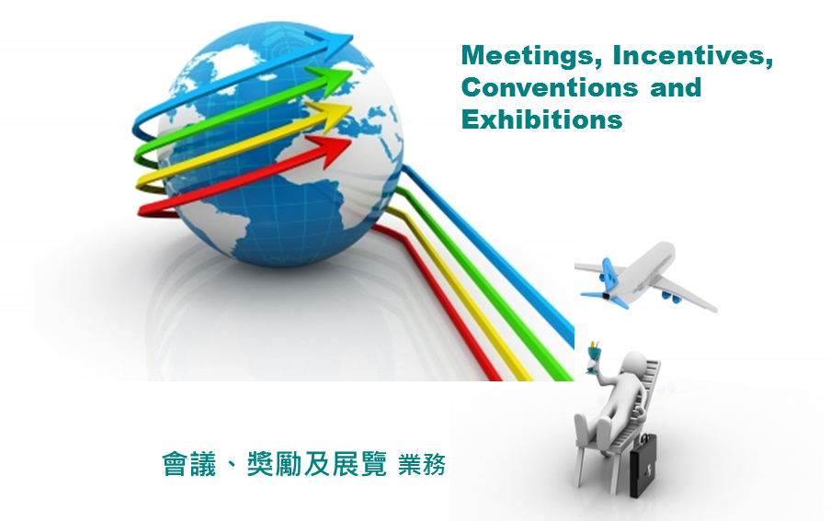

(Fine-tuned version) July 2024

Contributors

Dr. Chloe Lau, Assistant Professor,
School of Hotel and Tourism Management,
The Hong Kong Polytechnic University and
PSHE Section, Curriculum Development Institute

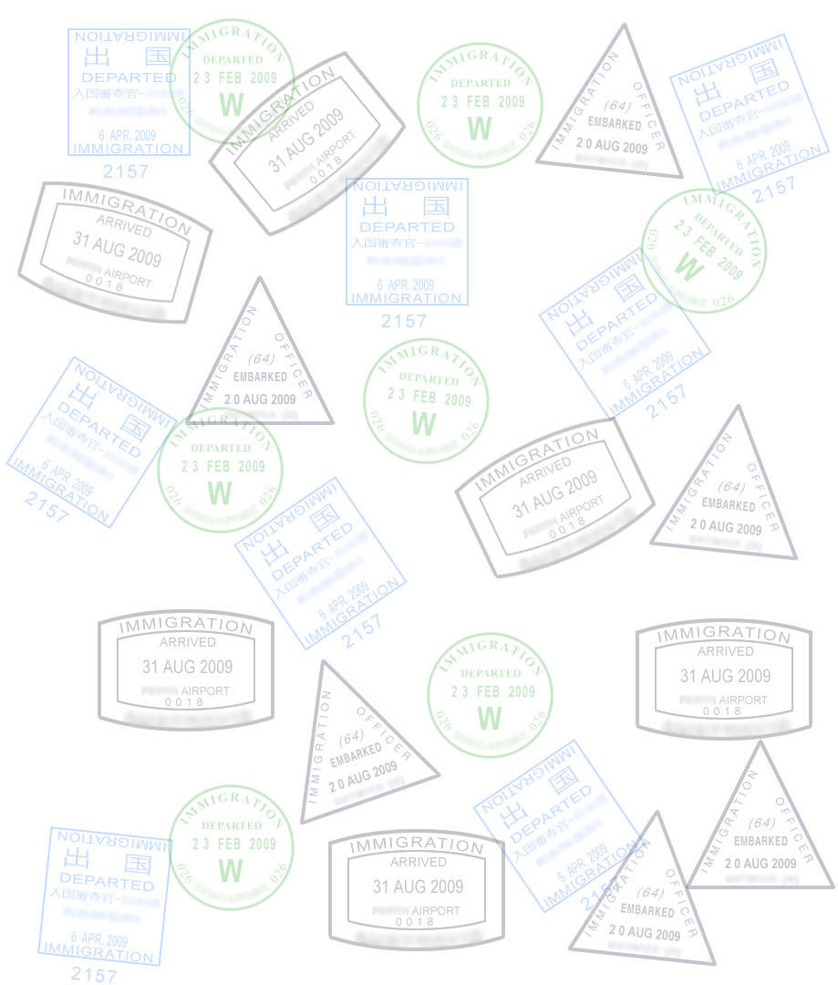

Copyright

© The Government of the Hong Kong Special Administrative Region

All rights reserved.
The copyright of this manual belongs to the Government of the Hong Kong Special Administrative Region. Commercial use is strictly prohibited. Offenders will be liable to legal responsibility.

Schools need not apply for permission to copy this manual in whole or in part for non-profit making educational or research purposes. All other uses should gain prior permission in writing from the Government of the Hong Kong Special Administrative Region. Requests should be directed to the:

Education Bureau
13/F, Room 1319, Wu Chung House
213 Queen’s Road East,
Wan Chai
Hong Kong
Acknowledgement

"Airplane Flying Over The Beach" courtesy of cooldesign. Published on 21 March 2013 Stock
photo - Image ID: 100148470 at FreeDigitalPhotos.net ( in the front cover).

"3d Earth Globe And Colourful Arrows" courtesy of cooldesign. Published on 23 July 2013
Stock photo - Image ID: 100148470 at FreeDigitalPhotos.net ( in the front cover).

Introduction

A set of curriculum support package of tourism and hospitality learning and teaching materials is being developed by the Personal, Social and Humanities Education Section of Curriculum Development Institute, Education Bureau for the implementation of the senior secondary Tourism and Hospitality Studies curriculum in schools. The curriculum support package is developed to broaden students’ knowledge of the different units of the Tourism and Hospitality Studies curriculum.

The content of this material – Meetings, Incentives, Conventions and Exhibitions (MICE), should enhance students’ understanding of the dynamic nature of the tourism and hospitality industry. In addition, the material includes activities to deepen students’ understanding and help them to apply theories and concepts. Furthermore, students should be able to develop enquiry, problem-solving and decision-making skills through these activities.

All comments and suggestions related to this curriculum support package may be sent to:

Chief Curriculum Development Officer (PSHE)
Personal, Social and Humanities Education Section
Education Bureau
Room 1319, Wu Chung House
213 Queen’s Road East, Wan Chai
Hong Kong

July 2024 (Fine-tuned version)

Table of Content
1 | The MICE Business |  |  |  | 1
 |  | Activity 1.1 |  |  | 1
 | 1.1 | Meetings |  |  | 3
 |  | Activity 1.2 |  |  | 4
 | 1.2 | Incentives |  |  | 5
 |  | Activity 1.3 |  |  | 5
 | 1.3 | Conventions |  |  | 6
 |  | Activity 1.4 |  |  | 7
 | 1.4 | Exhibitions |  |  | 8
 |  | Activity 1.5 |  |  | 10
 | 1.5 | The Value of MICE |  |  | 11
 |  | Activity 1.6 |  |  | 15
 |  | Activity 1.7 |  |  | 15
2 | Sectors Involved in MICE Business |  |  |  | 16
 | 2.1 | Sector Involved – Hotel |  |  | 17
 |  | 2.1.1 | Roles of Hotel |  | 17
 |  |  | 2.1.1.1 | Venue Facilities | 18
 |  |  |  | Activity 2.1 | 19
 |  |  | 2.1.1.2 | Accommodation | 20
 |  |  | 2.1.1.3 | Food and Beverage | 20
 |  |  | 2.1.1.4 | Facilities on Information Technology | 20
 |  | 2.1.2 | Types of Hotel |  | 22
 |  |  | 2.1.2.1 | Large Properties vs Small Properties | 24
 |  |  |  | Activity 2.2 | 25
 |  | 2.1.3 | Benefit to Hotels |  | 26
 | 2.2 | Sector Involved – Transportation |  |  | 27
 |  | 2.2.1 | International |  | 27
 |  | 2.2.2 | Local |  | 28
 |  |  | Activity 2.3 |  | 29
 | 2.3 | Sector Involved – Attractions |  |  | 30
 |  | Activity 2.4 |  |  | 31
3 | MICE Planning |  |  |  | 32
 | 3.1 | The Planning Process Components |  |  | 32
 |  | 3.1.1 | Organizational Goals |  | 34
 | 3.2 | Organizational Structure |  |  | 35
 | 3.3 | How to Start a Project |  |  | 37
 |  | 3.3.1 | Preparation Stage |  | 38
 |  | 3.3.2 | Programme Subcommittee |  | 38
 |  |  | Activity 3.1 |  | 39
 |  | 3.3.3 | Social Subcommittee |  | 40
 |  |  | Activity 3.2 |  | 40
 |  | 3.3.4 | Registration, Hotel and Tour Booking Team |  | 41
 |  |  | Activity 3.3 |  | 41
 |  | 3.3.5 | Publicity Subcommittee |  | 42
 |  |  | Activity 3.4 |  | 42
 |  | 3.3.6 | Sponsorship Subcommittee |  | 43
 |  |  | Activity 3.5 |  | 43
 |  | 3.3.7 | Printing and Production Team |  | 44
 |  |  | Activity 3.6 |  | 45
 |  | 3.3.8 | On-site Preparation |  | 45
 |  | 3.3.9 | Wrap-up |  | 46
Case Study 1 |  |  | ITE Hong Kong 2024 Introduction |  | 47
Case Study 2 |  |  | Convention and Exhibition Industry in Hong Kong |  | 48

1. The MICE Business

Learning Objectives:

- Understand how MICE relates to the tourism and hospitality industry
- Understand the meaning of each sector of MICE
- Identify the types of meetings
- Understand the factors behind incentive travel decisions
- Understand the difference between meetings and conventions
- Identify the purpose of exhibitions
- Understand what impacts MICE can bring to a destination

The term MICE (Meetings, Incentives, Conventions and Exhibitions) represents a sector of tourism which includes business events and activities.

Travellers attending MICE activities have a purpose beyond leisure tourism, and are in fact business travellers. These business travellers are connected to different sectors of the tourism and hospitality industry through their MICE activities. (See Figure1) Think of business travellers who travel to a city to attend an exhibition. They will need food, drinks, shopping, entertainment, transport, accommodation and more.

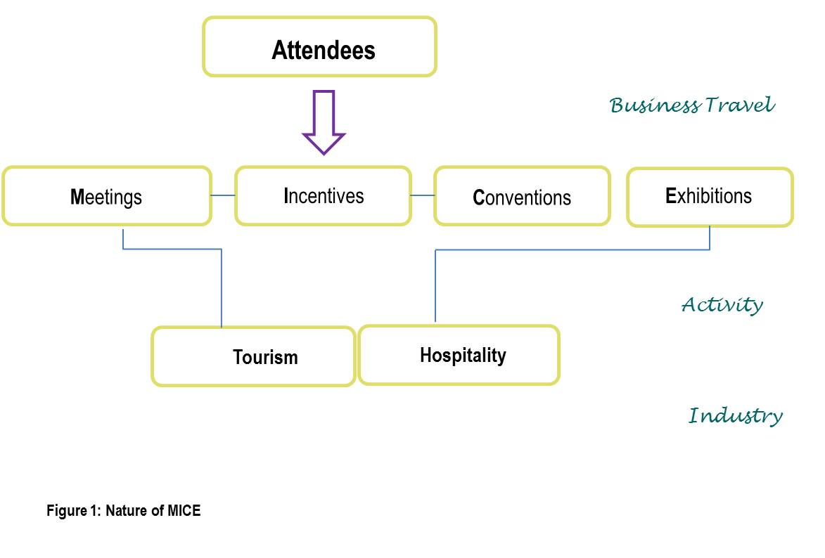

Activity 1.1

Based on Figure 1, fill in the cells with what you would need if you were attending a MICE activity.

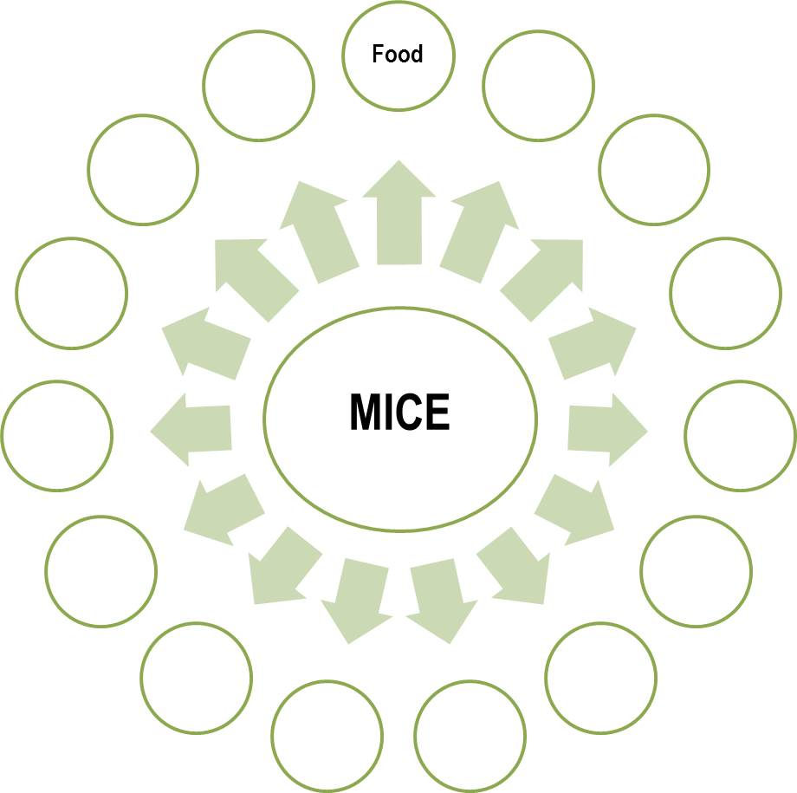

In general, MICE events are events and activities that involve attendees who share a common interest and gather in a place. The place for the gathering needs to be a venue arranged before hand. The venue will provide space and facilities necessary to satisfy the needs of those who attend the gathering. We can further explain the gatherings by their different formats:

M = Meetings (Corporate)
I = Incentives
C = Conventions (Congress, Conferences and Confexes)
E = Exhibitions

1.1 Meetings

Meetings bring people together in one place for the purposes of sharing information and discussing and solving problems. Meeting attendance can range from ten to thousands of people. During a meeting, there will usually be food and beverage served. Meeting times vary depending on the meeting type.

Most of the time, meetings refer to corporate meetings which are held by companies in the following ways:

- Board meetings – Meetings of the board of the directors of a corporation, usually held annually
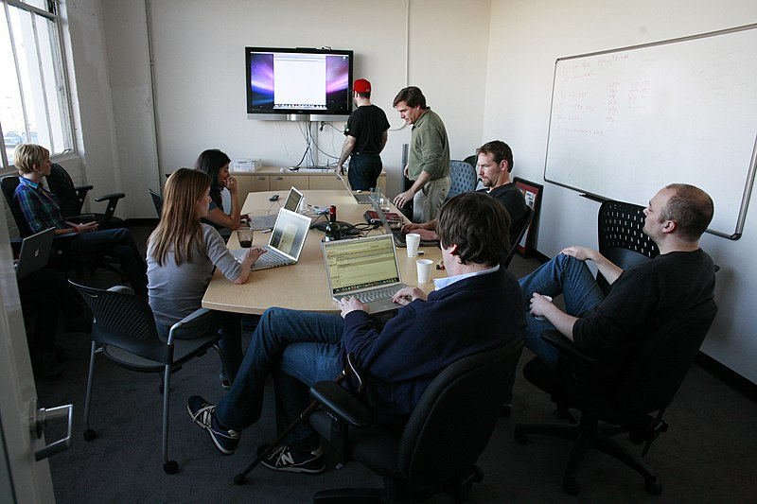
- Management Meetings – The managers from different regions of a corporation meet when necessary to make decisions for the corporation

- Shareholder Meetings – Investors who own a share in a company meet quarterly

- Training Seminars – A company conducts these to train employees when needed
Photo 1: A meeting (Robert Scoble, cc-by-2.0, via Wikimedia Commons)

- Meetings with partners, suppliers and clients – A gathering to discuss business deals, usually held with little prior notice
- Product launches – Usually a meeting with clients, the public, and journalists and reporters when new products are announced on the market

- Strategic planning – Managers meeting with employees to discuss the future of the company

- Retreats – The entire company staff spends a day or two together to participate in team-building activities, training seminars and strategic planning sessions

Activity 1.2

Visit Hong Kong Tourism Board website (www.discoverhongkong.com ) and find out from the MICE event calendar about what meetings have been scheduled to be held in Hong Kong for the coming year.

1.2 Incentives

Incentive travel is a management tool for rewarding and motivating sales representatives, dealers, distributors, production workers, support staff, and in some cases, customers. The company rewards sales representatives who reach sales targets by sending them on trips. Usually, the incentive trip comes with hotel stays, tour packages and planned activities such as dinners, parties and games. Basically, incentive travel does not have any business-related activity. The incentive travel market is mature in the U.S. and Europe, and is developing in Asia; especially in Singapore and Japan.

Factors behind Incentive Travel Decisions

- Incentive budget economy – How strong is the economy in the country in which the sponsoring group is headquartered?
- Buying power – Strength of the exchange rate in the countries being considered as the destination for the trip
- Political climate – Travel alert for destinations with political turmoil
- Safety and Security - Terrorist alert levels after the 911 incident
- Value - How do facilities and services compare with other choices of destination
- Uniqueness of experience – Takes into consideration whether these participants have experienced this type of trip before.
Activity 1.3

Check out the Hong Kong Tourism Board (HKTB) website to find out what activities can be included in an incentive trip to Hong Kong.

For an overview of incentives acitivities in Hong Kong, visit the website of HKTB – Explore Hong Kong : http://mehongkong.com/eng/meetings-incentives/mice-activities/explore-hk.html

1.3 Conventions

Similar to meetings, conventions are gatherings of people with common objectives, organized to exchange ideas, views and information of common interest to the group. An organization, usually an association, will organize a convention each year with a theme related to the organization’s topic. Those interested in registering for the convention can pay the association a fee for all the sessions, discussions, food and beverage, dinners, and site visits.
In particular, conventions consist of a variety of events include congresses (large-scale regular trade gatherings ), conferences (small scale gatherings aimed at information sharing), confexes (conferences with small exhibition attached), and one to one events (premium networking). All conventions can be organized into different levels: international, national, regional.

The major differences between a meetings and conventions is that a convention:

- Is a large event often lasting for several days and involving a social programme

- Is organized by associations:
  - Professional and trade associations, e.g. the Dentist Association
  - Voluntary associations and societies
  - Charities
  - Political parties

- Usually conducted once a year

- Generates income for the association

- Considerable amount of time spent on site selection of the convention

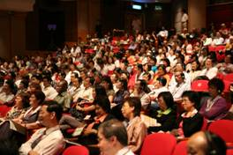

Photo 2: A general session of a convention (Courtesy of WFMH & NLPRA)

Activity 1.4

Choose a particular conference and meeting held last year in Hong Kong. Fill in the following table to describe their characteristics.

 | Convention | Meeting
- Can you find out the background information or history about the event?
- Who was the contact person?
- How long did it take to plan this event?
- How often does this event occur?
- Who decided where to have this event?
- Why attendees chose to attend this event?
- Were there any criteria on site selection?
- How many people attended this event?
- How long did this event last for?
- What kind of hotels did the attendees tend to stay in?
- What kind of venues or facilities did this event need?

For more information about meetings and exhibitions, refer to https://www.mehongkong.com/eng/home.html

1.4 Exhibitions

Exhibitions are activities organized to show new products, services and information to people who have an interest in them, such as potential customers or buyers. The company showing their new products, the exhibitor, typically rents an area from the organizer and sets up a booth to meet with potential buyers. The buyers or the public need an invitation or a ticket to be allowed into the exhibition.

- Purpose:
  - Get sales leads
  - New product introduction
  - Build a network for influential contacts
  - Gather latest information about the competitors
  - Build the company’s image

- Industry Associations:
  - International Association for Exhibition Management (IAEM)
  - Centre for Exhibition Industry Research (CEIR)
  - HKECIA , Hong Kong - www.exhibitions.org.hk

Depending on the size and type, exhibitions could be categorized into:

- For the public namely business-to-consumer (B2C):
  - Show – e.g. Hong Kong Car Show (New Edition)
  - Fair – e.g. Hong Kong Book Fair
  - Exposition or expo – e.g. HKTDC Food Expo

- Open only to business buyers namely business-to-business (B2B):
  - Trade show – e.g. Global Sources Gifts & Home
  - Trade fair – e.g. Fashion Access
  - Trade expo - e.g. HKTDC Hong Kong International Outdoor and Tech Light Expo

- A combined or mixed show
  - It is an exhibition that combines both trade and public together and is open to both corporate and public attendees. Most combined or mixed shows will have different specific visiting time for each group of attendees. Example – International Travel Expo, Hong Kong (ITE, Hong Kong)

Current supply of major convention and exhibition facilities in Hong Kong:

According to the Legislative Paper dated on February 10, 2015 prepared by the Legislative Council Panel on Commerce and Industry - Development of Convention and Exhibition Industries in Hong Kong, there are currently two major dedicated convention and exhibition facilities in Hong Kong, namely HKCEC (Hong Kong Convention and Exhibition Centre) in Wan Chai and AWE (AsiaWorld-Expo) on Lantau Island, as well as other smaller** and non-dedicated venues.
- HKCEC is a dedicated convention and exhibition venue in Wan Chai. It offers about 91 ,500 M² of rentable area, including about 66,000 M² of purposely-built exhibition facilities.
- AWE is a dedicated convention and exhibition venue on Lantau Island. It offers more than 70,000 M² of exhibition and convention space.

** Other venues such as Kowloon Bay International Trade & Exhibition Centre(operating until June 30 2024), high end hotels in the downtown or the Kai Tak cruise terminal can also host convention and exhibition events. However, these are rather niche, less frequent and smaller in size.
Photo 3: Exhibition Booths

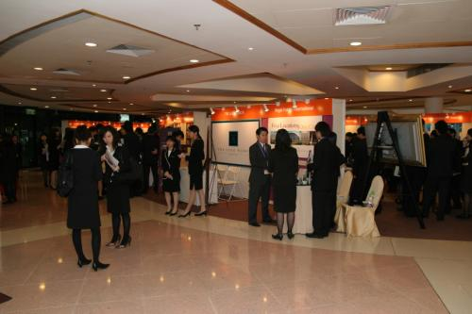

Activity 1.5

Recount the experience a show or fair you attended recently by answering the following questions.

- What was the show?

- When was it?

- Where was it?

- How much was the ticket?

- How many days did the show last for?

- How many people did the show attract?

- How many exhibitors were there?

- Why were you participating?

- Did you buy anything?

- Will you join the same show next year?

- Were there any activities besides exhibition’s booths?

1.5 The Value of MICE

Many cities would like to develop MICE because of the benefits MICE brings to a city. According to the Legislative Paper dated on February 10, 2015 prepared by the Legislative Council Panel on Commerce and Industry, the Hong Kong convention and exhibition industries are currently estimated to worth about US$0.5 billion, which is about 1% of the global convention and exhibition industries. The majority of the convention and exhibition industries in Hong Kong is centred around exhibitions, in particular, the majority of exhibitions in Hong Kong are currently business-to-retail (B2R) export trade exhibitions.

- Higher expenditures – A business traveller usually spends more than the average tourist, as they stay in better hotels and dine at fine restaurants since they are meeting with business clients. Based on data from August 2023, the average daily expenditure per business traveler is estimated to range between HK$2,800 and HK$4,100. On the other hand, the average daily expenditure per non-business traveler is estimated to range between HK$1,500 and HK$2,500. Therefore, the total average expenditure per business traveler is approximately 40% to 80% higher than that of non-business travelers.
- Even out travel demand – Many destinations have different travel seasons. Because the business traveller travels to a destination with the main purpose of attending a MICE event, the MICE event does not have to be scheduled during the peak season when most tourists tend to travel. The business traveller can help the city by taking up some of the empty hotel rooms available during off seasons.
- Prior arrangement– A MICE event is usually planned one to two years in advance, and even three to five years for international events due to the number of participants at the event. The event planners also need to book well before the event in order to select their preferred rooms and venues.
- Large scale – Most MICE events may have a large number of attendees. An international convention usually requires 500 hotel rooms per night and big conference rooms in the day. An exhibition, either local or international, expects to have over thousands of attendees and requires several large exhibition halls.
- Standardized services – All attendees for the same MICE event will have very similar requirements as to service standards while similar MICE events would usually have similar programmes and thus standardized services are required
- Enhance secondary businesses – Many suppliers are needed for MICE events. Booth set-up companies and decoration experts are necessary for the exhibition. Entertainment agencies are needed for incentive travel parties.
- Improve host city image – The city which holds the international MICE event can give travellers a professional image
- Independent of tourism attractions – Business travellers travel primarily for the purpose of attending a MICE event, not for the attractions of a destination. Even if a city does not have unique attractions, it can still be chosen to hold an event due to other reasons, such as ease of access
- No fixed destination– Many MICE events are not fixed on a host city or country. As long as a city has adequate MICE venues and facilities, it is possible for the city to be selected to hold the event
- Flexibility of venue selection – Other than traditional venues such as exhibition centres or conference halls, MICE events can make use of existing facilities that may originally have other purposes, e.g. universities.

Convention and Exhibition Industry in Hong Kong
Overview
- Being the world's sixth largest merchandise trading economy, Hong Kong has developed into a premier convention and exhibition centre in the region. As a free port with superb air connectivity at the heart of Asia, travel to Hong Kong is convenient, making the city a preferred location for staging international conventions and exhibitions.
- The city’s main MICE¹ venues include the HKCEC in the main business district, the AWE near the airport and the Hong Kong International Trade and Exhibition Centre in Kowloon Bay.
- In 2020, Hong Kong was crowned “Best City for Meetings in Asia” in the Smart Travel Asia Awards and “Most Anticipated Overseas Meeting & Incentive Destination (Short Haul)” in the China Travel Industry Awards.
- The mainland and Hong Kong governments signed the Agreement on Trade in Services in December 2015, applying liberalisation measures for Hong Kong service suppliers and professionals on the mainland from June 2016.
Industry Data
Overnight MICE Arrivals by Country/Region
Major Markets | 2018 |  |  | 2019
Major Markets | No of Arrivals | % Total | Growth (%) | No of Arrivals | % Total | Growth (YoY%)
Mainland China | 958,772 | 48.7 | -2.9 | 910,005 | 53.9 | -5.1
South and Southeast Asia | 294,341 | 15.0 | 5.4 | 239,094 | 14.2 | -18.8
Europe, Africa and the Middle East | 224,620 | 11.4 | 3.8 | 178,123 | 10.6 | -20.7
North Asia | 195,285 | 9.9 | 16.6 | 133,173 | 7.9 | -31.8
The Americas | 149,682 | 7.6 | 6.7 | 121,854 | 7.2 | -18.6
Taiwan | 82,159 | 4.2 | 6.0 | 56,070 | 3.3 | -31.8
Australia, New Zealand and  South Pacific | 50,445 | 2.6 | 7.4 | 35,570 | 2.1 | -29.5
Macao SAR | 11,734 | 0.6 | -5.4 | 13,839 | 0.8 | 17.9
Total | 1,967,038 | 100 | 2.1 | 1,687,728 | 100 | -14.2
Source: Hong Kong Tourism Board (HKTB)
Hong Kong’s Overnight Visitors
 | 2019 | 2020 | % Change
Number of Visitors (million) | 23.8 | 1.4 | -94.3
For Business and Meetings | 12.8% | — | —
Source: Hong Kong Tourism Board
Recent Development
More than 50 exhibition and convention venues of various sizes are available in Hong Kong. The main venues for MICE events are the Hong Kong Convention and Exhibition Centre (HKCEC) in the main business district, the AsiaWorld-Expo (AWE) near the airport and the Hong Kong International Trade and Exhibition Centre in Kowloon Bay. Total available exhibition space in Hong Kong now exceeds 150,000 sq m.
In 2019, Hong Kong hosted more than 100 exhibitions, with more than 1.6 million overseas overnight MICE visitors. The HKTDC organises more than 30 large-scale exhibitions a year in Hong Kong, connecting around 39,000 exhibitors and more than 750,000 buyers. 11 of these events are the largest marketplaces of their kind in Asia, five of which are the world’s largest, including the electronics, jewellery, gifts, watches & clocks and lighting sectors.
Hong Kong has received worldwide recognition as one of the best destinations for MICE and business travellers. In 2020, Hong Kong was crowned “Best City for Meetings in Asia” in the Smart Travel Asia Awards and “Most Anticipated Overseas Meeting & Incentive Destination (Short Haul)” in the China Travel Industry Awards.
During peak season, the HKCEC and AWE often face the challenge of tight exhibition space supply. A government-commissioned consultancy study estimates a peak-period shortfall of about 132,000 sq m of convention and exhibition space in Hong Kong by 2028.
According to 2021 Policy Address, the Government will continue to expand C&E facilities, including redeveloping the sites of the three government towers in Wan Chai North and the Kong Wan Fire Station into C&E facilities, hotel and Grade A offices, as well as expanding the AsiaWorld-Expo, in order to consolidate and enhance Hong Kong’s status as an international convention and exhibition hub.
The Hong Kong Tourism Board (HKTB) launched MEHK (Meetings and Exhibitions Hong Kong) in 2008 to offer one-stop professional support to MICE organisers choosing Hong Kong as a destination for meetings and exhibitions. Services include publicity, visitor promotion, coordination of site inspection, arranging local dignitaries in officiating events and liaison with government departments. As recognition of MEHK’s services, HKTB was awarded the “Best of Bureaus in Asia Pacific” in the CEI Readers’ Choice Awards 2018.
To tackle the shortage of space at the HKCEC during peak seasons, an endeavour to hold “one show, two locations” at both the HKCEC and AWE has been adopted since 2009, with free shuttle bus services offered. The September version of the Hong Kong Jewellery and Gem Fair, for example, has successfully adopted this approach since 2009, with the number of exhibitors and buyers recording strong growth over the subsequent years.

Service Providers
A wide variety of service companies are involved in the convention and exhibition industry, including event organisers, stand constructors, insurance companies, freight forwarders, travel agents and hotels. However, the central role played by event organisers in bringing together all these services makes them the most important industry service provider.
Exhibitions are broadly divided into two kinds: trade fairs and consumer fairs. The former targets buyers in specific industries operating largely on a business-to-business basis, while the latter is open to the public, targeting primarily the local market. Well recognised as a regional trade hub, Hong Kong succeeds in attracting a lot of overseas exhibitors and buyers to attend the city’s trade shows, with attendees able to enjoy an international exposure within the show.
Some exhibition organisers also provide a one-stop-shop solution by organising additional conferences and seminars, also bundling other side events to supplement the exhibitions. The main function of the supplementary events is to provide a holistic platform for participants to exchange news on recent industry developments and market information.
There are over 100 exhibition service providers offering specialised or integrated exhibition services. Some of the major international event organisers set up regional headquarters in Hong Kong, managing events organised in Hong Kong and mainland China. In general, the larger international organisations have a wide variety of shows, whereas smaller organisers tend to specialise in similar shows in different locations.
Apart from activities organised in the territory, Hong Kong's convention and exhibition organisers are also active in arranging for exhibitors to exhibit overseas. While the mainland is a priority, organisers are also actively seeking locations for events. Locations include not only developed markets, but also developing markets such as the Middle East and Eastern Europe.
In coping with the stable increase in inbound tourists, Hong Kong has seen parallel growth in hotel capacity. As at end-2021, there were 318 hotels offering 88,495 rooms at different price levels compared with 311 hotels and 86,700 rooms in 2020, both increasing by 2% year-on-year. The number of hotel rooms is expected to reach around 90,000 by 2022.

Hotel Tariffs in Hong Kong in November 2021
 | High Tariff A Hotels | High Tariff B Hotels | Medium Tariff Hotels | Unclassified Hotels | All Hotels
Hotels | 39 | 112 | 129 | 38 | 318
Rooms | 19,797 | 33,708 | 26,562 | 8,428 | 88,495
Average Tariff (US$) | 183 | 84 | 64 | — | 110
Source: Hong Kong Tourism Board
Exports of Services
A main source of export income from the convention and exhibition industry is spending by overseas participants in Hong Kong events. According to the latest figures from the Economic Impact Study commissioned by the Hong Kong Exhibition & Convention Industry Association (HKECIA), the exhibition industry contributed HK$52.9 billion (US$6.8 billion) to Hong Kong's economy in 2016, equivalent to 2.1% of Hong Kong GDP.
The exhibition industry's activities during 2016 were estimated to have provided an employment equivalent to 77,000 full-time jobs across a number of related industries. The expenditure and employment opportunities generated by the exhibition industry benefit not just industry players, such as venue operators, exhibition organisers and stand contractors, but also the advertising, hotel, retail, and food and beverages sectors.
According to the 2018 Hong Kong Exhibition Survey by the HKECIA, the exhibition industry remains steady, in terms of the number of ‘trade’ and ‘trade & consumer’ exhibitions, with a slight decrease in the number of participants. In 2018, the overall number of exhibiting companies decreased by 3.9% to 69,000. The overall visitor numbers to Hong Kong exhibitions fell slightly by 1.7% to 2.3 million.

The Mainland-Hong Kong Closer Economic Partnership (CEPA)
After 10 annual Supplements to widen and broaden liberalisation measures in favour of Hong Kong Service Suppliers (HKSS), Hong Kong and the mainland entered into a subsidiary agreement under CEPA in 2014 to achieve basic liberalisation of service trade in Guangdong (“Guangdong Agreement”). This was followed in December 2015 by the Agreement on Trade in Services (“ATIS”) to extend the coverage of the 2014 agreement from Guangdong to the rest of the mainland. Unlike the Supplements, which adopted a positive-list approach to introducing liberalisation measures, the two latest CEPA agreements adopt a hybrid approach to granting preferential access to Hong Kong, using both positive and negative lists.
The ATIS, which covers and consolidates commitments relating to liberalisation of trade in services provided in CEPA and its Supplements and also the Guangdong Agreement, has been implemented since June 2016. There is no reserved restriction for HKSS under the negative list.
Regarding the positive list, HKSS are allowed to provide convention services and exhibition services on the mainland in the form of wholly owned operations. Operations set up by HKSS on the mainland in the form of wholly owned enterprises or joint ventures are also allowed to undertake business in Hong Kong and Macao.
According to the Agreement Concerning Amendment to the CEPA Agreement on Trade in Services implemented on 1 June 2020, the geographical restriction on organising exhibitions through cross-border supply has been removed. HKSS are allowed to organise exhibitions, in the form of cross-border supply across mainland China. In addition, contractual service providers employed by HKSS are allowed to provide services under this sector or sub-sector on the mainland in the mode of movement of natural persons, a measure originally covered by Supplement X. Details of preferential access concerning the convention and exhibition services sector can be found here.
As of November 2021, 25 HKSS certificates in the convention and exhibition sector had been issued by the Hong Kong government.

https://research.hktdc.com/en/article/MzEzODk1MDk2

Activity 1.6
Referring to the above document, discuss the importance of MICE tourism in Hong Kong.

Activity 1.7

Brainstorm the possible benefits that MICE can bring to Hong Kong. Then draw a mind map to link them together. The mind map may start with the arrival of the tourist. Add to it and keep expanding to further levels. You may end up with a map with many levels, allowing you to see the complex effects and interrelationships.

F&B
Accommodation
MTR
Taxi
Flights

Transportation

Visitors to Hong Kong

2. Sectors Involved in MICE Business

Learning Objectives:

- Describe how sectors are involved in hosting MICE
- Identify the roles and types of hotel
- Look at the contribution of MICE to hotels
- Describe transportation management in relation to MICE
- Outline the roles of different types of transportation
- Explain the importance of supporting infrastructure to planners and attendees

There are industry sectors directly involved in the MICE industry, such as hotel, and transportation industries. These industries may benefit from MICE business by offering their services and facilities to the planner and attendees of MICE events. There are a range of participants in the event (i.e. convention and exhibition) industry, including event organisers, venue operators, marketers and event attendees:

- Event organisers organise and run events for marketers and attendees. This includes developing the event concept, sales and promotion to potential marketers and attendees, operational planning and event execution.

- Venue operators own and manage venues, and take bookings from event organisers.

- Marketers include companies which exhibit products/services at events, and event sponsors. Exhibitors use exhibitions to build and maintain business relationships, generate sales opportunities through acquisition of new customers, and to conduct sales. Event sponsors use conventions and exhibitions for brand promotion.

- Attendees refer to convention and exhibition attendees. Convention attendees mainly use conventions for networking and learning. Exhibition attendees use exhibitions to source and evaluate the products and services offered by marketers, networking and learning.

For more information about sectors involved in MICE business, refer to https://hkbookfair.hktdc.com/en/Exhibitor/Exhibitor-Supporting-Services.html

2.1 Sector Involved – Hotel

Hotels are the main suppliers of MICE and are the main beneficiaries as well. Business travellers who attend MICE events spend over 65% of their money on hotels for rooms and hotel dining while 15% is spent on other restaurants outside the hotel. Around 10% is spent on shopping and another 10% on local transportation.

Figure 3: Where attendees spend their money?

2.1.1 Roles of Hotel

One of the most common sites for a MICE event is a hotel. Hotels can provide facilities, space and function rooms for MICE activities; accommodations, housing for business travellers who attend the MICE event; and food and beverage services at the event, as well as meals for travellers who stay in the hotel. Typical hotels have accommodation rooms, restaurants, ballrooms, meeting rooms, swimming pools, a business centre and more. In relation to MICE activities, a hotel plays different roles depending on its facilities and the size of the MICE event:

1. Inclusive residential conferences and meetings
- All the activities related to the convention are held and delegates stay at the same hotel

2. Facilities for associated receptions, banquets and support events
- When some of the convention activities are held elsewhere and delegates stay in other hotels

3. Accommodation and meals
- When all the activities of the convention are held
Photo 4: Accommodation
( SHTM Hotel of PolyU )
Photo 5: Food and Beverage
( SHTM Hotel of PolyU )
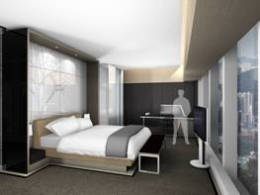
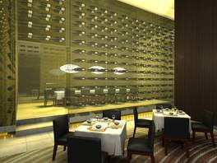

2.1.1.1 Venue Facilities

The facilities in a hotel vary in size and set-up, ranging from a small meeting room for 10 people to a large theatre for thousands. Different types of facilities can be suitable for the different functions of a MICE event.

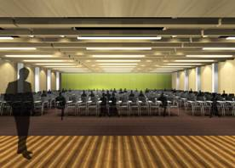
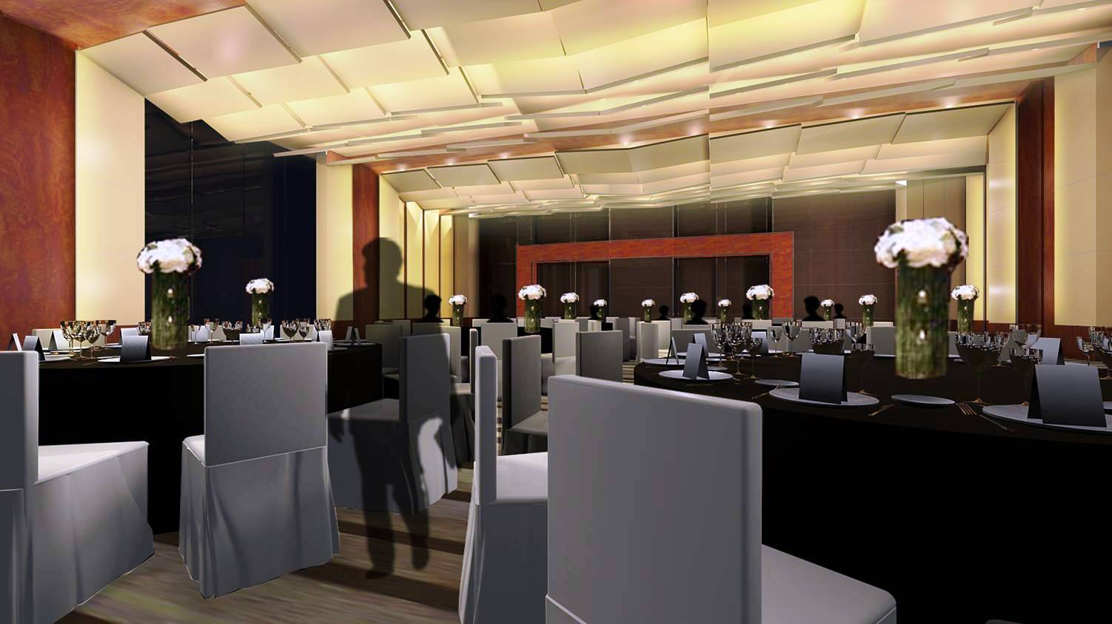
Photo 6: A Theatre
(SHTM Hotel of PolyU)
Photo 7: A Ballroom
( SHTM Hotel of PolyU )

Activity 2.1

Match the activities on the left with the suitable facilities on the right. Can a hotel provide all of the above facilities?

Activity | Facility of a hotel
- Meetings  - Incentives  - Conventions  - Exhibitions | - Meeting room  - Ballroom  - Exhibition hall  - Conference room  - Theatre  - Accommodation  - Reception area

2.1.1.2 Accommodation

When providing accommodation for business travellers to stay during the MICE event, the hotel needs to provide the following services for the delegates or attendees, the business travellers who attend the MICE event; and entourage, persons who travel with the delegates, usually the spouse, children, personal assistants, secretaries etc.

- When delegates and their entourages stay in the same hotel where the convention activities are held:

- Large hotels can take advantage by housing all related activities (in the case of a convention), including all accommodation and food and beverage services

- When delegates and their entourages stay in other hotels where the convention activities are not held, the hotel or convention/exhibition centre which holds the convention activities should:

- Provide a range of facilities, such as transportation
- The hotels and main event venue must keep in close contact

2.1.1.3 Food and Beverage

Other than supplying meals such as breakfasts, lunches, afternoon teas and dinner banquets for different sessions included in a MICE event programme, and hotels also need to provide delegates and entourages with food and beverages through its restaurants, cafes and coffee shops, as well as through room service.

2.1.1.4 Facilities on Information Technology

To facilities a smooth running of the event, hotels install the most advanced technology, such as

- registration networking – to support the on-line registration system
- attendee e-mail kiosks – a centre for attendees to access their e-mail
- attendee messaging centre
- office and press room communications centres
- speaker Internet access for presentations
- live Web conferencing for sessions – streaming audio and video via the Web

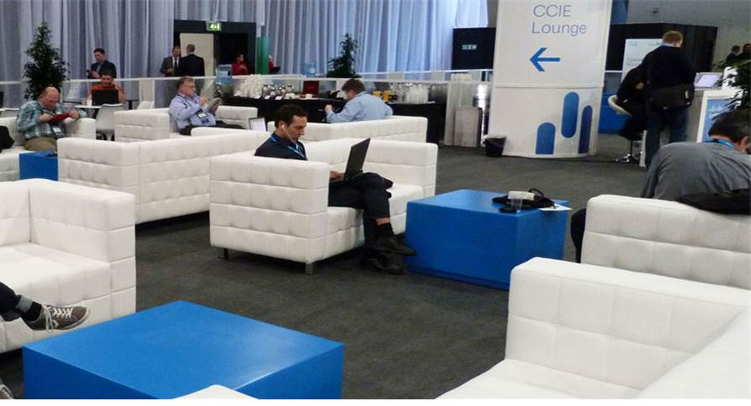

Photo 8:
A comfortable messaging centre fully equipped with telecommunication facilities are provided for attendees.

2.1.2 Types of Hotel

Certainly, different types of hotel are suitable for different types of MICE activities. In general, hotels can be grouped into five types, based on the hotel facilities:

Types of hotel | Location | Distinctive Features | Example
- Large city business hotels | - Central location  - Commercial business districts nearby  - Good access with public transport  - Parking | - High standard of business services  - Large ballroom  - Spacious lobby  - Room service  - Leisure/fitness centre | - The Grand Hyatt Hong Kong  - Conrad Hong Kong  - Four Seasons Hotel Hong Kong  - Island Shangri-La  - JW Marriott Hotel Hong Kong  - Mandarin Oriental, Hong Kong  - Kowloon Shangri-La, Hong Kong  - The Peninsula  Hong Kong  - The Marco Polo  Hong Kong Hotel  - The Ritz-Carlton Hong Kong
- Suburban hotels | - Near major junctions  - Access to highway routes and downtown | - Meeting rooms for 25-100 max  - Work stations in guest rooms  - Easy access and parking  - Leisure/fitness centre | - The Royal Park Hotel  - Hong Kong SkyCity Marriott Hotel  - Hyatt Regency Hong Kong, Sha Tin
- Large resort hotels and integrated resorts | - Nearby attractions  - Spacious | - Large ballroom(s)  - Extensive meeting and function rooms  - Pools and recreation facilities  - Golf course (features vary according to local property) | - The Gold Coast Resort  - Hong Kong Disneyland Hotel
- Airport hotels | - Linked to or near an airport terminal  - Easy access to city and regional transport and highways  - Signposted | - May have purpose-built theatre  - Usually provides a range of medium-sized and small function rooms  - Leisure/fitness centre  - Extensive glazing and soundproofing (features vary according to local property) | - The Regal Airport Hotel  - Hong Kong SkyCity Marriott Hotel  - Novotel Citygate Hong Kong
- Boutique resorts | - Remote locations  - Spacious grounds | - Small meeting rooms and suites  - High-quality service  - Leisure/fitness centre  - Golf course (features vary according to local property) | - Auberge Discovery Bay Hong Kong  - Noah's Ark Resort
- Others |  |  | - Le Meridien Cyberport  - L'hotel Nina et Convention Centre
Table 3: Types of Hotel
Source: Meetings and Exhibitions Hong Kong - Venue and Hotel Search at http://www.mehongkong.com/eng/planning-tools/venue-hotels.html

2.1.2.1 Large Properties vs. Small Properties

Hotels of different sizes are suitable for different types of MICE activities.
- Large properties

  - can cater to a wider range of MICE activities, from small corporate meetings of 30 to international association conventions of 1,000
  - tend to host international MICE activities

- Smaller properties

  - can take advantage of nearby convention and exhibition centres by hosting all food and beverage functions such as banquets and housing supplementary sessions such as small talks
  - tend to hold local MICE activities such as local corporate meetings and small local shows

Quick Fact: Hong Kong had 321 hotels with 90,109 rooms by end of December 2023
https://partnernet.hktb.com/en/home/index.html

Activity 2.2:

Complete the table below to specify which type of hotel is suitable for what kind of MICE events. It is suggested to visit the website of Meetings and Exhibitions Hong Kong - Venue and Hotel Search at http://www.mehongkong.com/eng/planning-tools/venue-hotels.html for additional information in completing this activity.

Types of hotel | Suitable for MICE activities because:
Large city business hotels | M | I | C | E
Suburban hotels | M | I | C | E
Large resort hotels and integrated resorts | M | I | C | E
Airport hotels | M | I | C | E
Boutique resorts | M | I | C | E
Others | M | I | C | E

2.1.3 Benefit to Hotel

MICE activities contribute the following to the hotel sector:

- MICE accounts for up to 65% of total sales in major hotels
- MICE attendees tend to use other services of the hotels, such as restaurants
- Spouses and entourages bring in additional business
- MICE events allow a hotel to forecast advance bookings and can help fill gaps during low seasons
- MICE customers have an excellent chance of becoming repeat guests

The cost of the hotel will in turn affect the attendance of a MICE event. Particularly for incentive trips, many activities take place in a hotel or resort and the company is responsible for the cost of a few nights’ accommodation. For international conventions and exhibitions, the cost of staying a few nights is part of the total travel cost.

2.2 Sector Involved – Transportation

Transportation management covers routing, vehicle use, staff requirements, maps, signage and preparation. The cost of transportation will also have an impact on the number of attendees. For incentive trips, transportation management is crucial, as most trips will involve large group travel. Group air tickets and ground coach bus tickets are also frequently used.

2.2.1 International transportation

Major international transportation methods, such as flights, cruise ships and trains are commonly used by MICE travellers.

For MICE events that involve international attendees, transportation plays a major role in determining the success of an event. Cities located near major air or land transport hubs have the advantage of being able to draw in more attendees. For example, travellers can fly directly from New York to Hong Kong on a direct flight using Cathay Pacific, they will need to tack on a ferry trip to reach Macau. In such cases, Hong Kong is more convenient due to its sophisticated and well-developed transportation network.

Map 1: Hong Kong is a well-established international air transportation hub

Quick Fact: Hong Kong is …..
* Easily accessible worldwide with 100 airlines operating about 1 100 passenger and cargo flights every day, providing services between Hong Kong and around 190 destinations worldwide, including about 50 Mainland cities.
* Allows visa-free entry from citizens of over 170 nations.
* The gateway to Asia and the Mainland.

2.2.2 Local transportation

Once the travellers arrive at the airport, they can be connected via the local transport system. This includes transportation from:
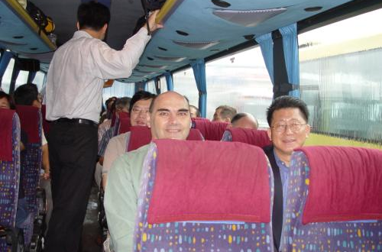
- airport to hotel
- hotel to MICE event venues
- venues to various site visit spots
- hotel to different attractions
- hotel to client’s office
- hotel to central business district
- hotel to airport
Photo 9: Travelling in a coach
Cities offering different vehicles of public transportation enhance the travel experience. Local public transports include:
- Water – ferries
- Land – limousines, taxis, buses, shuttle buses, trains, trams, cable cars

Map 2 is a local transportation map that shows you the different ways to reach the airport from any location in Hong Kong.

Activity 2.3

Referring to Map 2, and lists the ways in which attendees can travel to the airport from the Hong Kong Convention and Exhibition Centre in Wan Chai.

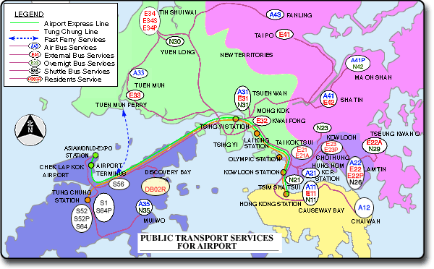
Map 2: Public transport to Hong Kong International Airport
(Source: http://www.td.gov.hk/tc/transport_in_hong_kong)

2.3 Sector Involved – Attractions

Although the main purpose for business travellers is to attend a MICE event, they would usually prefer to visit some of the local attractions. Most of the time, a post-conference tour is organized after the convention for international attendees to visit the attractions in and near the host city. For incentive travels, visiting local attractions might even be the objective of the trip. The MICE attendees are also good potential future visitors to these attractions. Therefore, when deciding whether or not to attend the MICE event, business travellers may also keep local attractions in mind.

An official travel agent will usually be contracted to organize the post-event tour. This travel agent also takes care of the travel arrangements of the attendees, if necessary, by providing a local guide.

Activity 2.4:

The following chart presents recommendations for attractions in the 18 districts:
Photo-taking Landmarks | Sightseeing | Dining & Entertainment | Shopping
Eastern District  Blossoming Garden @ | Wan Chai District  Lovers’ Rock | Wong Tai Sin District  Plaza Hollywood | Central & Western District  Dried Seafood Street, Ginsng and Brid’s Nest Street and Herbal Medicine Street
Sai Kung District  QUBY in Sai Kung | Southern District Literary Trail | Yau Tsim Mong District  Knutsford Terrace | Wan Chai District  Jardine’s Crescent
Southern District  Hundred-step Staircase | Eastern District  Oil! | Sha Tin District  New Town Plaza | Sham Shui PO District  Apliu Street Fles Market
YAU Tsim Mong District  Former Kowloon-Canton Railway Clock Tower | Kowloon City District  Kowloon Walled City Park | Tsuen Wan District  Sham Tseng | Island District  Yung Shue Wan Main Street
Source: https://www.gohk.gov.hk/en/index.php

Referring to two websites and chart as below
https://www.gohk.gov.hk/en/index.php
https://www.gov.hk/en/residents/culture/fun/index.htm

Plan a one-day post-conference tour for the attendees to experience Hong Kong.
You can:
- Draw the route on the map by linking different attractions
- List out the number that represents the different attractions
- Plan out the time required for each point of interest

For more information about Hong Kong’s enviable array of pre- and post-event activities, visit the website of Meetings & Exhibitions Hong Kong (MEHK) – Inspiring MICE Ideas - https://www.mehongkong.com/eng/home.html
3. MICE Planning

Learning Objectives:

- Understand the planning process components
- Introduce the aims and objectives of a MICE event
- Explore the basic tasks or components involved in planning

3.1 The planning process components:

                  2  3  4  5  6  7  8  9  1 | What to achieve?  Organization’s mission and objectives.
Which types of activity namely meeting, incentive, convention or exhibition best works for the organization?
Conduct feasibility study.
Who to ask for direction？
Identify stakeholders / hierarchical organizational structure
Identify those deciding factors?
Conduct external and internal analysis
Identify the risk factors as well as the challenges?
Look for opportunities and threats.
Is it ready to move forward with the plan?
Select appropriate strategy and operational plan.
Who is/ are in charge?
Take up the roles and responsibilities.
Ensure doing the right thing?
Adhere to the control system.
How to do it better next time?
Evaluation and feedback are collected to enhance the planning process.
Figure 4: The Planning Process Components
The planning starts with setting objectives. Objectives must be SMART:
 | pecific | - focus on goal and purposes, in other words, what are the outcomes.
 | easurable | - express in a way that it is quantifiable, in other words, how much or how many.
A | greeable | - agree by all stakeholders.
 | elatistic | - ensure the needed resources must be available to achieve the objectives including human resources, financial resources, etc.
 | ime specific | - ensure all the working stages must be completed within a particular time frame.
Table 4: The “SMART” Objectives

The following diagram illustrates the application of SMART in the first stage of planning, in addition, it shows the workflow of completing the event from the planning stage to the final stage. Each subcommittee is required to fulfil its roles throughout the staging process.
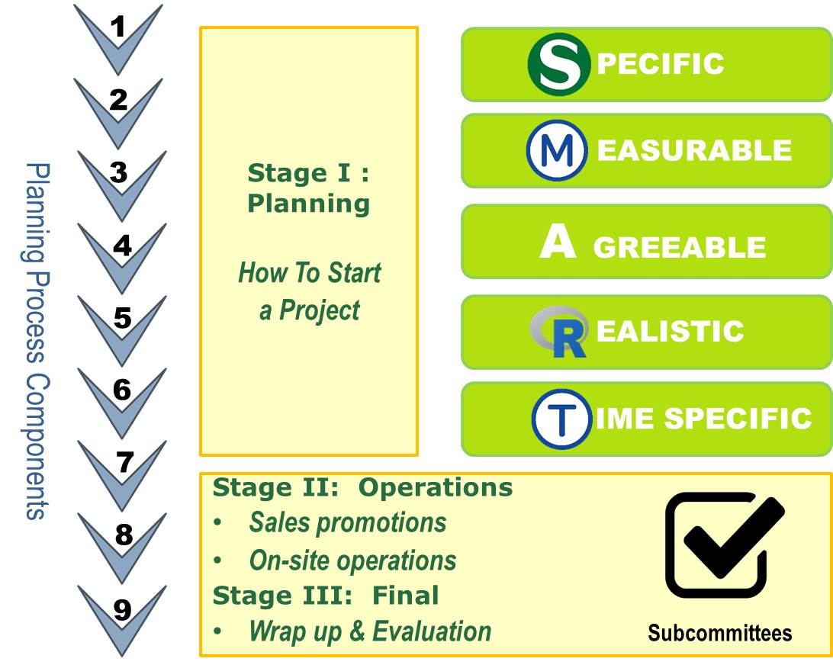

Figure 5: The relationship between planning, operations and the subcommittees
3.1.1 Organization Goals

Different types of organization have different goals when producing events.
Private for Profit
Not for Profit
Government Agencies, Public Groups or Private Groups
Companies producing events on their own or under contract
Corporations creating events for marketing reasons
Hotels, resorts, facilities using events as attractions and image makers
Leisure and social agencies, to foster sport, arts, or community integration
Arts / cultural groups to foster appreciation and participation
Economic development and tourism, to create jobs and income
Charities and causes, to attract revenue and support
Community-based societies and informal groups, for multiple community benefits
Figure 6: Organizational goals for producing events

3.2 Organization Structure

Planning a MICE event or any event involves different teams working on different functions. Depending on the type of organization, these teams can be entire departments or committees. Regardless of organizational background, each team must perform its specific function.

BOARD OF DIRECTORS
FINANCE
Fund raising
Sponsorships
Budget
Controls
PERSONNEL
Volunteers
Employees
Committee assignments
Records
MARKETING
Market plan
Research
Theming
Ticketing
ADMINISTRA-TION
Secretarial
Reports
Supplies
General records
PLANNING
Strategy
Research
Policies
Evaluation
PROGRAMME
Entertainment
Activities
Awards/prizes
CONCESSIONS
Food and beverages
Merchandise
OPERATIONS
Venues
Equipment
Security
Parking
Hospitality
Clean-up
Figure 7: Organizational structure – Functional-Based (Not for Profit)

Sometimes, the organizational structure can be monitored by a governing committee; especially when the event is organized by a membership association.

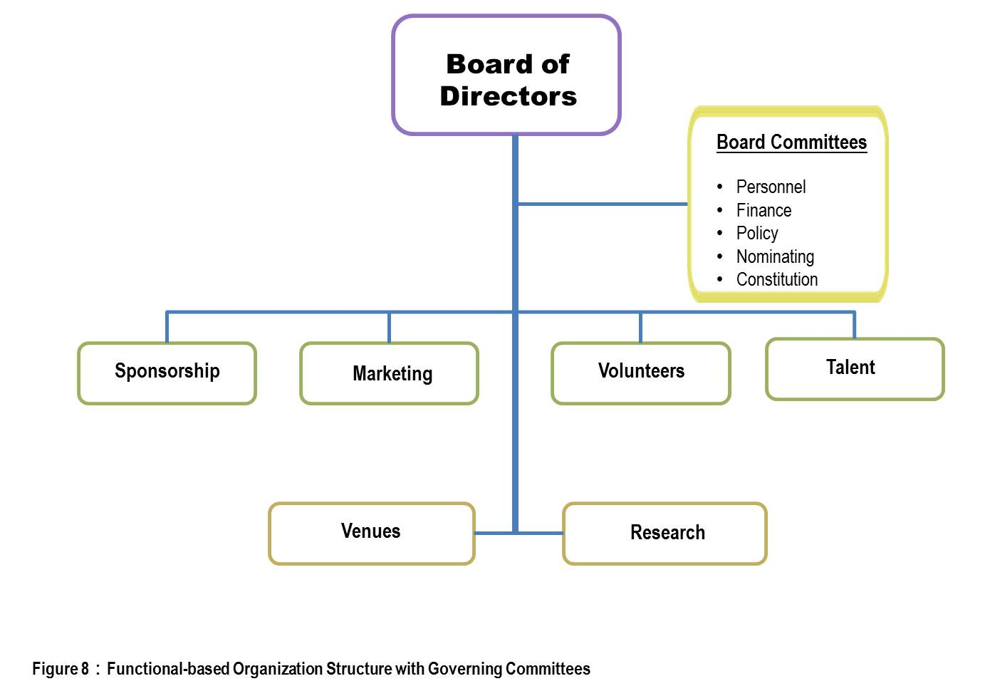
However, it may not be easy for a corporation to identify the structure of an event planning group. This is because the planner can be the secretary, personal assistant or an executive whose main duties do not involve event organization. If the corporation does not have a dedicated team of individuals to organize events, the structure will be similar to an ad hoc and functional-based one as displayed in Figure 8.

3.3 How to Start a Project

The checklist for starting a project.

- Confirm members of the organizing committee
- Confirm date and venue (submit requests for proposals (RFP))
- Decide on conference theme and logo
- Appoint Professional Congress Organizer (PCO) or event planner
- Invite and confirm members of the various subcommittees
- Set up a work plan – e.g. Critical Path Method (CPM) or Flow Chart
- Set up a budget (confirm registration fees)
- Set up a bank account
- Set up a conference website and e-mail account
- Produce conference stationeries -- letterhead and envelopes

RFP is a Request for Proposal. The event planner needs to send out a RFP to ask hotels, restaurants, convention and exhibition centres, and other venues to draft a proposal based on the organization’s requirements. By comparing different RFPs, the planner and organization representatives can then decide on their choice of suppliers. Therefore, the key of the RFP is to clearly state to suppliers the event planner’s expectations.

3.3.1 Preparation Stage

A typical MICE event will have the following subcommittees to perform different functions:

- Program subcommittee
- Social subcommittee
- Registration and hotel and tour booking team
- Publicity subcommittee
- Sponsorship subcommittee
- Printing and production team

For more information about the different types of committees, visit the following websites:

- https://www.ses.org.hk/en/about/organising-commmittee

3.3.2 Program subcommittee

The responsibility of program subcommittee:

- Set up programme schedule
  - An Example of a Setup Programme Structure:
    - Opening ceremony
    - Keynote presentation
    - Plenary session
    - Committee programs
    - Breakout sessions
    - Closing ceremony (if any)

- Nominate guest of honour and speakers / call for paper
- Follow-up speakers with bios, photos and/or abstracts
- Fix the program rundown
- Ensure following the protocol
- Ensure security
- Invitation to VIPs
- Confirm venue setup, decoration and A/V requirements (on stage/off stage)

Usually, it takes around 12 months or more to plan for a MICE event. (For large international events, the planning time can be up to 24 months or even up to 36 months.)
For more information about the roles and duties of subcommittees, visit the below websites for examples:
- http://wp.bpclub.org.hk/pgsubcom/
For more information about the duties and functions of the subcommittees, refer to:

- The roles and duties of the subcommittees – Exhibitor’s manual:
http://hkbookfair.hktdc.com/en/Exhibitor/Exhibitors-Manual.html
- EXHIBITOR/ADDITIONAL FACILITIES & SERVICES ORDER FORM
http://hkbookfair.hktdc.com/tc/Exhibitor/Additional-Facilities-Services-Order-Form.html

Activity 3.1:
Plan the above tasks. Think about which task should be done first and the best time to complete the tasks that are not as important.
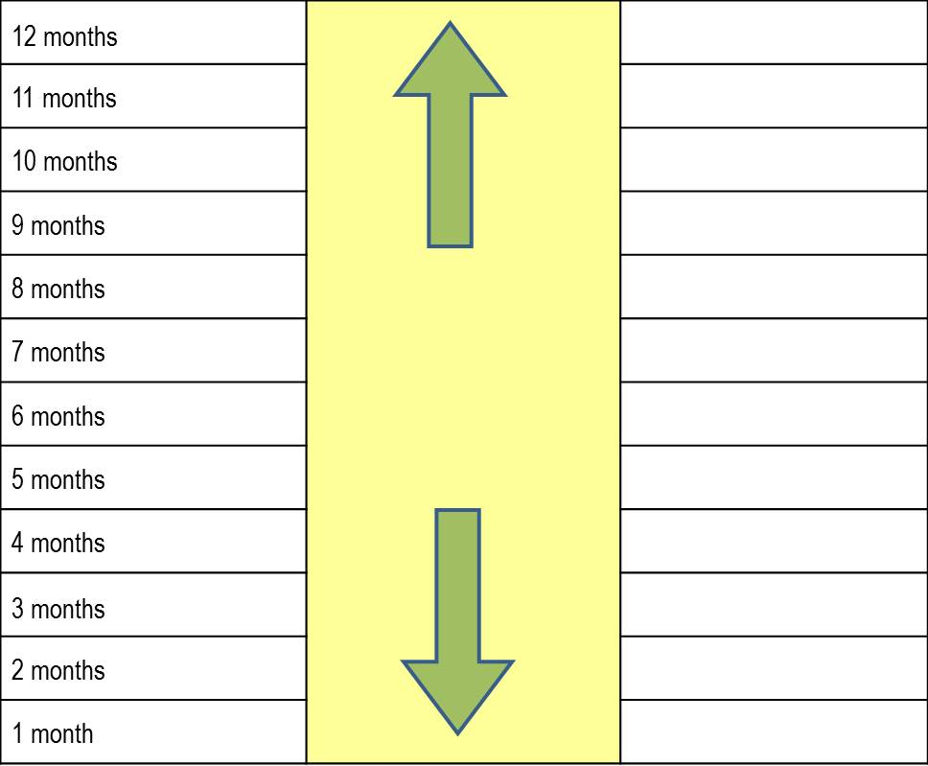
3.3.3 Social Subcommittee

The responsibility of social subcommittee:

- Set up the type/nature/quantity of social programs
- Confirm date/time/venue
- Decide on the program rundown
- Invite guest of honour
  - protocol
  - entertainment
  - transportation
  - security
- Confirm venue set-up, decoration and A/V requirements (on stage/off stage)
- Confirm food and beverage plan
  - Menu (Chinese or Western)
  - Drink package (wine, beer, juice, soft drinks)
  - Special meal requirements (no beef/pork, vegetarian etc.)

Activity 3.2:

Plan the above tasks. Think about which tasks should be completed first and the best time to complete the tasks that are not as important.

3.3.4 Registration and Hotel & Tour Booking Team

The responsibility of registration and hotel and tour booking team:
- Prepare registration forms (on-line/hard copy)
- Set up registration database
- Identify and reserve hotels
- Set up optional tour program for:
  - Accompanying persons during the conference
  - Pre/post-congress tour
- Send confirmations to delegates as registrations arrive

Activity 3.3:

Plan the above tasks. Think about which tasks should be completed first and the best time to complete the tasks that are not as important.

3.3.5 Publicity Subcommittee
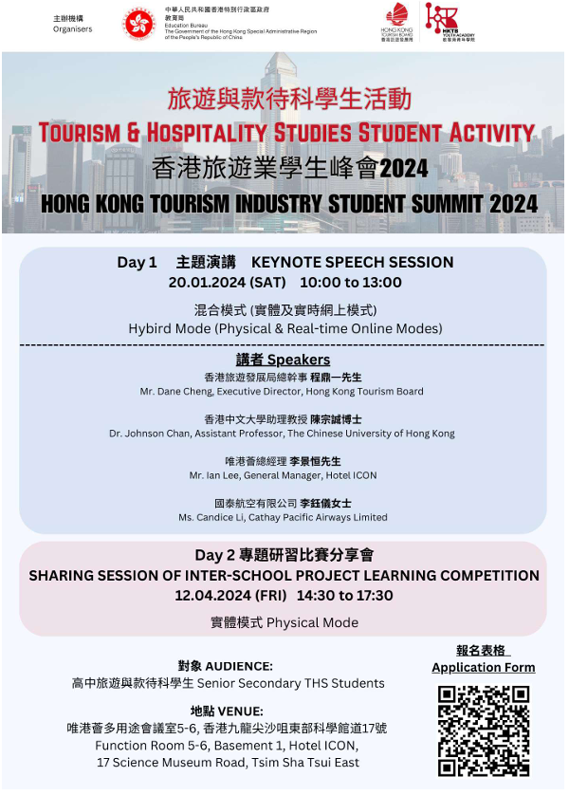
The responsibility of publicity subcommittee:

- Keep contact with individual and past conference delegates
  - Direct mail - send registration brochures by mail
  - Group e-mails - organize regular e-newsletters
- Keep contact with professional associations
  - Regular publications
  - Event calendars
  - Group e-mails
- Use Event Marketing
  - Promote own event in similar events
Photo 10:
Promotional poster
  - Media
    - Ad/Inserts in publications
    - Press releases
  - Sales Promotions
    - Complimentary/discounted registrations

Activity 3.4:
Plan the above tasks. Think about which tasks should be completed first and the best time to complete the tasks that are not as important.

3.3.6 Sponsorship Subcommittee

The responsibility of sponsorship subcommittee:

- Prepare a sponsorship and exhibition prospectus
- Appoint official contractors for exhibition floor plan and booth set-up
- Identify and recruit potential sponsors and exhibitors
- Send technical and instruction manuals to confirmed exhibitors
- Monitor all terms and conditions stated in the sponsorship contract

Activity 3.5:

Plan the above tasks. Think about which tasks should be completed first and the best time to complete the tasks that are not as important.

3.3.7 Printing and Production Team

The responsibility of printing and production team:
To prepare the following materials
- Registration brochures
- Invitation cards
- Conference proceedings – a book or CD that contains all written articles for presentation
- Conference program
- Delegates' list
- Badge
- Name plates
- Conference satchels
- Pens and pads
- Souvenirs - guests of honour, speakers, delegates
- Tickets

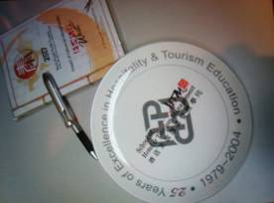
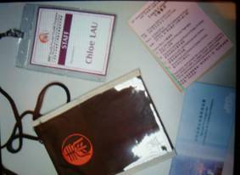
Photo 11: Pen, Pad & Souvenir
Photo 12: Name badges and tickets

Activity 3.6:

Plan the above tasks. Think about which tasks should be completed first and the best time to complete the tasks that are not as important.

3.3.8 On-site preparation

On-site preparation includes the followings:

- Set up an on-site work and manpower plan
- Prepare the venue operation order and food and beverage plan
- Buy insurance
- Arrange photographer/videographer
- Arrange transportation for on-site equipment
- Arrange on-site staff briefing
- Timeline: Six to eight weeks before conference start

3.3.9 Wrap Up

The followings should be carried out upon the end of the event:

- Send relevant thank you letters with photos
- Settle all payments
- Prepare an income and expenditure report
- Prepare a final report with statistics and recommendations
- Finalize all matters
- Timeline: Within two months after conference end

Case study 1

ITE Hong Kong 2024 Introduction

Into the 38th edition thus among the earliest in Asia, the annual ITE Hong Kong for many years been the city’s only travel fair.
Based on successes of holding ITE physically in HKCEC in 2021, 2022 and 2023, ITE2024 which target full recovery will use 5 halls of HKCEC featuring from some 50 countries and regions nearly 600 exhibitors of which over 80% from outside and overseas.
Its first two days open to local and regional trade while last two days open to public. Also registration is required in the first 1.5 days while in remaining time visitors can pay for admission.
An absolute majority of our exhibitors are part of an official pavilion / stand staged by tourism authorities from respective destinations. Thus, visitors will be able to get updated destination info; replies on last mile questions and likely unique travel maps etc. A goldmine of valuable travel information for trade and travelers!
The 4-days exhibition will be filled with attractively designed pavilions / official stands, photo booths, trade and public seminars, industry forums, prize presentations, cultural performances, workshops, demos and special displays on different travel themes etc., and there will be exhibitors making special offers! Thus great for making business deals and enjoying travel fun.
Source: https://www.itehk.com/travelexpo/

Discussion Questions:
- Identify the nature of ITE?
- What are the values of ITE to the local tourism and hospitality industry?

Case Study 2
The following paper was submitted by the Commerce and Economic Development Bureau to the Legislative Council Panel on Commerce and Industry Committee in September 2021

Convention and Exhibition Industry in Hong Kong

Purpose

1. This paper briefs Members on the future development of the convention and exhibition (C&E) industry in Hong Kong.

Overview of C&E Industry

2. The Nation’s 14th Five-Year Plan continues to support Hong Kong to enhance its status as an international trading centre, and the C&E industry is an important element thereof. Every year, Hong Kong hosts around 250 large-scale international conventions, including the “Asian Financial Forum”, “Asian Logistics and Maritime Conference”, “Belt and Road Summit” and “Business of Design Week”, bringing together government and business leaders to deliberate on the latest trend and development of the related areas and to facilitate business meetings. Regarding exhibitions, Hong Kong hosts over 160 large-scale international exhibitions every year. Among them, over 10 are the largest Asian or even global sourcing platforms for the trades concerned, including electronics, jewellery, gifts, watches and clocks, lighting, etc.

3. The C&E industry attracts high-spending overnight business visitors to Hong Kong, spurring economic activities and creating employment in sectors such as tourism, retail, catering, entertainment industries, etc. According to the Hong Kong Tourism Board, Hong Kong attracted 1.69 million overnight MICE (Meetings, Incentives, Conventions and Exhibitions) visitors in 2019, with an average spending of about HK$7,200, which is 23% higher than that of all overnight visitors.

4. The pandemic brings challenges to the C&E industry around the world. According to the information provided by the management companies of the Hong Kong Convention and Exhibition Centre (HKCEC) and AsiaWorld-Expo(AWE), 203 exhibitions originally scheduled during the 19-month period from February 2020 to November 2021 were postponed or cancelled. As the pandemic situation in Hong Kong eases, some of the local public exhibitions were successfully held during summer, such as the Hong Kong Book Fair, Ani-Com & Games Hong Kong, Hong Kong Brands and Products Shopping Festival and Food Expo, etc. Nevertheless, international trade exhibitions rely on the participation of non-local exhibitors and buyers, they are still being affected by the global pandemic situation and quarantine requirements.

5. The Government is promoting the development of Hong Kong’s C&E industry in the short, medium and long terms through provision of financial assistance, promotion of online exhibitions and expansion of C&E facilities, in order to consolidate and enhance Hong Kong’s status as an international C&E hub.

Provision of Financial Assistance

6. The Government implements the Convention and Exhibition Industry Subsidy Scheme (the Scheme) with a commitment of $1.07 billion to help the trade, through providing financial assistance, resume the organisation of C&E events as the pandemic situation eases. The Scheme consists of two parts. The first part started from 3 October 2020 and subsidises organisers of exhibitions and international conventions held at the HKCEC and AWE 100% of the venue rental without ceiling, and the Government urges the organisers to share the subsidy with participants. The other part started from 30 November 2020 and subsidises exhibitors of exhibitions organised by Hong Kong Trade Development Council (HKTDC) 50% of their participation fees, subject to a cap of $10,000 per nine-square-metre booth and 10 booths per exhibitor each time as well as participants of HKTDC’s major conventions 50% of their participation fees subject to a cap of $10,000 each time. The Scheme was originally planned to last for 12 months, and the Government has extended the validity of the Scheme twice until 30 June 2022.

7. As of 31 August 2021, the Scheme has provided total subsidy of around $121.85 million to 53 exhibitions, which involved around 7,670 exhibitors (around 6,000 local exhibitors and around 1,670 non-local exhibitors) and around 941,000 visits (around 938,000 local visits and around 3,000 non-local visits).

8. Eligible exhibitors can also apply for funding support under the “SME Export Marketing Fund” (EMF) to cover their participation fees of the relevant events on a matching basis. Since April 2021, for a period of two years, the funding scope of the EMF has been expanded to cover large-scale exhibitions and - 2 - virtual exhibitions targeting the local market held by organisations with good track record, and the eligibility criteria has been relaxed from covering SMEs only to covering non-listed enterprises. The EMF will support enterprises to conduct more local market promotional activities and business expansion, so as to alleviate the impact of shrinking business in overseas markets.

Promotion of Online Exhibitions

9. Amid the pandemic, the C&E industry needs to be more flexible, such as organising online exhibitions and online business matching etc., and there are also more and more exhibitions held in hybrid mode. In 2020, the HKTDC organised a number of online exhibitions to connect buyers and suppliers around the world, help unlock opportunities and explore overseas markets. The HKTDC also organised its flagship conventions such as the “Belt and Road Summit”, “Asian Financial Forum” and “Asian Logistics, Maritime and Aviation Conference” on virtual platforms, providing an avenue for stakeholders worldwide to share and exchange views amidst the pandemic. As the pandemic situation in Hong Kong eases, the HKTDC resumed organising physical conventions and exhibitions this year, making use of hybrid mode comprising both physical and virtual platforms to organise various C&E events, so as to broaden the reach to global audience.

10. The Financial Secretary announced in this year’s Budget that the Government will provide an additional subvention of a total of $301 million from 2021-22 to 2023-24 to the HKTDC to develop virtual platforms to enhance its capability in organising hybrid events to provide a seamless event experience for users (e.g. enhancing instant interaction functions, using artificial intelligence to help users conduct year-round business matching). The HKTDC will also proceed with digitalisation to enhance its overall service efficiency and quality, as well as upgrade its online service system for greater convenience to users and to provide personalised market analysis. In addition, the HKTDC will strengthen big data analysis to help forecast future business trends, and provide SMEs with services that are more effective, more diversified and better suit their needs.

Expansion of C&E Facilities

11. While online C&E events can help enterprises maintain business activities during the pandemic, physical C&E events, especially those emphasising on personal experience and establishing business connections, are indispensable. According to the study published by the Global Association of the Exhibition Industry in January 2021, 64% of the respondents considered that COVID-19 confirmed the value of face-to-face events and the C&E industry - 3 - would rebound quickly after the pandemic. Only 14% of the respondents considered that virtual exhibitions had the potential to replace traditional physical exhibitions.

12. Therefore, in the long run, there is still a considerable demand for C&E facilities. We must prepare for the future in order to consolidate and enhance Hong Kong’s status as a premier international C&E and sourcing centre by expanding C&E facilities in a pragmatic and cost effective manner with synergy with existing facilities and ancillary facilities in the vicinity, such that the C&E facilities in Hong Kong will better suit the need of the new mode of C&E activities. In this regard, we are proceeding with the expansion of C&E facilities in Wan Chai North and on the Airport Island.

Wan Chai North Redevelopment

13. The Government first announced the plan to redevelop the sites of the three government towers in Wan Chai North and the Kong Wan Fire Station into C&E facilities, hotel and grade A office (hereafter referred as the Wan Chai North Redevelopment) in the Policy Address in 2017, and reaffirmed its implementation in the Policy Address in 2020. The Government is taking forward projects of new government buildings in various districts to gradually relocate the concerned government departments and law court, and will carry out demolition and redevelopment afterwards.

14. The Government has commissioned the HKTDC and its consultants to conduct a series of technical studies. We preliminarily estimate that the site would provide around 30,150 square metres of additional rentable C&E space, comprising three storeys of exhibition halls seamlessly connected to the HKCEC, a column-free multipurpose hall suitable for large-scale international conferences, meeting rooms, etc.; a 500-room hotel; and about 90,000 square metres of Grade A office. There will be synergy between the new C&E facilities and the HKCEC, allowing greater flexibility for C&E events.

15. In addition, the Government will take the opportunity of the Wan Chai North Redevelopment to improve the road and pedestrian connections in Wan Chai North, thereby on the one hand improving the traffic condition, and on the other enhancing the pedestrian connectivity, in particular the connections between the C&E facilities and Wan Chai, Admiralty and Exhibition Centre MTR Stations, as well as connections with the harbourfront and public open spaces in Wan Chai North.

16. The Government has consulted the Wan Chai District Council and Harbourfront Commission on the preliminary scheme and obtained their support. The Government will initiate statutory town planning and road gazettal procedures in due course.

AWE Expansion
17. The Airport Authority (AA) has conducted a consultancy study on the AWE phase two expansion and will invest in the expansion. According to the preliminary design, the AWE phase two expansion will provide an additional 36,550 square metres of additional rentable C&E space, comprising exhibition halls and meeting rooms as well as the largest indoor performance venue in Hong Kong which could accommodate 20,000 patrons. There will be synergy between the AWE and the neighbouring SKYCITY, providing C&E, hotel, shopping, catering and entertainment facilities.

18. Upon completion of the two projects, the C&E space in Wan Chai North and on the Airport Island will increase by more than 40% to over 220,000 square metres.

Advice Sought
19. Members are invited to offer views on the future development of the C&E industry in Hong Kong.

. Commerce and Economic Development Bureau September 2021

Source: https://www.legco.gov.hk/yr20-21/english/panels/ci/papers/ci20210921cb1-1327-2-e.pdf

Discussion Questions:
Based on the above document, how does the Hong Kong Government promote the development of the MICE industry? Explain your answer.

List of Photos, Figures and Maps
Photos |  | Page
1 | A Meeting | 3
2 | A general session of a convention | 6
3 | Exhibition Booths | 9
4 | Accommodation | 18
5 | Food and Beverage | 18
6 | A Theatre | 19
7 | A Ballroom | 19
8 | A comfortable messaging centre | 21
9 | Travelling in a coach | 28
10 | Proceedings prepared in books and CD | 44
11 | Pen, Pad & Souvenir | 44
12 | Name badges and tickets | 44
Figures
1 | Nature of MICE | 1
2 | The growth rate of business visitors and MICE visitors | 12
3 | Where attendees spend their money? | 17
4 | The Planning Process Components | 32
5 | The relationship between planning, operations and the subcommittees | 33
6 | Organizational goals for producing events | 34
7 | Organizational structure – Functional-Based (Not for Profit) | 35
8 | FUNCTIONAL-BASED ORGANIZATION STRUCTURE WITH GOVERNING COMMITTEES | 36
Tables
1 | The economic value of MICE (2006 – 2012) | 12
2 | The economic impact of MICE business in 2006 and 2010 | 13-14
3 | Types of hotel | 22-23
4 | The “SMART” Objectives | 33
Maps
1 | Hong Kong is a well-established international air transportation hub | 27
2 | Public transport to Hong Kong International Airport | 29
3 | Attractions in Hong Kong | 30

Supplementary Resources

Remarks | Source of Information
- Meeting and Exhibition Hong Kong (mehk) | https://www.mehongkong.com/eng/home/why-hong-kong.html
- Examples of sectors involved in MICE business | http://hkbookfair.hktdc.com/en/Exhibitor/Exhibitor-Supporting-Services.html
- The roles and duties of the subcommittees - Exhibitor’s manual | http://hkbookfair.hktdc.com/en/Exhibitor/Exhibitors-Manual.html  https://hkbookfair.hktdc.com/en/Exhibitor/Additional-Facilities-Services-Order-Form.html
- For more information about the workflow of organizing an event, visit the website of HKTDC | http://hkbookfair.hktdc.com/en/Exhibitor/Important-Dates.html

