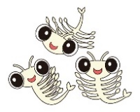
Investigation question:

- Do brine shrimps prefer to live in the light or the dark?

Our experimental set-up:

Designed by:

