XXX Secondary School
20xx-20xx
Business, Accounting and Financial Studies
Basics of Accounting: Accounting Equation Note 1

Name：__________________ Class：_____ Class No：____ Date：_________

2.1 Accounting Equation
Assets: ______________________________________________
Capital: ______________________________________________
Liabilities: _______________________________________________

Assets (A) = Capital (C) + Liabilities (L)
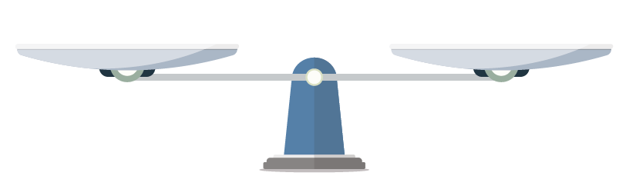
Resources owned by a business (Assets) is equal to
Resources provided by the owner(s) (Capital) and
Resources borrowed from others apart from the owner(s) (Liabilities)
The two sides of the equation must be the same and balanced.

Assets (A) = | Capital (C) | + Liabilities (L)

Effects of Business Transactions on Accounting Equation (Assets/Capital/Liabilities)
Transactions | Assets | = | Capital | + | Liabilities | Accounting Equation
- The owner introduced $50,000 cash into the business. |  | = |  | +
- The firm bought a van to deliver goods for $30,000 by cheque. |  | = |  | +
- The firm bought a non-trading motor van of $4,000 from ABC Company on credit. |  | = |  | +
- The firm borrowed $20,000 from a bank. |  | = |  | +
- The firm repaid $10,000 for the bank loan. |  | = |  | +
- The firm sold an old machine of $6,900 at cost to the SKH Company on credit. |  | = |  | +

Answers:

2.1 Accounting Equation
Assets: resources owned by the business
Capital: resources provided by the owner(s)
Liabilities: resources borrowed from others apart from the owner(s)

Assets (A) = Capital (C) + Liabilities (L)
Resources owned by a business (Assets) is equal to
Resources provided by the owner(s) (Capital) and
Resources borrowed from others apart from the owner(s) (Liabilities)
The two sides of the equation must be the same and balanced.
.

Assets (A) = | Capital (C) | + Liabilities (L)
Premises  Furniture  Inventory  Bank  Office Equipment  Cash  Machine  Motor Van | Cash contribution by owner(s)  Assets contribution by owner(s) for business use | Bank Loan  Loan from friends
Effects of Business Transactions on Accounting Equation (Assets/Capital/Liabilities)
Transactions | Assets | = | Capital | + | Liabilities | Accounting Equation
- The owner introduced $50,000 cash into the business. | ↑$50,000 | = | ↑$50,000 | + |  | Total increased but the equation remained balanced
- The firm bought a van to deliver goods of $30,000 by cheque. | ↑$30,000  ↓$30,000 | = |  | + |  | Total unchanged and the equation remained balanced
- The firm bought a non-trading motor van of $4,000 from ABC Company on credit. | ↑$4,000 | = |  | + | ↑$4,000 | Total increased but the equation remained balanced
- The firm borrowed $20,000 from a bank. | ↑$20,000 | = |  | + | ↑$20,000 | Total increased but the equation remained balanced
- The firm repaid $10,000 for the bank loan. | ↓$10,000 | = |  | + | ↓$10,000 | Total decreased but the equation remained balanced
- The firm sold an old machine of $6,900 at cost to the SKH Company on credit. | ↑$6,900  ↓$6,900 | = |  | + |  | Total unchanged and the equation remained balanced

