XXX Secondary School
20xx-20xx
Business, Accounting and Financial Studies
Key Business Functions
Group Discussion – Tai Hing’s Website Extract

Read the information regarding the human resources management of Tai Hing and answer the following questions.

1. What kind of HRM activities can you identify from Extract A?
2. Why does the HRM of Tai Hing carry out the activities in Extract A?
3. What kind of HRM activities can you identify from Extract B?
4. What happen if a company has no HRM activities mentioned in Extract B?
Extract A: Extracted from “Career” pages on Tai Hing’s Website

Extract B: Extracted from “Vacancies” pages on Tai Hing’s Website

To visualise "people-oriented" core value, the Group provides employees with a rewarding career with competitive salary, discretionary bonus, special leave package (birthday leave, marriage leave, family leave and so on), systematic training program and career development.
The Group also provides medical insurance plans, group life insurance plans and set up emergency assistance fund aiming to fully support every single one of our people.

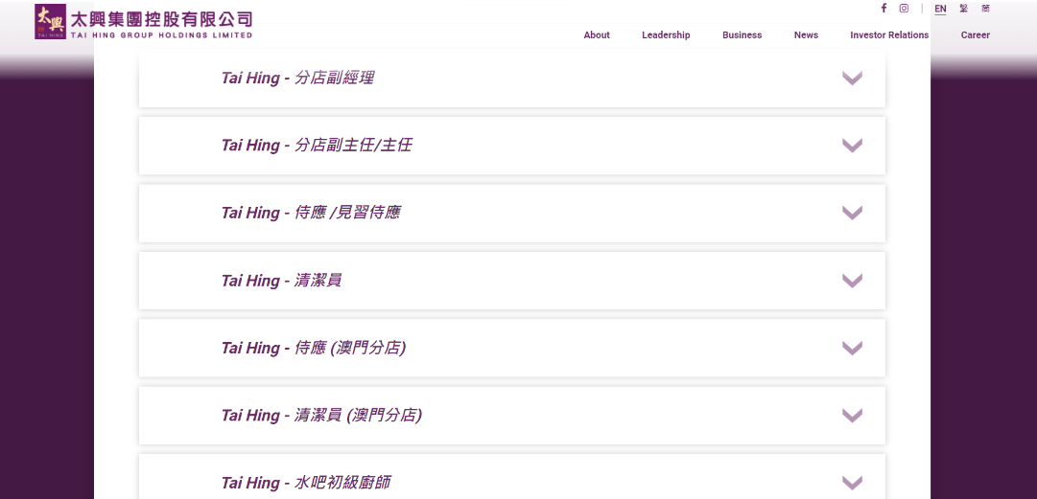

References:

Tai Hing Group Holdings Limited (2023, March 16). Career Opportunities: Join Tai Hing. https://www.taihing.com/?route=career.

Tai Hing Group Holdings Limited (2023, March 16). Job Opportunity: Vacancies. https://www.taihing.com/?route=vacancies&lang=1.

