XXX Secondary School
20xx-20xx
Business, Accounting and Financial Studies
Key Business Functions
Classwork Worksheet: Group Discussion (Answer)

Name: ___________________ Class: 4___ ( ) Date: ___________________

Read the information of Nissin Group and find out their marketing mix.

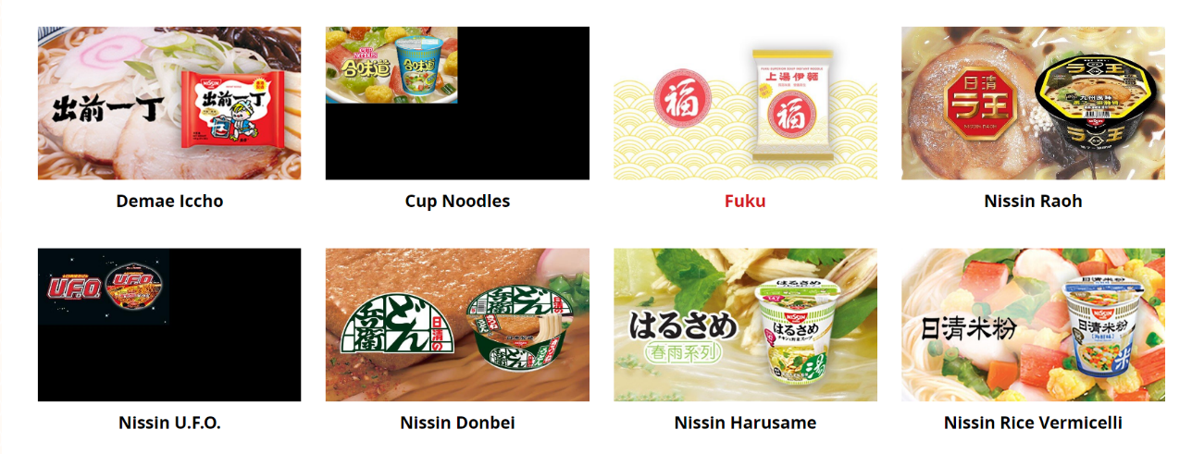
Extract A: Extracted from “Brands &Products” pages of Nissin Group’s website
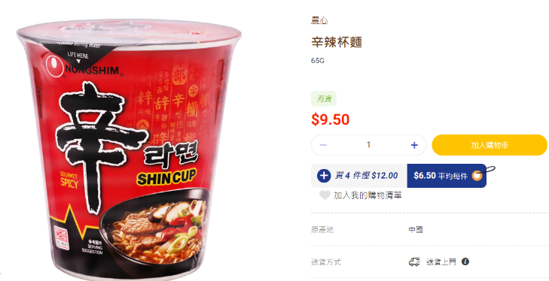
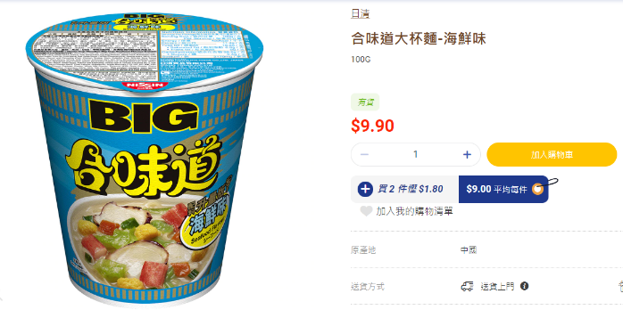
Extract B: Extracted from the website of a local supermarket

Extract C: Extracted from Nissin Group’s website
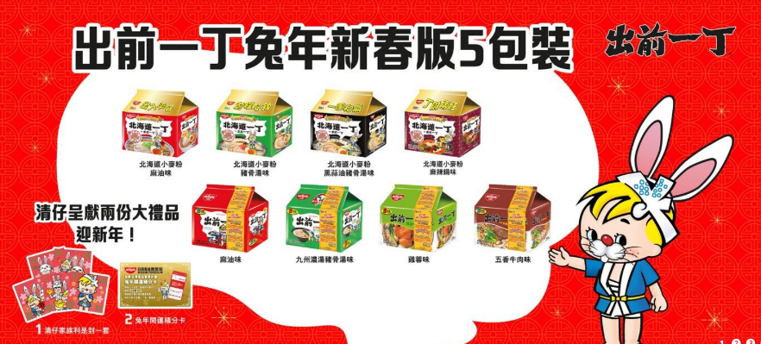
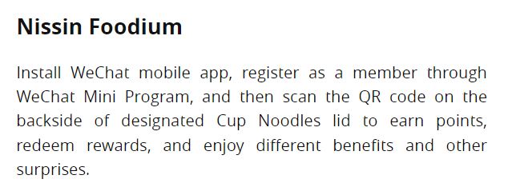

Please discuss and write down the marketing mix (Product, Pricing, Place and Promotion) of Nissin Group.
Nissin launches new flavours with special packaging.

Developing a membership program through the mobile app.

Nissin noodles can be easily bought from supermarkets, convenience stores and retail shops.

Position: offering “safe, convenient and delicious” food products
Target customers: the general public
Nissin noodles are comparable to other instant noodles.
Nissin Group produces different types of instant noodles including cup noodles, ramen, rice vermicelli, macaroni; local tastes are developed
Place
(Tips: Where can you get the products of the brand?)
Product
(Tips: what does the brand sell?)
Promotion
(Tips: How does the brand promote their products?)
Pricing
(Tips: What is the position and target customers of the brand?)
Compare the marketing mix (Product, Pricing, Place and Promotion) of Tai Hing Group and Nissin Group in the table below.

 | Tai Hing Group | Nissin Group
Product | Different brands which offer different catering services. | Different types of instant noodles.
Pricing | Position: multi-brand casual dining restaurant group  Target customers: the general public  Comparable to other restaurant groups. | Position: provide “safe, convenient and delicious” food product  Target customers: the general public  Comparable to other instant noodles.
Place | Located in some shopping malls and provision of online ordering services | Can be easily bought from supermarkets, convenient stores, retail shops and many online shops.
Promotion | Invite celebrities to film the TV commercials.  Launched products with limited edition. | Launched new flavors with special packaging.

References:

Nissin Group (2023, March 16). Nissin Group Official Website. https://www.nissinfoods.com.hk/tch/products

Tai Hing Group Holdings Limited (2023, March 16). Tai Hing Official Website. https://www.taihing.com/?route=home#home-banner

