Professional Development Programmme
New Senior Secondary (NSS) Learning & Teaching Strategies for Information and Communication Technology (ICT) - (3)



Development of Generic Skills
(Critical Thinking, Creativity and Problem Solving)

LAI Yiu Chi
Produced by
Department of Mathematics, Science, Social Sciences & Technology
The Hong Kong Institute of Education for Education
for
Education and Manpower Bureau
The Government of the Hong Kong Special Administrative Region of the People’s Republic of China
2007


© Education and Manpower Bureau All Rights Reserved 2007

Background:
The EMB has commissioned the Hong Kong Institute of Education to organise a series of professional development programmes on learning and teaching strategies for teachers with an intention to teach ICT. This course is the third of the same series.

Acknowledgements:
These training materials were written with contribution from the following students (in alphabetical order):

FT PGDE(S) Major in Information Technology:
Lam Hon Yuen
Lau Ngai
Lee Hang To Flora
Lee Wai Kit
Liu Ying Shun
Wong Pui Ying
Wu Chi Fai

BSc Mathematics (Mathematics and IT Education):
Chan Wai Ting
So Yin Ting
Wong Ka Yin
Wong Suet Mui

Course developer & Instructor: Dr. LAI Yiu Chi
Course coordinator: Dr. NG Mee Wah, Eugenia
Cover design: Mr. Wong Hon Fai
Contents
Unit 1 Teaching thinking 3
1.1 Development of generic skills and NSS ICT Curriculum
1.2 Our knowledge of thinking
1.3 Instructional approaches for teaching thinking

Unit 2 Developing learner’s generic skills: creativity 8
2.1 About creativity
2.2 Teaching for creativity in ICT lesson
Activity 2.1 Using Random ICT terms to stimulate creativity
Activity 2.2 Developing elaboration ability through learning graphics software
2.3 Infusing creativity thinking skills into ICT lesson
Activity 2.3 Enhancing the understanding of computer crimes through Brainstorming
Activity 2.4 Using SCAMPER in video editing

Unit 3 Developing learner’s generic skills: critical thinking 28
3.1 About critical Thinking
3.2 Teaching for critical thinking in ICT lesson
3.3 Infusing critical thinking skills into ICT lesson
Activity 3.1 Using Thinking map and Graphic Organizer to evaluate Internet information
3.4 Further considerations for teaching critical thinking

Unit 4 Developing learner’s generic skills: problem solving 32
4.1 Problem solving strategies
4.2 Infusing problem solving skills into ICT lesson
Activity 4.1 PMI (Should we use ICQ/MSN as a communication tool?)
Activity 4.2 Fishbone diagram ( The problem of browsing a web page)
Activity 4.3 Force Field Analysis (Upgrading my computer)
Activity 4.4 SWOT Analysis (Build a free video sharing website)
Activity 4.5 The Six Hats (Give a title for a digital photo)
4.3 Reflections on development of problem solving skills

Appendix 49
I Internet Resources
II References
III Course presentation (PowerPoint slides)

Unit 1 Teaching Thinking

1.1 Development of generic skills and NSS ICT Curriculum

We believe that our students must be prepared to exercise critical judgment and creative thinking to gather, evaluate, and use information for effective problem solving and decision making in their studies, in their careers, and in their lives (Swartz and Parks, 1994). We also observe that complex-level thinking is one of the hottest topics in education today. We want to know what complex-level thinking is and how to teach it (Udall and Daniels, 1991).

In Hong Kong, the coming NSS curriculum also emphasizes the complex thinking processes like creativity, critical thinking and problem solving. The Rationale of the NSS ICT Curriculum states that the course should provide “opportunities for the development of key generic skills such as critical thinking, communication, creativity and problem-solving, in contexts that derived naturally from the learning objectives, outcomes and experiences” (Curriculum Development Council, 2006, p.2). Besides, one of the guiding principles for effective learning and teaching in Information and Communication Technology states:

Generic skills, especially creativity, critical thinking and problem-solving skills, are integrated into the learning and teaching of the subject. (p.82)

However, Marzano and his colleagues (1988) suggest that an appropriate framework is needed for teaching thinking. It would allow practitioners in different subject areas and grade levels to develop a common knowledge base and a common language for teaching thinking.

1.2 Our knowledge of thinking

Fisher (2005) points out that our knowledge of thinking derives largely from two distinct traditions, philosophy and psychology. Philosophy has emphasized the study of critical thinking, through analysis of argument and the application of logic. On the contrary, cognitive psychologists have tended to emphasize creative thinking, how ideas may be generated in the mind. He summarizes that thinking involves critical and creative aspects of the mind, both the use of reason and the generation of ideas. Thinking is involved in any mental activity that helps us to process information and solve problems.

Complex thinking processes and core thinking skills

Presseisen (2001) argues that there are four different complex thinking processes: problem solving, decision making, critical thinking and creative thinking. These complex processes draw on and expand the underlying essential skills. However, he also points out that there are many suggestions for the taxonomy of basic thinking skills. He proposes that at least five categories of thinking skills should be considered:

A Taxonomy of Basic Thinking Skills
- Qualifying – finding unique characteristics
- Classifying – determining common qualities
- Finding Relationships – detecting regular operations
- Transforming – relating known to unknown
- Drawing Conclusions – assessing

Furthermore, each category can be further elaborated. For example, Classifying may involve the following basic thinking skills:
Classifying
- Recognizing similarities and differences
- Grouping and sorting
- Comparing
- Making “either/or” distinctions
Creative thinking, critical thinking and problem solving

Fisher (2005) reminds us that the partitioning of thinking into two types is an oversimplification. It is mistaken to think of these approaches to thinking as radically different or unconnected. In fact, most problems require both types of thinking. For example, critical judgment is essential for creating better solutions. In other words, an education that focused on only one type of thinking would be incomplete and unbalanced.

He also argues that problem solving is applied thinking and can be contrasted with two other kinds of thinking: creative (divergent) thinking and critical (analytical) thinking. These three kinds of thinking are closely inter-related. Creative and critical thinking are essential forms of investigating thinking which can be applied for a purpose in problem solving

Creative thinking (divergent)
Critical thinking (analytical)
Problem Solving (applied)
Fig. 1.1 Kinds of thinking: Investigative and problem solving
Source: Teaching children to think (Fisher, 2005).

1.3 Instructional approaches to teaching thinking

There are three common instructional approaches to teaching thinking:
(1) Direct instruction in thinking in non-curricular contexts (Teaching of thinking).
(2) Use of methods which promote thinking in content lessons (Teaching for thinking).
(3) Infusing the teaching of thinking into content instruction.

Approaches to teaching thinking
Teaching of Thinking
Teaching for Thinking
Infusing the teaching of thinking into content instruction.
Content oriented
Focus on Thinking Strategies
Fig.1.2 Three common approaches to teaching thinking

Swartz and Parks (1994) explain that infusing critical and creative thinking into content instruction blends features of two contrasting instructional approaches that educators have taken to teaching thinking: (1) direct instruction of thinking in non-curricular contexts and (2) the use of methods which promote thinking in content lessons (See Fig. 1.2).

(1) Teaching of thinking

The teaching of thinking by direct instruction means that students are taught how to use explicit thinking strategies in a lesson designated for teaching thinking. Costa (2001) points out that most authors and developers of major cognitive curriculum projects would agree that direct instruction in thinking skills is imperative.

However, the skills are usually taught using examples that are not curriculum related. It means that they must then be bridged into the ICT curriculum if students apply them to content learning.

(2) Teaching for thinking

Teaching for thinking simply means that teachers and administrators examine, monitor, and strive to create school and classroom conditions that are conducive to students’ thinking. In other words, teachers are encouraged to employ methods to promote students’ deep understanding of the content. These methods may include using co-operative learning, higher order questioning, Socratic dialog, and inquiry learning. Although students are expected to respond thoughtfully to the content, no thinking strategy is taught explicitly. When using this approach, the product (student answers), rather than the process (student thinking), is the focus in these lessons.

(3) Infusing the teaching of thinking into content instruction

Infusion lesson aims to integrate direct instruction in specific thinking skills into content area lessons. Classroom time is spent on the thinking skill or process, as well as on the ICT curriculum content.

We see that the last two approaches are content related and can be considered by ICT teachers in their lessons. In the following units, we are going to use some examples to illustrate how to teach teaching thinking in ICT lessons. More discussions on infusion will also be found.
Unit 2 Developing learner’s generic skills: creativity

2.1 About Creativity

From the NSS ICT curriculum and assessment guide, it points out that creativity should be integrated into the learning and teaching of the subject.

What is creative thinking?

But what is creative thinking? Presseisen (2001) describes creative thinking as follows:

Using basic thinking processes to develop or invent novel, aesthetic, constructive ideas or products from percepts as well as concepts. Stresses the initiative aspects of thinking as much as the rational. Emphasis is on using known information or material to generate the possible, as well as to elaborate on the thinker’s original perspective or design. (p.49)

On the other hand, Fox and Fox (2000) advocate a simple yet elegant equation for creativity presented by Dr. Ruth Noller, an early pioneer in the field:

Creativity equals the function of an attitude multiplied by knowledge, imagination and evaluation.(p.13)

The creative process

Fisher (2005) summarizes the creative process in five stages:
Stimulus → Exploration → Planning → Activity → Review

He also reminds us some misconceptions about creativity:
- That creativity is unrelated to critical thinking.
- That creativity is found in some subjects but not in others.
- That creativity is simply ‘doing your own thing’.
- That creativity requires a high IQ.

There are four important creative thinking skills: fluency, flexibility, originality, and elaboration.

Some educators also point out three basic underlying principles of creativity ( see http://philosophy.hku.hk/think/creative/steps.php ).

Principle I : New ideas are composed of old elements
Principle II : Not all new ideas are on a par
Principle III : Creativity is enhanced by the ability to detect connections between ideas

How to integrate creativity into ICT lessons?

To integrate creativity into ICT lessons, teachers are advised to
- encourage learners to think from different perspectives
- suggest to learners the alternatives for doing things
- accept different answers from learners
- help learners develop the ability to produce original ideas and solve problems appropriate to contexts
- develop learners’ ability to detect connections between ideas, etc.

However, ICT teachers should understand that the development of creativity will be affected by the following factors:
- lack of imagination and curiosity
- lack of self-confidence
- a failure to look at information from different angles

In the following sections, we are going to discuss two different approaches: teaching for creativity in ICT lesson and infusing creative thinking skills into ICT contents.
2.2 Teaching for Creativity in ICT lesson

In this section, two examples will be used to show how we can stimulate the students’ creativity. However, we should also note that no thinking strategies will be taught in these two activities.

Activity 2.1 Using Random ICT terms to stimulate creativity

Random word is a simple but useful creativity technique for stimulating creativity. This method forces you to depart from your conventional train of thought and makes you tackle a problem from a different direction. By using your creativity, you can make connection between some words, ideas, concepts which you want to memorize. The connection may help you get a sentence or a story.

In this activity, we are going to use the random word technique to stimulate the students’ creative thinking. Students are asked to link some computer terms learnt in their ICT lessons. Before the lesson, we need to prepare some cards printed with ICT terms.

motherboard

main memory

Operating
system

application
software

execute

direct access

Memory card

access time

Fig. 2.1 Cards for playing random word game

The activity can be implemented as follows:
- Students are asked to form groups of 3 to 5.
- Each group is asked to draw three cards.
- Try to link the selected words to form a sentence.
- The teacher should discuss with his/her class about the meaning of these sentences.
Fig. 2.2 shows some possible answers from students.

Card 1 | Card 2 | Card 3 | Sentence made
motherboard | store |  | This operating system is really good. When you press a key, you can store the data to a hard disk that is connected to an interface card on the motherboard.
  operating system
 | execute | memory card | How do we read data from a memory card? You should execute some application software.
  application software
main memory | fetch | data | How do we fetch data from the main memory?

Fig. 2.2 Possible answers from students

Your task

Suppose you have drawn the following cards in the activity. Try to link the computer terms shown on the cards to form a meaningful sentence.

Card 1 | Card 2 | Card 3 | Sentence
Binary | Hyperlink | Interaction
Spreadsheet | Search | Chart
Text | Web browser | Sort

Activity 2.2 Developing elaboration ability through learning graphics software

Elaboration means constructing things in the way of adding simple stimulus to make it more complex. The following is an example of using Squiggle to practise the elaboration skill. We will provide a wavy or curly line or shape to students and let them develop a picture by their creativity.

In this activity, we are going to produce a drawing based on a squiggle. Use graphics software (e.g, PhotoImpact ) to elaborate the squiggle shown below.



Here are some examples:
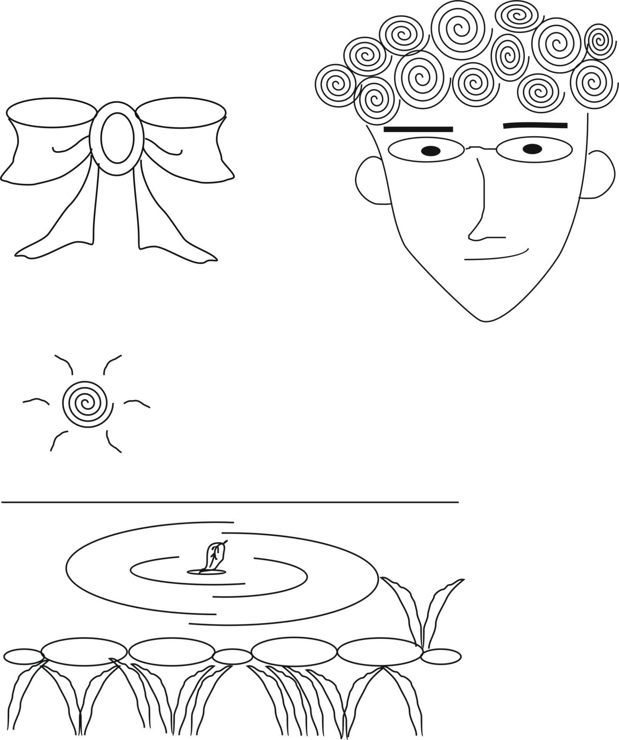
Your task 1
Draw anything you like to improve the picture below.


Your task 2
Base on the squiggle shown below, draw a picture.



2.3 Infusing Creative thinking skills into ICT lesson

In this section, two powerful tools: brainstorming and SCAMPER checklist will be introduced. These tools are useful for generating ideas.

Activity 2.3 Enhancing the understanding of computer crimes through Brainstorming

Brainstorming is a powerful tool for generating ideas. Students are given a word or phrase as a starting point. They are challenged by suggesting any ideas, knowledge, information etc. which are related to the word. The process involves:
- listing as many ideas as possible
- withholding comments on the ideas proposed
- building on the ideas generated
- choosing the best ideas. (Fisher, 2005)

The process can also help students to consolidate and apply their knowledge practically. Task can be further extended by creating a mind map in the brainstorming process. Students can also develop their classification and reorganization skills.

In this activity, we are going to brainstorm a topic in the NSS ICT curriculum - computer crimes. List out as many the types of computer crimes as possible and use FreeMind to draw a mind map. FreeMind is premier free mind-mapping software written in Java. (http://freemind.sourceforge.net/wiki/index.php/Main_Page).

Follow the steps below:
- Download and install the free software – FreeMind.
- Using FreeMind to list out the types of computer crimes during the brainstorm process.
- Reorganize and classify the above information with FreeMind.
- Concepts are circled. Place the most general concepts at the top. Place intermediate concepts below general concepts. Put specific concepts at the bottom.
- Draw lines between related concepts
1) Download and install FreeMind

Step 1: Go to http://freemind.sourceforge.net/wiki
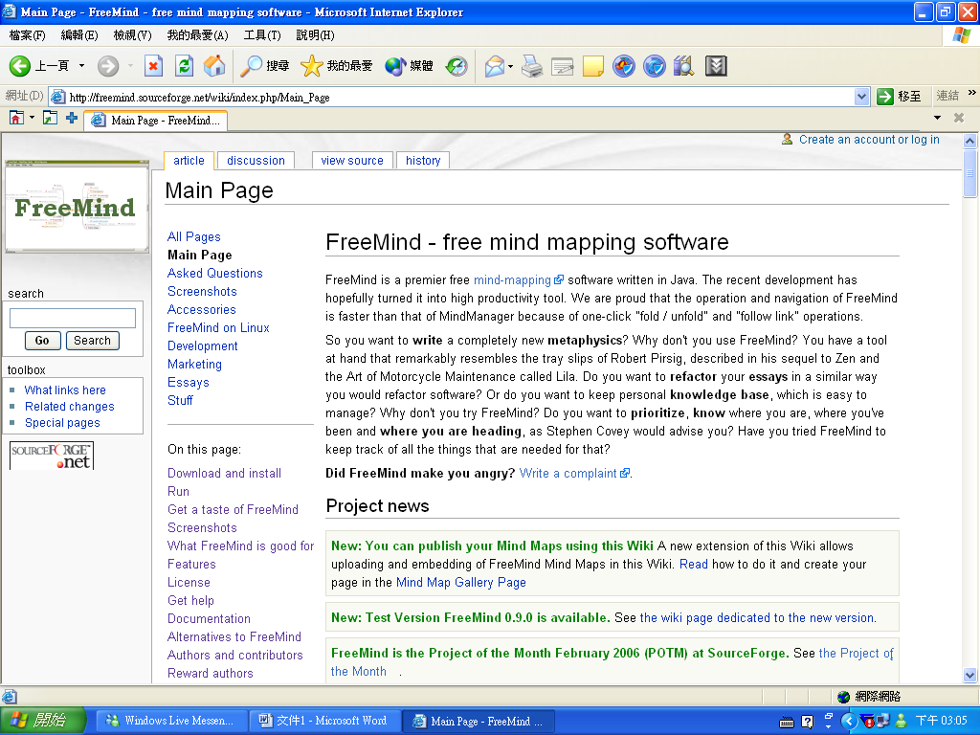

Step 2: Download the suitable version for your operating system. Make sure your computer has installed Java Runtime Environment (JRE) for running the FreeMind.
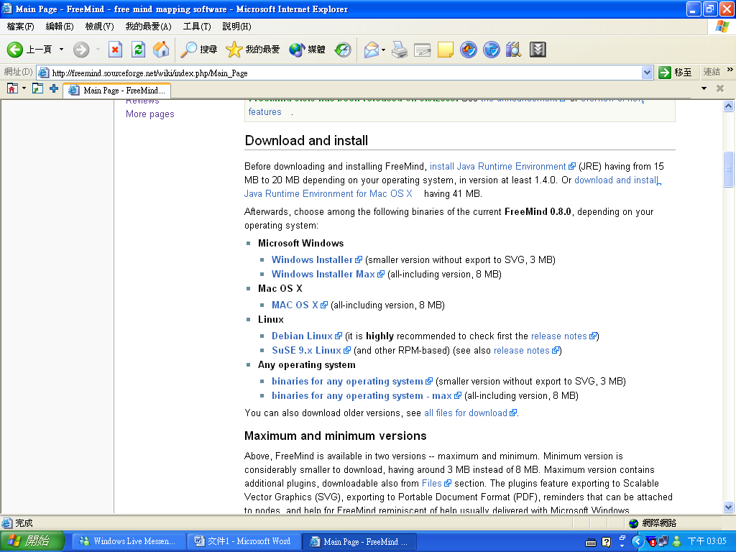
Step 3: Install FreeMind.
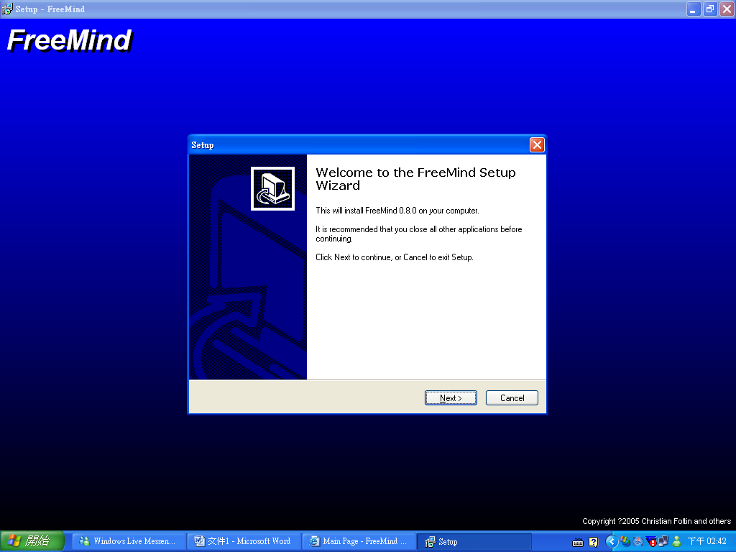

2) Using the FreeMind for brainstorming
Step 1: Click the icon -“FreeMind”.


Step 2: Click “New” to start the map.
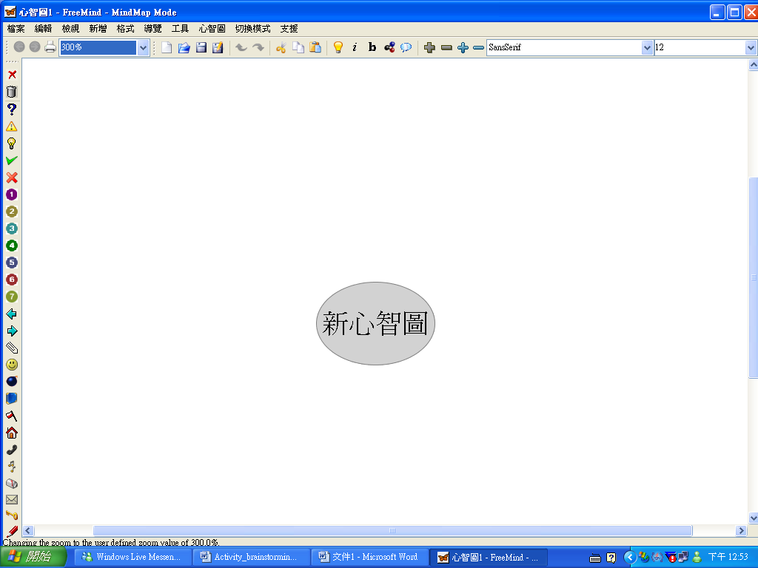
Step 3: Click on the circle shown above to change the topic.
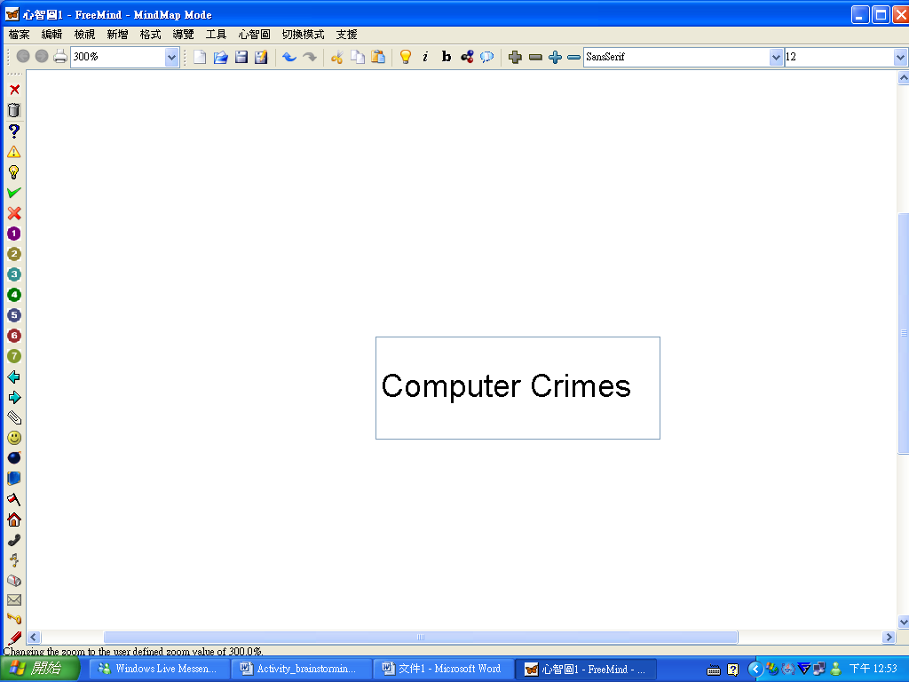

Step 4: Click on the topic “Computer Crimes” and then click on the light bulb icon on the top tool bar to add branch.
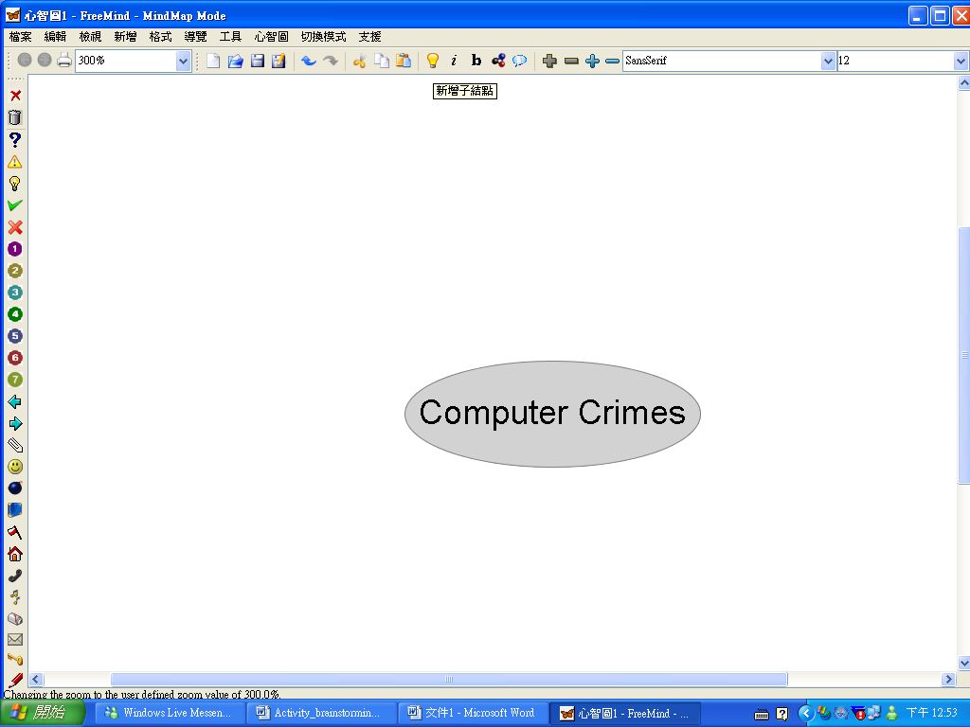
Step 5: Click the new branch and add your new ideas.
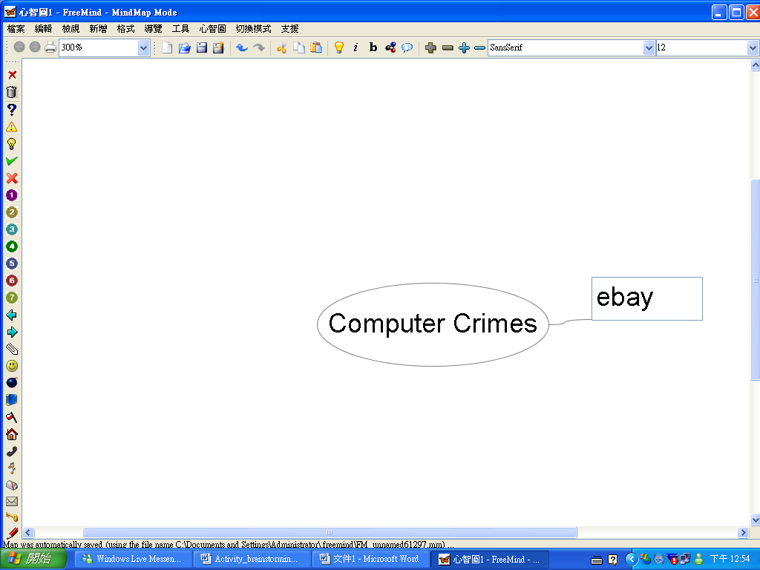

Step 6: Repeat step 4 and 5 to add branches to the topic until you finish your job.
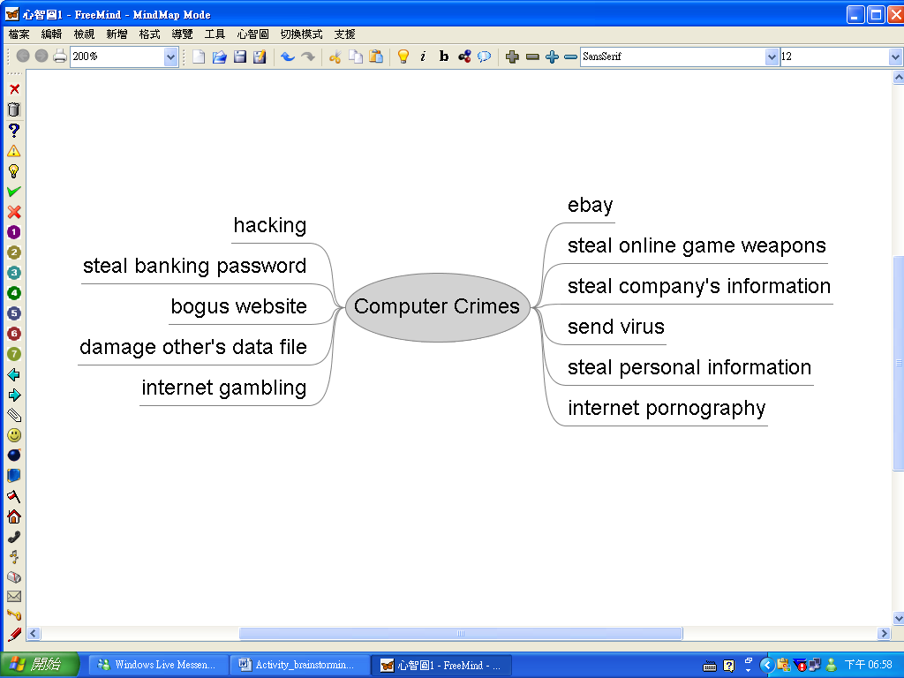
Remember to store your work before leaving!
3) Further example of mind map
Step 1: Follow steps 1 – 5 as above. Choose the “format” column to form a box for the branch.
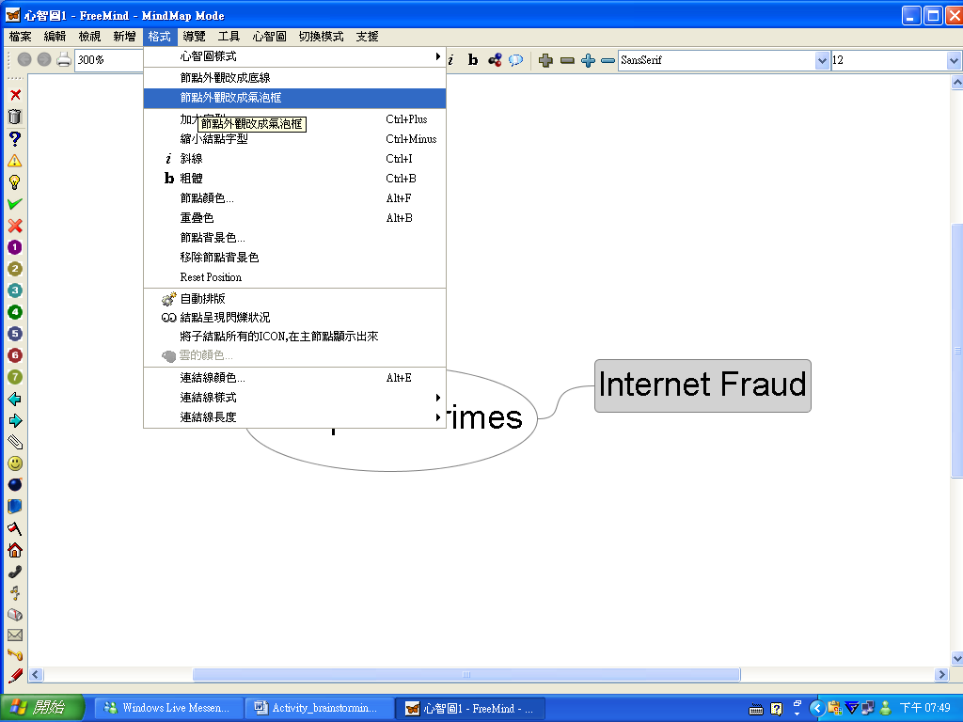

Step 2: Click on the branch and the light bulb icon for extending new branch.
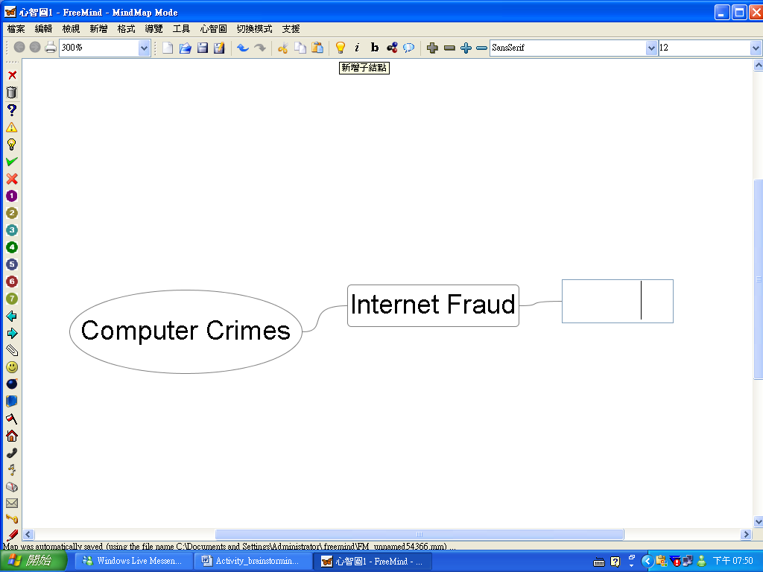
Step 3: Click the first level extended branch and click the column “new a parallel point (below)” to extend a branch of the same level.
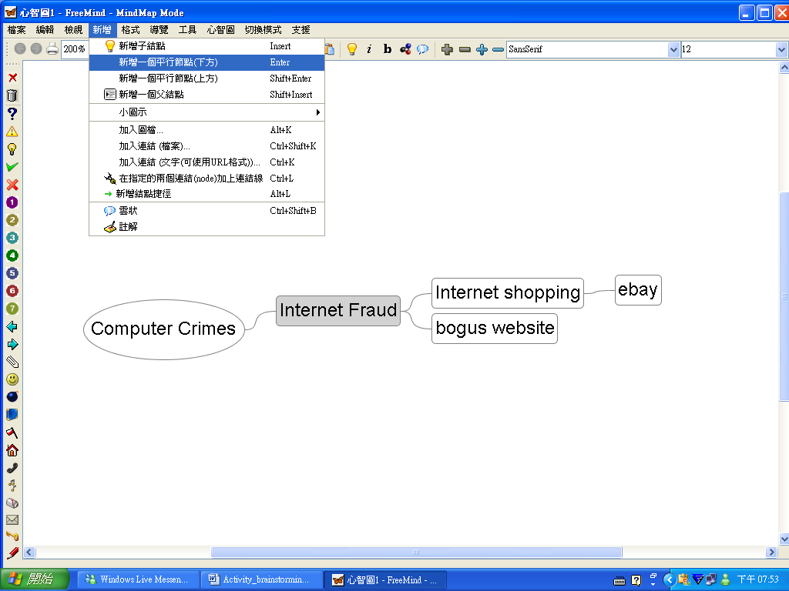
Step 4: Repeat step 1-3 to complete the mind map.
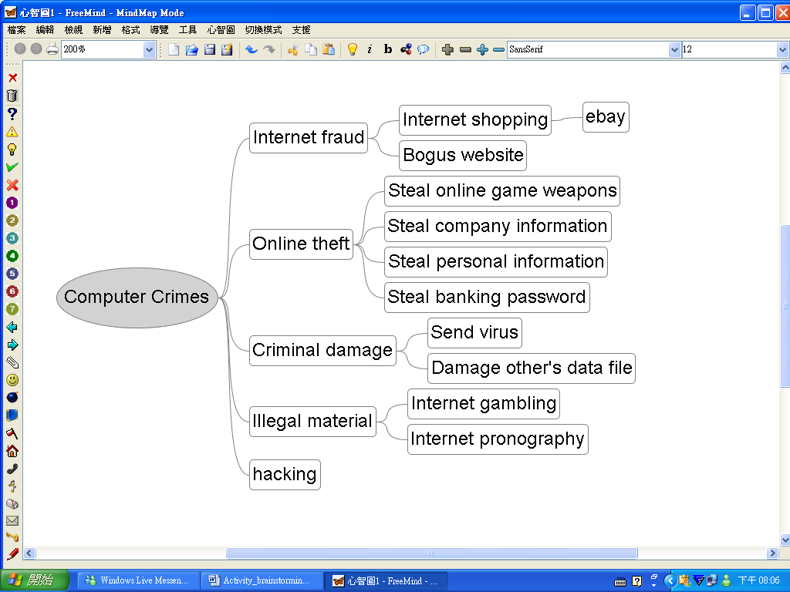
The mind map has been created. At this moment, you can modify the wordings used by the student.
Your task 1
Can you image what facilities will be installed in the computer laboratory ten years later? Brainstorm your ideas and write them down in the box below.

Your task 2

Reorganize your ideas and draw a mind map in the box below.

Activity 2.4 Using SCAMPER in video editing

SCAMPER is a technique to guide you to create a new product from an existing product. It represents a powerful checklist:

S | Substitute | Replace some parts by other components.
C | Combine | Combine some parts to form a new part.
A | Adapt | Change the nature of the product.
M | Modify | Change part of the product, e.g. color, shape, scale.
P | Put to another use | Change the usage of the product.
E | Eliminate | Eliminate some parts of the product to create a new one.
R | Reverse / Rearrange | Think reversely or in a different order.

The following example shows how Ms Wong infused this creativity tool in teaching video editing.

After teaching students how to edit video with Video Studio, Ms Wong wanted to assess their skill on video editing and incorporate the SCAMPER technique in her ICT lesson. Miss Wong asked her students to find some video clips. After that, she divided them into groups of 3 to 4 students. They were required to use their video editing skills together with SCAMPER technique to combine their video clips into a new product. Miss Wong also advised her students to divide each video clip into smaller parts. The following table was used to guide them to use the SCAMPER technique. They were instructed to fill in the “How to do?” column themselves. Below shows the result:

Technique | Meaning | How to do?
S: Substitute | Replace some parts by other components. | Find another sound track to replace the original sound track.
C: Combine | Combine some parts to form a new part. | Combine some transition effects with the video clip.
A: Adapt | Change the nature of the product. | Add a title or some captions to the clip to help audience to understand more about the content of the clip. This can help adapt the teaching purpose.
M: Modify | Change part of the product, e.g. color, shape, scale. | Fade in and Fade out the background music to make the transition more natural.
P: Put to another use | Change the usage of the product. | Change the purpose of video clip from recording to teaching.
E: Eliminate | Eliminate some parts of the product to create a new one. | Cut unnecessary parts of the clip to shorten the clip.
R: Reverse/ Rearrange | Think reversely or in a different order. | Rearrange the events into different orders.

Their final products can be posted on the learning platform to share with other students.

Your task

Blog is a popular service on the Internet. People usually use it as a dairy. They record the things happened in their daily lives and share them with their friends. Use the SCAMPER technique to develop Blog into another innovative Internet service.

Technique | Meaning | How to do?
S: Substitute | Replace some parts by other components.
C: Combine | Combine some parts to form a new part.
A: Adapt | Change the nature of the product.
M: Modify | Change part of the product, e.g. color, shape, scale.
P: Put to another use | Change the usage of the product.
E: Eliminate | Eliminate some parts of the product to create a new one.
R: Reverse/ Rearrange | Think reversely or in a different order.

Unit 3 Developing learner’s generic skills: critical thinking

3.1 About critical thinking

Critical thinking is sometimes defined narrowly and sometimes more globally. In the narrower sense, it may imply assessing the accuracy of statements (Marzano et al., 1988). Ennis (2001) has a broader interpretation and defines critical thinking as “reasonable and reflective thinking that is focused on deciding what to believe or do” (p.44).

On the other hand, Presseisen (2001) defines critical thinking as:
Using basic thinking processes to analyze arguments and generate insight into particular meanings and interpretations; develop cohesive, logical reasoning patterns and understand assumptions and biases underlying particular positions; attain a credible, concise, and convincing style of presentation or argument (pp.49-50).

Fisher (2005) points out that learning to think critically means:
- learning how to question, when to question and what questions to ask.
- learning how to reason, when to use reasoning and what reasoning methods to use. (p.53)

In order to develop learner’s critical thinking skills, teachers should
- enhance learner’s understanding of the logical connections between ideas
- help learners identify the relevance and importance of ideas
- help learners identify, construct and evaluate arguments
- help learners detect inconsistencies and common mistakes in reasoning
- develop learner’s reflection on the justification of one’s own beliefs and values, etc.

3.2 Teaching for critical thinking in ICT lesson

To promote critical thinking, many teachers employ higher order questioning or Socratic dialogue (or Socratic questioning) to stimulate more thinking about the content than asking questions that simply recall facts. Teachers typically ask “Why,” “What if,” and “How” questions. This kind of questioning remains content oriented and aims to yield a deeper understanding of what is being taught.

Socratic questioning provides unique opportunities for critical thinking and student reflection. In the process, the instructor poses thoughtful questions to help students learn. For details of Socratic questioning, you may visit the following website created by Merritts and Walter:
Using Socratic Questioning (http://serc.carleton.edu/introgeo/socratic/index.html )

3.3 Infusing critical thinking skills into ICT lesson.

We often rely on others as sources of information. Evaluating sources skillfully is an important critical thinking skill.

Activity 3.1 Using thinking map and graphic organizer to evaluate Internet information.
In this activity, we are going to learn how to use thinking map and graphic organizer to evaluate Internet information. These tools are similar to those designed by Swartz and Parks (1994). In learning ICT, students are often asked to gather information from different websites. It is important for them to know how to select the Internet information critically.

We shall adopt some criteria that are used in the evaluation checklist from the UC Berkeley Library.
(see http://www.lib.berkeley.edu/TeachingLib/Guides/Internet/Evaluate.html )
To illustrate the underlying thinking strategy, the activity will look at the quality of information only. Fig. 3.1 shows a thinking map for evaluating the quality of Internet information. It guides us in making judgments about sources.

Indicators of quality of Internet Information
1. Sources well documented?
2. Complete? If 2nd-hand information, is it not altered or forged?
3. Links to more resources? Do they work?
4. Other viewpoints? Bias?
Fig. 3.1 Thinking map for evaluating the quality of Internet Information

Choose a website you are interested in and use the following graphic organizer to evaluate the quality of information provided by the website.

 | Questions |  | Information | (+/-/?)
 | Sources well documented?
 | Complete? If 2nd-hand information, is it not altered or forged? |  |  |  | Reliable, Unreliable, or uncertain?
 | Links to more resources? Do they work?
 | Other viewpoints? Bias?

Fig. 3.2 Graphic Organizer for evaluating the quality of Internet Information
  - Further considerations for teaching critical thinking

We should also note that many people confuse argument with quarrelling. Argument aims at discovering the truth by exposing belief to the light of reason. Argument is not an invitation to quarrel and should be a challenge to reason. On the contrary, quarrelling can be seen as a verbal fight.

Moreover, teachers should note that a number of factors will affect the learner’s development of critical thinking such as:
- ability to think clearly and rationally
- ability to make deductions/ inferences from sources
- ability to engage in independent thinking
- ability to identify right and wrong
- ability to engage in self reflection to draw out meaning from given data or statements
- ability to generate and evaluate arguments
- ability to make judgments

Unit 4 Developing learner’s generic skills: problem solving

4.1 Problem solving strategies

From his classic text on problem solving, “How to solve it : a new aspect of mathematical method”, Polya (1971) states that most problem-solving strategies can be classified under four general principles:
- understand the nature of the problem
- draw up a plan to solve the problem
- try out the plan
- monitor the outcome of the plan

Similar procedures are widely used in learning programming concepts. We note that these principles are highly related to the strategies to develop student’s problem solving skills. In ICT lessons, teacher should
- help learners identify the problem
- help learners identify sources of information
- encourage learners design more than one potential solution
- encourage learners examine the pros and cons of each potential solution
- help learners plan the details of each step and analyze how they fit together, etc.

Although these general principles are useful in problem solving, most students may not have full confidence to tackle a problem. Therefore, we will introduce some well-known problem solving tools in this unit. The contents of the activities are based on the NSS ICT curriculum.

4.2 Infusing problem solving skills into ICT lesson

In this section, we are going to introduce some commonly known problem solving tools. These tools can be taught in your ICT lessons with the infusion approach.
Activity 4.1 PMI
(Should we use ICQ/MSN as a communication tool?)

PMI is a decision making tool introduced by Edwards de Bono. PMI means:
P ----‘Plus’ , M ----‘Minus’ and I ---- ‘Interesting’

How PMI works?
When we are facing a difficult decision, we can use PMI as follows:
- Draw a table with three columns named ‘Plus’, ‘Minus’ and ‘Interesting’
- Write down all positive points about an idea under the ‘Plus’ column
- Write down all negative points about an idea under the ‘Minus’ column
- Write down what you find interesting about the idea, whether positive or negative, under the ‘Interesting’ column.
- Assign a positive or negative score for each point
- Sum up all the score

A strongly positive score will support this idea, otherwise it should be avoided.

PMI is easy to use and can be used in ICT lessons. Students can use this tool when they have problems in finding an appropriate choice. Teachers can use PMI to explore some ICT topics with students. In the discussion, teachers should encourage students to generate more ideas or points, so that students’ creativity can also be developed.

In this activity, Miss Wong wanted to use PMI to discuss some online communication tools with students. Nowadays, students are familiar with ICQ or MSN, so Miss Wong set the discussion topic as ‘Should we use ICQ/MSN as a communication tool?’

Miss Wong divided the students into 3 groups. They were asked to discuss the points for Plus, Minus and Interesting columns. In order to develop students’ thinking, teacher may use the following questions to stimulate students’ thinking:
- Why do/don’t you choose MSN/ICQ as a communication tool?
- Think as many points as possible to fill in the columns.
- Have you met any difficulties when using these tools?

Fig. 4.1 shows a sample result after the discussion.

Should we use ICQ/ MSN as a communication tool?
Plus | Minus | Interesting
- easier to chat with friends  - many functions to use  - save time  - flexible; we can use MSN with mobile | - too rely on these tools  - drift apart interpersonal relation  - don’t know people’s identity  - not face to face  - easy to get virus | - meet more people  - not related to study
Fig 4.1 The PMI table on the blackboard

Then Miss Wong asked her students to assign a positive or negative score for each point.
Should we use ICQ/ MSN as a communication tool?
Plus | Minus | Interesting
- easier to chat with friends +3  - many functions to use +2  - save time +3  - flexible; we can use MSN with mobile +1 | - too rely on these tools -5  - drift apart interpersonal relation -5  - don’t know people’s identity -4  - not face to face -2  - easier to get virus -4 | - meet more people +3  - not related to study -2
+9 | -20 | +1
Total =
Fig 4.2 The PMI table with scores
Your task
- Sum up all the scores in the table.
- The total score is __________________________ which is (positive/ negative).
- Your conclusion is _______________________________________________

Activity 4.2 Fishbone diagram
(The problem of browsing a web page)

Fishbone diagram is a diagram that looks like a fishbone. It helps us look at a specific problem and recognize the main areas of fault that can lead to this problem. Furthermore, the diagram also shows the possible causes for each area of fault. In short, the fishbone gives us greater insight into the dynamics of the situation (Craig, 2000).

Fig. 4.3 Fishbone diagram (outline)

To draw a fishbone diagram, we place the key problem inside the head of the fish. Then we label larger bones with the areas of fault. The smaller bones are used to show the possible causes that can be associated with a fault area. The fishbone diagram helps us visualize a problem in terms of the causes with the added advantage of clear structure.

In the following example, Ms Chan raised a problem about browsing a web page. She first asked students to write down all the possible causes of the problem. Then she asked them to rethink the problem and causes with the help of a fishbone diagram.

Figures 4.4 and 4.5 show the results. Which method do you prefer? Try and find an answer in your lesson!

Why can’t my computer show a web page properly?
- Network cable not connected.
- Parental control software has blocked the connection to certain websites.
- Virus infection
- Modem problem
- Router problem
- The website has been hacked.
- Earthquake
Fig. 4.4 A list of possible causes
Cable problem

Router failure
ISP problem

Parental control software blocks the page.
Forget to switch on the router

Network Card failure
Wire not connected
Earthquake
Power supply off

Modem failure

Forget to switch on the modem

The website down

Parental control software blocks all websites

Website hacked

Internet Explore out set properly.

External factors
Software problem
Hardware Problem
Human factors

Internet Explore not installed

Why can’t my computer display a web page properly?
Fig. 4.5 A fishbone diagram for the problem
Your task

Draw a fishbone to show the causes of the problem shown in the fish head.

Lack of RAM

Computer is outdated

Software Problem

Hardware problem

Why speed of a computer becomes slower?
Activity 4.3 Force Field Analysis
(Upgrading my computer)

Kurt Lewin’s Force Field Analysis is an effective decision making model which can help students to develop problem solving skill. When doing Force Field Analysis, the opposing force and supporting forces of a decision will be listed and scored. Force Field Analysis helps you to identify or reduce the opposing forces, and strengthen or reinforce the supporting forces.

How does Force Field Analysis work?
To carry out Force Field Analysis, we can follow the steps below:
- Identify all the supporting and opposing forces in separate columns.
- For each force, give a score between 1 and 5 (1 is the weakest and 5 is the strongest)
- Draw opposing arrows for each force and the size of each arrow should be proportional to the score.
- Total the score of all supporting forces and that of opposing forces.
- Increase the score of supporting forces or decrease the score of opposing forces by making an appropriate action plan. Calculate the new score.

Once the action plan has been made, your confidence in implementing this plan/idea will be increased. Force Field Analysis can help students develop decision making skill. The following example shows you how Force Field Analysis can be infused in an ICT lesson.

In this activity, Miss Wong used the topic of ‘upgrading my computer’ to teach students how to use a problem solving tool - Force Field Analysis. The conversation between Miss Wong and her students is shown below:
Miss Wong: Do you want to upgrade your personal computer?
Student A: Yes, but my budget is very tight.
Student B: I think that space is the concerned area. My study room is too small to accommodate a 21” monitor.
Miss Wong: Is there a supporting reason for upgrading your own computer?
Student C: Of course. After upgrading my computer, I can have more storage space.
Student D: As the operational speed of the computer increases, my work efficiency can also be increased.
Then Miss Wong put down all the suggested supporting and opposing forces on the blackboard (see Figure 4.6)
Force for upgrading Force against upgrading

More storage Cost
space
Upgrading my
computer
Operation speed Lack of space
and efficiency
increase
Parents’ resistance Can support more
software and hardware
Environmental
pollution

Fig 4.6 Showing all the forces

Then Miss Wong asked students to give each force a score. She put the scores and drew arrows aside the forces (see Fig 4.7). The scores for and against forces were calculated.
Force for upgrading Force against upgrading

More storage
Space 5 5 Cost
Upgrading my
computer
Operation speed 4 Lack of space
and efficiency 5
increase Parents’
4 resistance
Can support more
software and 3 2 Environmental
hardware pollution

Total: 13 Total: 15
Fig 4.7 The Force Field Analysis diagram with scores

Do you agree with the result?
Miss Wong asked students to review all the forces carefully. Miss Wong asked, ‘How can we reduce the score for opposing forces? Look at each factor, decide what actions can be taken to reduce the score of each opposing force?’

Miss Wong and her students constructed an action plan and a modified Force Field Analysis model (see Fig 4.8).

Action Plan:
For:
- No action required.

Against:
- Use a cheaper upgrading plan.
- Deposit the waste at appropriate area.

Force for upgrading Force against upgrading

More storage
Space 5 2 Cost
Upgrading my
computer
Operation speed 4 Lack of space
and efficiency 5
increase Parents’
4 resistance
Can support more
software and 3 1 Environmental
hardware pollution

Total: 13 Total: 11
Fig 4.8 The modified Force Field Analysis diagram
Your task
Try to use Force Field Analysis to determine the feasibility of the following plan:
Build a FTP site for students

A. Write down the supporting and opposing forces for this plan. Assign a score and an arrow for each factor
For Against

Build a FTP site for students

Total: Total:

B. Try to increase the score of supporting forces or decrease that of opposing forces. Write an action plan. Assume your action plan will be implemented, construct a new Force Field Analysis diagram.

Action Plan:
________________________________________________
________________________________________________
________________________________________________
________________________________________________
________________________________________________

For Against

Build a FTP site for students

Total: Total:

Activity 4.4 SWOT Analysis
(Build a free video sharing website)

SWOT is an effective way to analyze an issue. It can help you identify the strengths and weaknesses of an issue and to examine the opportunities and threats that the issue faces.
S: Strengths
W: Weaknesses
O: Opportunities
T: Threats

The example shows how Ms Wong, an ICT teacher, used it in her ICT lesson.

Sharing video through the Internet is popular nowadays. Miss Wong tried to examine the value of this type of Internet service with her students. She divided students into groups of 4 and asked them to draw a SWOT diagram to analyze the following issue:

Build a free video sharing website

Each group needed to discuss the strengths, weaknesses, opportunities and threats of the issue and showed it in a SWOT table. After the discussion, Miss Wong summarized the ideas collected from each group in a table.

Build a free video sharing website
S  - It is a convenient way to share some short video clips with others.  - Information spreads quickly and widely through this channel. | W  - Uploaded video clips not filtered  - Inappropriate messages can be spread without monitoring  - Heavy loading on the website  - Copyright problems
O  - It is an excellent business opportunity to make money. Google has acquired YouTube for $1.65 billion. | T  - More and more similar websites available.

Your task

Consider the situation in your school and draw a SWOT diagram to examine the following issue:
Infusing the teaching of thinking into ICT contents.

S | W
O | T

Activity 4.5
Six Thinking Hats method
(Give a title for a digital photo)

This method was invented by Dr. de Bono in the 1980s. It is a framework for thinking. The six hats represent six modes of thinking and are directions to think (see Fig. 4.9). The thinker can put on or take off one of these hats to indicate the type of thinking being used. There are two basic ways to use the hats:
- The hats can be used singly to request a type of thinking.
- The hats can be used in sequence to explore a subject or solve a problem.
(de Bono, 1985)

White  白 | White Hat thinking  Netural and objective, concerned with facts and figures  What are the facts?
Red  紅 | Red Hat thinking  The emotional view  What do I feel about this?
Black  黑 | Black Hat thinking  Careful and cautious, the “devil’s advocate” hat  What is wrong with this?
Yellow  黃 | Yellow Hat thinking  Sunny and positive  What are the good points?
Green  綠 | Green Hat thinking  Associated with fertile growth, creativity, and new ideas  What new ideas are possible?
Blue  藍 | Blue Hat thinking  Cool, the color of the sky, above everything else – the organizing hat  What thinking is needed?
Fig. 4.9 Six modes of thinking

Making Choice
When we have alternatives, we must choose among them. The sequence shown in Fig. 4.10 is useful for making choices and decisions (de Bono, 1991).

- Yellow hat thinking is used to
- find the good points and
- strength the alternatives.
- Black hat thinking is used to
- find the weak points so they can be corrected and
- point out the remaining difficulties and dangers.
- The final choice depends on our feelings, which means the application of our values.

If a choice cannot be made, then there is a need to find further alternatives.

Yellow  黃  1. What are the good points? | Black  黑  2. What are the difficulties and dangers? | Red  紅  3.Now how do you feel about it?
Fig.10 Simple sequence for making choices and decisions.

In the following activity, we are going to learn how to use the Six Hats method to help us choose a title for a digital photo.
Your task
Peter has taken the following photo in a robot exhibition. Four possible titles for this photo have been suggested. Examine each title by using the hat sequence shown and then choose a title. Jot down your thoughts beside each hat.
Four suggested titles
- A female robot
- Tomorrow world
- My virtual friend
- Is it Real?

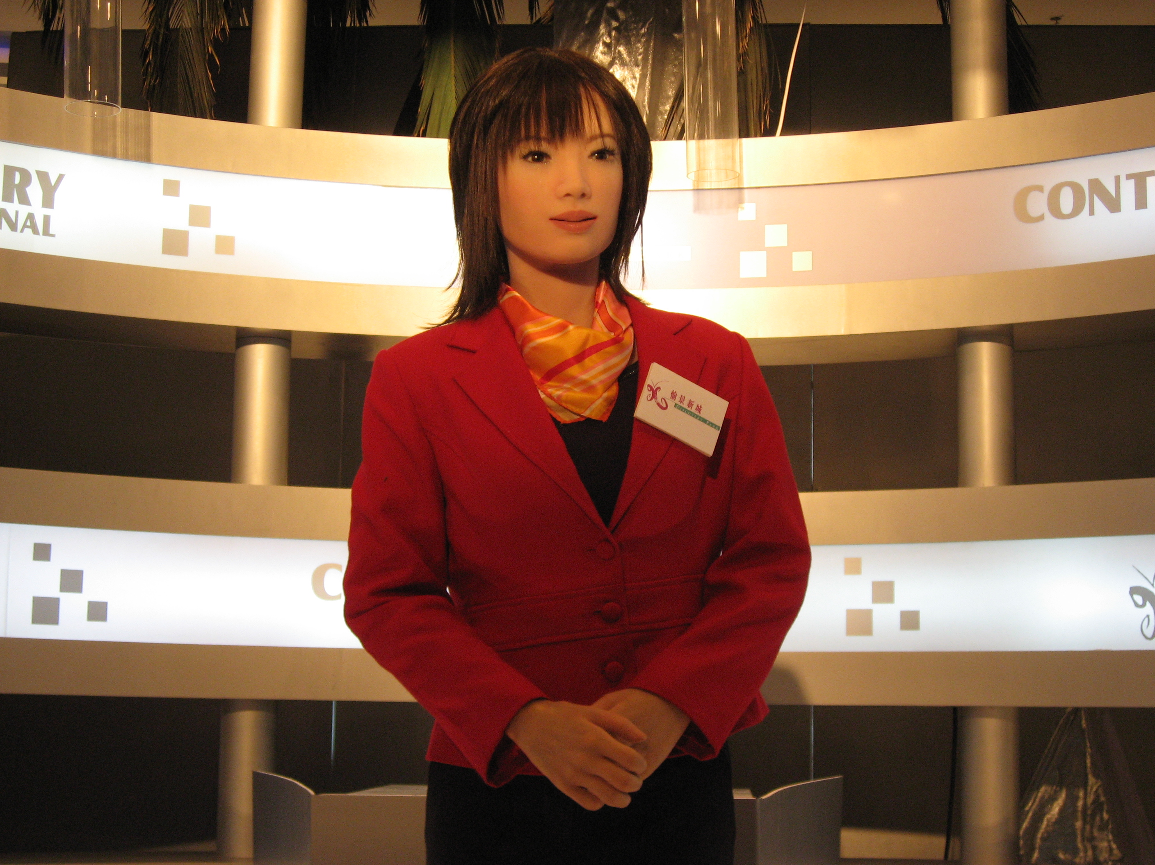
Yellow
黃

Black
黑
Red
紅

When students have completed the activity, tally the number of votes for each suggested title. The teacher can then invite students to share their yellow, black, and red hat thinking about the titles. After the presentation, students should be asked to vote again to see if any minds are changed.
4.3 Reflections on development of problem solving skills

ICT teachers should understand that the following factors will affect the learner’s development of problem solving skills:
- unable to identify the problem clearly
- knowledge gap between analysis and design
- ability of independent learning, e.g. creativity and critical thinking skills
- lack of self-reflection

Furthermore, we have mentioned in Unit 1 that problem solving is applied thinking and can be contrasted with two other kinds of thinking: creative (divergent) thinking and critical (analytical) thinking. These three kinds of thinking are closely inter-related. Creative and critical thinking are essential forms of investigating thinking which can be used to solve problems.

Appendix

I Internet Resources

ICT Curriculum and Assessment Guide
Provisional Final Draft:
New Senior Secondary Curriculum and Assessment Guide (Secondary 4-6):
Information and Communication Technology (Provisional Final Draft)
http://www.emb.gov.hk/index.aspx?nodeid=5594&langno=1
新高中課程及評估指引(中四至中六) - 資訊及通訊科技科（暫定稿）
http://www.emb.gov.hk/index.aspx?langno=2&nodeID=5594
Final version:
Information and Communication Technology Curriculum and Assessment Guide (Secondary 4-6):
http://www.emb.gov.hk/index.aspx?nodeid=5962&langno=1
資訊及通訊科技課程及評估指引 (中四至中六)
http://www.emb.gov.hk/index.aspx?nodeid=5962&langno=2

Teaching Thinking
校本資優課程教師培訓教材套：創意思維
http://prod1.e1.com.hk/education1/information/firstpage.htm
創造力百科_Creativity Resources Information Center
http://ccaweb.creativity.edu.tw/creapedia/intro/index.htm
EDWARD DE BONO'S Authorised Website
http://www.edwdebono.com/
NCTT - The National Center for Teaching Thinking
http://www.nctt.net/
OpenCourseWare on critical thinking 思方網
http://philosophy.hku.hk/think/
Thinking Qualities Initiative思維工程
http://www.hkbu.edu.hk/~think/

Brainstorming
Brainstorming .co.uk for all your brainstorming needs
http://www.brainstorming.co.uk/contents.html
Mind Tools - Brainstorming
http://www.psychwww.com/mtsite/brainstm.html

Evaluating Information on the Internet
Critically Analyzing Information Sources
http://www.library.cornell.edu/olinuris/ref/research/skill26.htm
Evaluating Internet information
http://www.library.jhu.edu/researchhelp/general/evaluating/index.html
Evaluating Web Pages Techniques to Apply & Questions to Ask
http://www.lib.berkeley.edu/TeachingLib/Guides/Internet/Evaluate.html
Evaluating Web Sites
http://www.library.cornell.edu/olinuris/ref/research/webeval.html

Fishbone
The Cause and Effect Diagram (a.k.a. Fishbone)
http://www.isixsigma.com/library/content/t000827.asp

Force Field Analysis
Kurt Lewin's Force Field Analysis Decision Making Made Easy
http://www.mftrou.com/Lewins-force-field-analysis.html
Mind Tools - Decision Making & Analytical Techniques - Force Field Analysis
http://www.psychwww.com/mtsite/forcefld.html

Graphic organizer
Graphic Organizers
http://www.graphic.org/
Graphic Organizers - TeacherVision.com
http://www.teachervision.fen.com/graphic-organizers/printable/6293.html
Thinking Graphical Thinking
http://www.i-learnt.com/Thinking_Graphical_Thinking.html

PMI
Mind Tools - PMI - Plus-Minus-Interesting
http://www.psychwww.com/mtsite/pmi.html

Programming
Alice v2.0 - Learn to Program Interactive 3D Graphics
http://www.alice.org/
LEGO.com MINDSTORMS NXT Home
http://mindstorms.lego.com/
Logo Foundation
http://el.media.mit.edu/logo-foundation/
Logo Self-learning Centre
http://talent.ied.edu.hk/module/logo/msgbox/index.htm
Simulator
http://talent.ied.edu.hk:8080/contech/

SCAMPER
SCAMPER technique training for lateral thinking
http://www.brainstorming.co.uk/tutorials/scampertutorial.html

Six Thinking Hats
Edward de Bono Personal Website
http://www.edwarddebono.com
New IQ's Six Hats Printable Web Brochure
http://www.newiq.com/services/wbrochure/w_sixhats.htm
Six Thinking Hats - Decision Making Techniques from Mind tools
http://www.mindtools.com/pages/article/newTED_07.htm

Socratic questioning
Socratic questioning
http://changingminds.org/techniques/questioning/socratic_questions.htm
Taxonomy of Socratic Questions
http://ed.fnal.gov/trc/tutorial/taxonomy.html
Thinking_Socratic_Questioning
http://www.i-learnt.com/Thinking_Socratic_Questioning.html
Using Socratic Questioning
http://serc.carleton.edu/introgeo/socratic/index.html
What is Socratic Questioning
http://serc.carleton.edu/introgeo/socratic/second.html

SWOT
Mind Tools - Decision Making and Analytical Techniques - SWOT Analysis
http://www.psychwww.com/mtsite/swot.html

II References
Costa, A. L. (2001). Teaching for, of, and about thinking. In A. L. Costa (Ed.) (2001). Developing Minds, A Resource Book for Teaching Thinking (3rd Ed.). (pp. 354-358). Alexandria: ASCD.
Craig, M. (2000). Thinking visually : business applications of fourteen core diagrams. New York : Continuum.
Curriculum Development Council. (2006). New senior secondary curriculum and assessment guide (secondary 4-6): information and communication technology (provisional final draft). Hong Kong: The Printing Department, HKSAR Government.
de Bono, E. (1985). Six thinking hats. Boston: Little, Brown and Company.
de Bono, E. (1991). Six thinking hats for schools: Resource book for adult educators. Logan, IOWA: Perfection Learning.
Ennis, R. H. (2001). Goals for a Critical thinking curriculum and its assessment . In A. L. Costa (Ed.) Developing Minds, A Resource Book for Teaching Thinking(3rd Ed.). Alexandria: ASCD.
Fisher, R. (2005). Teaching children to think (2nd ed.). Cheltenham: Nelson Thornes.
Foundation for Critical Thinking (1999). Critical thinking: Basic theory & Instructional Structures. Dillon Beach, CA: Foundation for Critical Thinking
Fox, J.M. & Fox, R.L. (2000). Exploring the nature of creativity. Dubuque, Iowa: Kendll/ Hunt.
Marzano, R. J., Brandt, S., Hughes, C.S., Jones, B. F., Preseisen, B. Z., Rankin, S. C. and Suhor, C. (1988). Dimensions of thinking. Alexandria: ASCD.
Polya, G. (1971). How to solve it: A new aspect of mathematical method (2nd ed.). Princeton: Princeton University Press.
Presseisen, B. Z. (2001). Thinking skills: Meanings and models revisited. In A. L. Costa (Ed.) Developing Minds, A Resource Book for Teaching Thinking(3rd Ed.) Alexandria: ASCD.
Swartz, R.J., & Parks, S. (1994). Infusing the teaching of critical and creative thinking into content instruction. Pacific Grove, CA: Critical Thinking Books & Software.
Udall, A. J. & Daniels, J.E. (1991). Creating the thoughtful classroom – strategies to promote student thinking. Tucson, Arizona: Zephyr Press.
III Course presentation (PowerPoint slides)
Unit 1 Teaching thinking

Unit 2 Developing learner’s generic skills: creativity

Unit 3 Developing learner’s generic skills: critical thinking

Unit 4 Developing learner’s generic skills: problem solving

