
Professional Development Programmme
New Senior Secondary (NSS) Learning & Teaching Strategies for Information and Communication Technology (ICT) - (2)

Quality Interaction

LAI Yiu Chi

Produced by
Department of Mathematics, Science, Social Sciences & Technology, The Hong Kong Institute of Education for Education and Manpower Bureau, The Government of the Hong Kong Special Administrative Region of the People’s Republic of China
2007

© Education and Manpower Bureau All Rights Reserved 2007

Background:
The EMB has commissioned the Hong Kong Institute of Education to organise a series of professional development programmes on learning and teaching strategies for teachers with an intention to teach ICT. This course is the second of the same series.

Acknowledgements:
These training materials were written with contribution from the following students (in alphabetical order):

FT PGDE(S) Major in Information Technology:
Lam Hon Yuen
Lau Ngai
Lee Hang To Flora
Lee Wai Kit
Liu Ying Shun
Wong Pui Ying
Wu Chi Fai

BSc Mathematics (Mathematics and IT Education):
Chan Wai Ting
So Yin Ting
Wong Ka Yin
Wong Suet Mui

We also wish to express grateful thanks to:
Mrs Lo-Fu Yin Wah, Priscilla, Field Experience Liaison Manager of Field Experience Office, the Centre for Learning-study and School Partnership (CLASP), HKIEd
for her professional comments.

Course developer & Instructor: Dr. LAI Yiu Chi
Course coordinator: Dr. NG Mee Wah, Eugenia
Cover design: Mr. Wong Hon Fai
Contents

1 Needs of quality interaction in teaching ICT 3 Activity 1 Problems in Teaching ICT
Notes for teachers
2 What is quality interaction? 8
Activity 2 Interactions in a Computer Lesson
Activity 3 Analysis of Patterns of Interaction
Notes for teachers
3 Effective strategies to improve the quality of interaction 19
Activity 4 Audio Editor
Activity 5 What is BT?
Activity 6 Classroom Protocol
Activity 7 Simple HTML
Notes for teachers
4 Computer-mediated interactions 37
Activity 8 Knowing more about adware and spyware
Notes for teachers
5 Factors affecting the quality of interaction 43
Activity 9 – Planning a Multimedia Presentation
Notes for teachers

Appendix
I Internet Resources 51
II References 53
II Course presentation (PowerPoint slides) 54
1 Needs of quality interaction in teaching ICT

Activity 1 Problems in teaching ICT
Scenario

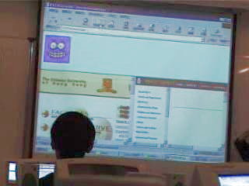
In the lesson, Mr. Chan taught his class how to use frames to put web pages from different websites together. According to his lesson design, he used Notepad as the web authoring tool and tried to display the homepages of two universities: CUHK and HKUST on the same screen. He expected that his students should be able to know how to specify frames in HTML after the lesson as he could explain the steps clearly.
Fig.1.1 Teaching in a computer room
However, from the video recording of his lesson, he found that a number of students did not listen to him and spent a lot of time playing computer games.

Discussion

- Study the video clip of his lesson and find out the following information:
  - Topic: ______________________

  - Task design:
_____________________________________________________________

_____________________________________________________________
  - Teaching strategy

_____________________________________________________________
- Compare a lesson in a computer room with a lesson in an ordinary classroom. Are there any significant differences? If so, please explain.

__________________________________________________________________

- How does the learning environment affect the interaction in the lesson?

__________________________________________________________________

- Give some advice to Mr. Chan on activity design and classroom management.

__________________________________________________________________

Curriculum Information
The compulsory part
Module: | (C) Internet and its Application
Topic: | c. Elementary Web Authoring
Theme: | Practise the basic constructs of Hypertext Markup Language (HTML) which is a means to address cross-platform issue.

Notes for Teachers

From Activity 1, we can observe that teaching in a computer lab is quite different from teaching in a normal classroom. The presence of computers and access to the Internet often distract students’ attention and weaken their reception of the teacher's new message seriously.

Look at the messages in the discussion thread as shown in Fig. 1.2. It seems that classroom management in computer room is not a new issue for IT teachers. From their replies (see Fig. 1.3), a teacher even suggested that not to take any computer lesson in computer room.

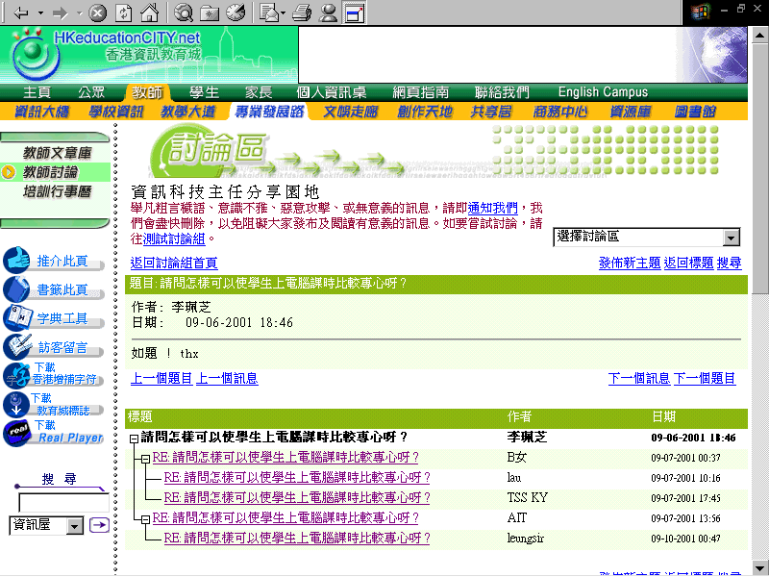
Fig.1.2 Management problem in computer room is a common topic among IT teachers
(Source: HKeducationCITY.net Forum – http://www.hkedcity.net)
Fig. 1.3 Replies to the thread about the computer classroom management issue
(Source: HKeducationCITY.net Forum – http://www.hkedcity.net)
請問怎樣可以使學生上電腦課時比較專心呀?
李珮芝: ( 09-06-2001 18:46 )
如題 ! thx
B女: (09-07-2001 00:37)
可以用boardcast的器材，將老師機的mon project到學生的電腦，咁咪唔怕佢地在自己位上做自己野唔聽書lor，學生又可以看得清楚一點，因個子較小或底年級的學生如坐在後排的話，跟本看不到教室的銀幕，因已被自己部電腦擋視線了。
Lau: (09-07-2001 10:16)
若老師講課講得吸引,學生何故唔專心.........
TSS KY: (09-07-2001 17:45)
這個辦法是最好的,再鎖定學生的鍵盤和滑鼠就更完美.
AIT: (09-07-2001 13:56)
Yes, you can.
Student not use the computer when you in the lesson.
Or .... don't take a computer lesson in computer room.
No other ways you can.
leungsir: (09-10-2001 00:47)
Do you mean that, they use other software in the lesson?
or they browse the internet in your class?
I disable the proxy server, then they cannot browse the internet.
I try to make the lesson more interesting and attract their attention.
I seldom lock their machines.

In fact, “teaching IT is problematic” is not unique for Hong Kong IT teachers, Crawford (1999) points out that IT teachers in UK also face the same problem:
… teachers of IT have greater difficulty controlling the focus of pupils' work in the classroom because, for example, pupils may have full access to all the features of the software they are using, and to all other installed software. In other NC subjects, teachers have much greater control over the texts, worksheets and other learning resources available to pupils.
Obviously, the traditional teaching methods like lecturing and teacher’s demonstration are not suitable for teaching and learning IT subjects. We should also note that a major cause of the problem is lack of quality interaction in the classroom. Moguel (2004) also points out that “teacher spends too much time talking” is one of the problems of classroom interaction.

Actually, promoting quality interaction is one of the guiding principles for effective teaching in Information and Communication Technology:
Teachers’ effective use of questioning and feedback are vital in guiding students in the learning process. Students also contribute to learning when they interact through different groupings with mutual feedback, as well as with teachers. (Curriculum Development Council, 2006, p.86).
In the units followed, we will explore what is quality interaction and how to improve the quality of classroom interaction.

References

Crawford, R. (1999). Teaching and learning IT in English state secondary schools - towards a new pedagogy? Retrieved January 7, 2007 from http://www.hud.ac.uk/ITsec/roger%20professional/itped.htm
Curriculum Development Council. (2006). New senior secondary curriculum and assessment guide (secondary 4-6): information and communication technology (provisional final draft). Hong Kong: The Printing Department, HKSAR Government.
Moguel, D. (2004). What does it mean to participate in class? Integrity and inconsistency in classroom interaction. Journal of Classroom Interaction, 39(1), 19-29.

Internet Resources

Computer and IT Labs
http://www.shambles.net/pages/staff/ITlabs/

Design your own classroom: online application
http://www.atschool.org/materials/classroom/buildaclass/

ICT Layout, Design & Furniture : Photographs
http://www.shambles.net/ict/design/index.htm
2 What is quality interaction?

Activity 2 Interactions in a computer lesson
Scenario

Miss Leung wants to explore the interaction patterns when she is teaching in the computer lab. She asked her colleague, Mr. Wong to record the teacher-student interactions in one of her ICT lessons. In that lesson, she explained how to use flowchart in designing algorithm and demonstrated how to draw flowcharts with Microsoft Word. Then the students were required to do a hands-on exercise in the class.

Mr. Wong used the following notations to record the interaction between the teacher and her students:
teacher to student
student to teacher
His recording is shown below:
Teacher
Discussion

- What information can Ms Leung get from the diagram?

_________________________________________________________________

_________________________________________________________________

2. (a) Can the above diagram show the types of interactions in her classroom?

_________________________________________________________________

  - What types of class interactions are commonly found in an ICT lesson?

_________________________________________________________________

_________________________________________________________________

3. Comment on the limitations of the diagram drawn by Mr. Wong.

_________________________________________________________________

_________________________________________________________________

_________________________________________________________________

_________________________________________________________________

Curriculum Information
The compulsory part
Module: | (D) Basic Programming Concepts
Topic: | b. Algorithm Design
Theme: | Define algorithm. Use pseudocode and program flowchart as methods for representing algorithms.
Activity 3 Analysis of patterns of interaction

Scenario

In activity 2, Mr. Wong recorded the teacher-student interactions in one of Ms Leung’s ICT lessons. However, they were not satisfied with the limited amount of information embedded in the diagram. Mr. Wong tried to modify the instrument to cater for different types of interactions in an ICT lesson: He used the following notations in his instrument.

Q: Asking closed question by teacher/student
OQ: Asking open question by teacher/student
P: Asking probing question by teacher
M: Instruction given by teacher for classroom management purpose
D: Student invited to do demonstration in class
I: Providing supplementary information by teacher/ student
F: Free Response to teacher’s question that is not targeted at a specific student
X: Teacher answers his/her own question
E: Asking for elaboration by student

The recording for another class is shown below:

Instrument for analyzing Classroom Interaction between Teacher and Students
Teacher
Key:
Q: Asking closed question
OQ: Asking open question
P: Asking probing question
M: Instruction (Classroom Management Purpose)
D: Demo in Class
I: Providing supplementary information.
F: Free Response
X: Self-answered Question
E: Asking for elaboration

OQ
P
P
OQ
P
OQ
P
P
Q
Q
M
E
I
D
X
X
X

Student Categories:
A: ________________
B: ________________
C: ________________

Q
I
F
Q
Q
Q
Q
E
F
Teacher: Ms Leung Observer: .Andy Wong
Subject: Information & Communication Technology
Class: F.4 Location: Computer Lab.

Start: 3:10 p.m. End: 3:45p.m.
Event | From | To | Remarks
Revision | 3:10 | 3:20
Lecture and Demo | 3:20 | 3:35
Hands-on Practice | 3:35 | 3:45 | Dotted line
Discussion

- Describe a situation for each case that will give the interaction patterns as follows:
(a) (b)
OQ
P
P
Q
Q
Q

_________________________________________________________________

_________________________________________________________________

_________________________________________________________________

_________________________________________________________________

- What information can Ms Leung get from the above instrument?

_________________________________________________________________

_________________________________________________________________

_________________________________________________________________

_________________________________________________________________

3. Can this instrument show the quality of interactions in her classroom? Explain.

_________________________________________________________________

_________________________________________________________________

_________________________________________________________________

_________________________________________________________________
Notes for Teachers

In this unit, we are going to examine the classroom interactions in an ICT lesson. There are two basic types of classroom interactions: interaction between teacher and students and interaction among students.

Although the activities of this unit have put the focus on the interaction between teacher and students instead of the peer interaction, it does not mean the latter is not as important as the former. In fact, they serve for different purposes. The provisional final draft of new senior secondary curriculum and assessment guide (secondary 4-6): information and communication technology states that:
- interaction between the students and the teacher can motivate learning, assess knowledge and provide support and encouragement; and
- interaction among peers helps students to consolidate ideas, test hypotheses and affirm opinions

In addition, we should also note that:
- the purpose for interaction must be meaningful to the students.
- opportunities should be provided for students to exchange ideas and opinions; and
- the teacher should not dominate the discussion and conversation during such exchanges, but should encourage risk-taking and creativity.
(Curriculum Development Council, 2006)

Interaction between teacher and students
After completing Activity 2, some of us may be aware that we have often overlooked a certain portion of students in a classroom. Nevertheless, this problem can be figured out easily by using simple instrument like the one used in Activity 2. However, this kind of instrument can only show us a limited amount of information. The data recorded cannot tell you the quality of interaction. Examine the progress of the lesson shown in Fig. 2.1. Malamah-thomas (1987) reminds us that action and reaction are not real interaction.
Teacher Class
Fig. 2.1 Progress of a lesson

In a typical IT lesson, the teacher follows his plan of action and acts upon the class according to plan. He may demonstrate some IT skills and ask the class to repeat the steps and practise the skills taught. Students merely react to the teacher’s actions. Unfortunately, some teachers fail to respond to unexpected reactions from their students. They do not probe the silence to see if it indicates understanding or confusion and do not pick up the mistakes made by their students. It seems that they are acting in complete isolation from the class.

Interaction is more than this. It does not mean that action is followed by reaction. Interaction means acting reciprocally, acting upon each other. Thus a lesson which exemplifies interaction will progress as shown in Fig 2.2

Teacher Class

Fig. 2.2 Interaction between teacher and the class

The teacher acts upon the class, but the class reaction subsequently modifies his next action, and so on. There should be a constant pattern of mutual influence and adjustment.

In this regard, we should note that the purpose of Activity 3 is to direct our focus on real interaction and also its quality. Since it is not practical for the observer to record too much data on the observation form, we try to bring out some messages like asking open questions and probing for student’s conceptual understanding. Interaction pattern involving a series of discrete questions are often gap-filling questions which do not invite higher thinking.
Fig. 2.3 A series of discrete questions
Q
Q
Q
More discussions on questioning techniques and strategies for improving quality of interaction can be found in Unit 3.

Malamah-thomas (1987) also brings out an interesting issue. She argues that the textbook writer often becomes a participant in the interaction, albeit a more indirect one. The normal pattern of interaction might look more like Fig. 2.4 with no real teacher-learner interaction going on at all. Perhaps, if the same argument is applied to ICT, the interaction pattern of lessons mainly consisting of demonstrations might look like Fig. 2.5. The teacher’s computer becomes a participant in the interaction.

Textbook
Teacher
Learners
Fig. 2.4 Textbook writer as a participant
Teacher’s Computer
Teacher
Learners
Fig. 2.5 Teacher’s computer as a participant
Interaction among students
As mentioned before, interaction among peers helps students to consolidate ideas, test hypotheses and affirm opinions. But how can we promote peer interaction in our lessons? In teaching ICT, there are many topics in which the classroom activities can be incorporated with peer interaction. Here are some examples:

Activity involving Group Task

Activity – How to connect the peripherals to the system unit
In this activity, we are going to learn how some common peripherals such as monitor, keyboard, mouse, are connected to the system unit.
- Divide the class into groups of 5 students.
- Prepare one computer system with the main power disconnected for each group.
- Disconnect the monitor, mouse, keyboard, network cable, speakers, microphone on each system.
- Ask another group to identify the peripherals and connect back all the devices.
- Each group starts to connect all the devices.
- Record the total time taken for each group.

Activity involving Group Discussion

Activity – Are personal photos copyright protected?
Tai Man downloaded Mrs Chan’s photo from her family album and then uploaded it to his personal web site.

- Do you think Mrs Chan’s photo is protected by copyright?
- Is the subsistence of copyright of his photo determined by its quality and creativity? Why?

Join another student to form a group of two and try to find the answers from the Internet. Discuss your findings with your partner.

Activity involving Debate

Activity – Problem of computer waste
In this activity, you are asked to form a group of six students and prepare for a debate on the following topic:
Taxation on computer products is not a feasible way to reduce the amount of disposal of computer waste.

- If your group number is an even, you are on the for side. Otherwise your group is on the against side.
- Do some Internet research on the topic and discuss the key points for your side.
- Write down the key points.
- Write down two questions you would ask the opposite group in the debate.
- State an 8-minute debate with an opposite group appointed by your teacher.

Activity involving Role-play and whole class presentation

Role-playing: Positive and negative impacts of Globalization.
In this activity, try to list both the positive and negative impacts of globalization in our society. Search data from the Internet to support your findings. Students take on specific roles such as a farmer, an economist, a policy maker etc. and present the opinion in the class.

Impacts of globalization in the society
Positive Impact | Negative impact

Chapman (2004) also identifies five types of learning activities/experiences which can provide opportunities for students to engage in peer interaction:
- Inquiry of the problem-solving process
- Inquiry of a new concept
- Whole-class presentation
- Practicing problem solving
- Investigations/projects

Furthermore, Morris (1996) argues that when teacher encourages pupils to learn from situations that are as close to real life as possible, it will involve high learner involvement and low teacher participation. In Unit 3, more activities and examples will be used to illustrate different strategies to promote quality peer interaction.

References
Chapman, O. (2004). Facilitating peer interactions in learning mathematics:Teachers’ practical knowledge. In M. J. Høines and A. B. Fugelstad, (Eds.) Proceedings of the 28th Conference of the International Group for the Psychology of Mathematics Education, Volume 2, pp. 191-198. Bergen, Norway: Bergen University College, July 2004
Curriculum Development Council. (2006). New senior secondary curriculum and assessment guide (secondary 4-6): information and communication technology (provisional final draft). Hong Kong: The Printing Department, HKSAR Government.
Morris, P. (1996). The Hong Kong school curriculum: Development, issues and politics. (2nd Ed.). Hong Kong: HKU Press.

3 Effective strategies to improve the quality of interaction

Activity 4 Classroom Activity – Audio editor
Scenario

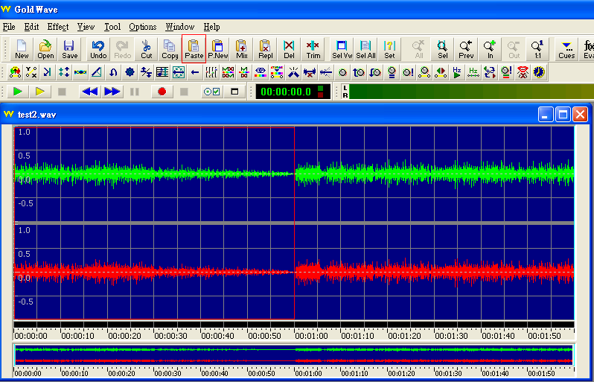
Mr. Lau taught his class some basic audio editing techniques. In this lesson, Mr. Lau decided to use a popular joke which he got from the Internet (see Fig. 3.2) for the audio contents. Besides, he used GoldWave to edit the audio files.
Fig. 3.1 The user interface of Goldwave

In his original design, the sound clips were prepared by him and he demonstrated the procedure step-by-step. However, he was not sure whether this approach was good enough for his students. Then he attempted to use different teaching approaches for other groups of students (see Table 3.1). In this activity, we are going to analyze his activity designs in several aspects.

Table 3.1 Teaching strategies used by Mr. Lau for learning basic audio editing techniques
Design | Teaching strategy | Video clips
Step-by-step demonstration | - Mr. Lau demonstrated how to use GoldWave to edit the sound clips step-by-step.  - The sound clips were prepared by the teacher. | Activity4a.mpg
Group Work | - Mr. Lau divided the students into groups of two.  - He asked them to practice the skills themselves.  - He attempted to give hints for the students when they found difficulty in using the software.  - The sound clips were prepared by the teacher. | Activity4b.mpg
Role Play | - Mr. Lau divided the students into groups of two.  - Mr. Lau asked the group members to play different roles to prepare for the sound clips. | Activity4c.mpg
Discussion

1. Study the videos of his lesson and give comments on the following aspects:

 | Step-by-step demonstration | Group Work | Role Play
Teacher-student interaction

Peer interaction

Pupil involvement

IT Skills learnt in the activity

Other comments

2. In designing a learning task, what features you think are more important?

_____________________________________________________________________

_____________________________________________________________________

音訊編輯活動
蜘蛛和蜜蜂訂婚

蜘蛛和蜜蜂相親之後訂婚了，蜘蛛感到很不滿意，於是就問他媽媽：「為什麼要讓我娶蜜蜂？」
蜘蛛的媽媽說：「蜜蜂是吵了一點，但人家好歹也是個空姐。」
蜘蛛說:「可是我比較喜歡蚊子耶！」
蜘蛛的媽媽說：「不要再想那個護士了，打針都打不好，上次搞到媽水腫。」
蜜蜂也感到很不滿意，於是就問她的爸爸：「為什麼要讓我嫁給蜘蛛呢？」
蜜蜂的爸爸說：「蜘蛛是醜了一點，但人家好歹也是搞網路的 ........」
蜜蜂說：「可是人家比較愛螞蟻啊！」
蜜蜂的爸爸說：「別再提那瘦巴巴的工頭，整天扛著食物東奔西跑，連台貨車都沒有。」
蜜蜂說：「那隔壁村的蒼蠅哥也不錯。」
蜜蜂的爸爸說：「他是長得蠻帥的，但也不能揀個挑糞的！」

Fig.3.2 Contents for audio editing activity (Source: http://e-info.org.tw/node/3549 )

Curriculum Information
The Elective part
Option: | (C) Multimedia Production and Web Site Development
Topic: | c.(iii) Multimedia products
Theme: | - Preparing multimedia elements  - Multimedia editing and processing

Activity 5 What is BT?

Scenario

Ms Wong discussed with her class on the topic of Intellectual Property. She wanted to remind her students about the possible crimes and consequences of illegal uses and broadcasting of copyrighted materials on the Internet. Therefore, she got an article from Wikipedia and prepared a reading exercise about a person called “古惑天皇” (see fig. 3.3) for them.
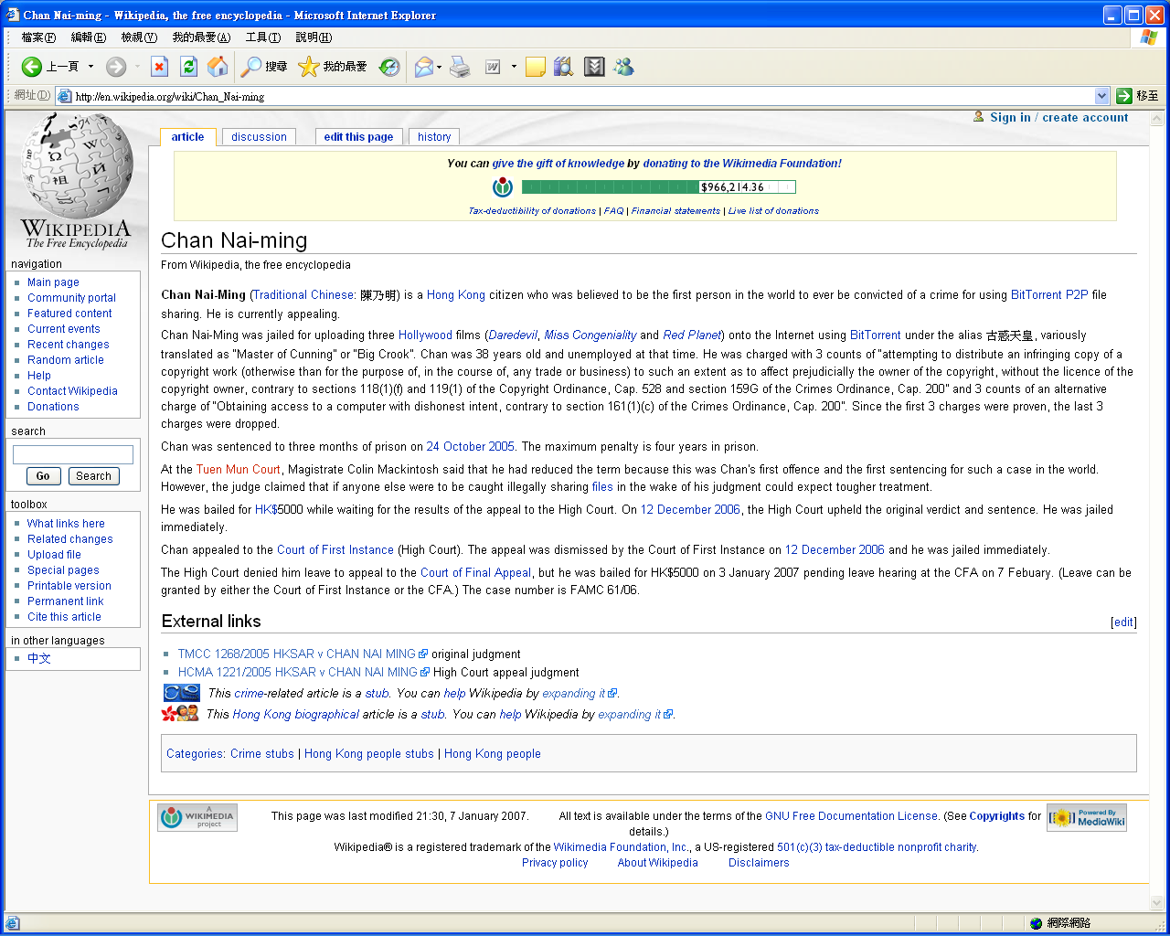

Q.1 Suggest three popular types of copyrighted materials distributed on the Internet through BT.

Q.2 What information helps the Customs office track the identity of the uploader?

Q.3 Which party can help the Customs office locate the uploader after knowing his IP address?

Q.4 Did the arrested man upload the movie files to the forum directly? Explain briefly?

Q.5 Some people argue that it is an offence to download an illegal copy of copyrighted materials through BT as you will distribute illegal copies at the same time. What is their argument?
.

Fig. 3.3 Reading exercise prepared by Ms Wong

Discussion

- Examine the questions asked in the exercise.

  - Classify the questions according to the following types.

Recall question | Q.1 Q.2 Q.3 Q.4 Q.5
Comprehension question | Q.1 Q.2 Q.3 Q.4 Q.5
Application question | Q.1 Q.2 Q.3 Q.4 Q.5
Analysis question | Q.1 Q.2 Q.3 Q.4 Q.5
Synthesis question | Q.1 Q.2 Q.3 Q.4 Q.5
Evaluation question | Q.1 Q.2 Q.3 Q.4 Q.5

  - Classify the questions according to the following types.

Question which elicit information | Q.1 Q.2 Q.3 Q.4 Q.5
Question which shape understanding | Q.1 Q.2 Q.3 Q.4 Q.5
Question which urge reflection | Q.1 Q.2 Q.3 Q.4 Q.5

  - Which questions are open questions?

  - Could you add an open question for the reading exercise?

- Ms Wong held a group discussion on the positive and negative impacts of peer-to-peer sharing software. However, she found that her students were not eager to express their ideas in their group.

(a) What factors will discourage their participation in the group?

(b) What factors will encourage their participation in the group?

- After the discussion, Ms Wong asked their students to present their ideas in the class. However, she did not record anything, wrote nothing on the blackboard, and gave no feedback to her students during the presentation time. Please comment.

- Ms Chan suggested that Ms Wong should invite their students to post their ideas about BT activities on subject discussion forum of their school. How can Ms Wong facilitate peer interactions through this kind of activity?

Curriculum Information
The compulsory part
Module: | (C) Social Implications
Topic: | c. Intellectual Property
Theme: | Relate acts of possible infringement of copyright in software and Internet piracy.

Activity 6 Classroom Protocol

Scenario

During a school visit of a study tour, Ms Ho found that a Japanese school used an interesting protocol in class. Students can use following gestures as an initial signal to their teachers instead of just raising up their hands.

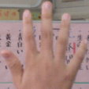 |  |  |  | 
Answer a question | Agree | Disagree | Supplement | Query

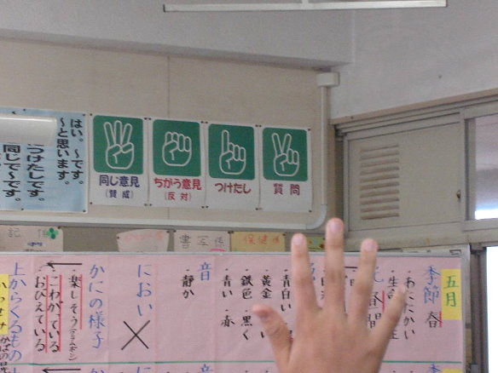
Fig. 3.4 Classroom protocol used by a Japanese teacher
(Source: Centre for Learning-study and School Partnership (CLASP), HKIEd)

Discussion

- Consider the classroom mentioned above.
  - Can it be used in your lessons?

_________________________________________________________________

  - What types of classroom activities will get benefits from using a classroom protocol?

_________________________________________________________________

- Ms Ho hopes to adapt the classroom protocol in her NSS ICT class. Could you help her to design a new classroom protocol?

Gesture

Purpose

- Describe a classroom activity in an ICT lesson that can use the classroom protocol described in Q.2.

_________________________________________________________________

_________________________________________________________________

_________________________________________________________________

_________________________________________________________________

_________________________________________________________________

Activity 7 Simple HTML

Scenario

Mr. Ho is the ICT teacher of Class 4S. In this lesson, he taught this class to be familiar with the structure of an HTML document and identified some basic HTML tags. He has written down the following information on the blackboard:

Type | Opening tag | Closing tag | Description
Text appearance tag | <B> | </B> | Bold words
Text appearance tag | <I> | </I> | Italic words
Text appearance tag | <U> | </U> | Underline words
Text appearance tag | <EM> | </EM> | Emphasize words

He also showed an example on the computer screen (see Fig. 3.5).
<B>
Hello, World!
</B>

Fig. 3.5 A simple HTML example

The following shows a questioning sequence in Mr. Ho’s lesson:

10 | Mr. Ho: | Candy, which Markup Language have you learnt?
20 | Candy: | HTML.
30 | Mr. Ho: | Which tools have you used?
40 | Candy: | Notepad.
50 | Mr. Ho: | How can you bold a word “student”?
60 | Candy: | Highlight the word and click the ‘B’ icon on the toolbar.
70 | Mr. Ho: | I mean how to use HTML tags to display the word “student” in bold letters?
80 | Candy: | I think, it should be … Sorry, I don’t know.
90 | Mr. Ho: | Look at the example on the blackboard. Can you get any idea now? …..  Anyone?
100 | Mr. Ho: | The example displays the words “Hello, World!” in bold letters. Think what happens if these words are replaced by other words.
110 | Peter: | I think we can use <B>student</B>.
120 | Mr. Ho: | Good. How can we display the word “student” in italic letters?
130 | Peter: | I think it is <I>student</I>
140 | Mr. Ho: | Excellent. How about adding both display effects, bold and italic, to the word “student”?
150 | Peter: | Maybe …. <IB>student</IB>.
160 | Mr. Ho: | Do you agree, Teddy?
170 | Teddy: | No.
180 | Mr. Ho: | Why? Can you tell me your idea?

Discussion

- Clarity is important in questioning. Which of the questions shown above is not clearly expressed? Give reasons.

- Prompts are follow-up questions and usually contain hints. Prompting implies that a student cannot give an expected response. In other words, the question is beyond him/her or his/her answer is inadequate or inappropriate. Write down the prompting question(s) used by Mr. Ho.

- Probing questions are an important tactic for developing the thinking of students. Please identify the probing question(s) in the questioning sequence.

- Which question shown above is an undirected question?

- Teacher can ask directing questions by name.

  - Find an example in the script.

  - In addition to directing questions by name, what methods have you used?

Curriculum Information
The compulsory part
Module: | (C) Internet and its Application
Topic: | c. Elementary Web Authoring
Theme: | - Practise the basic constructs of Hypertext Markup Language (HTML) which is a means to address cross-platform issue.  - Design and construct web pages by writing HTML or by using a web authoring tool, for an intended audience and upload them on the World Wide Web.

Notes for Teachers

In this unit, we are looking at the strategies that are effective for improving the quality of interaction. These strategies have been highlighted in the activities of this unit.

- Active participation in the learning activity

In an interactive classroom, students should have adequate opportunities to exchange ideas and opinions. Teachers should motivate their students to participate in the learning activities actively. In Activity 6, the teacher used a classroom protocol to encourage contributing in class discussion at different levels. In his design, students can take up different roles: answering questions, giving supplementary information, having a query, being a supporter or an opponent. In fact, students should have their own role in each class activity though not all are significant or noticeable.

Morris (1996) points out that those activities involving problem solving, inquiry, discovery, inductive learning, role-play, or games can encourage active pupil participation. In Activity 4, the students were eager to do practice on audio editing techniques through role-playing and could gain peer support in collaborative activities.

However, Morris (1996) also argues that these methods may be time consuming to reach certain levels of cognitive understanding and the constant use of single pedagogy can lose its effectiveness as pupils become bored and the principle of diminishing return sets in.

- Design of learning task

Task-oriented approach is widely used in teaching IT skills. It implies that quality of interaction should be closely related to the design of the task. In Unit 2, we have mentioned that the purpose for interaction must be meaningful to the students. Therefore we should target at designing meaningful tasks. Although different people have different interpretations for the word “meaningful”, most IT teachers may agree that the task is meaningful if at the end of the lesson, the student can achieve one of the followings:

(a) Mastering the focused IT skills
IT skills are useful for many careers in this information age. The rationale of the NSS ICT curriculum states that “many of the skills of information and communication technologies are important aspects of Information Literacy, which relates to the ability to select, organise, discriminate, analyse and use information effectively (Curriculum Development Council, 2006, p.2).

(b) Understanding the underlying concepts and related principles
The tasks should invite students to think about the underlying IT concepts and principles related to the tasks rather than just memorizing the steps involved. For example, in making a PowerPoint presentation, the students should be asked to know more about their audience, the purpose of the presentation, the considerations in using fonts, sound effects, animations etc.

(c) Applying the skills in other tasks or subject areas
The reason why our students are asked to learn IT is that IT can facilitate teaching and learning. The students are also always encouraged to use their IT knowledge in exploring learning opportunities.

To improve the quality of interaction, IT teachers should also think about questions like:
  - Is the task purposeful?
  - Is the task interesting enough?
  - Can the task motivate the student to learn?
  - Can the task stimulate their higher order thinking?

In summary, we may conceptualize a well designed IT task as follows:

A good IT task should be a goal-oriented, interesting, meaningful task, which can motivate the students to engage in the tasks and stimulate high-order thinking. Consequently, the students may master the IT skills, understand the underlying IT concepts and apply the knowledge to other situations

- Supportive learning atmosphere

Teachers play an important role in creating an interactive classroom. Meyers (1986) suggests some basic rules for consistently encouraging student interaction:

(a) Begin each class with a controversy or problem.
Instead of "We're going to cover the topic of Intellectual Property ... ", teacher can begin with “BT is not illegal.”

(b) Use silence to encourage reflection.
A reflective pause in your own discourse tells students that you are thinking about this. Many teachers often try to fill the silence or answer the question for them. In fact, pauses after teacher-initiated questions encourage student responsibility.

(c) Arrange and use classroom space to encourage interaction.
Move chairs when there is a need! Different classroom layouts are suitable for different types of activities. For group discussion, we should let the students face each other, form a semi-circle or circle.

(d) Create a friendly environment.
Refer to Activity 5, it is expected that most students have some experience in downloading copyrighted materials from the Internet. They will be eager to share their feelings and express their own idea if the teacher-students relationship is good. Jiang and Ramsay (2005) argue that building up rapport with learners is essential for a teacher to teach successfully. Teachers can help make learning more enjoyable by consciously building up rapport with learners. Rapport helps motivate learners and also reduces learners' anxiety.

- Use of oral assessment

Making good use of oral assessment can stimulate students’ critical thinking. Therefore it can improve the quality of interaction. In fact, the success of oral assessment greatly depends on the teacher’s questioning skills.

Questioning Skills
In activity 5, we have a discussion on ‘open question’. Sweeting (1994) states the difference between the open and closed questions:
This makes good sense because responses to the first type of question open up the conservation, whereas responses to the second type close (or complete) it (p. 29)

Kissock and Iyortsuun (1982) point out that there are three types of questions which teachers should avoid asking:

The first is the question that requires students to simply guess what the teacher is thinking or has on his/her mind. It is better to tell students what the idea or information is and asks students to make use of it by answering another question. For example, ‘I don’t like Microsoft. Do you know why?’

The second type is the general and vague question; for example: ‘Are there any questions?’ or ‘What do you think about mp3?’ These questions are difficult to answer because they do not help students focus their thoughts on the important issues.

Rhetorical questions such as: ‘Don’t you agree that visual programming is easy?’ should also be avoided. These questions limit the student’s opportunity to think for himself/herself and result in students simply agreeing with the view of the person asking the question.

Directing, prompting and probing
In activity 7, we have highlighted some basic questioning techniques like directing, prompting and probing. Wragg and Brown (2007) points out that undirected questions often lead to chorus answers and lack of control. Directing question is important and may be by name, gesture, head movement or facial expressions. Prompts and probes are follow-up questions when the first answers are inadequate, or inappropriate. Prompts contain hints (e.g. ‘Think back to what we learned about the tags for bold characters in HTML…), while probes require more precise or detailed answers (‘Can you give me an example of impact printer?’).

Common ‘errors’ in questioning
Wragg and Brown (2001) also list some common ‘errors’ in questioning (see Fig. 3.6). This may be a good reminder for teachers.

Fig. 3.6 Common ‘errors’ in questioning (Source: Wragg and Brown, 2001)
Common ‘errors’ in questioning
- Asking too many questions at once.
- Asking a question and answering it yourself.
- Asking questions only of the brightest or most likeable pupils.
- Asking irrelevant questions.
- Always asking the same types of question (e.g. closed ones).
- Asking questions in a threatening way.
- Not indicating a change in the type of question.
- Not using probing questions.
- Not giving pupils the time to think.
- Not correcting wrong answers.
- Failing to see the implications of pupils’ answers.
- Failing to build on answers.

Making learning meaningful for all learners
If we hope to design questions for learners of different learning styles, it may be interesting to look at the 4MAT Model. It is designed to help people to think and learn well and derived from the understanding that everyone learns differently. While all people must engage in all modes of learning, 4MAT assumes that most people seem to favor one particular type.
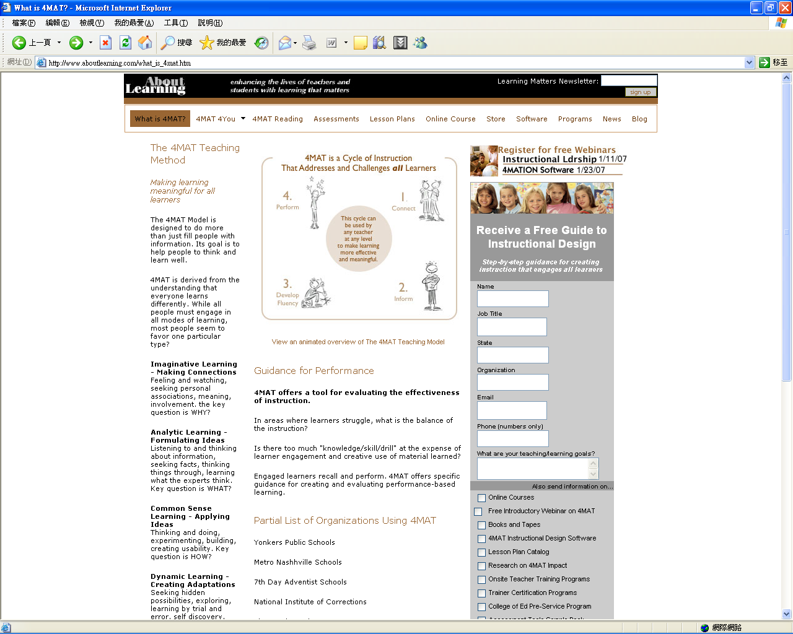

Fig. 3.7 What is 4MAT? (http://www.aboutlearning.com/what_is_4mat.htm )

In fact, the 4AMT Model provides a strategy for designing questions. Examples are shown in the table below:

Table 3.2 Designing questions based on the 4MAT Model
Type One | Learners perceive with sensing and feeling and process reflectively. | They need to be engaged, to answer the question, "Why?" | Why anti-spyware program is necessary for protecting our personal information?
Type Two | Learners perceive with thinking and process reflectively. | They need the facts, to answer the question, "What?" | What is the main objective of the Personal Data (Privacy) Ordinance?
Type Three | Learners perceive with thinking and process actively. | They need to see real-world relevance, to answer the question, "How?" | How can we get a free anti-spyware program?
Type Four | Learners perceive with senses and feeling and process actively. | They are dynamic learners, who need to answer the question, "If?" | If a company resells personal information of its customers to other organizations, is it illegal?

- Insightful and timely/ quality feedback

Refer to the activity on audio editing techniques, Activity 4, it can be observed that the teacher purposely walked around during the practical session. Timely feedback on student’s performance is important for learning IT skills. Feedback from a teacher may be for guidance purpose. Student always tries to imitate the teacher’s or other people’s models while being provided with guidance. This may occur in the form of questions like, ‘Why didn’t it work?’ or ‘What do you need to do next?’

On the other hand, the teacher in Activity 5 should provide insightful, timely feedback to the class. This will help her students think about intellectual properties in the appropriate direction.

- Expression, gesture, body language, classroom layout,

As mentioned above, directing and redirecting questions can be by name, gesture, head movement or facial expressions. Gesture, body language and classroom layout are also important for improving the quality of interaction. In Activity 6, a Japanese teacher used a classroom protocol to encourage students to have different levels of participation.

Appropriate use of non-verbal communication can facilitate classroom interaction. These include visual signals: facial expression, gaze, head and body posture, hand movements, interpersonal distance and spacing; and also other non-verbal signals such as intonation and pace of speech, and dress (Neill and Caswell, 1993). In this unit, we have discussed several useful strategies for improving the quality of interaction. Could you point out more from your own experience?

References

Curriculum Development Council. (2006). New senior secondary curriculum and assessment guide (secondary 4-6): information and communication technology (provisional final draft). Hong Kong: The Printing Department, HKSAR Government.
Jiang, W. & Ramsay, G. (2005). Rapport-building through CALL in teaching Chinese as a foreign language: An exploratory study. Language Learning & Technology, 9 (2), 47-63.
Kissock, C. & Lyortsuun, P. (1982). A guide to questioning: Classroom procedures for teachers. London: Macmillan.
Meyers, C. (1986). Teaching students to think critically. San Francisco: Jossey-Bass.
Morris, P. (1996). The Hong Kong school curriculum: development, issues, and policies (2nd Ed.). Hong Kong: Hong Kong University Press.
Neill, S. & Caswell, C. (1993). Body language for competent teachers. London: Routledge.
Sweeting, T. (1994). Questioning. Hong Kong: Longman.
Wragg. E.C. & Brown, G. (2001). Questioning in the secondary school. London: Routledge.

Internet resources

What is 4MAT?
http://www.aboutlearning.com/what_is_4mat.htm

4 Computer-mediated interactions

Activity 8 Knowing more about adware and spyware

Scenario

When teaching the topic on adware and spyware, Mr. Cheng found that their students had no interest to study the Internet resources selected by him. As a result, he decided to use a social bookmarking system as a tool to enhance the student involvement in the class. He used the online bookmark manager from iKeepBookmarks.com to add and organize links. Then their students were instructed to bookmark links having information about adware and spyware collaboratively and shared them among the students.
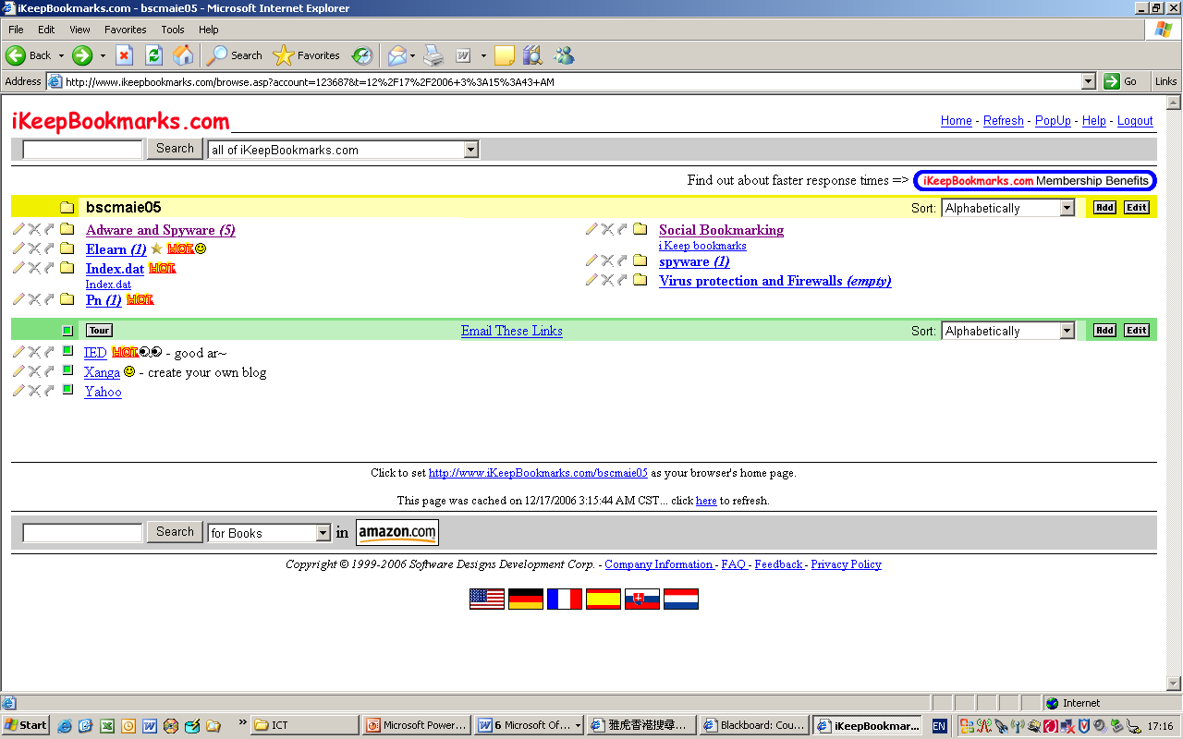
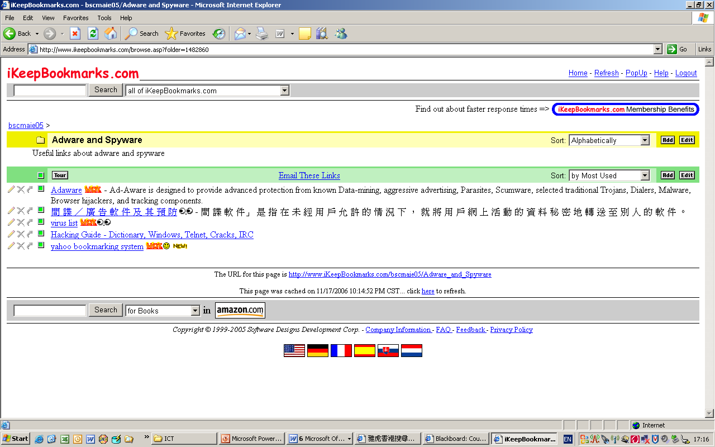
Fig. 4.1 Sharing links with an online bookmark manager
(Bookmark page: http://www.iKeepBookmarks.com/bscmaie05 )
Discussion

What is social bookmarking? From Wikipedia, social bookmarking sites are a popular way to store, classify, share and search links through the practice of folksonomy techniques on the Internet or Intranet. Other than web page bookmarks, services specialized to a specific subject or format - feeds, books, videos, music, shopping items, map locations, wineries, etc. - can be found.

- Compare the following methods for collecting Internet resources in different aspects.

 | Provided by the teacher | Collected by students
pupil involvement
ownership
relevancy

- State some disadvantages of using social bookmarking in teaching ICT. Give topics in NSS ICT that are suitable to use social bookmarking as a learning and teaching tool.

_________________________________________________________________

_________________________________________________________________

_________________________________________________________________

- Can social bookmarking be used to enhance quality interaction in teaching ICT?

_________________________________________________________________

_________________________________________________________________

_________________________________________________________________

- List other Computer mediated tools that can help to enhance quality interaction.

_________________________________________________________________

_________________________________________________________________

_________________________________________________________________

Curriculum Information
The compulsory part
Module: | (E) Social Implications
Topic: | d. Threats and Security on the Internet
Theme: | Know, from the user’s perspective, possible security threats on the Internet
Notes for Teachers

In activity 8, we want to bring out the issue of computer-mediated interactions, although it is not the main focus of this booklet. Computer-mediated interactions can be a supplement for face-to-face interaction after school.

Computer-mediated interactions

Numerous research on computer-mediated interactions has been done. Jonassen et al (1995) argues that engagement and collaboration are characteristic of constructivist learning environments using computer-mediated communication. Tu and McIsaac (2002) point out that quality of CMC interaction will be influenced by the following factors:
- timely responses to CMC messages;
- use of stylistic communication styles;
- casual conversation;
- communication strategies;
- appropriate message length;
- planning, creativity, intellectual, decision-making, and social tasks; and
- appropriate communication group size.

They also found that positive influences on interaction occurred
- when the instructor provided time and activities so students got to know each other initially;
- when the instructor created a supportive environment and modeled positive communication; and
- when small groups were formed for interaction.

We should note that the Internet and web have brought about whole new ways of learning. The experience of being a student is undeniably different from those of his/her teachers (Thurlow, Lengel and Tomic, 2004).

Tools for enhancing computer mediated interactions

Most IT teachers may have experience to use common computer mediated tools like blog, discussion forum, email, instant messaging system, chat room, social bookmark system, RSS, podcast, learning platform etc. Figs. 4.2 and 4.3 show an IT teacher using a website as a learning platform and a discussion forum for sharing.

We should also note that each tool has its own characteristics. Some tools like email, blog are more suitable for teacher-students interaction while tools like discussion forum, chat room are better for peer-to-peer interactions. Some tools like instant messaging system (e.g. Windows Live Messenger) provide synchronous interaction while email and forum are used for asynchronous interactions.

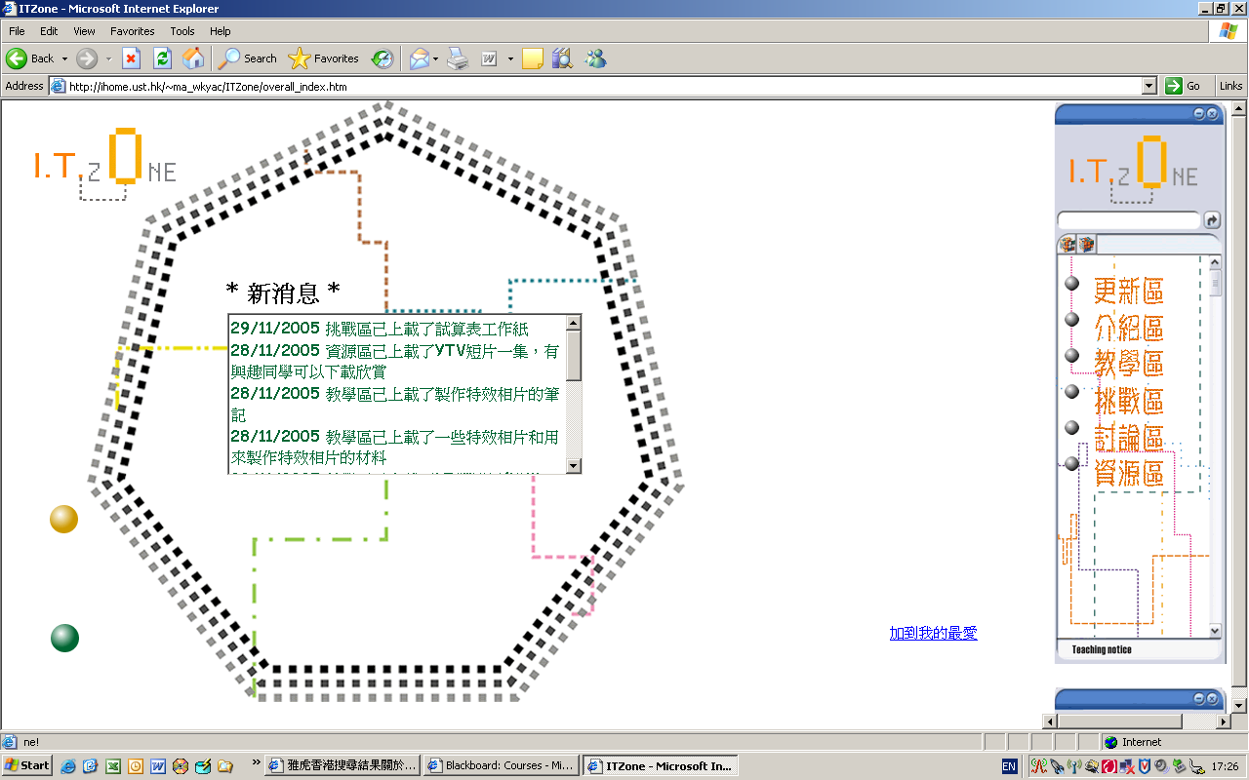
Fig. 4.2 A learning platform for teaching IT

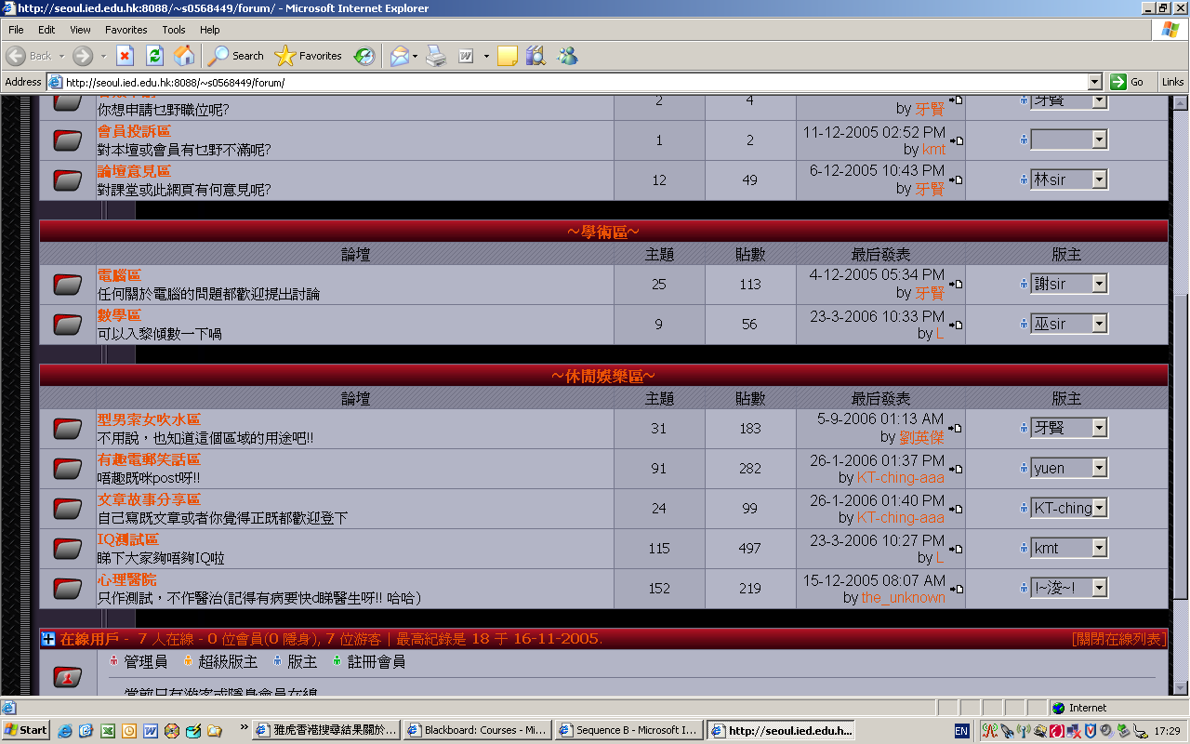
Fig. 4.3 Discussion forum as a supplement for classroom interactions

However, could you figure out the difficulties in using these tools in teaching and learning?

References

Jonassen, D., Davidson, M., Collins, M., Campbell, J. & Haag, B. (1995). Constructivism and computer-mediated communication in distance education, The American Journal of Distance Education, 9(2), 7-26.
Thurlow, C., Lengel, L. & Tomic, A. (2004). Computer mediated Communication: Social interaction and the Internet. London: SEGE.
Tu, C. H., & McIsaac, M. (2002) The relationship of social presence and Interaction in online classes. The American Journal of Distance Education, 16(3), 131-150.

5 Factors affecting the quality of interaction

Activity 9 Planning a Multimedia Presentation

Scenario

Mr. Lo conducted an ICT lesson and made the following record:
The Compulsory Part of NSS ICT curriculum
Option: | A | Information Processing
Topic | e | Presentation of Information
Theme | Construction and design a presentation incorporating multimedia elements
The focus of this topic is on the planning of a storyboard and presentation, not the formats of presentation. Teachers are expected to guide students how to think in a systematic way.

The teacher devised a plan (see Fig. 5.1) to guide his students in brainstorming, categorizing ideas, and using appropriate multimedia elements in their presentations.
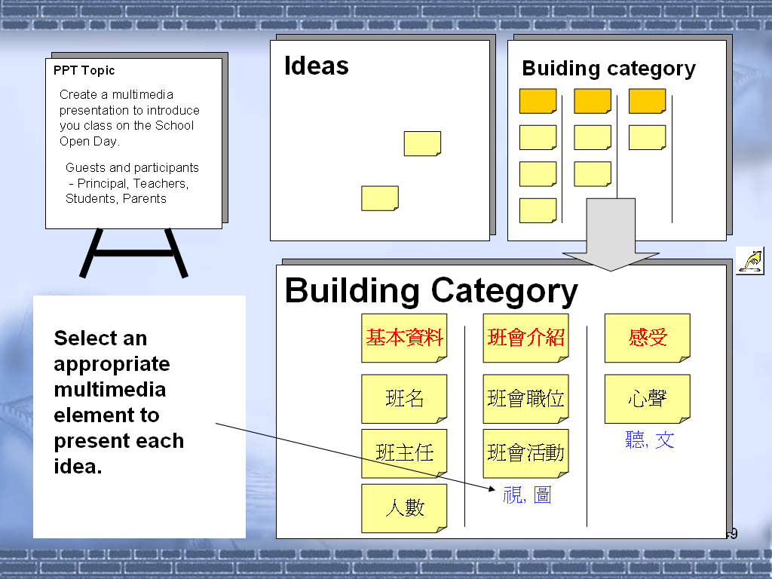
Fig.5.1 Planned learning tasks

At the beginning of the lesson, he deployed a suitable classroom setting for his lesson design and assigned a topic, School Open Day, for the multimedia presentation.

Figure 5.2 shows that different media formats are used in the classroom.
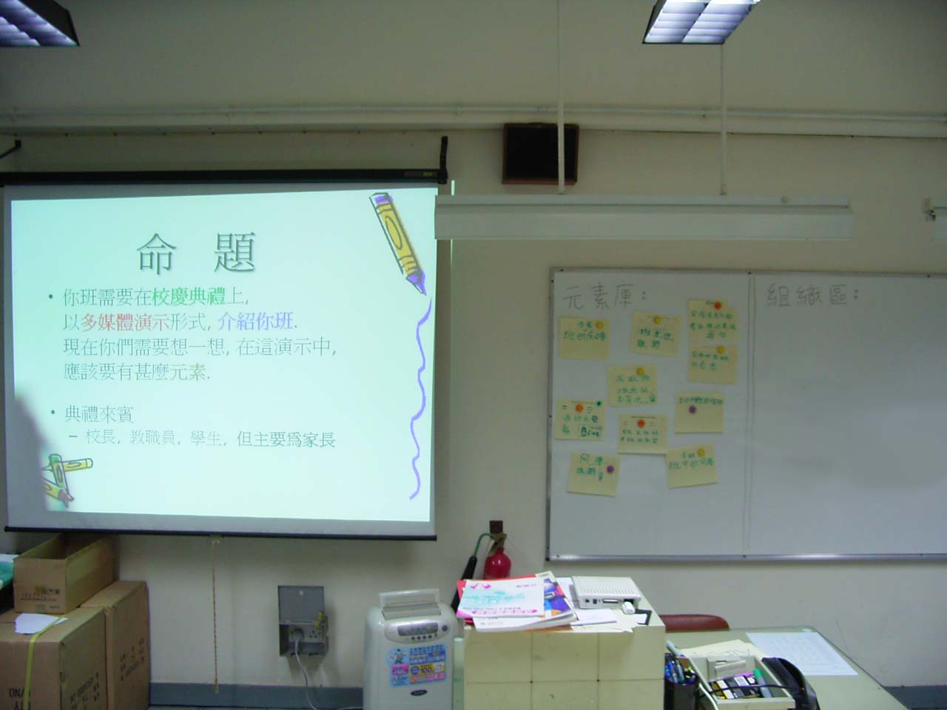
Fig. 5.2 Classroom setting for the learning task

Students were required to work in groups to brainstorm different formats of presentation.
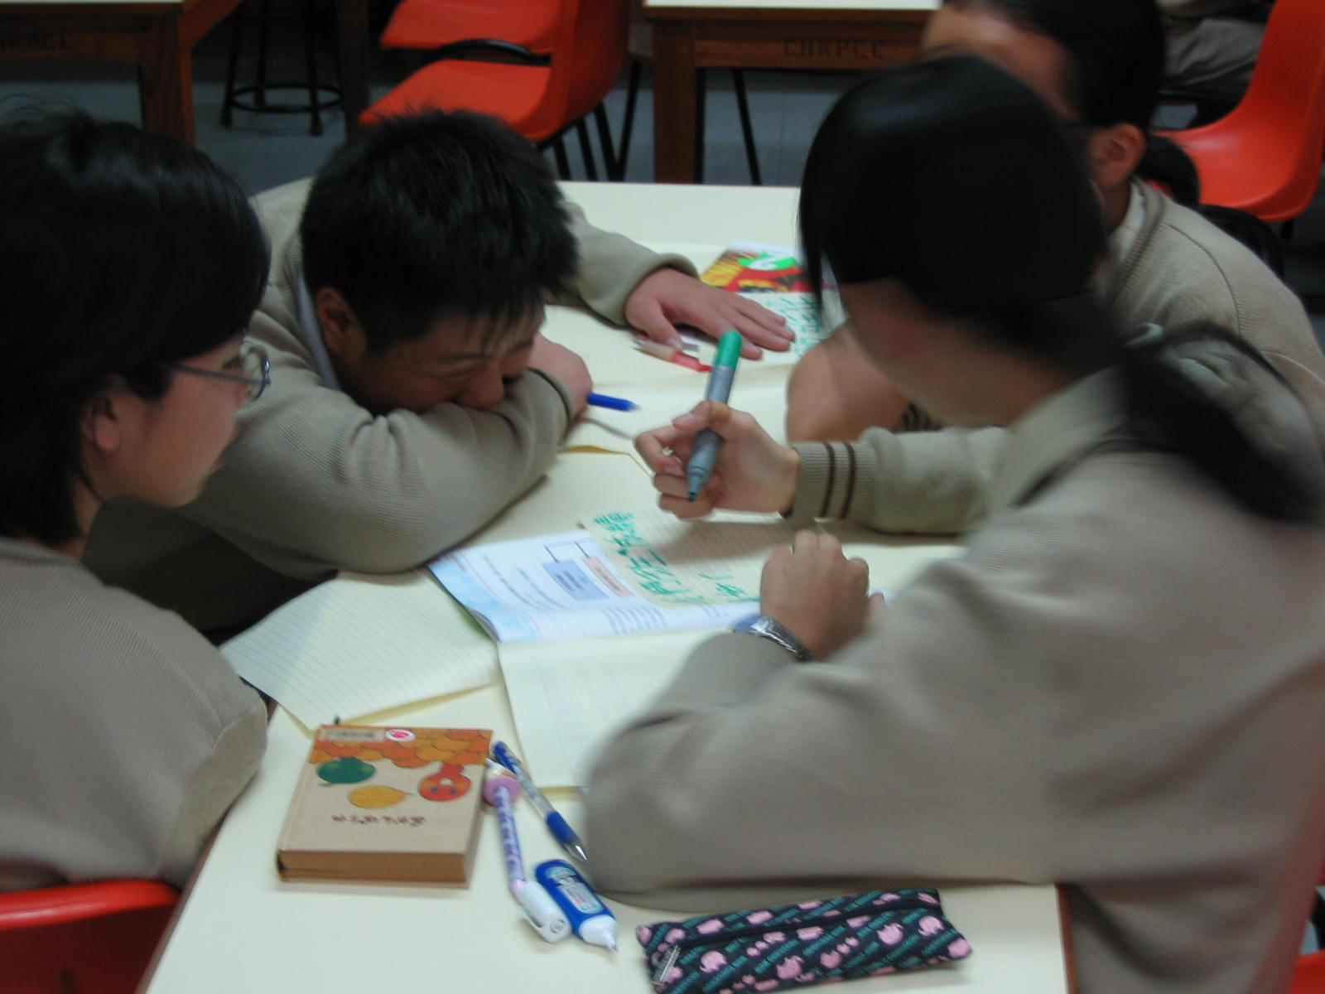
Fig. 5.3 Brainstorming process

Meanwhile the teacher walked around in the classroom and to provide support for each group.

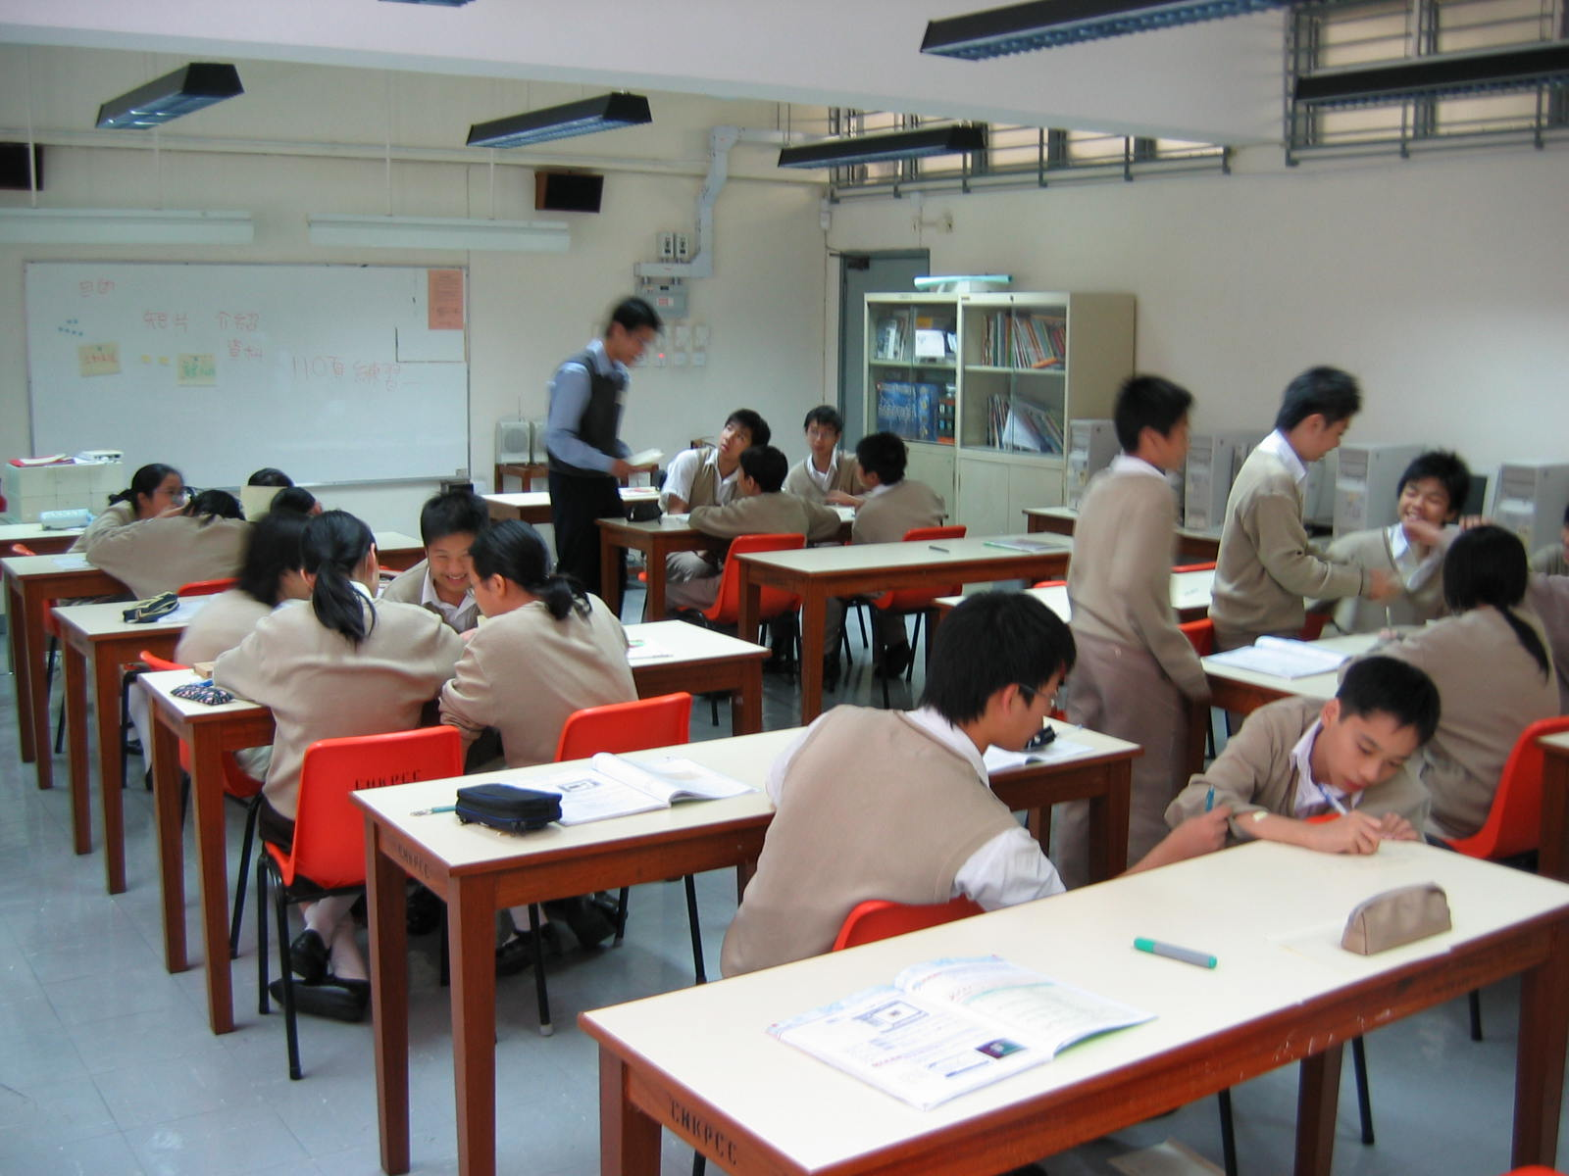
Fig. 5.4 Teacher helps students brainstorm their ideas

After the brainstorming process, each group was invited to display their ideas on the whiteboard as shown in Fig.5.5.

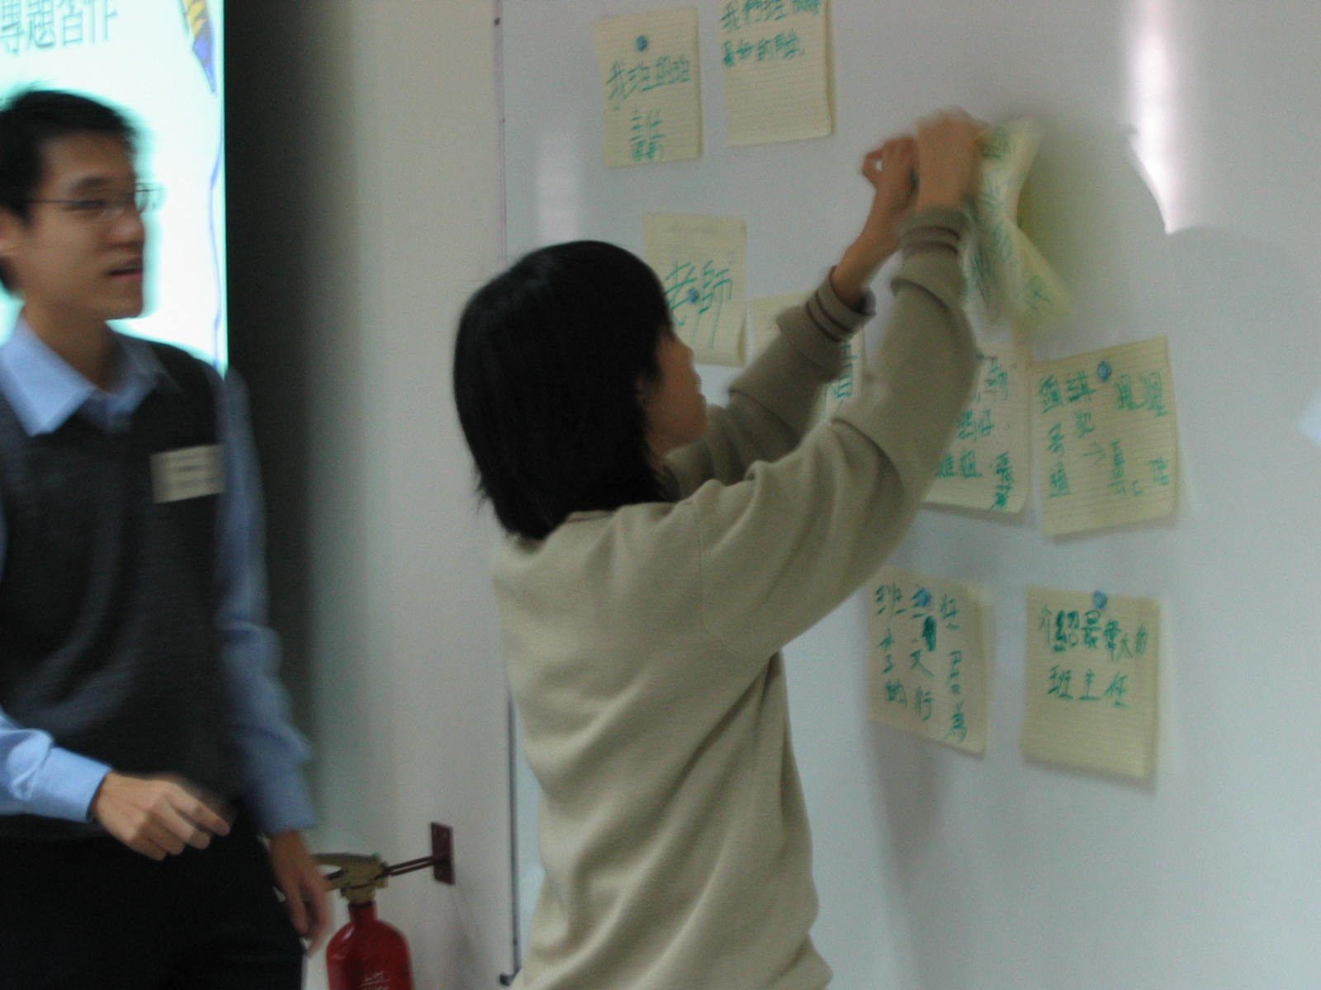
Figure 5.5 Display the group’s ideas on the whiteboard

The teacher provided immediate feedback on students’ work. By the end of this lesson, students have learnt how to organize the ideas from the class discussion.
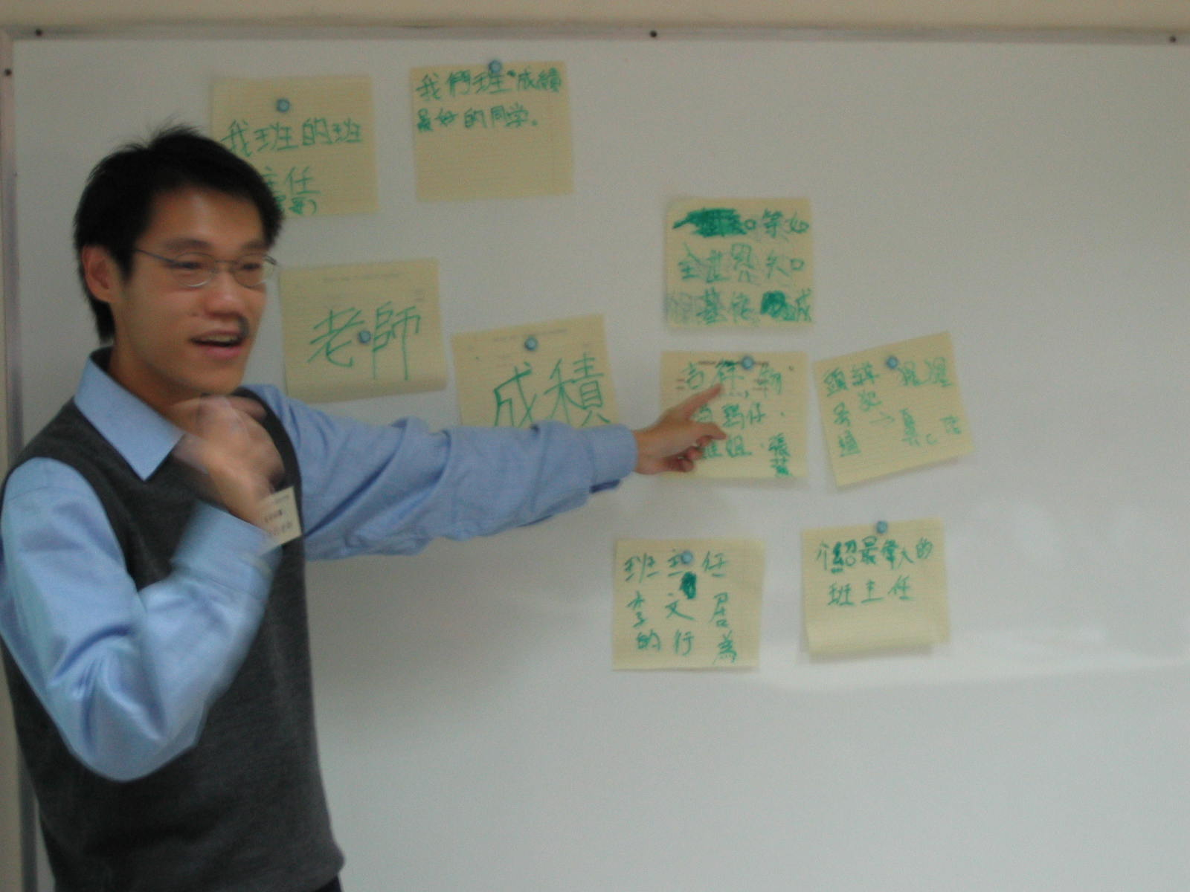
Fig. 5.6 The teacher discusses with the class about the ideas collected

Furthermore, students were asked to give a title for each category of presentation and also decided which media would be suitable for selected sub-topics in the multimedia presentation.
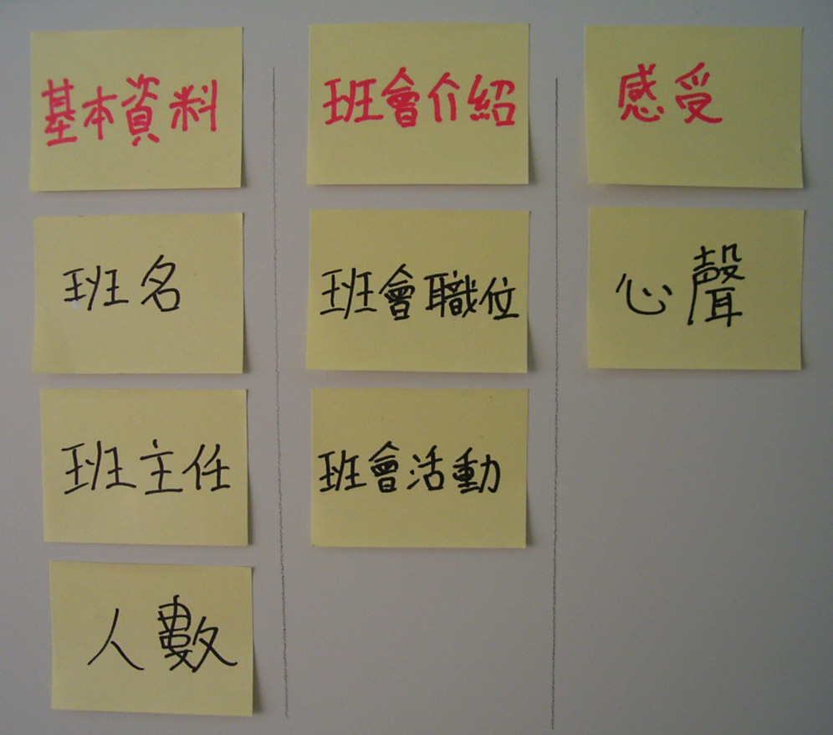
Fig. 5.7 The ideas are categorized and types of media are selected.

In addition to face-to-face interaction in the class, students and teacher further discussed their ideas in their school online discussion forum.
Discussion

- How Mr. Lo encouraged the students to have more involvement in the classroom?

_________________________________________________________________

- During the class, Mr. Lo walked around the classroom. What is his purpose?

_________________________________________________________________

- Besides face-to-face interaction, what can we do to help students rethink what they have learnt after school?

_________________________________________________________________

_________________________________________________________________

- Summarize the strategies he has used to improve the quality of interaction in the class.
_________________________________________________________________

_________________________________________________________________

_________________________________________________________________

_________________________________________________________________

- List some factors that will affect the quality of interaction.

_________________________________________________________________

_________________________________________________________________

_________________________________________________________________

_________________________________________________________________

_________________________________________________________________
Notes for Teachers

We have discussed some strategies to promote interactions in an ICT class. But the quality of interaction still depends on a range of factors in different aspects: the organisation of the learning environment, the teachers’ subject and pedagogical knowledge, and the teachers’ and students’ communication skills (CDC, 2006).

Organization of learning environment

From activity 4, we may find that role-play is a feasible method to promote peer interactions. Also in Activity 9, it includes activities like brainstorming, group discussion and whole-class presentation, the preparation work on creating an appropriate learning environment is tremendous.

Teachers’ subject and pedagogical knowledge

Obviously, closed questions are often easily to design. Teachers who can probe the student’s conceptual understanding should have sound subject knowledge about the learning object. For example, the teacher in Activity 7 should know the subject contents and be able to identify the critical features for understanding HTML tags.

Teachers’ and students’ communication skills

For quality communications, teachers should have sound communication skills. Teachers should have at least some understanding of basic questioning skills, for example, Sweeting (1994) suggests that the following general questioning skills might be essential for teachers:
- Clarity
- Timing
- Distribution
- Probing
- Reinforcement
Furthermore, peer interactions are certainly improved by good students’ communication skills in collaborative learning activities.

Teacher’s Behaviors

Chapman (2004) identifies the following behaviors of the teacher that will facilitate or support peer interactions that promote learning (see Table 5.1).

Table 5.1 Teacher’s Behaviors that will facilitate or support peer interactions that promote learning.
Listens and observes | This provides the teacher with feedback to determine when and how to intervene.
Questions and prompts | This involves the teacher using questions to extend concept  development or check for understanding or prompts when students are stuck.
Supports students’thinking | Make students aware that they have tools, then give them the freedom to use whatever they want to solve these problems.
Models questioning | This involves the teacher using a questioning approach during whole-class instruction that students can follow.
Promotes good peer relations | As one teacher explained, “If you can facilitate good peer  Relations, you can have some really healthy dialogue.” Some ways in which this occurred can be through shared questions, seating plan, voluntary grouping, and peer observations.

Concluding remark

This is the last unit of this booklet. We have just only suggested some feasible strategies and factors that will improve the quality of interaction. It is time to decide which of them are suitable for your students. Besides, you may find some useful Internet resources in the Appendix that will be your starting point to explore more about how Quality Interaction can be used as a strategy for improving teaching and learning in NSS ICT.

References

Chapman, O. (2004). Facilitating peer interactions in learning mathematics:Teachers’ practical knowledge. In M. J. Høines and A. B. Fugelstad, (Eds.) Proceedings of the 28th Conference of the International Group for the Psychology of Mathematics Education, Volume 2, pp. 191-198. Bergen, Norway: Bergen University College, July 2004
Curriculum Development Council. (2006). New senior secondary curriculum and assessment guide (secondary 4-6): information and communication technology (provisional final draft). Hong Kong: The Printing Department, HKSAR Government.
Sweeting, T. (1994). Questioning. Hong Kong: Longman.

-

Appendix

Internet Resources

Curriculum and Teaching of ICT
New Senior Secondary Curriculum and Assessment Guide (Secondary 4-6):
Information and Communication Technology (Provisional Final Draft)
http://www.emb.gov.hk/FileManager/EN/Content_5630/ict_e_060630b.pdf
新高中課程及評估指引(中四至中六) - 資訊及通訊科技科（暫定稿）
http://www.emb.gov.hk/index.aspx?langno=2&nodeID=5594
Roger Crawford's Professional Activities Web site
http://www.hud.ac.uk/ITsec/rac1.htm

Computer Lab
Computer and IT Labs
http://www.shambles.net/pages/staff/ITlabs/
ICT Layout, Design & Furniture : Photographs
http://www.shambles.net/ict/design/index.htm
Lots of photographs and images of computer suites and labs
Design your own classroom : online application
http://www.atschool.org/materials/classroom/buildaclass/
How to design ICT suites and Workstations
http://buildingthegrid.becta.org.uk/docs/ict_design.pdf

Questioning Techniques
Questioning Techniques for Teachers
http://www.deil.uiuc.edu/QuestioningTechniques/index.html
A Questioning Toolkit
http://www.fno.org/nov97/toolkit.html
Questioning
http://changingminds.org/techniques/questioning/questioning.htm
Teaching Methods - QUESTIONING TECHNIQUES
http://newali.apple.com/ali_sites/ali/exhibits/1000328/Questioning_Techniques.html
What is 4MAT?
http://www.aboutlearning.com/what_is_4mat.htm
Computer-Mediated Communication
Computer-Mediated Collaborative Learning: Theory and Practice
http://www.gse.uci.edu/faculty/markw/cmcl.html
Computer-Mediated Communication Magazine
http://www.december.com/cmc/mag/
iKeepBookmarks.com
http://www.iKeepBookmarks.com/bscmaie05
HEMiDEMi - 共享書籤
http://www.hemidemi.com/home
Linkagogo - free Online Favorites manager and Social Bookmarking application
http://www.linkagogo.com/
del.icio,us - Social bookmarking
http://del.icio.us/
Project: Scuttle
http://sourceforge.net/projects/scuttle/
Simple PHP Blog - Project Homepage
http://www.simplephpblog.com/
SourceForge.net: Simple PHP Blog
http://sourceforge.net/projects/sphpblog/
phpBB.com :: Creating Communities
http://www.phpbb.com/
竹貓星球
http://phpbb-tw.net/phpbb/
AppServ Open Project
http://www.appservnetwork.com

References
Chapman, O. (2004). Facilitating peer interactions in learning mathematics:Teachers’ practical knowledge. In M. J. Høines and A. B. Fugelstad, (Eds.) Proceedings of the 28th Conference of the International Group for the Psychology of Mathematics Education, Volume 2, pp. 191-198. Bergen, Norway: Bergen University College, July 2004
Crawford, R. (1999). Teaching and learning IT in English state secondary schools - towards a new pedagogy? Retrieved 7 January 2007 from: http://www.hud.ac.uk/ITsec/roger%20professional/itped.htm
Curriculum Development Council. (2006). New senior secondary curriculum and assessment guide (secondary 4-6): information and communication technology (provisional final draft). Hong Kong: The Printing Department, HKSAR Government.
Jiang, W. & Ramsay, G. (2005). Rapport-building through CALL in teaching Chinese as a foreign language: An exploratory study. Language Learning & Technology, 9 (2), 47-63.
Jonassen, D., Davidson, M., Collins, M., Campbell, J. & Haag, B. (1995). Constructivism and computer-mediated communication in distance education, The American Journal of Distance Education, 9(2), 7-26.
Kissock, C. & Lyortsuun, P. (1982). A guide to questioning: Classroom procedures for teachers. London: Macmillan.
Meyers, C. (1986). Teaching students to think critically. San Francisco: Jossey-Bass.
Moguel, D. (2004). What does it mean to participate in class? Integrity and Inconsistency in classroom interaction. Journal of Classroom Interaction, 39(1), 19-29.
Morris, P. (1996). The Hong Kong school curriculum: Development, issues and politics. (2nd Ed.). Hong Kong: HKU Press.
Neill, S. & Caswell, C. (1993). Body language for competent teachers. London: Routledge.
Sweeting, T. (1994). Questioning. Hong Kong: Longman.
Thurlow, C., Lengel, L. & Tomic, A. (2004). Computer mediated Communication: Social interaction and the Internet. London: SEGE.
Tu, C. H., & McIsaac, M. (2002) The relationship of social presence and Interaction in online classes. The American Journal of Distance Education, 16(3), 131-150.
Wragg. E.C. & Brown, G. (2001). Questioning in the secondary school. London: Routledge.

III Course presentation (PowerPoint slides)

1 Needs of quality interaction in teaching ICT
2 What is quality interaction?
3 Effective strategies to improve the quality of interaction
4 Computer-mediated interactions
5 Factors affecting the quality of interaction

© Education and Manpower Bureau All Rights Reserved 2007

