Design and Applied Technology

Assessment Exercises

M3 - Design Implementation and Material Processing

Curriculum Development Institute,
Education Bureau
(Trial version - March 2021)

Preface
This learning resource package was developed to provide DAT assessment exercises for teachers’ reference, so as to support the implementation of the DAT curriculum in schools and promotion of assessment for learning.
This learning resource package includes:
(i) Tips for Answering Questions
(ii) Two sets of Practice Questions
(iii) Marking Scheme and Answering Guide

Suggestions for use
- Teachers may share the Tips for Answering Questions with students to enable them to become familiar with the common question style, as well as gain confidence in interpreting the questions and planning the completion time.
- Teachers may guide students to complete related practice questions after teaching a topic to help students master what they have learned. Students may also practise answering questions within the suggested time duration. Teachers are advised to adapt the material according to the diverse learning needs of students if deemed necessary.
- Marking schemes with suggested answers are provided for each question. For ‘open-ended’ questions, example answers have been included. Students could refer to the marking schemes to understand about the answering requirements in each question.
- After completion of the practice question, students could refer to the Answering Guide to further understand the points to note for the question concerned.

*This is the trial version of the learning resource package. Teachers are welcome to provide comments and feedback by sending email to:
te_team4@edb.gov.hk

Table of Content

(i) Tips for Answering Questions 4
(ii) Question Paper 6
M3 - Design Implementation and Material Processing (6 questions in total) 6
(iii) Marking Scheme and Answering Guide 15
Marking Scheme 15
Answering Guide 28

(i) Tips for Answering Questions

- General advice on answering questions
- Read the question carefully. Pay attention to all information provided in the question. It is a good practice to read the question twice to ensure you fully understand the answer requirements.
- Look at the number of marks allocated to each item in the question and determine whether marks would be awarded point by point based on the number of answers required, or according to the level criteria of the answer. The former only needs you to provide the corresponding number of correct answers; the latter needs you to determine the implicit requirements in the question carefully, and provide answers in response to each requirement with more details to obtain marks at a higher level.
- Underline the ‘command words’ and ‘key terms’ in the question before start.
- For longer questions, students should take time to think and plan the answers.
- For questions to be answered in the Question & Answer booklets, students could make reference to the space given when assessing how much to write.
- Example question:
Give two mechanical properties of mild steel that make it suitable for the construction industry. (2 marks)
Specific situation connected to the major information
Major information
Command word
Key term in this question
As deduced from the total mark, it is likely that one mark would be awarded for each property correctly named

- Where most of the marks lost when answering a question?
- Misunderstand (some) requirements of the question
- Ignoring (some) clues in the question
- Missing bits of a question
- Poor representation of information and/or annotations in diagrams
- Inaccurate diagrams
- Understanding command words
- The command words in questions instruct you to provide the answers required. Therefore, you need to understand the meaning of the command words used to prepare for the answers. The following are the commonly used command words in DAT:

Command word | What does it mean
- Analyse | Examine in detail to show meaning, identify elements and the relationship between them.
- Apply | To use previous learning and understanding in another familiar situation.
- Annotate | Add brief notes to a drawing, diagram or graph.
- Calculate | Work out from given facts, figures or information. Obtain a numerical answer showing the relevant stages in the working. You may use a calculator or equations.
- Compare | Identify/comment on similarities and/or differences.
- Describe | State the points of a topic / give characteristics and main features.
- Develop | Take forward to a more advanced stage or build upon given information.
- Draw / Produce | Represent by means of accurate diagrams or graphs using drawing equipment. A ruler should be used for straight lines. Diagrams and graphs should be drawn to scale.
- Distinguish | Make clear the differences between two or more concepts or items.
- Explain | Set out purposes or reasons / make the relationships between things clear / say why and/or how and support with relevant evidence.
- Give / State | Produce an answer from a given source or recall from memory. Express in clear terms.
- Illustrate / (Using annotated sketches to) Explain | Include examples or a diagram to show what you mean or demonstrate understanding of issues or concepts.
- Indicate | To show that something exists.
- Justify | Support a case with evidence/argument.
- List | Give a number of features or points without further elaboration.
- Name | Identify using a recognised technical term.
- Outline | A general description showing essential features.
- Sketch | Make a simple freehand and roughly proportional drawing showing the key features.
- Suggest | Apply knowledge and understanding to situations and propose a solution or other possible answers.

(ii) Question Paper

M3 - Design Implementation and Material Processing (6 questions in total)

This question is about ‘Materials, Components and Systems’ and ‘Processing and Manufacturing’ and has a total of 25 marks. The reference completion time is 25 minutes.
1. | The figure below shows a height adjustable desk.
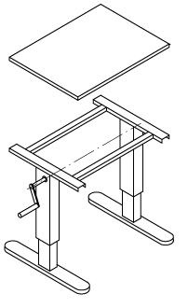
Desktop
(MDF)
Crank handle, connected to height adjustable system
Leg (Mild steel, rectangular tube)
Joint X
 | (a) | - Give TWO reasons why mild steel is a suitable material for making the legs. (2 marks)
- Suggest one appropriate surface finish method for the mild steel legs.
(1 mark)
 |  | - Give one reason why medium-density fibreboard (MDF) is a suitable material for making the desktop. (1 mark)
- Suggest one appropriate surface finish method for the MDF desktop.
(1 mark)
 | (b) | Using annotated sketches, show a method of producing Joint X using knock-down fittings and standard components. (4 marks)
 | (c) | The height of the desktop can be adjusted by turning the crank handle.  - Using annotated sketches, show a mechanical system that provides the required operation and explain its working principle. Name TWO of the mechanisms used. (6 marks)
 |  | - Using annotated sketches, show an improved design to reduce the amount of effort required for turning the crank handle, and explain its working principle. (4 marks)
 | (d) | Explain TWO advantages of designing and producing the desk as knock-down furniture for each of the following parties:  - the manufacturer  - the client (4 marks)
 | (e) | Give TWO reasons why standard components are used in the manufacture of consumer products. (2 marks)
This question is about ‘Materials, Components and Systems’ and ‘Processing and Manufacturing’ and has a total of 25 marks. The reference completion time is 25 minutes.
2. | The figure below shows a trolley suitcase. The shells of the suitcase are made by vacuum forming.
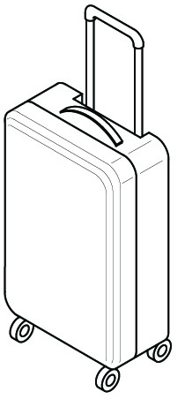
Caster wheel
Grip
Rim of shell
Middle part of shell surface
Corner of shell
 | (a) | (i) Using annotated sketches, describe how one half of the case shell could be vacuum formed. (5 marks)  (ii) Give TWO reasons why vacuum forming is a suitable method for manufacturing the plastic suitcase shells. (2 marks)
 | (b) | (i) Using annotated sketches, describe how to join two halves of the formed case shell with metal hinge plates using pop riviting. (4 marks)  (ii) Give TWO reasons why pop riveting is a suitable method for joining metal hinge plates to the suitcase shells. (2 marks)
 | (c) | Name a suitable plastic material for making the following parts of the suitcase and give one reason for each of the choices.  - Grip  - Shell  - Caster wheel (6 marks)
 | (d) | Using annotated sketches, suggest a method for strengthening each of the following parts of the suitcase shell.  - Middle part of the shell surface  - Corner of the shell  - Rim of the shell (6 marks)

This question is about ‘Materials, Components and Systems’ and ‘Processing and Manufacturing’ and has a total of 25 marks. The reference completion time is 25 minutes.
3. | Figure 1 shows two views of a skateboard. The deck of the skateboard is made by lamination using multiple layers of veneer.
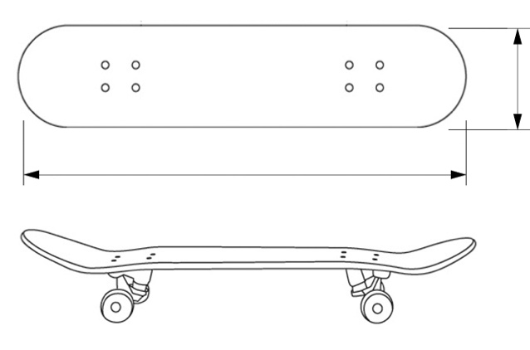
80
20
Deck
 | Figure 1
 | (a) | Give TWO advantages of making the deck by using lamination. (4 marks)
 | (b) | Using annotated sketches, show in detail the structure of the laminated deck, including the grain direction of each layer. (3 marks)
 | (c) | Using annotated sketches, describe the following steps for making the deck using lamination:  - Preparing material  - Preparing former / mould  - Forming process  - Cutting into shape  - Finishing the edges (10 marks)
Figure 2 shows the structure of a skateboard ramp.
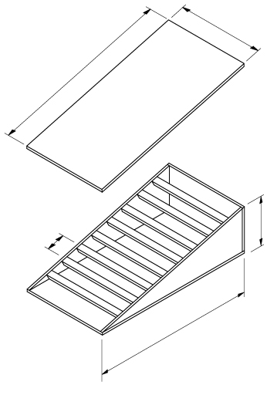
Ramp

Block lumber

Joint A

Side planks
(Plywood)

 | Figure 2
 | (d) | - Using annotated sketches, show a suitable type of woodworking joint for fixing the block lumber to the side planks at Joint A and name the joint used. (4 marks)
 |  | - Using annotated sketches, show a template used to draw the shape of the joint on the side planks, and give two reasons to explain the benefits of using templates. (4 marks)

This question is about ‘Materials, Components and Systems’ and ‘Processing and Manufacturing’ and has a total of 25 marks. The reference completion time is 25 minutes.
4. | The figure below shows an incomplete design of a wind-powered machine. The machine can be used outdoors in all weather conditions.
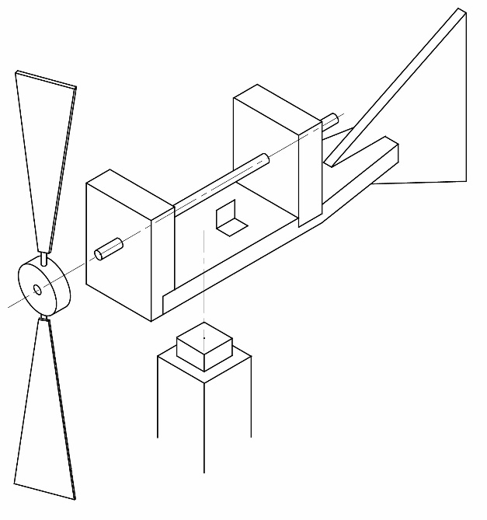
Post
Spring leaf
Main spindle
Rotor
 | (a) | Suggest one suitable metal for each of the following parts. Give one reason in each case to justify your answer.  - main spindle  - spring leaf (4 marks)
 | (b) | Using annotated sketches, improve the design of the post and related parts so that it can still operate as normal no matter which direction the wind is blowing from. (6 marks)
 | (c) | Using annotated sketches, suggest a method in order that when the main spindle rotates once the spring leaf can make two ‘click’ sounds. (6 marks)
 | (d) | Using annotated sketches, suggest a method of reducing the friction between the main spindle and the brackets. (5 marks)
 | (e) | Using annotated sketches, suggest a method of fixing the rotor to the front end of the main spindle. (4 marks)

This question is about ‘Materials, Components and Systems’ and ‘Processing and Manufacturing’, and has a total of 25 marks. The reference completion time is 25 minutes.
5. | Figure 1 shows two views of a bottle opener.
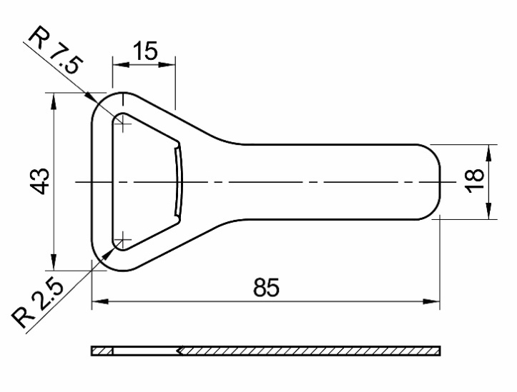
Material: Mild Steel (2 mm thick)

Opening
Lip
 |  | Figure 1
 | (a) | - Using annotated sketches, describe the major steps of making the opening of the bottle opener with the use of hand tools involved. The steps should start from marking out on a mild steel plate. (6 marks)
 |  | - State TWO safety precautions to be observed when making the bottle opener. (2 marks)
 | (b) | Referring to Figure 2.
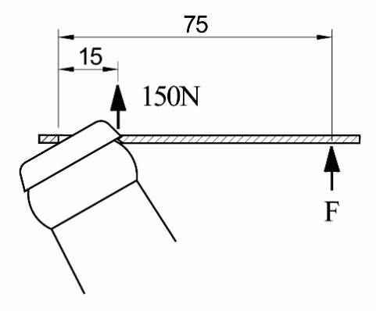
Bottle cap
Bottle opener (Sectional view)

 |  | Figure 2
- Name the class of lever for the bottle opener and explain your answer.
(2 marks)
 |  | - Using the principle of moments, calculate how much force F the user must apply if 150 N of force at the lip is sufficient to remove the cap. (5 marks)
 | (c) | Figure 3 shows an exploded view of the bottle opener and its handle. The parts should be joined together with countersunk rivets.
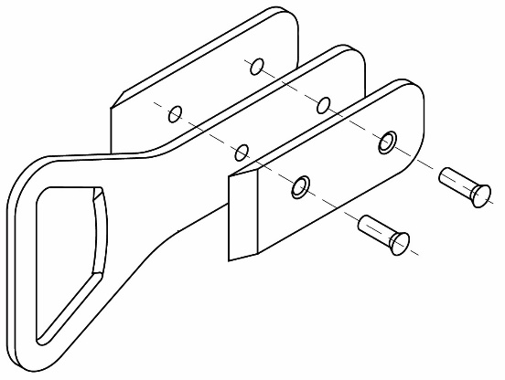
Handle × 2
(Material: Brass, 2.5 mm thick)

Bottle opener (Material: Mild steel, 2.5 mm thick)
Countersunk rivets × 2 (Material: Copper, Ø3.5 mm)
 |  | Figure 3
- Give one advantage and one shortcoming of countersunk riveting.
(2 marks)
 |  | - Using annotated sketches, describe the steps for joining the bottle opener with the handle using countersunk riveting with the use of hand tool. (5 marks)
 |  | - Name the two major compositions that made brass. (2 marks)
 |  | - Give TWO reasons why copper is used as the material for the countersunk head rivets. (2 marks)

This question is about ‘Materials, Components and Systems’ and ‘Processing and Manufacturing’ and has a total of 25 marks. The reference completion time is 25 minutes.
6. | Figure 1 shows a soap box which is made from polypropylene (PP) and manufactured by injection moulding.
 | 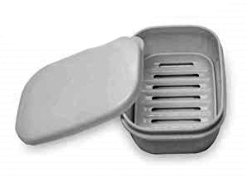
 | Figure 1
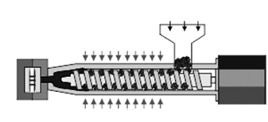
Hopper
Heater
Motor
Mould
Screw thread
 | Figure 2
 | (a) | Give TWO material properties of polypropylene (PP) which make it suitable for making soap boxes and justify your answer with a reason for each property.  (4 marks)
 | (b) | State TWO reasons of using injection molding to make soap boxes. (4 marks)
 | (c) | Write down steps to of the following flow chart that shows the process of making soap boxes by injection molding. (6 marks)
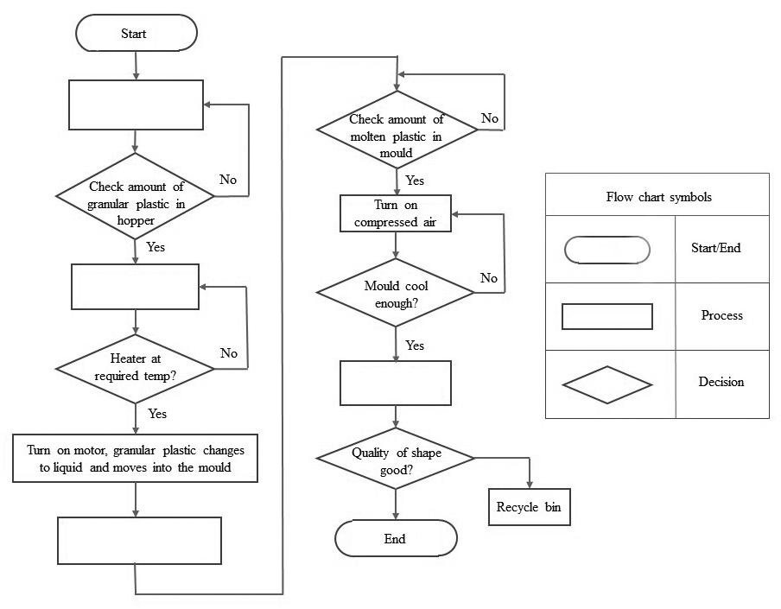

 | (d) | State TWO reasons to explain the importance of product quality inspection in the mass production process. (4 marks)
 | (e) | State TWO reasons to explain the importance of recycling plastic waste generated in the production process. (4 marks)
 | (f) | Sketch a recycling symbol suitable for posting on the recycling bin and explain its meaning. (3 marks)

(iii) Marking Scheme and Answering Guide

Marking Scheme
 |  |  |  |  | Marks
1. | (a) | (i) Reasons that mild steel is a suitable material for making the legs of the desk: (@1 × 2 = 2)
 |  | - High tensile strength, therefore suitable for bending and forming to a variety of shapes  - High heat resistance, therefore facilitate welding |  |  | (2)
 |  | (ii) Appropriate surface finishing method to the mild steel frame: (Any one of the following:
 |  | - Dip coating  - Spraying  - Painting |  |  | (1)
 |  | - Reason why Medium-density fibreboard (MDF) is a suitable material for making the desk to: (Any one of the following)
 |  | - Does not contain knots, making it more uniform than natural woods and consistent in strength and size.  - Has no grain, can be cut, drilled, machined and filed without damaging the surface. |  |  | (1)
 |  | - Appropriate surface finish method for the (MDF) desktop: (Any one of the following)
 |  | - Can be painted with oil, water-based paints and varnishes to produce a smooth surface.  - Can be laminated with thin veneer and laminate |  |  | (1)
 | (b) | Suggest a method of making joint X using knock-down fittings and standard components.
 |  | - Appropriate component(s): (e.g.) Table leg mounting bracket and screw (2M)
 |  | Example: Table leg mounting brackets
 |  | 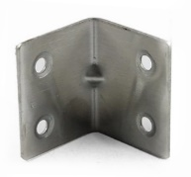 | 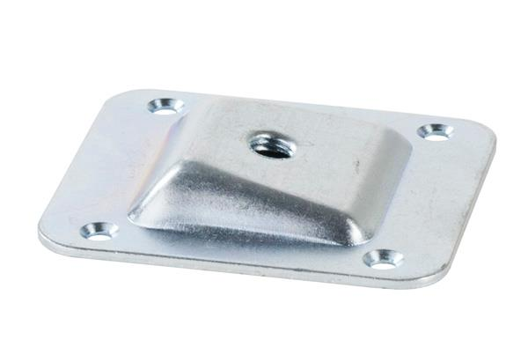
 |  | - Method of joining the leg to the base plate (2M) |  |  | (4)
 | (c) | - Desk height adjustment mechanical system:
 |  | - Appropriate mechanical system and working principle: Including motion transition and synchronization of both legs (2M)  - Technical feasibility: Location and method of installing to the desk (2M)  - Two mechanism involved: (e.g.) Bevel gears, threaded shaft and nut (2M) |  |  | (6)
 |  | Example: (For reference only)
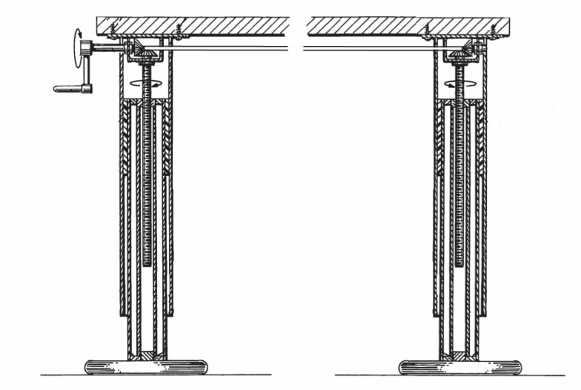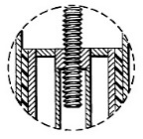
Bevel gears

Enlarged diagram: Threaded shaft & nut

Crank handle

 |  | - An improved design to reduce the amount of effort required for turning the crank handle:
 |  | - An effective effort-saving design: (e.g.) lengthening the arm of the handle (2M)  - Reason: A longer length of the arm allows for greater torque / mechanical advantage (2M) |  |  | (4)
 |  | Example: (For reference only)
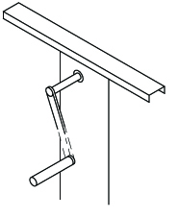
Lengthening the length of handle arm
 | (d) | - Advantage for the manufacturer: (@1 × 2 = 2)
 |  | - Knock-down furniture can be flat-packed and fit more on flat shelves, so as to enhance inventory management and storage efficiency.  - Furniture units can be easily made via CNC mills, which lowers labour cost. |  |  | (2)
 |  | - Advantage for the client: (@1 × 2 = 2)
 |  | - Knock-down furniture come in boxes and flat packed, makes it easier to bring home.  - Clients can change colours or repurpose at will. |  |  | (2)
 | (e) | Reasons why standard components are widely used in the manufacture of consumer product: (@1 × 2 = 2)
 |  | - Standard components can be manufactured in large quantities, keeping costs down.  - Reduces maintenance costs, as the same components / units can be purchased and used all over the world. |  |  | (2)
 |  | Total: |  |  | 25 marks

 |  |  |  |  |  | Marks
2. | (a) | (i) Vacuum forming the shell:
 |  | 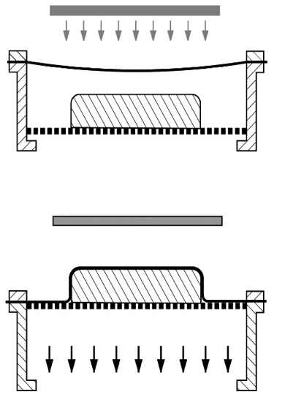  Extract air  Platen and mould  Heater  Plastic sheet |  | Notes and/or sketches that include:  - a mould is placed on the platen, which is lowered (1M)  - a plastic sheet is clamped into place above the mould (1M)  - the heater is pulled over the plastic sheet / the platen is raised when the plastic sheet is softened (1M)  - pump expels the air, which creates a vacuum causing the plastic to be forced over mould (1M)  - the platen is lowered and the mould removed (1M) |  | (5)
 |  | (ii) Reasons why vacuum forming is a suitable method for manufacturing the plastic suitcase shell: (Any TWO of the following) (@1 × 2 = 2)
 |  | - Low forming pressures are used, so it is possible to use relatively low-cost tooling and moulds  - With thermoplastic like high impact resistance polystyrene (HIPS), can form deep parts and almost any shape.  - Trimmed waste can be re-ground and recycled. |  |  |  | (2)
 | (b) | - Procedure of joining two halves of the formed case shell with metal hinges using pop riviting: (@1 × 4 = 4)
 |  | - Drill a hole on suitcase shell.  - Insert pop rivit through holes on hinge plate and case shell  - Pull rivet mandrel (pin, stem) into rivet body , causing it to expand and grip the parts to be joined  - Once gripped, the mandrel breaks, permanently holding the pop rivet in place. |  |  |  | (4)
 |  | Example: (for reference only)
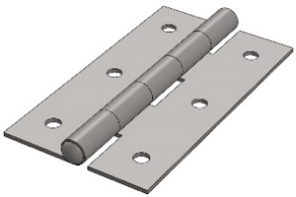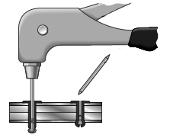
Riveting gun
Pin breaks off at the neck location
Pop rivet
Metal hinge plate
Metal hinge plate
Suitcase
 |  | - Reasons why pop riveting is a suitable method for joining hinge plates to case shells. |  |  |  | (2)
- Allowing for joining of parts when there is limited rear access
- Can make high strength joints on plastic and sheet metal
 | (c) | Material for making the following parts of the suitcase and their reasons:
 |  | (Name + reason) (@(1 + 1) × 3 = 6)
 |  | - Grip:  - Rubber / polyurethane (PU): Elastic, shockproof  - Shell:  - Acrylonitrile butadiene styrene (ABS) / polycarbonate (PC): Easy to vacuum form, heat resistant, fairly sturdy, scratch-resistant, water repellent  - Caster wheel:  - Rubber: Excellent cushioning properties / good elasticity which can run stably on uneven surfaces  - Nylon: Excellent abrasion resistance / shock proof which can run stably on uneven surfaces  - Polyurethane (PU): High load bearing, durable |  |  |  | (6)
 | (d) | Methods of stiffening each of the following parts of the suitcase shell: (For each of the following) (Sketch + annotation) (@(1 + 1) × 3 = 6) |  |  |  | (6)
 |  | - Middle of the shell:  - Corrugated design at the middle of the shell | 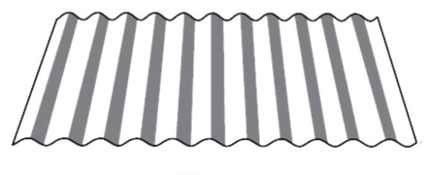
 |  | - Corner of the shell:  - Metal corner guard / bracket attached to corners of the shell | 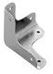
 |  | - Rim of the shell:  - Metal protection strips for edges | 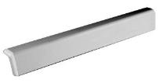
 |  | Total: |  |  |  | 25 marks

 |  |  |  |  |  |  | Marks
3. | (a) | Advantages of making the deck by using the laminating method:  (@2 × 2 = 4)
 |  | - During the manufacture of the skateboard deck, non-wood materials can be adhered to the wood laminate to reinforce the deck.  - Laminating veneers horizontally makes it easy to press in complex concaves and profiles. |  |  |  |  | (4)
 | (b) | Detail structure of the laminated deck and grain direction of each layer:
 |  | - Structure of deck: (e.g.) The deck is made of seven/nine layers of thin veneer (1M)  - Grain direction of each layer: Long grain on face layers, long and cross grain on other alternative layers (2M) |  |  |  |  | (3)
 |  | Example: (For reference only)
 | 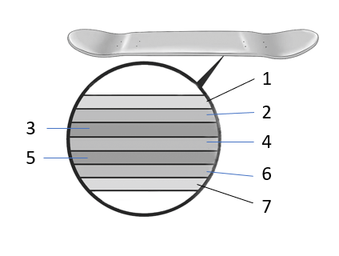  The deck is made of seven/nine layers of thin veneer |  | 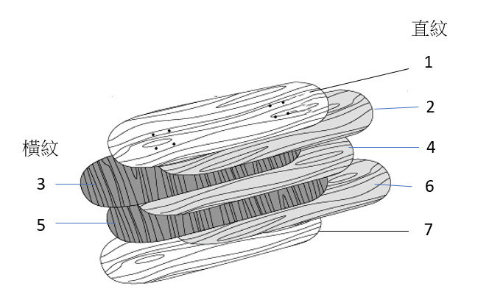  Cross grain  Long grain
 | (c) | Steps for making the deck using the laminating method: (@2 × 5 = 10) |  |  |  |  | (10)
 |  | - Preparing material:  - Cut veneers to the required size  - Evenly spread wood glue on veneers |  | 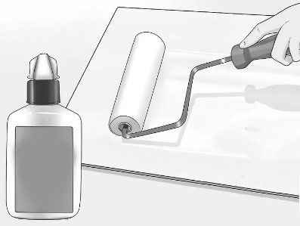  Wood Glue
 |  | - Preparing former/mould  - Use wooden strips to make the upper and lower moulds according to the required shape |  | 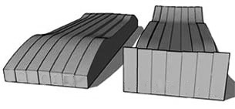
 |  | - Forming process  - Place the thin veneers in the mould while the wood glue is still wet |  | 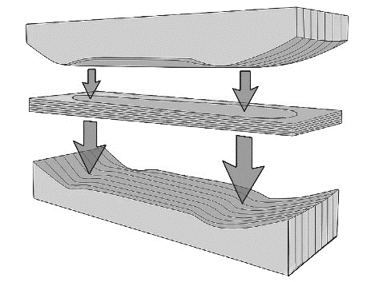
 |  | - Use a press or clamps to press the laminate for about 24 hours until it is cured |  | 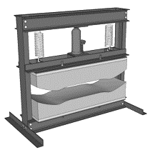
 |  | - Cutting into shape：  - Use a jigsaw to cut the laminate into the required shape. |  | 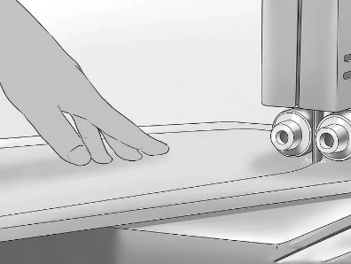
 |  | - Finishing the edges  - Sand the edge of the deck with a belt sander  - Then sand the edges of the deck with fine sandpaper |  | 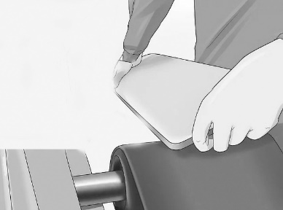
 | (d) | - Suitable type of joint for fixing the block lumber to the side planks:
 |  | - Name of wood working joint: (e.g.) Halving joint (2M)  - Ways to strengthen the joint: (e.g.) add adhesives (1M)  - Technical feasibility: Suitable for narrow location (1M) |  |  |  |  | (4)
 |  | Example: (For reference only)
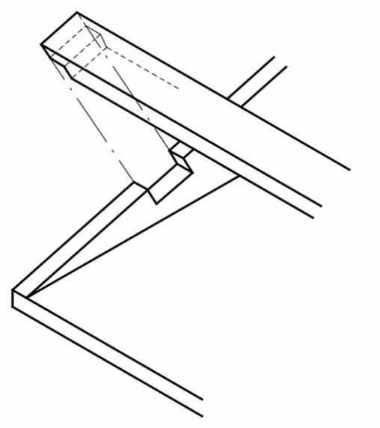
Block lumber

Side plank
Halving joint

 |  | - Template:
 |  | - Properly designed template: Correct cut-out shape (1M) and size (1M) |  |  |  |  | (2)
 |  | Example: (For reference only)
 |  | 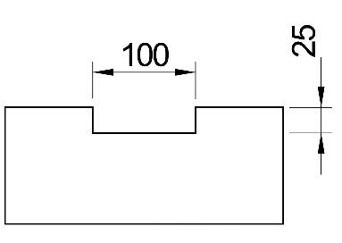
 |  | - Benefits of using the template: (@1 × 2 = 2)
 |  | - Can simplify the marking out procedure, no need to use hand tools to mark out each tenon and mortise one by one  - Can ensure that the size and shape of each tenon and mortise drawn are consistent |  |  |  |  | (2)
 |  | Total: |  |  |  |  | 25 marks

 |  |  |  | Marks
4. | (a) | Suitable material for each of the following parts of the wind-powdered machine:
 |  | - Main spindle:  - Material: (e.g.) Stainless steel  - Reason: Wear resistant |  | (2)
 |  | - Spring leaf:  - Material: (e.g.) Spring steel, Brass  - Reason: Good elasticity |  | (2)
 | (b) | Improve the design of the post:
 |  | - Appropriate method: (e.g.) Install a thrust bearing (1M) between the bottom plate and the column of the wind turbine (1M), which can bear the axial load (1M) on the one hand, and reduce the direct friction between the bottom plate and the column (1M) on the other hand, so that the wind turbine can rotate freely no matter which direction the wind blows from, the wind turbine can still operate.  - Technical feasibility: (e.g.) The shaft and housing of the thrust bearing can be easily installed and operate efficiently. (2M) |  | (6)
 | (c) | Method of making ‘click’ sounds:
 |  | - Appropriate method: (e.g.) Install a tapping device (1M)on the main spindle(1M). Two drumsticks separated by 180° (1M) are attached to the main spindle. When the spindle rotates once, each drumstick strikes the spring leaf once to produce two "click" sounds in total. (1M)  - Technical feasibility: The device can be easily installed on the main shaft with set screws, and can operate efficiently. (2M) |  | (6)
 | (d) | Method of reducing friction between the main spindle and the brackets:
 |  | - Appropriate method: (e.g.) Install two brass bushes or ball bearings (1M) between the main spindle (1M) and the brackets to reduce friction. (1M)  - Technical feasibility: (e.g.) The bushes/ ball bearings can be easily installed, removed or replaced if necessary. (2M) |  | (5)
 | (e) | Method of fixing the rotor to the main spindle:
 |  | - Appropriate method: (e.g.) Cut a notch (1M) near the front end of the main spindle, and use a set screw (1M)to fix the rotor securely on to the spindle at the position of the notch.  - Technical feasibility: Use standard components, easy to assemble, disassemble and replace. (2M) |  | (4)
 |  | Example: (For reference only)
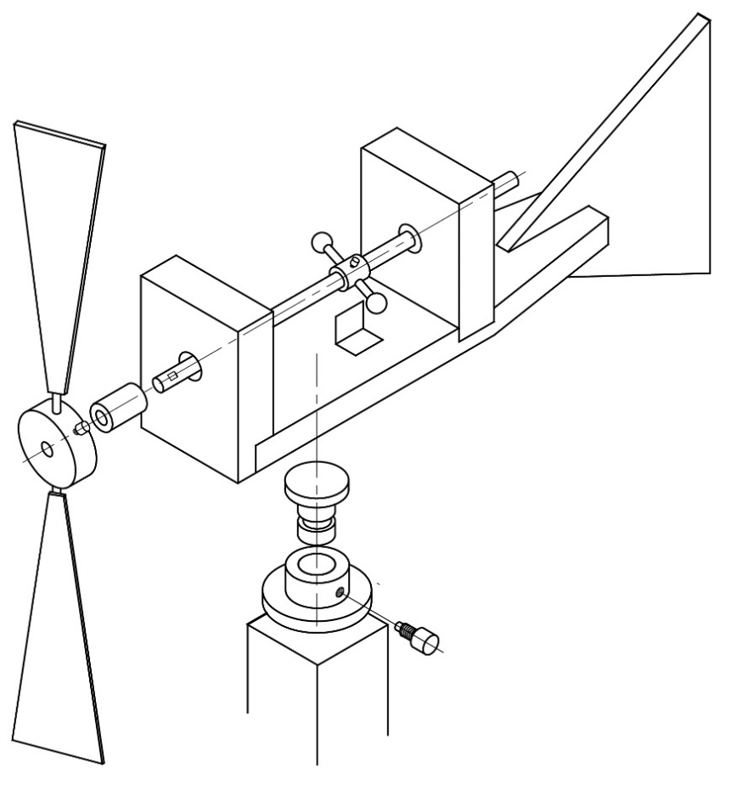
Brass bush
Tapping device
Thrust bearing
(Upper part: shaft, lower part: housing)
Set screw
Notch
Spring leaf
 |  | Total: |  | 25 marks

 |  |  |  |  | Marks
5. | (a) | - Major steps of making the opening of the bottle opener: ( (@1 × 5 = 5)
 |  | - Mark out and centre punch the positions of the two Ø5 holes  - Hold work piece in a machine vice and drill the holes  - Roughly remove waste material with a coping saw  - File the metal down to the correct size and shape  - Draw file to finish the surfaces of the opening, and check the final size of the opening |  |  | (5)
 |  | Example for individual step: (For reference only)
 |  | 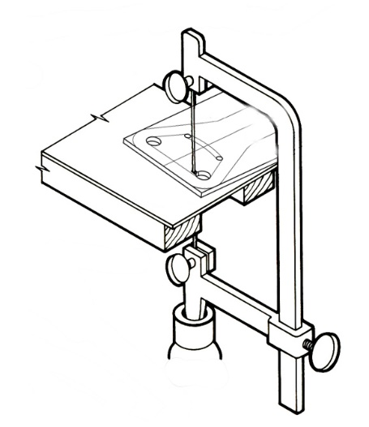 | - Remove waste material with a coping saw
 |  | - Safety precautions to be observed：(Any TWO of the following) (@1 × 2 = 2)
 |  | - Keep hands away from moving/rotating parts of the drilling machine.  - Drilling machines should not be used without an effective guard over the drill, chuck and spindle.  - Ensure that the chuck key is removed from the chuck before starting the drilling machine.  - The work to be drilled should be securely held on the drill table, e.g. with a machine vices or hand vice.  - Persons with long hair should not be allowed to operate drilling machines without the hair being adequately covered. |  |  | (2)
 | (b) | - Class of lever for the bottle opener:
 |  | - Class of lever: Second-class lever (1M)  - Reason: The load (50N, which is the resistance of the cap holding onto the top of the bottle) is between the fulcrum/pivot (P) and the effort (E). (1M) |  |  | (2)
 |  | - Calculation on the Force F:
 |  | - Take moments through fulcrum/pivot (P) and effort (E) (1M)  - Correct formula: Moment (M) = Force (F) x Distance (d) (1M)  - Clockwise moment = Anti-clockwise moment (1M)  - 150 x 15 = F × 75 (1M)  - Correct answer, F = 30 N (1M) |  |  | (5)
 | (c) | - Using countersunk riveting:
 |  | - Advantage: The rivet head will not protrude from the surface of the handle such that the user would feel more comfortable when holding the bottle opener. (1M)  - Disadvantages: The rivet can only support lower loads. (1M) |  |  | (2)
 |  | - Procedure of forming the countersunk head:
 |  | - Clamp workpiece in hand vice, and drill a through hole  - Countersunk both ends of the hole  - Insert the countersunk rivet into the hole, and use the rivet set to press the parts together  - Shape the rivet tail with a round head hammer  - Use a file to remove excess material and smooth the surface |  |  | (5)
 |  | Example: (For reference only)
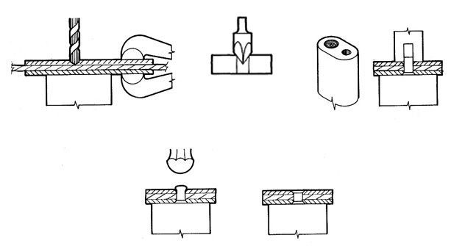
Ball peen hammer
File surface flush
(1)
(2)
Rivet set
(4)
Hand vice
(5)
Countersinking
(3)
 |  | - Base metals for composing brass:
 |  | - Copper and Zinc (1 + 1 = 2) |  |  | (2)
 |  | - Reasons for using copper as the material for countersunk head rivet: (@1 × 1 = 2)
 |  | - Good malleability  - Good ductility |  |  | (2)
 |  | Total: |  |  | 25 marks

 |  |  |  | Marks
6. | (a) | Properties of polypropylene (PP)
 |  | (Any two of the following properties + reasons) (@ 2 × 2 = 4)
 |  | - Good tensile strength: Can withstand heavy loads  - Semi-rigid: More likely to bend and flex with an impact  - Good chemical resistance: Can resist many organic solvents, acids, and alkalis.  - Good water resistance: Highly impermeable, essential property for washing process  - Tough: Strong enough to withstand reasonable impact  - Good fatigue resistance: Can retain its shape after being bent or subjected to torsion  - Low melt viscosity (easy flow): Ensure fast filling rate during the injection moulding process |  | (4)
 | (b) | Benefits of using injection molding to make soap boxes: (Any two of the following benefits + reasons) (@ 2 × 2 = 4) (Answers such as cheap/fast are not accepted, and further explanation is required.)
 |  | - With split mould (1M), complex contour/shape can be manufactured (1M)  - Automated process (1M), suitable for mass/continuous production (1M)  - Multiple products can be manufactured in the same mould (1M), thus reducing the cost of production (1M)  - Finished product with high finish (1M), no other surface treatment is required (1M)  - The finished product achieves a high tolerance (1M) and the size is very accurate (1M)  - Waster materials can be recycled (1M), thereby reducing waste (1M) |  | (4)
 | (c) | Complete the flowchart：(@1 × 6 = 6)
 |  | - Fill hopper with granular plastic  - Turn on heater  - Inject molten plastic into the mould  - Split mould, remove product  - Yes  - No |  | (6)
 | (d) | Importance of product quality inspection in the mass production process: (@2 × 2 = 4)
 |  | - Through quality inspection of products during the manufacturing process, defective items can be identified to ensure that the result of the manufacturing process is the same as expected.  - Through quality inspections, products are compared with established standards and specifications to achieve standardisation and uniformity to control product quality. |  | (4)
 | (e) | Importance of recycling plastic waste generated in the production process: (@2 × 2 = 4)
 |  | - It takes a long time for plastic to decompose in the natural environment, and individual plastics release toxins during the decomposition process.  - Plastic waste generated in the production process, such as plastic scraps, can be recycled and returned to the supply chain to reduce the consumption of natural resources. |  | (4)
 | (f) | Recycle logo:
 |  | - Logo design: Appropriate, distinctive, attractive, understandable (2M)  - Meaning: The logo is composed of three green arrows that are connected to each other, which is associated with the three R’s of recycling; recycle, reuse, reduce. This brings out the meaning of recycling resources and benefiting the environment and future generations. (1M) |  | (3)
 |  | Example: (For reference only, anyone of the following)
 |  | Total: |  | 25 marks

Answering Guide

Question No.
1(b) | Standard Component
- Nuts, bolts and washers are perhaps the most common standard components used today, but the term ‘standard component’ covers a wide range of items that are used on a number of different products. Thus, this term is best defined as any pre-prepared item used in the production of a product.
- Standard components can be manufactured in high quantity quickly and accurately by specialists. This would greatly reduce the overall cost of producing the individual part.
1,2 | Technical Terminology
 | - For questions related to ‘Materials, Components and Systems’ and ‘Processing and Manufacturing’, the correct terminology of tools, processes, and materials should be used instead of generic terms or common name to obtain a score.
2 | Standard Abbreviation
 | - Unless otherwise specified, questions related to ‘Materials, Components and Systems’ and ‘Production Process and Manufacturing’ usually accept standard abbreviations as answers to plastic materials, e.g. PP, PVC.
6(c) | Flowchart
- Flowcharts are diagrams of connected shapes, combined to represent instructions to a workflow or process.
- Different symbols in a flowchart represent different types of operation. Oval represents start/end, parallelogram means input/output, diamond for making decisions, rectangle is processes, and arrow is a connector showing relationships between shapes.
- Quality assurance decisions can also be added to the flowchart to ensure that problems are picked up and fixed within the system.

